

Project PAM

A Reference Design for

Photoresin Additive Manufacturing for

The Open Source Community

Saluki Engineering Company

Reference Number: S14-75-3DPR

2014-12-02

|  |  |
| --- | --- |
| Nicholas Lowman | Computer Engineering |
| Daniel Olsen | Computer Engineering |
| Chance Baker | Electrical Engineering |
| Casey Spencer | Electrical Engineering |
| Jeffrey Burdick (PM) | Mechanical Engineering |
| Nathaniel Tyler | Mechanical Engineering |

# Transmittal Letter: CWB

2014-12-03

Saluki Engineering Company

Southern Illinois University Carbondale

College of Engineering – Mail Code 6603

1230 Lincoln Drive

Carbondale, IL 62901

Steven Blair, President

Saluki Makerspace

Southern Illinois University Carbondale

College of Engineering – Mail Code 6603

Room E0021

1230 Lincoln Drive

Carbondale, IL 62901

Mr. Blair,

On behalf of the Saluki Engineering Company, I would like to thank you for including us in the bid for a project to design a digital light processing printer. Attached is a design report for a DLP photoresin printer, Project PAM. Along with this report, we have included the computer host software code and build instructions of the prototype.

Project PAM proposes a reference Photoresin Additive Manufacturing (PAM) system which maximizes accessibility to the hobbyist. It is intended to be easily obtainable to consumers. This is achieved through extensive use of currently available or easily fabricated hardware and open-source software. The design allows this hardware to be very flexible, to scale to the size requirements of the maker. The reference design will be open-source hardware and software to the lowest practical level. Thorough documentation will provide the necessary means for the maker to go from an empty table to a functioning printer.

Our prototype is constructed to allow a build volume up to 192 mm x 216 mm x 216 mm with an X and Y pixel size of 100 μm and layer thicknesses down to 10 µm. In its current single-projector configuration it can provide a build volume of up to 216 mm x 121.5 mm with an X and Y pixel size of 112.5 µm. It can also close focus to provide a much smaller pixel size for smoother builds of smaller objects. This can be accompanied with a smaller build table and build vat to involve a smaller volume of resin.

The prototype comes with a 1920 x 1080 pixel ViewSonic projector which has been proven to provide very close focusing and will be perfect for later expansion to a large volume two projector system.

Please feel free to contact me at (815) 214 9661 or by email, burdickjp@siu.edu, if you have questions about this project.

Sincerely,

Jeffrey P Burdick

Project Manager

Project PAM: Team75-3DPR

Saluki Engineering Company

(815) 214-9661

burdickjp@siu.edu

# Acknowledgements: CWB

We would like to express our thanks to Dr. Spyros Tragoudas and Dr. Rasit Koc along with the Electrical and Computer Department and the Mechanical Department for the support and financial contributions. The project would not have been possible without their financial backings.

We would also like to take the time to thank the backers of the crowed funding campaign. Very person’s contribution was very much accommodating to the needs of our group. We would like to thank them for not only their financial report but their words of encouragement and belief in our project.

From the beginning of the project Dr. Lizette Chevalier has given priceless words of encouragement and advice that has been very critical to the success of the project.

At this time we would like to thank Lakendria Kenner of WSIU, Scott J. Grunewald of 3D Printing Industry, Eddie Krassenstein of 3D Print, and Austin Miller of Dailey Egyptian for the kind words in their articles. Their articles have help spread the work of Project PAM out to the global community.

We would like to take this opportunity to thank Dr. James Mathias for him allowing us to have use to his laboratory space giving Project PAM a place to call home.

We also would like to express a deep sense of gratitude to the team’s Faculty Technical Advisors; Dr. James Mabry and Joe Lennox, for their constant support, valuable guidance, and professional advice throughout the various stages of the design project.

We are grateful for the assistance of Tim Attig of the SIUC Machine Shop. His vast machining skills and knowledge have been a great part of the project’s success. Tim’s time and technical advice was invaluable to the team.

Lastly, we would like to thank the professors and teachers of the class; Dr. Tod Policandriotes, Dr. Vidya Singh-Gupta, Dr. Frances Harackiewicz, and Dr. Alan J. Weston for their support, ideas, and suggestions.

# Table of Contents: CWB

1 Transmittal Letter: CWB 2

Acknowledgements: CWB 3

Table of Contents: CWB 4

Table of Figures: CWB 5

Table of Tables: CWB 5

2 Executive Summary: CWB 6

3 Project Description: 6

3.1 Introduction: CWS 6

3.2 Overall Printer Diagram: 8

4 Costs: DMO 8

4.1 Crowdsourcing Campaign: DMO 9

4.1.1 Indiegogo 9

4.1.2 Social Media 12

4.1.3 Media Coverage 12

4.2 Prototype Costs: DMO 13

5 Schedules: 13

5.1 Proposed and Reworked Schedule: DMO 13

5.2 As Worked Schedule: DMO 13

6 Subsystem Descriptions: 14

6.1 Chassis: JPB 14

6.1.1 Process of Design 14

6.1.2 Process of Assembling 15

6.1.3 Equipment Needed 15

6.1.4 Recommendations 15

6.2 Mechanical Motion: JPB 15

6.2.1 Process of design 15

6.2.2 Process of Assembling 16

6.2.3 Equipment Needed 16

6.2.4 Recommendations 16

6.3 Technical Drawings: NBT 16

6.4 Printer Control Software: DMO 20

6.4.1 Process of Design 20

6.4.2 development Process 23

6.4.3 development SCHEDULE 24

6.5 Hardware-Software Interface: NAL 25

6.5.1 Process of Design 25

6.6 Motors/Motor Control: CWS 25

6.6.1 Process of Design 25

6.6.2 Health and Safety Concerns 27

6.7 Resin Management: CWB 27

6.7.1 Process of Design 27

6.7.2 Health and Safety Issues 27

6.7.3 Recommendations 28

6.8 Optics: CWB 28

6.8.1 Design 28

6.8.2 Recommendations 29

7 Test Print Results: CWB 29

8 References: CWB 30

9 Appendix 34

9.1 Schedules 34

9.1.1 Proposed and Reworked 34

9.1.2 As Worked 36

9.2 Bill of Materials 38

9.3 CAD Models 41

9.3.1 Printer 42

9.3.2 Chassis 44

9.3.3 Motion Control 55

9.3.4 Ribbed Vat 62

9.4 MakerJuice G+ Safety Data Sheet 70

9.5 MakerJuice G+ Techincal Data Sheet 78

9.6 Website (GitHub Pages) 80

9.6.1 Home Page 80

9.6.2 Hardware Page 83

9.6.3 Software Page 84

9.6.4 Google Analytics Reports 85

9.7 Project PAM Prezi 88

9.8 Indiegogo 103

9.8.1 Story 104

9.8.2 Funders 109

9.8.3 Gallery 111

9.9 Social Media Pages 113

9.9.1 Twitter Page 114

9.9.2 Facebook Page 119

9.10 Articles Project PAM Was Featured In 124

9.10.1 3DPrint.com 125

9.10.2 3D Printing Industry 128

9.10.3 WSIU 132

9.10.4 Make Magazine 133

9.11 User Manual 134

9.11.1 Printing Instructions 134

9.12 Flashing Grbl 135

9.12.1 Configuring Grbl 136

# Table of Figures: CWB

Figure 1. Market gap 8

Figure 2. Flow diagram for Project PAM printer control software 8

Figure 3. Crowdsourcing campaign activity 12

Figure 4. An isometric view of the current chassis design 14

Figure 5. Ribbed vat undergoing an FEA simulation (displacement diagram) 18

Figure 6. Generic open source hardware title block 19

Figure 7. Open Source Hardware Logo 20

Figure 8. Proposal for Project PAM printer control software 20

Figure 9. Problem with STL files [25] 22

Figure 10. KDevelop 5 pre-alpha on Windows [34] 23

Figure 11. Screenshot of KTechLab 24

Figure 12. Wire diagram 26

Figure 13. Robot Test Print 30

Figure 14. 20 mm Cube Test Print 30

# Table of Tables: CWB

Table 1. Indiegogo perks 10

Table 2. Articles Project PAM was featured in 12

Table 3. Cost of subsystems 13

Table 4. Total system cost 13

Table 5. Stepper motor data [36] 26

# Executive Summary: CWB

Project PAM proposes a reference Photoresin Additive Manufacturing (PAM) system which maximizes accessibility to the hobbyist. It is intended to be flexible by allowing for configurations of hardware available or easily obtainable to the maker. This is achieved through extensive use of currently available or easily fabricated hardware and open-source software. The reference design uses open-source hardware and software to the lowest practical level. Thorough documentation provides the necessary means for the maker to go from an empty table to a functioning printer.

The major subsystems of Project PAM include: Mechanical Motion, Chassis, Printer Control Software, Hardware-Software Interface, Resin Management, Optics, Vat, and Coupler. Our teams is still striving to achieve the optimist solution to achieve the highest level of quality.

Several of the design activities and decisions show how Project PAM is more desirable than the competition. One example of this is Project PAM’s build volume size. The maximum build volume is almost double that of any other DLP printer. This is achieved by supporting the use of two 1920 x 1080 pixel projectors. As consumer resins increase with quality this feature will allow the PAM system to grow. Though the maximum build volume would use up to 9 L of resin, Project PAM’s flexible design can accommodate smaller vats and build tables. The maker can use a vat and build table sized appropriately for their build. This will minimize resin waste, saving the maker money.

This printer is expected to have the capability of producing high quality prints. The initial goals of Project PAM included: keep the cost of the project under $700 excluding the price of the projectors, support the use of two projectors, have a maximum build size of approximately 8 L, layer thickness as thin as 100 µm, and have a printing resolution error within 100 µm.

The prototype is sized to support a build volume of 192 mm x 216 mm x 216 mm which is a volume of 8.9 L. This would be achieved through the use of two 1920 x 1080 pixel projectors used in tandem, providing a pixel size of 100 μm. The prototype is currently configured with a single 1920 x 1080 pixel projector. With 2mm pitch lead screws and stepper motors providing 200 steps per revolution layer heights can be as thin as 10 µm without microstepping.

This report consists of: a project description that will introduce the report and project, a cost analysis allowing the open-source community to see the end cost, expected build time schedule, detailed subsystems descriptions along with recommendations, and an appendix.

# Project Description:

## Introduction: CWS

Today when one uses the term "3D printing" they referring to the manufacturing process that allows a digital model to be manufactured through an additive process. 3D printing is unique from other machining processes because it implements what's known as additive manufacturing rather than the more common techniques of drilling or cutting to remove material. 3D Printers are able to accomplish this by slicing the virtual models into several two dimensional layers and then printing those layer one by one to build up the object. This is advantageous because it is much less wasteful than traditional techniques. A 3D printer is also capable of building nearly any object which allows manufacturers to change products without having to buy any new equipment.

The first 3D printer was built in 1984 by Chuck Hall [1] but the process has not been widely available until the early 2010's. Printers are most commonly used for cheap and rapid prototyping but the process has shown potential in a number of fields, including architecture, automotive design, and even the biomedical field to print human tissue and organs. Because of this potential the industry is estimated to be worth more than $2.2 billion today [2].

There are several techniques used to accomplish this layer-by-layer building operation, the most common of the additive manufacturing processes today is extrusion deposition. With this extrusion deposition each 2D layer is built by extruding a bead of material which will harden almost instantly upon leaving the extruder nozzle. The nozzle head moves across a surface depositing the material in the shape of the given layer and then moves on to build the next layer of the object. As each layer is added the print object gains volume. This method is simple and inexpensive but is less accurate than other techniques and also error prone since any defect can lead to a jam or clog in the extruder.

However, another method that is slowly gaining popularity is using light and photocurable resins to build these layers. The resin is exposed to some form of UV light which hardens the resin. This hardened section of resin is one layer of the object. The print area then moves down and the process is repeated to build the next layer. This is known as photopolymerization and the most common form of photopolymerization is using a DLP projector to project images onto the resin. DLP printing has several advantages over the previously mentioned extrusion deposition method, the first of which is speed. Instead of moving an extrusion nozzle slowly across a surface to build the individual layers, DLP printers project an image of the entire layer and cure it all at once. Another advantage is that since there is no physical contact between the projector and the building material there is not possibility for jamming. However, DLP printing’s greatest strength lies in its ability to produce extremely precise and detailed print objects since its resolution is only limited by the resolution of the projector used.

Figure 1. Market gap

## Overall Printer Diagram:



Figure 2. Flow diagram for Project PAM printer control software

# Costs: DMO

## Crowdsourcing Campaign: DMO

The idea of crowdsourcing Project PAM was brought up during the spring; however, it was decided to be too much of a commitment for the team members at that time. As the semester continued and the estimated cost of building the prototype became apparent crowdsourcing was again looked at. The decision was made at the beginning of the fall to move forward with a crowdsourcing campaign.

The first step of this process was to pick a crowdsourcing platform. Originally Kickstarter was chosen; however, after during the process of trying to create the campaign it was determined Kickstarter did not meet the needs of the project. Because of this Indiegogo was chosen as the crowdsourcing platform for Project PAM.

One of GitHub’s features called GitHub Pages, which hosts simple static HTML websites for free and provides Creative Commons licensed templates to use, was used to develop a website for Project PAM [3]. GitHub supports both project pages (website for repo) and organization pages. For Project PAM an organization page along with two project pages (Hardware and Software Repos) were created using the Architect theme as a starting point. The print outs of the website are included in the appendix at 9.6.

### Indiegogo

The first part of the Indiegogo campaign was to take the information from the website and modify to follow the Indiegogo Playbook, a guide to running a successful crowdsourcing campaign [4]. Indiegogo recommends creating a short video to introduce the project and be a commercial for the product [4]. The decision was made to use an online tool called Prezi, a kind of PowerPoint tool for presenting ideas on a virtual canvas [5]. With the help of a student in the Mass Communications program voice over was recorded for the Prezi.

The second step for the Indiegogo campaign was to set the funding goal for the campaign. Unlike other crowdsourcing platforms Indiegogo has an option to allow the campaign to keep all funds raised instead of requiring the campaign to reach the goal to receive the funds. Indiegogo calls this option flexible funding and charges a higher rate if the goal is not reached. Because of this and the ability to receive funds that were donated through PayPal immediately it was decided to use Indiegogo flexible funding option [6]. The main portion of the project that was hoped to be funded through the crowdsourcing campaign was the two 1080p projectors, which at the time coasted a total of $1,400. Because of Indiegogo’s and credit card companies’ percentage they take of the raised funds and it was decided to set the goal at $2,500. This goal would have made possible for the purchase of the two projectors along with the purchase of additional resin and additional prototyping costs.

The final step was to decide on the perks for funders to claim. It was decided for Project PAM to have 4 perks at differing price points. The perks that were used for Project PAM are described in Table 1 along with the number of funders who claimed them.

Table 1. Indiegogo perks

|  |  |  |  |
| --- | --- | --- | --- |
| Perk | Price | Description | Number Claimed |
| Thank You | $5 | For contributing $5.00 or more you will receive a personalized thank you email from the team and you will be immortalized as a funder on our website. | 0 |
| Key Chains | $25 | For a contribution of $25.00 or more you will receive one Open Source Hardware Association logo key chain AND one Open Source Initiative logo key chain. Our intent is to 3D print these key chains with the Project PAM prototype. (Additional cost of $10 for international shipping.) | 7 |
| Bound Documentation of Design | $250 | For a contribution of $250.00 or more you will receive all documentation associated with the design professionally bound and well presented. Also includes $25 perk. (Additional cost of $50 for international shipping.) | 1 |
| Full Kit and Documentation | $1500 | For a contribution of $1,500.00 or more you will receive a full unassembled build kit for the printer. (The kit does not include projectors.) Also includes $25 perk and $250 perk. (Additional cost of $300 for international shipping.) | 0 |

The campaign was launched on September 30, 2014 and was originally planned to be 14 days and end on October 14, 2014. However, after a week and a half the decision was made to use Indiegogo’s one time campaign extension to extend it to a full 30 days and to end on October 28, 2014. The performance of the campaign is shown in Figure 3. The majority of the funds raised was raised in the final day of the campaign, it went from $300 to over $700 during that day.

Overall $741 was raised, in 11 contributions, of the $2,500 goal or the project was 29.64 % funded. This does not include funds raised outside of Indiegogo. If the funds raised outside of the Indiegogo are included the total was around $960, which was enough to purchase a single refurbished 1080p projector and additional items needed for prototyping. Additionally the Indiegogo page had 1,253 visits and 146 referrals.

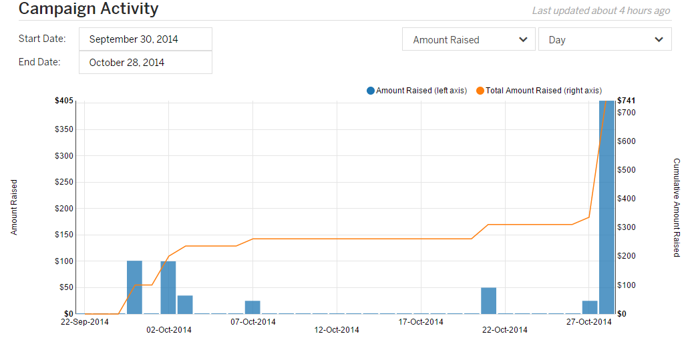

Figure 3. Crowdsourcing campaign activity

### Social Media

In addition to the GitHub organization for Project PAM, a Gmail account for email, and the GitHub Pages, social media accounts/pages were created to supplement the crowdsourcing campaign. These accounts/pages included Twitter (@ProjectPAM), Facebook, Google+, and YouTube. Twitter had 59 tweets and 17 followers, Facebook had 40 likes, and the YouTube videos had 1062 views. Additionally, Google Analytics were set up for the GitHub Page and the reports of traffic for September to December are included at 9.6.4.

### Media Coverage

The Project PAM crowdsourcing campaign was featured in 4 major news outlets. Those include 3DPrint.com, 3DPrintingIndustry.com, WSIU, and Make Magazine. Full page print outs are included at 9.10.

Table 2. Articles Project PAM was featured in

|  |  |
| --- | --- |
| Media Outlet | Article Titles |
| 3DPrint.com | Project PAM – College Students Look to Create an Entirely Open Source DLP 3D Printer [7] |
| 3DPrintingIndustry.com | Help The Open Sourced DLP 3D Printer called Project Pam on Indiegogo? [8] |
| WSIU | SIU Engineering Students Use Crowdfunding for 3D Printer [9] |
| Make Magazine | Cool Crowdfunding: October 26, 2014 [10] |

## Prototype Costs: DMO

The costs of Project PAM are split into two tables: one for the cost of the subsystems and the total cost of the printer including the projector. A complete bill of materials is included at 9.2.

Table 3. Cost of subsystems

|  |  |
| --- | --- |
| Subsystem | Price |
| Motion control | $113.61 |
| Chassis | $315.99 |
| Hardware software interface | $25.97 |
| Motors/motor control | $82.83 |
| MakerJuice G+ resin | $45.00 |
| Total | $602.17 |

Table 4. Total system cost

|  |  |
| --- | --- |
| Subsystem | Price |
| Printer | $602.17 |
| Projector | $690.00 |
| Total | $1292.17 |

# Schedules:

## Proposed and Reworked Schedule: DMO

With the addition of an additional team member at the start of the second semester, the schedule was able to be reworked to free up team members. The proposed and reworked (additions in orange) are included in the appendix at 9.1.1.

## As Worked Schedule: DMO

Project PAM experienced procurement problems that set the schedule back 3 weeks. The setback was not a total waste because it allowed for the construction of a linear motion test rig to be used for testing as soon as the parts arrived.

The other big change to the schedule was the addition of the crowdsourcing campaign. This set software back a whole month because the team member doing software was put in charge of developing the campaign.

The as worked schedule can be found at 9.1.2.

# Subsystem Descriptions:

## Chassis: JPB

### Process of Design

An early goal of the hardware design was to have a product which was very rigid and allowed adjustability for all pieces which need to be aligned. Several options were considered for the construction of the chassis, from an incorporated enclosure and chassis design to open source linear motion systems.

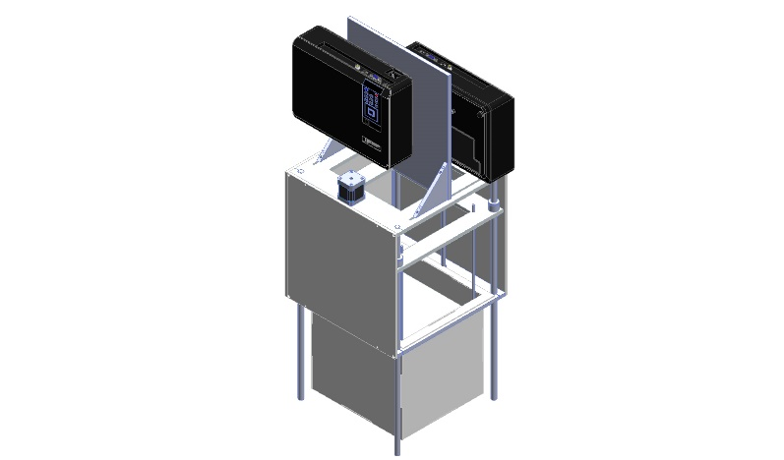

Figure 4. An isometric view of the current chassis design

It was decided that conventional round linear bearing shafts could be used as the vertical component of the chassis, as shown in Figure 4. This removes the necessity for a separate vertical chassis structure. This simplified the chassis design to just two horizontal structural plates to hold the motion-driving components, projector, and vat, and the linear bearing shafts. The chassis plates attach to the linear bearing shafts by clamping. The height of the system could then be easily changed, and the system could be easily squared by adjusting the plates and shafts.

A design was considered which used three linear bearing shafts as legs instead of four, as this would make the alignment process easier and was thought to reduce material. It was found that material costs would not be reduced, as a configuration using three or four legs would involve ordering the same length of shaft because of minimal material requirements with most industrial suppliers. The tripod design would also necessitate larger chassis plates and more material waste.

The initial design proposal involved chassis dimensions of 300 x 320 mm to accommodate stepper motors mounted on the bottom chassis plate. This would require the order of a 12 x 18 inch plate and involve wasting a lot of material. In order to fit the design within a 12 x 12 inch plate the stepper motors were moved to the top plate. This also allowed the weight of the carriage to be carried by thrust bearings in the bottom plate rather than the stepper motors and couplers.

The throw and focusing distance of the project allowed it to be clamped directly to the top chassis plate. Testing could then be accomplished without needing to permanently mount the projector.

### Process of Assembling

The four bearing shafts are placed in the bottom chassis plate. The protrusion of the shafts from the plate is established using calipers. One of the shafts is tightened fully, while the others are left snug. The assembly is then placed on a surface plate and the chassis plate is leveled using a height gage. The carriage is placed on the bearing shafts and the top plate is placed. After the correct distance between the two plates is determined, the top chassis plate is leveled using the height gage and the carriage can be leveled according to the assembly directions in section 6.2.2.

### Equipment Needed

Manufacturing of the prototype was completed using machine tools, but manufacturing for the maker can be achieved by water jetting, EDM, or CNC machining. This is easy and inexpensive to contract with machine shops, or made in bulk. Finish machining can be done using hand tools.

### Recommendations

An enclosure can be assembled from nearly any sheet material. Gaffers tape is good for sealing. When doing quick testing a leaf bag can be used as an expedient enclosure.

## Mechanical Motion: JPB

### Process of design

The single axis of motion is achieved by the use of a carriage plate riding on four linear bearings riding on the chassis shafts. The build table hangs from this carriage into the vat.

The initial motion control design involved a single lead screw. It was determined that the rigidity required to implement the design with a single lead screw would require a prohibitive amount of complication. Using two lead screws would allow for smoother operation without an excessive cost increase. Both lead screws ride on ball-bearing thrust bearings held in the bottom chassis plate.

Backlash has been a rather prolific problem with 3d printers of all varieties. Many interesting and complicated methods of handling backlash have been suggested in the community [11]. It was decided to make the lead screw nut out of acetal and attempt a novel method of implementing threads which involved heating the lead screw and allowing the acetal to flow form around it [12]. The cooled lead screw nut would then fit more snugly than cut threads. This proved excessively difficult with the acetal used. It was decided to abandon this method in favor of a more traditionally manufactured lead screw nut, but retain delrin as the material of choice. A section of lead screw was used to construct a tap and a section of acetal was drilled to the smallest inside diameter specified for the thread profile in the hopes that a tight fit could be achieved. After tapping this proved to provide a sufficiently tight enough fit to prevent backlash. When implemented on the chassis it has shown to not produce so much friction as to cause mistepping of the stepper motors.

The stepper motors are connected to the lead screws by flexible couplers, which allow axial misalignment while maintaining torque transmission. While off-the-shelf components are readily available and inexpensive, a design for these couplers is included in the project.

### Process of Assembling

The linear bearings are assembled on the carriage plate which is then installed between the chassis plates during chassis assembly. The lower chassis plate is then leveled. The thrust bearings are then installed in the lower chassis plate. The lead screw nuts are fitted to the lead screws, which are fitted up into the carriage plate and dropped into the thrust bearings. The positioning of the upper chassis plate is determined to ensure the lead screw couplers engage the stepper motors and lead screws thoroughly. The lead screws are then removed, the upper chassis plate is then leveled, and then the lead screws are reinstalled. The lead screw nuts are fastened to the carriage plate by M20 jam nuts threaded to the outside of the lead screw nuts. The couplers are attached to the lead screws and the stepper motors are installed, but left unattached to the couplers. The carriage is leveled by adjusting the lead screws and then the couplers are tightened to the stepper motors. The lead screws should not be turned by hand, as this would put the carriage out of level.

The build table should be suspended from the carriage and leveled. The level of the build table should be checked by filling the vat with salt water and adjusting the build table to ensure that the liquid is level over the build table.

### Equipment Needed

Proper leveling should be done on a surface plate with a height gage, but can be achieved on any sufficiently flat surface with a good ruler, calipers, or trammel points.

### Recommendations

Suspending smaller build tables by three rods instead of four should allow faster leveling. If there is a bend or warp to the table the fourth rod can be introduced to minimize this. Level and flatness of the build table is much more obvious when suspended over a level of liquid than when just using a height gage.

## Technical Drawings: NBT

While adhering to ISO standards, part files were dimensioned in drawing files. In short, ISO, is an international standard-setting body composed of representatives from various national standards organizations.

The ISO standard for dimensioning parts is GD&T (Geometric Dimensioning and Tolerance). In short, this system is useful when communicating engineering tolerances. This form of dimensioning follows a symbolic language that allows engineering drawings within a computer three-dimensionally. In other words, one can virtually fabricate solid models that explicitly describes nominal geometry and its allowable variation.

It is important to clarify that GD&T is not synonymous for Basic Dimensioning. In short, basic dimensioning represent an ideal case and consequently lacks the necessary tolerances to appropriately design parts. Thankfully, GD&T overcomes this fabrication hurdle and provide the machinist both the necessary dimensions tolerances to produce high quality parts. In technical drawings, a basic dimension is a theoretically exact dimension, given from a datum to a feature of interest. Basic dimensions only communicate a designs critical dimensions and consequently lack tolerance. To facilitate manufacturability, a feature control frame is often used to assign a dimensional tolerance to the feature that is referenced in by the basic dimension. It is important to note that a set of chained basic dimensions do not create tolerance stack up. Furthermore, proper tolerance must be inferred by Datum’s referenced in the feature control frame, and not by dimension arrows or start points. In summary, a numerical value used to describe the theoretically exact size, profile, orientation or location of either a feather or datum target is the basis from which permissible variations are established by tolerances on other dimensions, in notes, or in feature control frames. In conclusion, basic dimension are denoted by enclosing the number of the dimension in a rectangle.

The 3D printer is comprised of many parts which must be appropriately dimensioned. To produce a high quality design one should GD&T the hardware component; i.e. the ribbed vat, carriage, lead screw(s), coupler, and etcetera.

SolidWorks was the program used to create parts, technical drawings, assemblies, & preform simulations on subsystem assemblies; i.e. the ribbed vat as shown in

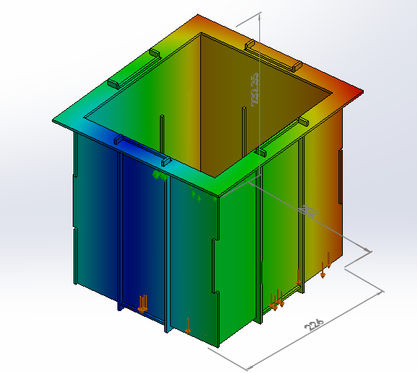

Figure 5. Ribbed vat undergoing an FEA simulation (displacement diagram)

The point of the placing the Ribbed Vat under an FEA Simulation was to determine the theoretical motion of the assembled subsystem when holding the resin in a static environment. The goal of this simulation was to reduce all areas of motion to values less than zero. Due to bonding issues experienced in SolidWorks the simulation above is incorrect. At the end of the FEA Simulation, SolidWorks was able to generate a Report in Microsoft words which summarized all of its findings in the FEA analysis.

In total there were three subassemblies prior to the final printer assembly; the chassis, build table, & ribbed vat. Furthermore, the final assembly included the projector. The purpose of the three subassemblies was to simplify the overall/final assembly, and to assist the end user. Exploded assemblies were created to help the client gain a visual understanding of all the components comprised within the 3D Printer assembly. These visuals assisted in the instructions for piecing the subassemblies and final design.

The Printer assembly was comprised of the Chassis Assembly, the Motion Control Assembly, the Projector and the Ribbed Vat Assembly. The Chassis Assembly served as the main body of the 3D Printer and held all the other components. The Motion Control Assembly moves up and down the chassis. The movement of this subassembly is controlled by the Stepper Motors. The Projector projects UV Light in order to cure the resin in the vat and solidify the liquid. The Ribbed Vat Assembly servers as the container for the resin. The Motion Control Assembly is submerged and raised out of the Ribbed Vat during the systems printing phase.

The Chassis Assembly is currently comprised of 10 unique parts; a Base Plate, a Top Plate, Side Plate Enclosures, Screws, 12mm Rods, Stepper Motors, a Bracket Plate for the Projector, Mounting Plates for the Projector, Lead Screws, & Bearing Lead Screws. The Base Plate & Top Plate sever as fixtures which hold together the main components which make up the Chassis. Furthermore, the Side Plate Enclosures serve as both a stabilizer and light shield which blocks out external light which may over cure the resin. The Screws simply keep the chassis from falling apart. The 12mm Rods act as the stands of the Chassis and vertical sliders of the Motion Control Assembly. The Stepper Motors control the vertical movement of the Motion Control Assembly which greatly affects the quality of the 3D Print. The Bracket Plate’s job is to hold up the Projector(s). The current design allows for a maximum of two Projectors. The Mounting Plates serve as supports for the Bracket Plate holding the Projector(s). The Lead Screws are turned by the Stepper Motors and consequently affect the vertical position of the Motion Control Assembly. The Bearing Lead Screws are found at the Base Plate, and hold the bottom ends of each Lead Screw.

The Motion Control Assembly is currently comprised of 5 different types of parts; a Carriage, a Build Table, 4mm rods, Linear Bearings, & Nuts for the Lead Screws. The Carriage serves as the core component of the Motion Control Assembly, and in turn houses most of the subassembly’s components. The Build Table is the area which is submerged within the Resin and holds the part which is being printed. The 4mm Rods connect the carriage to the Build Table. The Linear Bearings allow the subassembly to slide up and down the 12mm Rods on the Chassis. The Nuts connect the subassembly to the Lead Screws.

The Ribbed Vat Assembly is currently comprised of 6 different types of parts; a Vat Base Plate, Wall X, Wall Y, a Lip, Rib Y and Rib X. The Vat Base Plate is the floor plate of the subassembly. The Wall X & Wall Y are wall components of the subassembly. The Lip is the part which rests atop the Bottom Plate of the Chassis. Both Rib Y and Rib X are fixtures within the subassembly that brace together the subassembly.

Furthermore, it was necessary to create a title block in SolidWorks that would meet our team’s needs while adhering to both ISO standards and the needs of the Open Source Hardware Community. This title block serves as a template for technical drawings. The title block template was based off the Open Source Ecology title block templates [13].

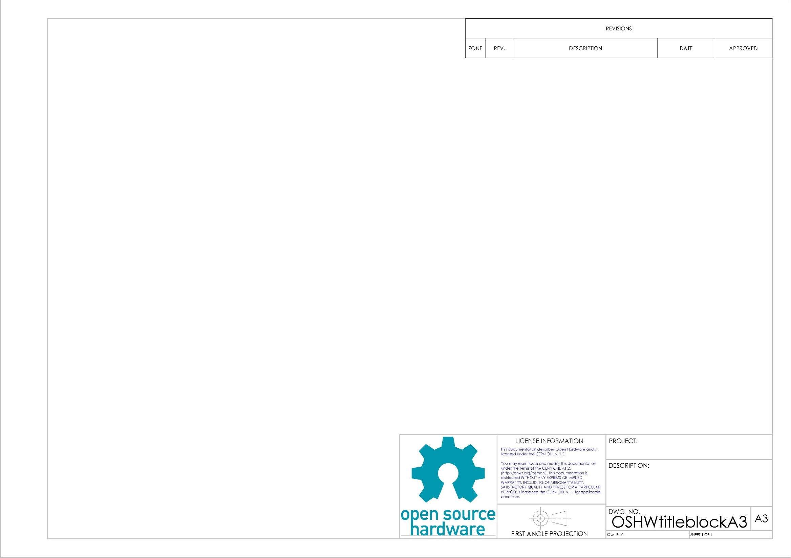

Figure 6. Generic open source hardware title block

In order to provide the Open Source Hardware Community with standard paper sizes several title block & block templates were created: ‘A0’, ‘A1’, ‘A2’, & ‘A3.’ These templates adhered to the ISO standards for the ‘Open Source Hardware Community’ which are licensed under Creative Commons Share-Alike 4.0 [14]. Also, the CERN Open Source Hardware license was included in the title block [15].

In total three files were saved under the folder OSHWtitleblocks; SLDDRW, DRWDOT, and slddrt. SLDDRW files are part files, DRWDOT files drawing template files, and slddrt files are format. When creating a new drawing in SolidWorks the user is asked to choose a format prior to importing and dimensioning a part. In order to use formats ‘A0’, ‘A1’, ‘A2’, or ‘A3’ the respective ‘slddrt’ files should be placed in the “sheetformat” folder.

The open source hardware Logo experienced pixilation issues when imported as a jpeg file. Therefore the logo was imported as a psd file which took SolidWorks a full minute.

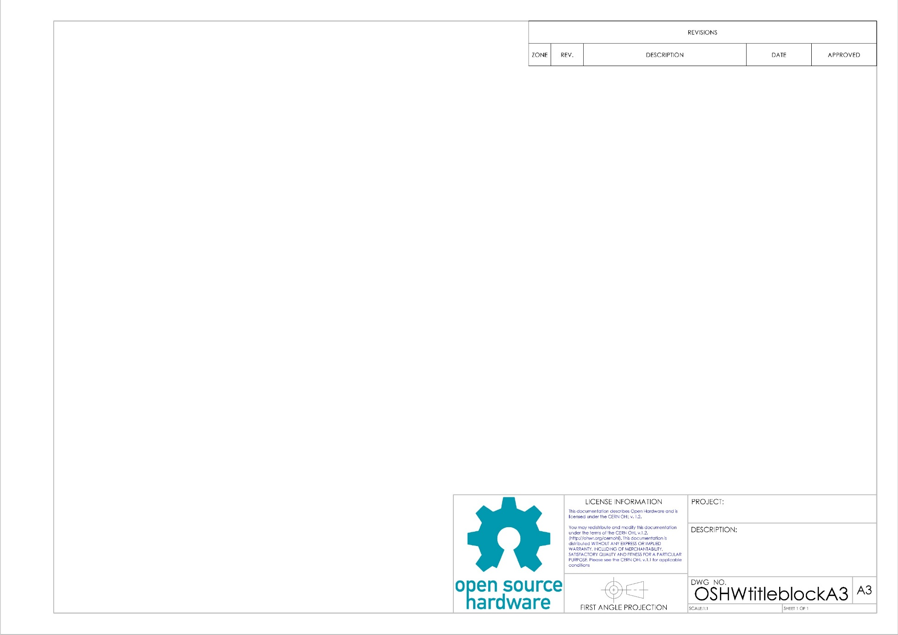

Figure 7. Open Source Hardware Logo

The psd file corrected the pixilation problem and provided the title block with a professional appearance. In short, a psd file is a layer image file used in Adobe PhotoShop. PSD, which stands for Photoshop Document, is the default format that Photoshop uses for saving data. PSD is a proprietary file that allow the user to work with the images’ individual layers even after the file has been saved.

## Printer Control Software: DMO

### Process of Design

Project PAM’s printer control software set out to solve the issue of with the recent rise of DLP 3D printing in the hobbyist market there is a need for a more consolidated form of printer control software that is also open source. Originally it was proposed to modify the B9 Creator printer control software and make it more flexible and make the user interface better, as explained in Figure 8.

Figure 8. Proposal for Project PAM printer control software

|  |  |  |  |  |
| --- | --- | --- | --- | --- |
|  | B9 Creator | MiiCraft | Creation Workshop | Project PAM |
| Language | C++ [16] | Python [17] | C# [18] | C++ |
| Cross-platform | ✓ [19] | ✗ [20] | ✓ [21] | ✓ |
| Slicing Software | Custom [16] | Skeinforge [17] | Slic3r [18] | Slic3r |
| G-Code Support | ✗ [16] | ✓ [17] | ✓ [18] | ✓ |
| CAD File Input | STL [19] | STL [20] | STL, OBJ, 3DS [21] | STL, OBJ, 3DS, STEP, AMF |
| Ablity to Add Supports | ✓ [19] | ✗ [20] | ✓ [21] | ✓ |
| Image Output | SLC [16] | SVG [22] | SVG [23] | SVG |

Figure 8 also shows the comparison of the B9 Creator and Project PAM to additional DLP 3D printer control software on the market. During the time since the B9 Creator software was evaluated there had been multiple updates; however, the updated source code was not being posted to their GitHub. These updates consisted of very important bug fixes and support for more hardware. Eventually the developers of the B9 Creator software were contacted, after multiple attempts through various mediums, and they had decided to not release any additional source code. Their reasoning for this was that they weren’t getting any help from the community and doing all the work themselves. This was an unfortunate set back but one that was not a show stopper.

Once it was determined that there would be no newer versions of the B9 Creator printer control software to fork from the newest version was forked and development began. The first step was to change various code formatting problems, for example mixed file formatting, and wrong licensing information in file headers. The B9 Creator software came with a built in updater, which was removed. An attempt at porting the B9Creator software to Qt 5 from Qt 4 was made; however, because of the differences in the OpenGL portions of Qt between the versions were so great that effort was abandoned.

The first big modification that was attempted was to remove the custom slicing software and replace it with Slic3r. It was at this point that it was discovered the custom slicer was so heavily embedded into the software that by removing it would cause more headaches then it would fix, i.e. it was easier to start from scratch then to try to remove the slicer.

Once it was determined that the B9Creator software should not be used as a starting point an in depth evaluation of Slic3r was done. Slic3r supports STL (Sterelithography), AMF (Additive Manufacturing File Format), and OBJ files [23]. Because a goal of the Project PAM printer control software was to add STEP file support and Slic3r only supports mesh based models there would have been no way to modify Slic3r to support STEP files. The only option would have been to convert STEP files into one of the supported file formats when the model was loaded. However, that defeats the whole reason to support STEP files.

The reason STEP needed to be supported was to ensure flexibility, because STEP files are a CAD file interchange format, and to allow for the better printing of curves [24]. The problem of mesh based models is illustrated in Figure 9.

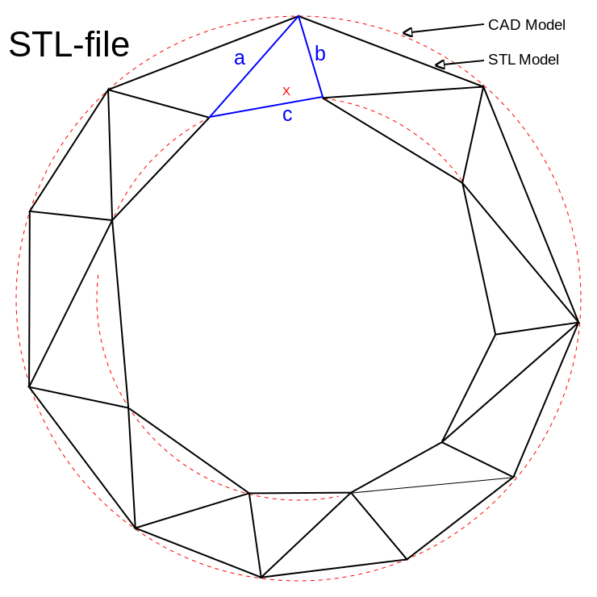

Figure 9. Problem with STL files [25]

Additive Manufacturing File Format (AMF) was released, a superset of STL, by the International Organization of Standards (ISO) and American Society for Testing and Materials (ASTM) as ISO/ASTM 52915:2013 [26]. AMF supports curved triangles that are then recursively subdivided into smaller triangles at import, this allows for “smoother models” and smaller file sizes [26] [27]. Even though AMF is an improvement of STL it still does has the problem of turning curves into triangles and introducing error into the print.

The larger problem with developing an open source 3D printing control software platform is the lack of open source CAM software, which is why the idea of DLP 3D printing control software has grown to become a complete open source CAM platform with a DLP 3D printing plugin. This new software is being called LibreCAM. The main reason this is possible is because there is an open source library called Open CASCADE, which is a C++ platform for 3D CAD/CAM and can be easily integrated into the Qt platform [28].

FreeCAD was evaluated to determine if it was a suitable candidate for fork to create LibreCAM. FreeCAD is written in C++ and uses Open CASCADE [29]. However, FreeCAD uses an outdated 3D visualization library (this feature is now built into Qt), also, FreeCAD was a completely custom user interface [29] [30].

It was decided to start from scratch and define a new platform and user interface. The challenge with was to pick an interface that was strait forward and easily conveyed the steps the user needed to make something. However, this would have been a lot of rework and would have mediocre results.

### development Process

KDevelop and the KDevPlatform are a C++/Qt/KDE based IDE and IDE development platform, respectably [31] . Currently these platforms are based on Qt 4 and KDE 4; however, in August of 2014 the process of porting the platforms to Qt 5 and KDE Frameworks 5 had begun [32]. The most recent release from September of 2014 was still based on Qt 4 and KDE 4 [33]. The port to Qt 5 and KDE Frameworks 5 is still in pre-alpha stage, a screenshot of the pre-alpha stage is shown in Figure 10. The developers of KDevelop say that KDevelop 5 will “become the first true cross-platform release of [they’re] IDE” [33]. KDevelop 5 is on track to release early 2015 [33].

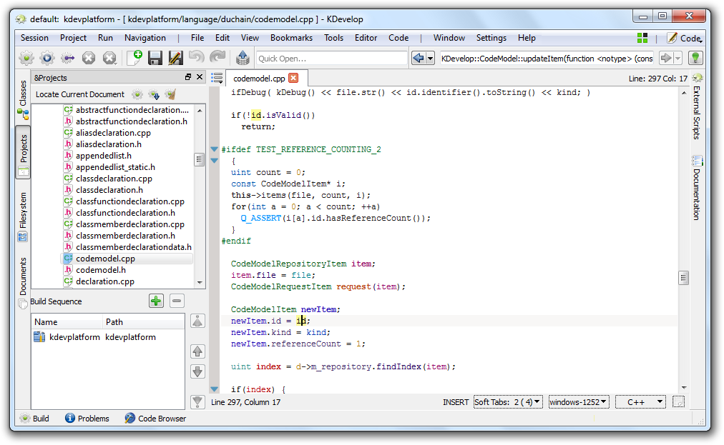

Figure 10. KDevelop 5 pre-alpha on Windows [34]

A great example of a tool built with the KDevPlatform is KTechLab, an IDE for microcontrollers and electronics [35]. A screenshot of KTechLab is shown in Figure 11.

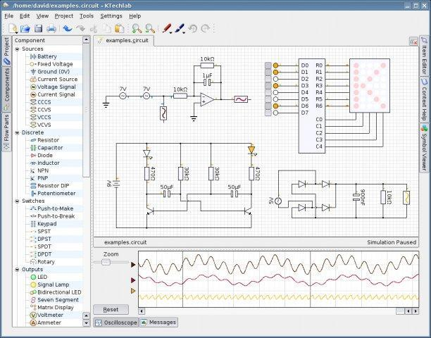

Figure 11. Screenshot of KTechLab

The problem with the current release of KDevelop using Qt 4 instead of Qt 5 is a show stopper. There were massive changes to Qt’s OpenGL module between Ot 4 and Qt 5. Because LibreCAM requires Qt’s OpenGL support. The QtOpenGL module was deprecated in Qt 5 and completely rewritten to support full OpenGL instead of only OpenGL ES (Embedded Systems) as in Qt 4. If the current version of KDevPlatform was used to create LibreCAM the entire 3D visualization portion would have to be redone early next year when KDevPlatform 5 is released.

### development SCHEDULE

The first major planned releases of LibreCAM are outlined below.

Ver. 0.1.0: Initial user interface and ability to load in CAD models.

Ver. 1.0.0: Completed user interface, full support for plugins, and support for projects.

The first major planned release of the DLP 3D printer control plugin for LibreCAM, called LibrePAM, are outlined below.

Ver. 0.1.0: Basic slicing to SVG and G-Code and G-Code transmission to firmware.

Ver. 1.0.0: Resin profiles, projector control, projects, and automatic support generation.

Ver. 2.0.0: Parallel slicing and continuous printing.

## Hardware-Software Interface: NAL

### Process of Design

When testing the motor and shield there are numerous variables to take into account. Testing the motor control with a scaled down build table helped speed up testing while the rest of the system was being constructed. In order to determining the optimum velocity and acceleration of the system, the velocity of the motors was increased until they started to miss-step and get caught in the threads. From there the acceleration was set to one tenth the velocity, to let the motor gain velocity during the movement rather that start at max velocity. In addition to movement control, current control is also monitored. Due to the specifications of the motors, they are meant to draw more current than the power supply can handle. The potentiometers on the drivers were adjusted accordingly to prevent blowing the power supply.

The Adafruit motor shield uses 4 h-bridge drivers, capable of driving 2 stepper motors. It is a cheaper alternative to the CNC Motor Shield that is currently compatible with the Grbl firmware.

In order to interface with the motors there are already libraries supported by Adafruit to drive the motors. The AFMS Library and the AccelStepper library are provided by Adafruit for use with their shield. The AFMS library provides general support for driving the motors with little velocity control. With the AccelStepper library the motors can be driven at slightly higher velocities as well as control for variable acceleration.

Due to limitations of the shield, it is unable to drive the motors at high enough velocities and accelerations required to be implemented into the Grbl firmware. Additionally the CNC shield and AFMS use different pins to send signals to the motors. To implement the AFMS into Grbl would require massive changes in the source code and all of the functions required for stepper control would need to reimplemented for the AFMS.

## Motors/Motor Control: CWS

### Process of Design

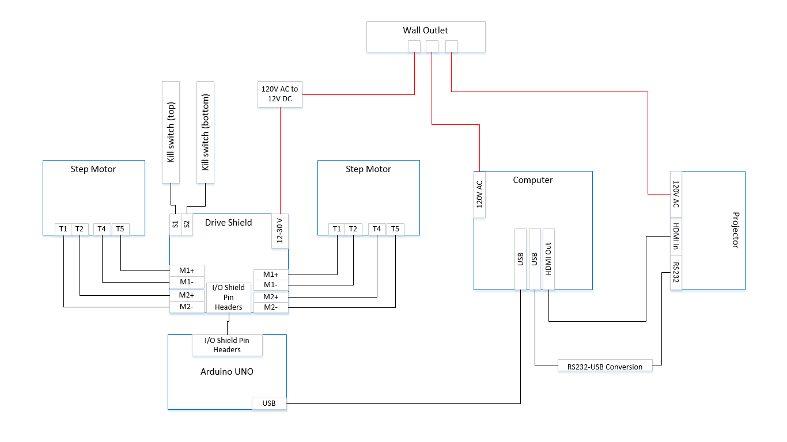

Figure 12. Wire diagram

The lead screws of the printer are driven by two NEMA 17 bi-polar stepper motors. These two lead screws turning in one direction or the other will cause the chassis to move up or down, and thus move the build table up and down. This vertical movement is what always the object to be built layer by layer. The motors each produce a holding torque of 200 mN-m at 12 volts and pull 0.35 A per phase. Full motor specifications are listed in Table 5.

Table 5. Stepper motor data [36]

|  |  |
| --- | --- |
| Drive Method | Bi-Polar |
| Number of Phases | 2 |
| Step Angle | 1.8 deg/step |
| Voltage | 0.35 V |
| Current | 0.34 A/phase |
| Winding Resistance | 4.3 I/phase |
| Inductance | 200 mH/phase |
| Holding Torque | 11.8 mN-m |
| Detent Torque | 38 mN-m |
| Rotor Inertia | 0.21 g-cm2 |
| Weights | 0.57 g |

The motors are controlled by a CNC shield that implements four Pololu motor drivers. The original design called for an Adafruit motor shield that supported H-bridge drive techniques due to its low cost popularity within the field. However, the Grbl software that sends movement commands to the drive shield requires specific motor acceleration variables that are not supported by H-bridge drivers. Much effort was spent trying to remedy this problem, however we eventually learned that this was not a practical solution. Adding H-bridge support to the system would have required developing brand new firmware from scratch, and our team simply did not have time to complete such an endeavor. After this had been determined, the CNC shield was selected as a replacement solution. The CNC shield is advantageous for our purposes because the shield directly handles all acceleration parameters needed to drive the motors. Another advantage is the Pololu drivers are cheap and are easily replaced if they were to ever be damaged.

### Health and Safety Concerns

A consequence of stepper motor design is that they pull high current due to the reactance in the winding of the motor. As mentioned previously, each two phase motor is pulling 0.35 A per phase, which means each motor is pulling 0.70 A. The drive shield has a built-in potentiometer which allows the user to adjust the maximum current pulled through the shield however a certain amount of current is needed to maintain holding torque. Even with adjusting the potentiometer the printer has been shown to pull nearly 0.90 A while in operation. This amount of current can be very harmful to a user and can even lead to death through ventricle fibrillation. Because of this risk a user must familiar with electric current be extremely careful when operating the machine.

## Resin Management: CWB

### Process of Design

As Project PAM was unfolding, the decision to become a photoresin printer emerged. The first design of the resign was to use a custom product from Momentive. Momentive Specialty Chemicals Inc. serves the global wood and industrial markets through a broad range of thermoset technologies, specialty products and technical support for customers in a diverse range of applications and industries [37]. This would have allowed Project PAM complete control over the wavelength needed to cure the resin, over the color, over the density, and over the curing agents.

Because of the goal of the project to be completely open source, this idea was abandon for buying resins that will be more accessible to the open source community. While looking through photoresin system forums, there was one company that had shown up on multiple posts as being reliable and cost effective, MakerJuice Labs [38]. MakerJuice Labs is an American company first started in 2013 with a focus of quality and low cost resins aimed for the hobbyists’ community [39]. They have sold over eight-thousand items and have over two-thousand customers since their start [39]. This gave Project PAM the facts it needed to use MakerJuice for the prototype.

### Health and Safety Issues

Resins by MakerJuice Labs are in compliance of USA and Canada standards [39]. Material safety data sheets (MSDS) for all of their products can be found on their website. The MSDS for the resin G+, ordered by Project PAM can be found in this report at 9.1.

G+ is a category 2 skin corrosion, category 1 serious eye damage, and a category 1 for skin sensitization set by the 2012 OSHA Hazard Communication Standard [39]. The precautionary prevention steps are as follows: Wash face, hands and any exposed skin thoroughly after handling, wear protective gloves/protective clothing/eye protection/face protection, avoid breathing dust/fume/gas/mist/vapors/spray, and contaminated work clothing should not be allowed out of the workplace [39].

The precautionary response steps are as follows: If in the eyes; Rinse cautiously with water for several minutes. Remove contact lenses, if present and easy to do. Continue rinsing. Immediately call a POISON CENTER or doctor/physician. If on the skin; Wash with plenty of soap and water. Take off contaminated clothing and wash before reuse. If skin irritation or rash occurs: Get medical advice/attention [39].

### Recommendations

There are several different types of resins that are open to the hobbyist community. Some resins cure harder than other resin, but this can result in a longer cure time. Different types of resins can allow for the end print to be flexible, like MakerJuice Lab’s Flex [39].

There are a few things to keep in mind while shopping for resin. The first thought is the cost. There are several companies that are based out of the US who have cheaper resins but the shipping cost is sometimes up to triple the cost of their product. Another thought is the shrink percent. MakerJuice Lab’s G+ substance has an experimental shrinkage of 3.3%, while their G substance has an 8% experimental shrinkage [39]. Shrinkage is the most common problem with prints with a build volume over 100cm3 [38]. The G+ was $45.00 a liter, and the G was $40 a liter in May of 2014 [39]. The user will have to decide if it is worth the extra $5 to ensure precise prints.

To help offset the use of resin several hobbyist have had success of using saltwater [38]. The resin floats on top of the saltwater. This means that a hobbyist only needs to put as much resin in the vat as what is needed for the build or the layer thickness. With the price of most resins being around $50, this idea is a great way to save resin and money.

## Optics: CWB

### Design

The project is the biggest investment of the project. ­­­­There are several things to keep in mind when making a choice on what projector to go with. There are several different types of projectors. The two main projectors are light-emitting diode (LED) and digital light processing (DLP). For the truest and highest quality of prints the best choice to use is DLP. DLP uses a mirror for each pixel in the projected image. This allows each pixel to be controlled individually unlike the LED were groups of pixels work together to make an image.

Another big decision is the native pixel resolution. The resolution will directly decide the quality of the prints and the size of the build area. The higher the number, the higher the max build area and better the quality. A full HD 1080p is actually at the ratio of 1920 by 1080 pixels. This allows a max build area with a 100µm precision to be 20 cm by 10 cm.

Another major component of the projector that will impacted the quality of the prints is the throw ratio. This effects the screen size or in printing terms the build area. Personal off-the-shelf projectors are not made for projecting images less than a foot away from the lens. The farther back the projector is from the build area will mean a larger build area, but at the sacrifice of pixel resolution. Depending on the projector this may be fixed by opening up the projector and modifying or replacing the lens to account for the shorter distance [1].

Aside from the pixel resolution is the lumen output. Depending on the type of resin that is used for the print will decide how many lumens it takes to cure. MakerJuice’s resin takes 2000 lumens to cure [39].

### Recommendations

Though Project PAM’s design is flexible to allow use of almost all consumer projectors, the prototype used View Sonic’s PJD7820HD 1080p 3D Home Theater Projector. This projector outputs 3000 lumens allowing faster build times. It has a 15000:1 contrast between a fully on pixel and off pixel. It supports HDMI in, dual VGA in, and VGA out giving great flexibility to the user. The projector has a filter-less design. It also has a 3-year limited warranty on parts and labor; and a 1-year warranty on the lamp. All of this comes in a 4 lb plastic case, making it ideal for mounting it over head. [40]

Most importantly the 1.2x Optical Zoom lens and throw ratio of 1.25-1.5:1 is able to give Project PAM the build area and resolution without modifying the lens [40]. This was found by doing a test. The project was set 21 cm away from the screen to simulate the space between the build layer and the lens. The zoom was then set to give a build area of 10.2 cm by 18.4 cm, which is close to the desired 10 cm by 20 cm. The focus was then adjusted until font size 8 was easily readable.

# Test Print Results: CWB

Project PAM has had several different successful prints. The first print attempted by Project PAM was a robot that can be seen on the right side in Figure 13. Robot Test Print. The projector was not calibrated correctly and this led to the aspect ratio to be wrong. The left robot in Figure 13 is the second print and as can be seen, is of much better quality. The was accomplished by fixing the aspect ratio, increasing the down and up travel from 1mm to 2mm, and doubling the move speed to 50 mm/min down and 100 mm/min up.

Though the robots were a good starting point to prove full system success, Project PAM aimed to quantify test. This led to the printing of 20 mm cubs that can be easily measured and compared. In Figure 14 the first printed cube is on the left and the second cube printed is on the right. Cube #1 had 2 second cure time layers, 50 μm layer thickness, and move speed of 200 mm/min down and 200 mm/min up. The actual print came out to be 19.4x19.6x unmeasurable (um) mm. The first couple of layers where ruined when removing the build from the build table. There is also imprecise edges do to over curing the resin giving a bleed effect. The error of the cube is 3x2xum %. Cube #2, right side of Figure 14, has the same parameters but with a 1 second cure time and a 100μm layer thickness. Not only did this cut the build time in half, but it gave a much higher quality print with less bleed. The actual dimensions are the same as Cube #1 but the edges are almost a true 900. Both of these cubes are smaller than the set dimensions do to the shrinkage percentage from the resin. More testing is being done to find what the shrink percentage is so that prints can be compensated in the software.

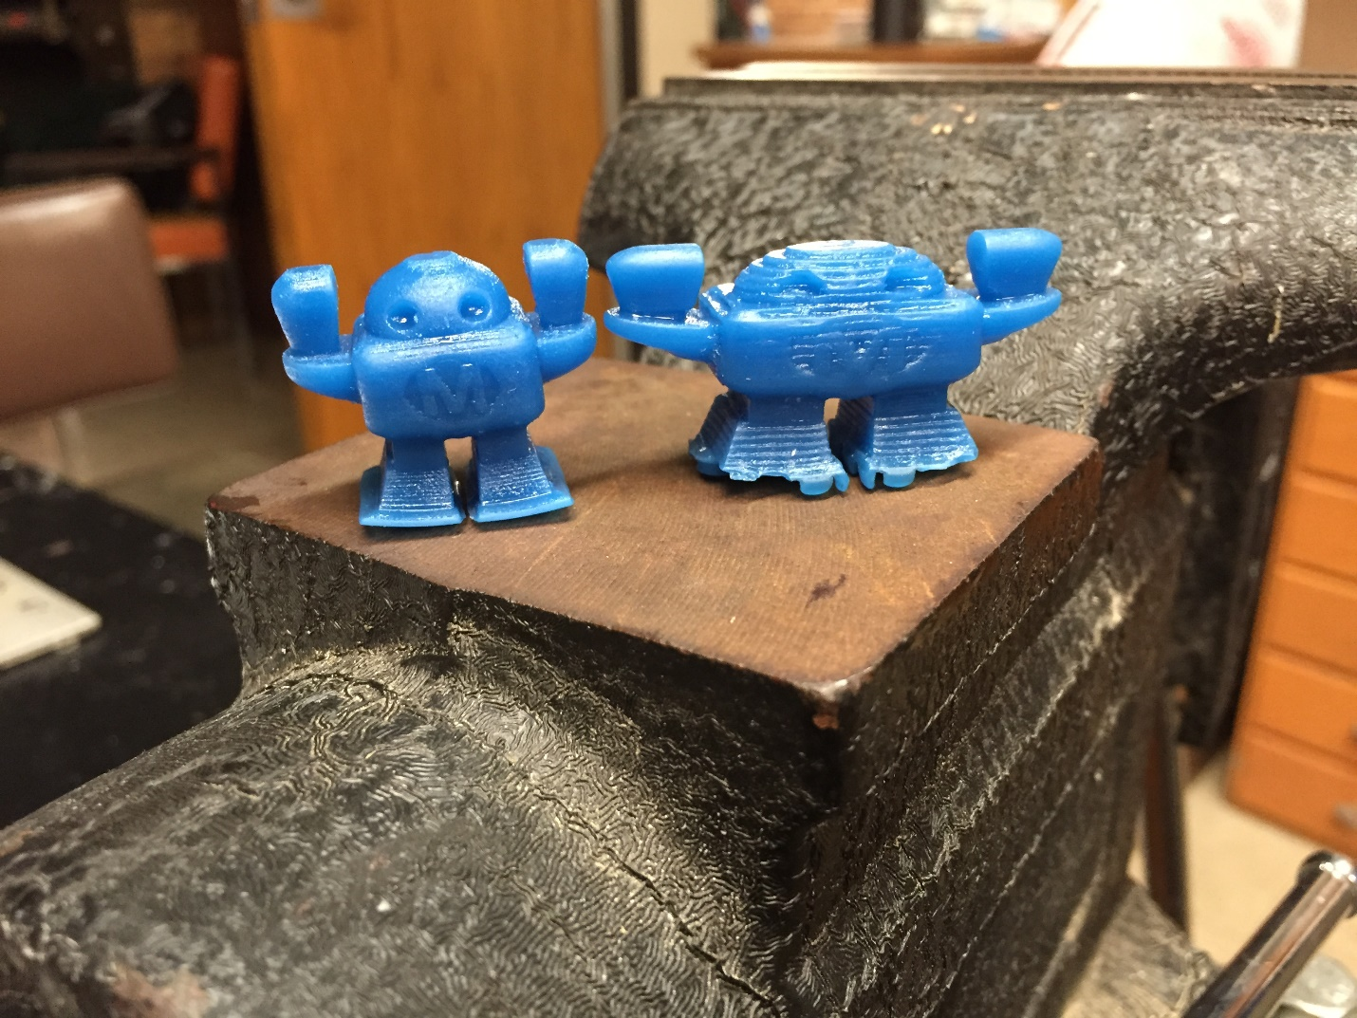

Figure 13. Robot Test Print

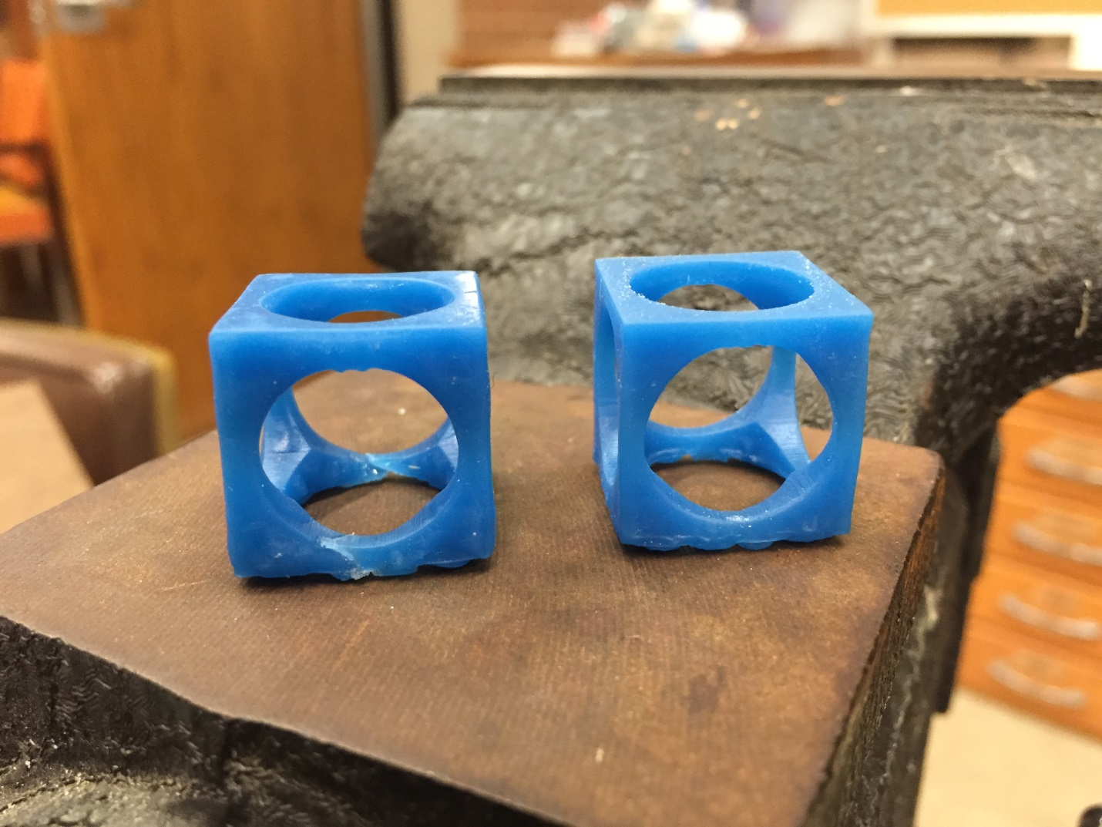

Figure 14. 20 mm Cube Test Print

# References: CWB

|  |  |
| --- | --- |
| [1] | "3D Printing: What You Need to Know," [Online]. Available: http://www.pcmag.com/slideshow_viewer/0,3253,l=293816&a=289174&po=1,00.asp. [Accessed 17 April 2014]. |
| [2] | "3D Printing Scales Up," *The Economist,* 7 September 2013. |
| [3] | GitHub, Inc., "GitHub Pages," 2014. [Online]. Available: https://pages.github.com/. [Accessed 3 December 2014]. |
| [4] | Indiegogo, Inc., "Indiegogo Playbook," 2014. [Online]. Available: https://go.indiegogo.com/playbook. [Accessed 3 December 2014]. |
| [5] | Prezi Inc., "Prezi," 2014. [Online]. Available: http://prezi.com/. [Accessed 3 December 2014]. |
| [6] | Indiegogo, Inc., "Pricing & Fees," 2014. [Online]. Available: https://go.indiegogo.com/pricing-fees. [Accessed 3 December 2014]. |
| [7] | E. Krassenstein, "Project PAM – College Students Look to Create an Entirely Open Source DLP 3D Printer," 2 October 2014. [Online]. Available: http://3dprint.com/17504/project-pam/. [Accessed 3 December 2014]. |
| [8] | S. Grunewald, "Help The Open Sourced DLP 3D Printer called Project Pam on Indiegogo?," 2 October 2014. [Online]. Available: http://3dprintingindustry.com/2014/10/02/help-open-sourced-dlp-3d-printer-called-project-pam-indiegogo/. [Accessed 3 December 2014]. |
| [9] | L. Kenner, "SIU Engineering Students Use Crowdfunding for 3D Printer," 15 October 2014. [Online]. Available: http://news.wsiu.org/post/siu-engineering-students-use-crowdfunding-3d-printer. [Accessed 3 December 2014]. |
| [10] | C. Kraft, "Cool Crowdfunding: October 26, 2014," 2014 October 2014. [Online]. Available: http://makezine.com/2014/10/26/cool-crowdfunding-october-26-2014/. [Accessed 3 December 2014]. |
| [11] | S. Wygant, "M5 Nut Anti Backlash Assembly," [Online]. Available: http://repables.com/r/349/. [Accessed 30 November 2014]. |
| [12] | Evan, "Making Acetal leadscrew nuts the easy way," 15 September 2010. [Online]. Available: http://bbs.homeshopmachinist.net/threads/43645-Making-Acetal-leadscrew-nuts-the-easy-way. [Accessed 30 November 2014]. |
| [13] | Open Source Ecology, "CAD Standards," 30 October 2014. [Online]. Available: http://opensourceecology.org/wiki/CAD_Standards. [Accessed 3 December 2014]. |
| [14] | Creative Commons, "Attribution-ShareAlike 4.0 International," [Online]. Available: https://creativecommons.org/licenses/by-sa/4.0/. [Accessed 3 December 2014]. |
| [15] | M. Ayass, "CERN Open Hardware Licence," 29 July 2014. [Online]. Available: http://www.ohwr.org/projects/cernohl/wiki. [Accessed 3 December 2014]. |
| [16] | B9 Creations LLC, "B9 Creator GitHub," GitHub Inc., 2014. [Online]. Available: https://github.com/B9Creations/B9Creator. [Accessed 27 February 2014]. |
| [17] | MiiCraft, "MiiCraft Suite GitHub," GitHub Inc., 2014. [Online]. Available: https://github.com/miicraft/MiiCraftSuite. [Accessed 27 February 2014]. |
| [18] | S. Hernandez, "Creation Workshop GitHub," GitHub Inc., 2014. [Online]. Available: https://github.com/Pacmanfan/UVDLPSlicerController. [Accessed 27 February 2014]. |
| [19] | E. Chu, "B9 Creator," *Make: Ultimate Guide to 3D Printing,* p. 93. |
| [20] | Rays Optics Inc., "MiiCraft User Guide," 2012. [Online]. Available: http://www.miicraft.com/web/assets/2012/11/MiiCraft-3D-printer-User-Guide.pdf. [Accessed 27 February 2014]. |
| [21] | S. Hernandez, "Creation Workshop - SLA / FDM Slicer and Controller," Makerbot Industries LLC, 8 January 2013. [Online]. Available: https://www.thingiverse.com/thing:40778. [Accessed 27 February 2014]. |
| [22] | Fabmetheus, "Skeinforge Vectorwrite," Demozendium, 17 July 2012. [Online]. Available: http://fabmetheus.crsndoo.com/wiki/index.php/Skeinforge_Vectorwrite. [Accessed 27 February 2014]. |
| [23] | A. Ranellucci, "Slic3r Manual," GitHub Inc., 2014. [Online]. Available: https://github.com/alexrj/Slic3r-Manual. [Accessed 27 February 2014]. |
| [24] | ISO 10303-21:2002, *Industrial automation systems and integration -- Product data representation and exchange -- Part 21: Implementation methods: Clear text encoding of the exchange structure.* |
| [25] | L. Lieshout, "Example of STL vs CAD format," 13 August 2014. [Online]. Available: https://commons.wikimedia.org/wiki/File:STL-file.jpg. [Accessed 3 December 2014]. |
| [26] | ISO/ASTM 52915:2013, *Standard specification for additive manufacturing file format (AMF) Version 1.1.* |
| [27] | Duann, "AMF: A Better File Format for 3D Printing?," Shapeways, Inc., 28 June 2011. [Online]. Available: http://www.shapeways.com/blog/archives/898-amf-a-better-file-format-for-3d-printing.html. [Accessed 3 December 2014]. |
| [28] | T. Paviot, "Open CASCADE Community Edition," 2014. [Online]. Available: https://github.com/tpaviot/oce. [Accessed 3 December 2014]. |
| [29] | "FreeCAD," 2014. [Online]. Available: http://www.freecadweb.org/. [Accessed 3 December 2014]. |
| [30] | Digia Plc, "QtOpenGL Module," 2013. [Online]. Available: http://qt-project.org/doc/qt-4.8/qtopengl.html. [Accessed 3 December 2014]. |
| [31] | "KDevelop," 2014. [Online]. Available: https://www.kdevelop.org/. [Accessed 3 December 2014]. |
| [32] | M. Wolff, "KDevelop master now depends on KDE Frameworks 5!," 8 August 2014. [Online]. Available: https://www.kdevelop.org/frameworks/kdevelop-master-now-depends-kde-frameworks-5. [Accessed 3 December 2014]. |
| [33] | M. Wolff, "KDevelop 4.7.0 Released," 13 September 2014. [Online]. Available: https://www.kdevelop.org/news/kdevelop-470-released. [Accessed 3 December 2014]. |
| [34] | M. Wolff, "KDevelop 5 Pre-Alpha on Windows," 13 September 2014. [Online]. Available: https://www.kdevelop.org/screenshots/kdevelop-5-pre-alpha-windows. [Accessed 3 Deceber 2014]. |
| [35] | Z. Padrah, "KTechLab," 2014. [Online]. Available: https://github.com/ktechlab/ktechlab. [Accessed 3 December 2014]. |
| [36] | Adafruit, "Stepper motor - NEMA-17 Datasheet," 2014. [Online]. Available: http://www.adafruit.com/datasheets/12vstepper.jpg. [Accessed 3 December 2014]. |
| [37] | Momentive, "Momentive," 2014. [Online]. Available: http://www.momentive.com/. [Accessed 2014]. |
| [38] | Build Your Own SLA, "Resins," January 2014. [Online]. Available: www.buildyourownsla.com. [Accessed 26 February 2014]. |
| [39] | Maker Juice Labs LLC, "Maker Juice," 2014. [Online]. Available: www.makerjuice.com. [Accessed May 2014]. |
| [40] | VeiwSonic Corporation, "PJD7820HD," 2014. [Online]. Available: http://www.viewsonic.com/us/projectors/high-performance/pjd7820hd.html. [Accessed 3 December 2014]. |

# Appendix

## Schedules

### Proposed and Reworked

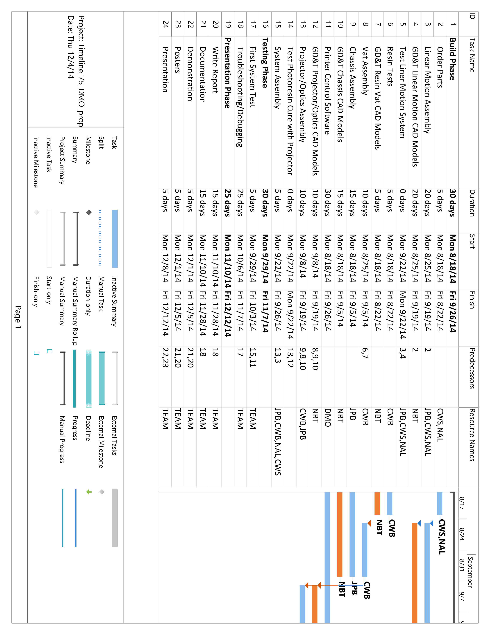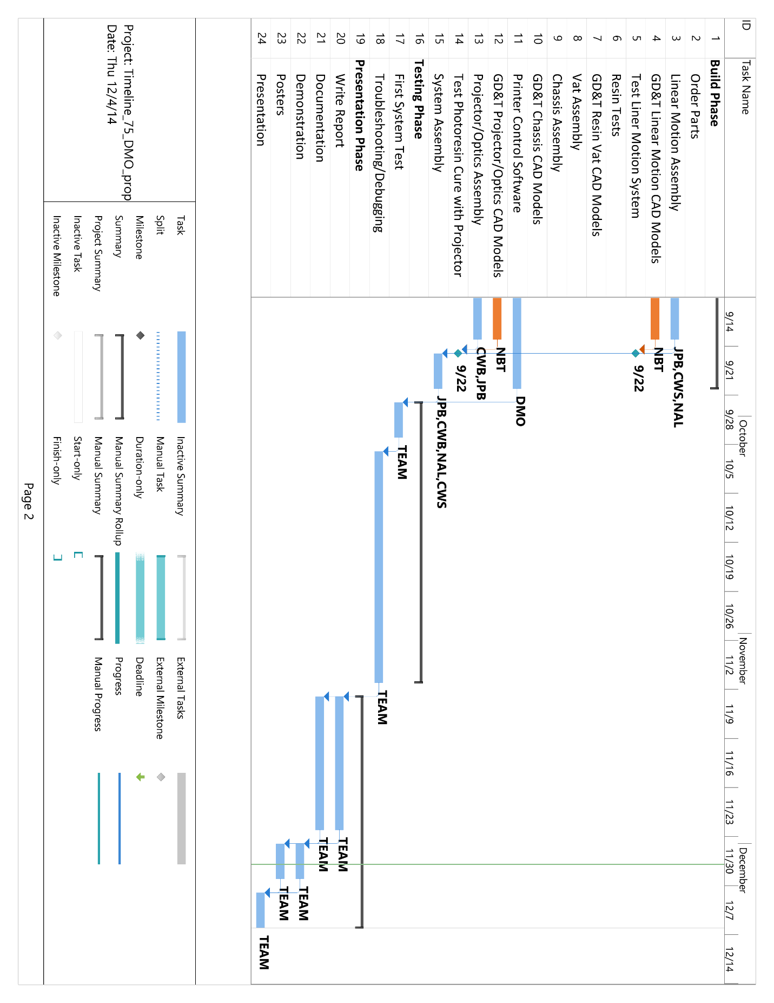

### As Worked

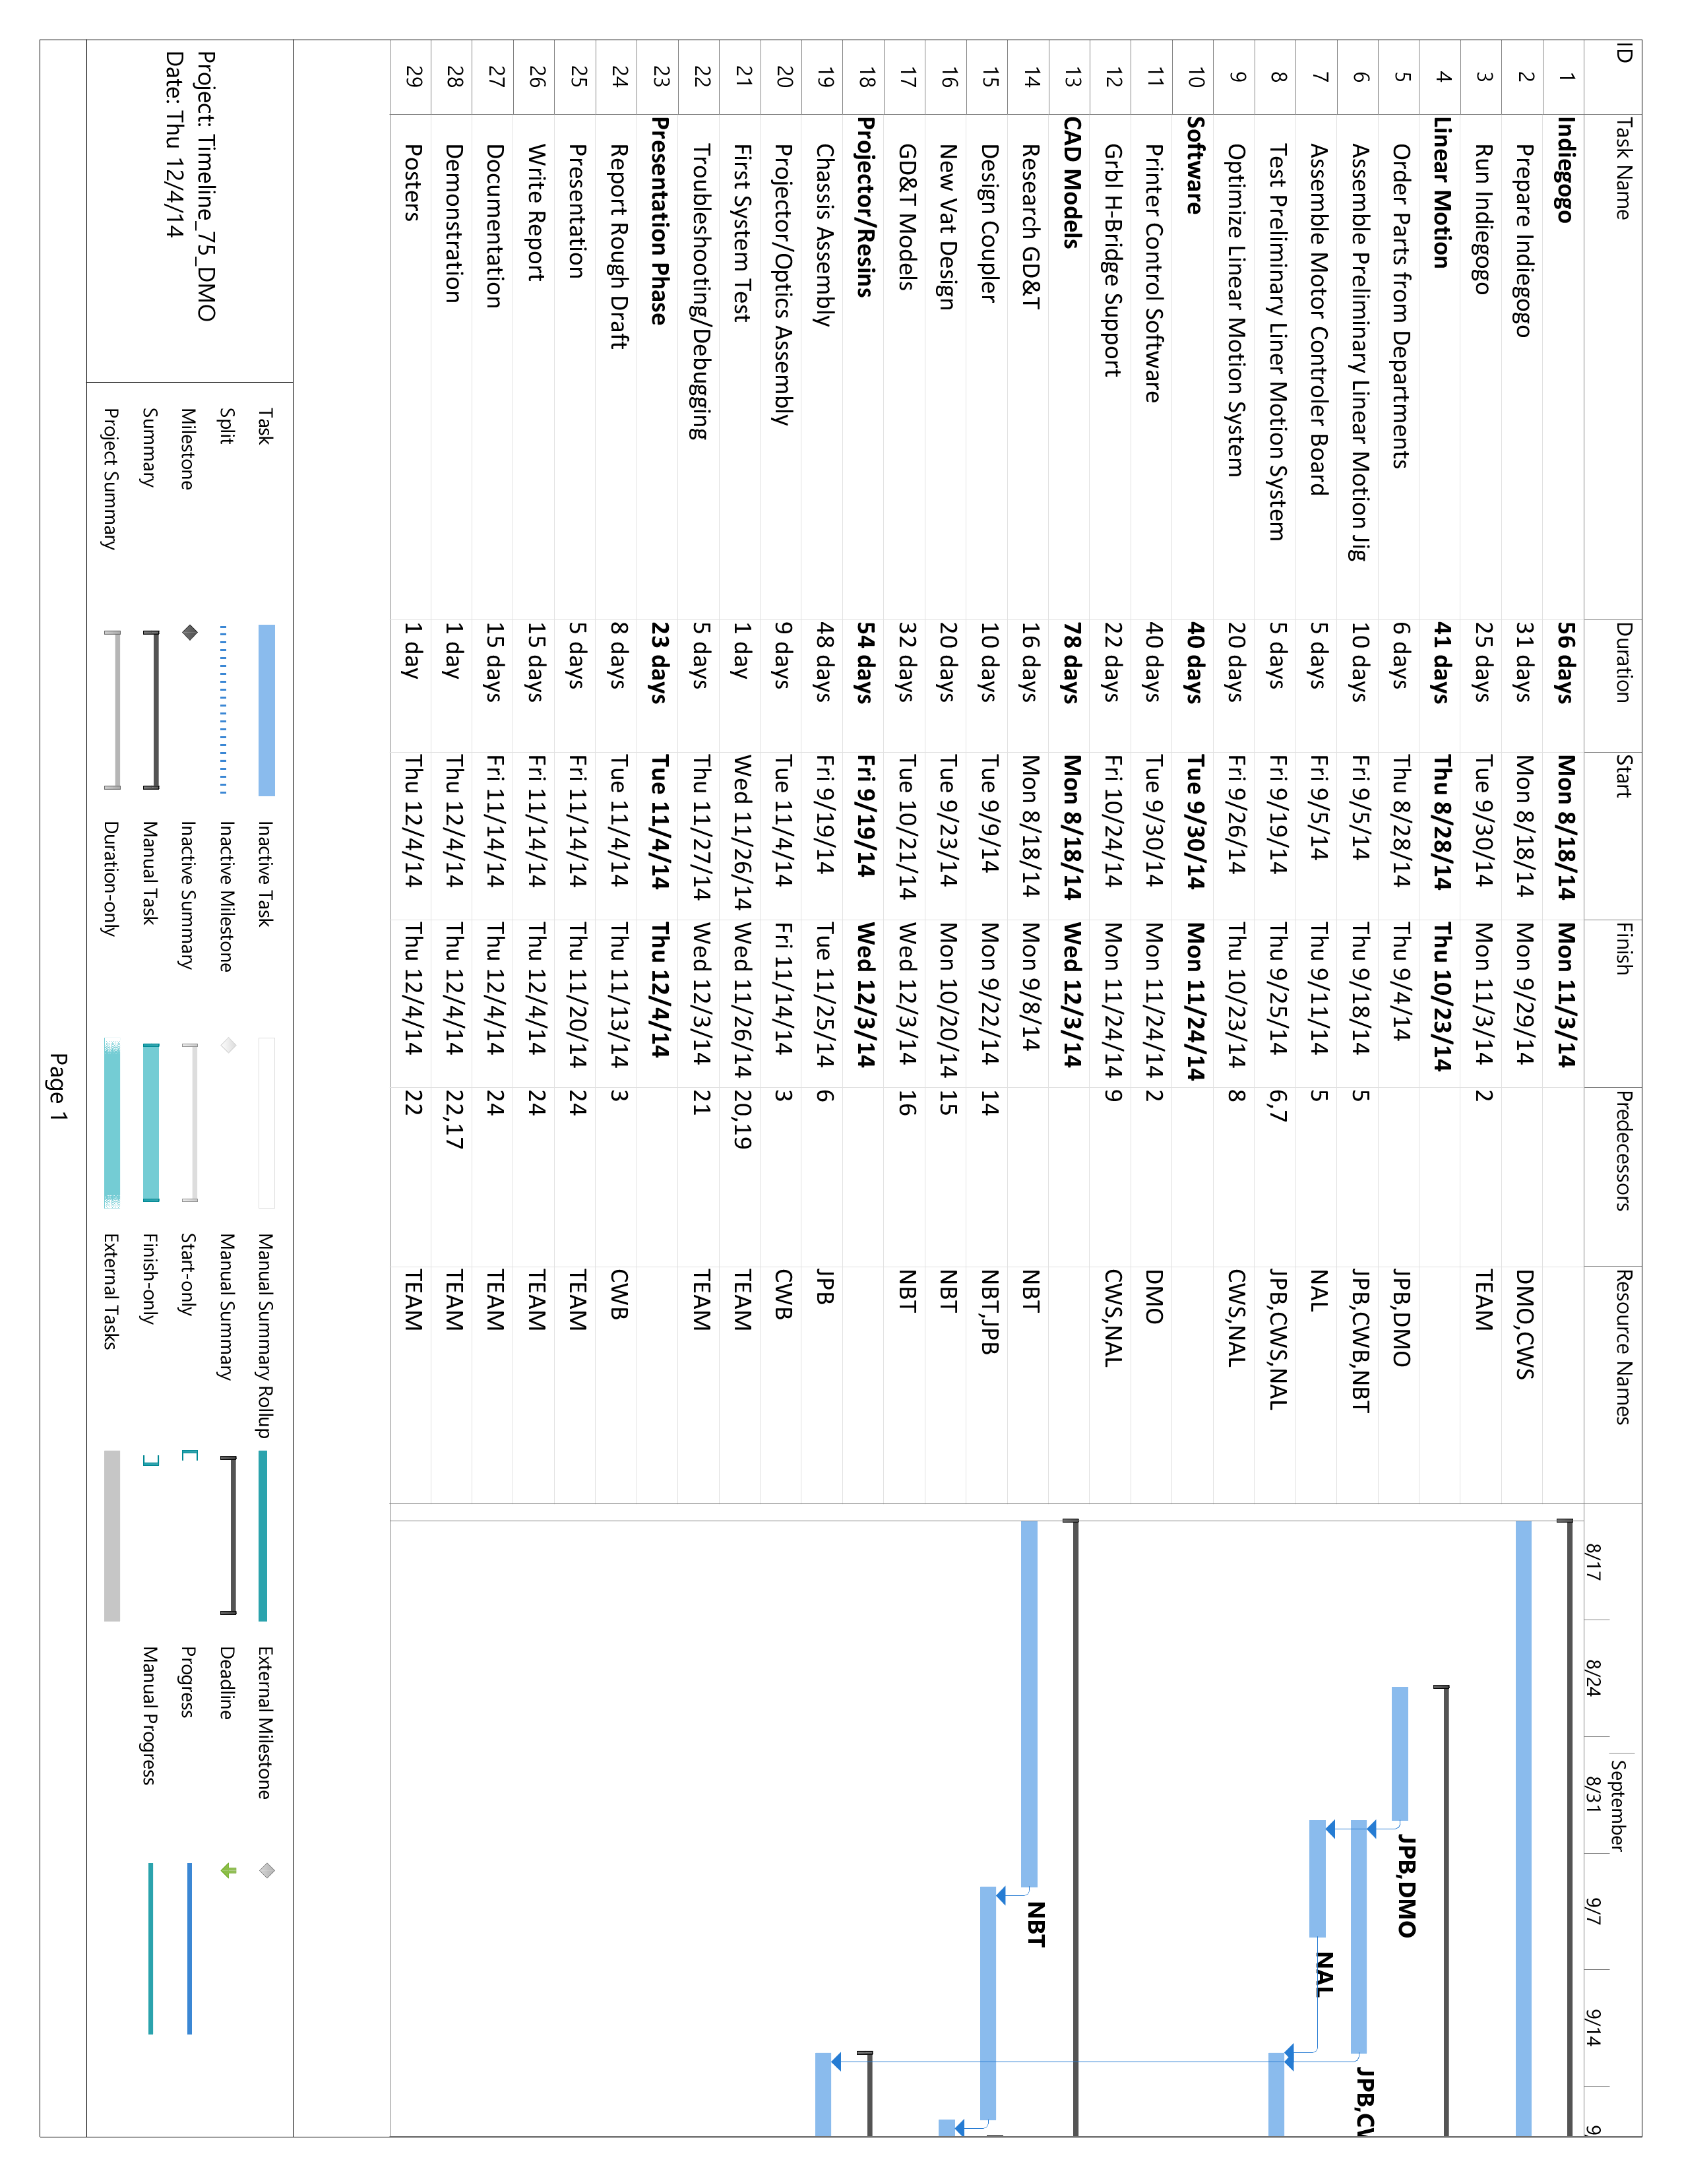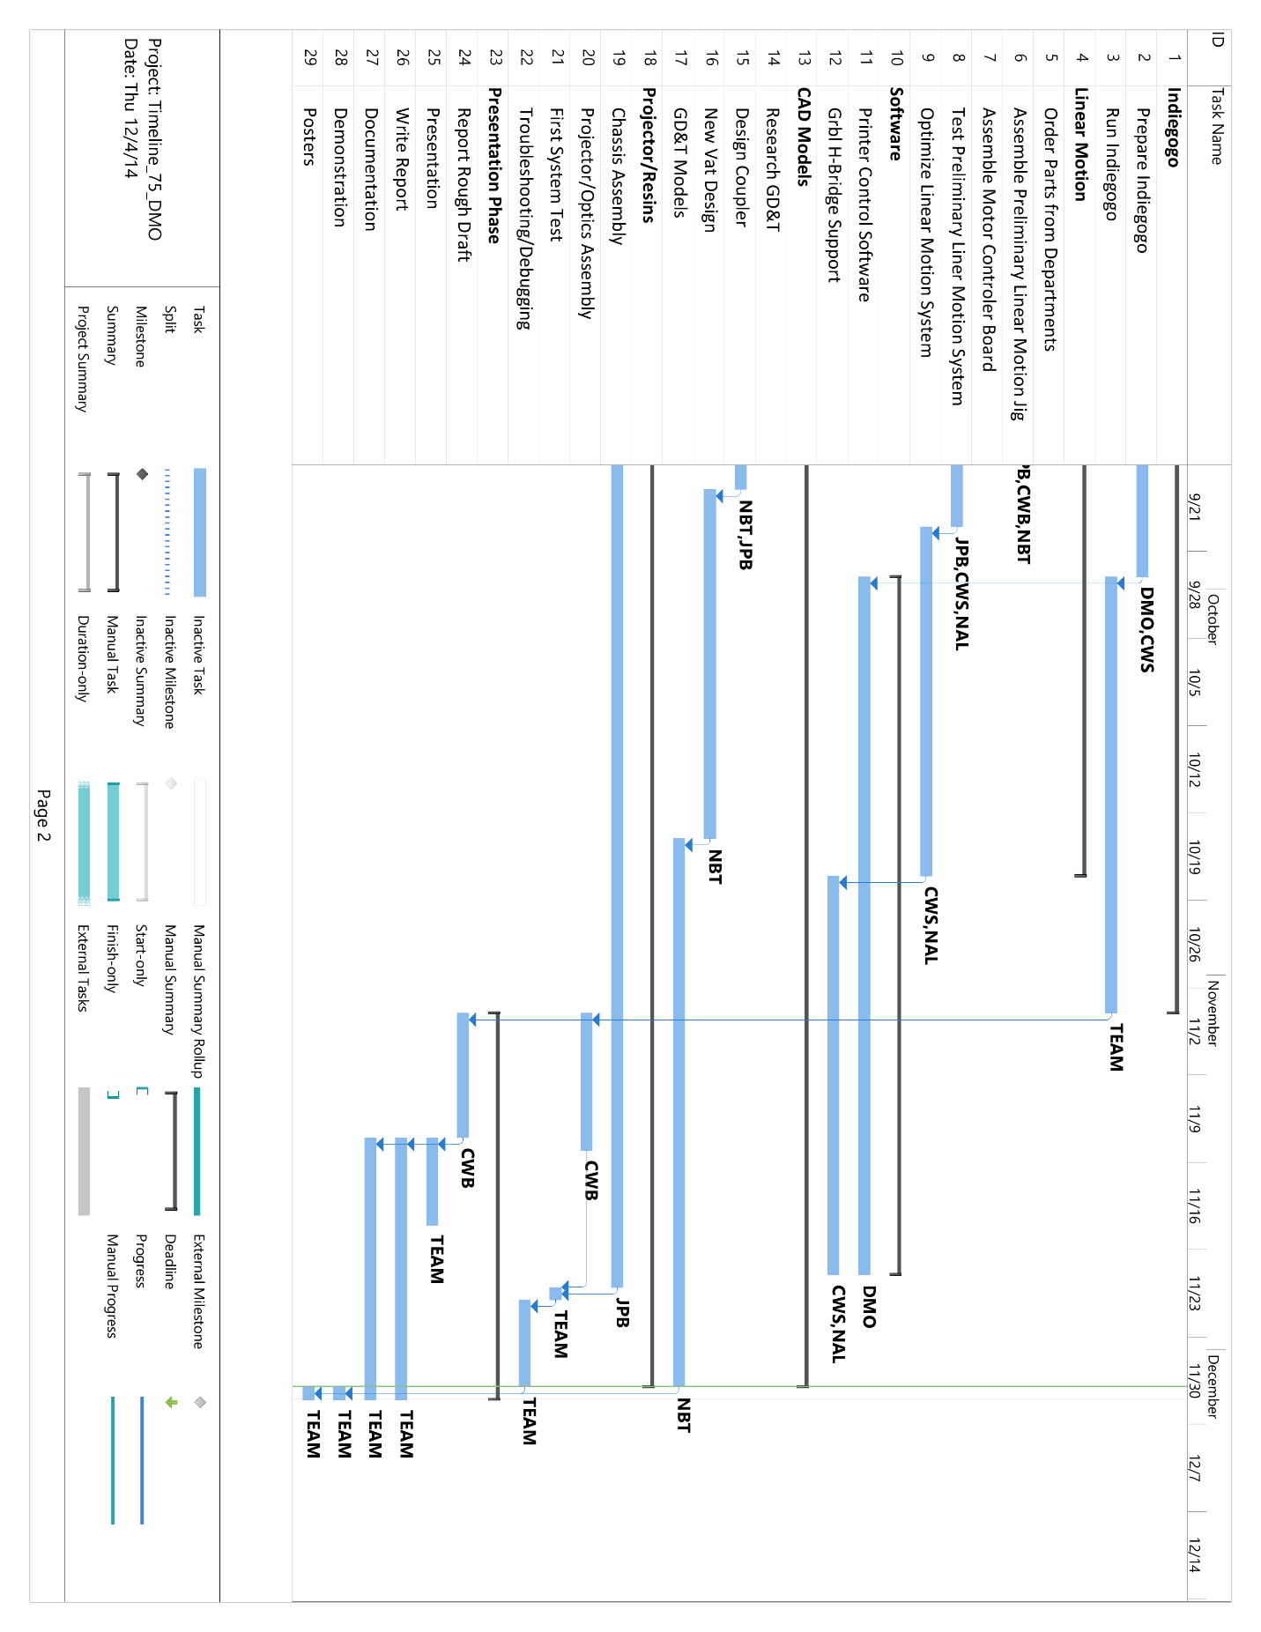

## Bill of Materials

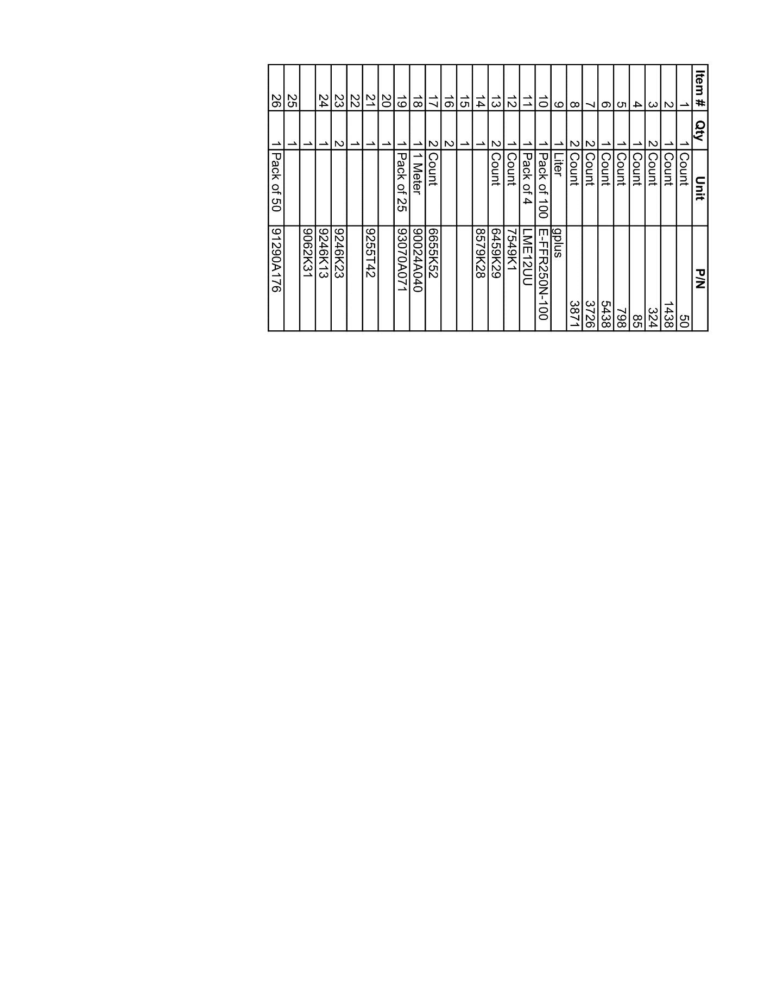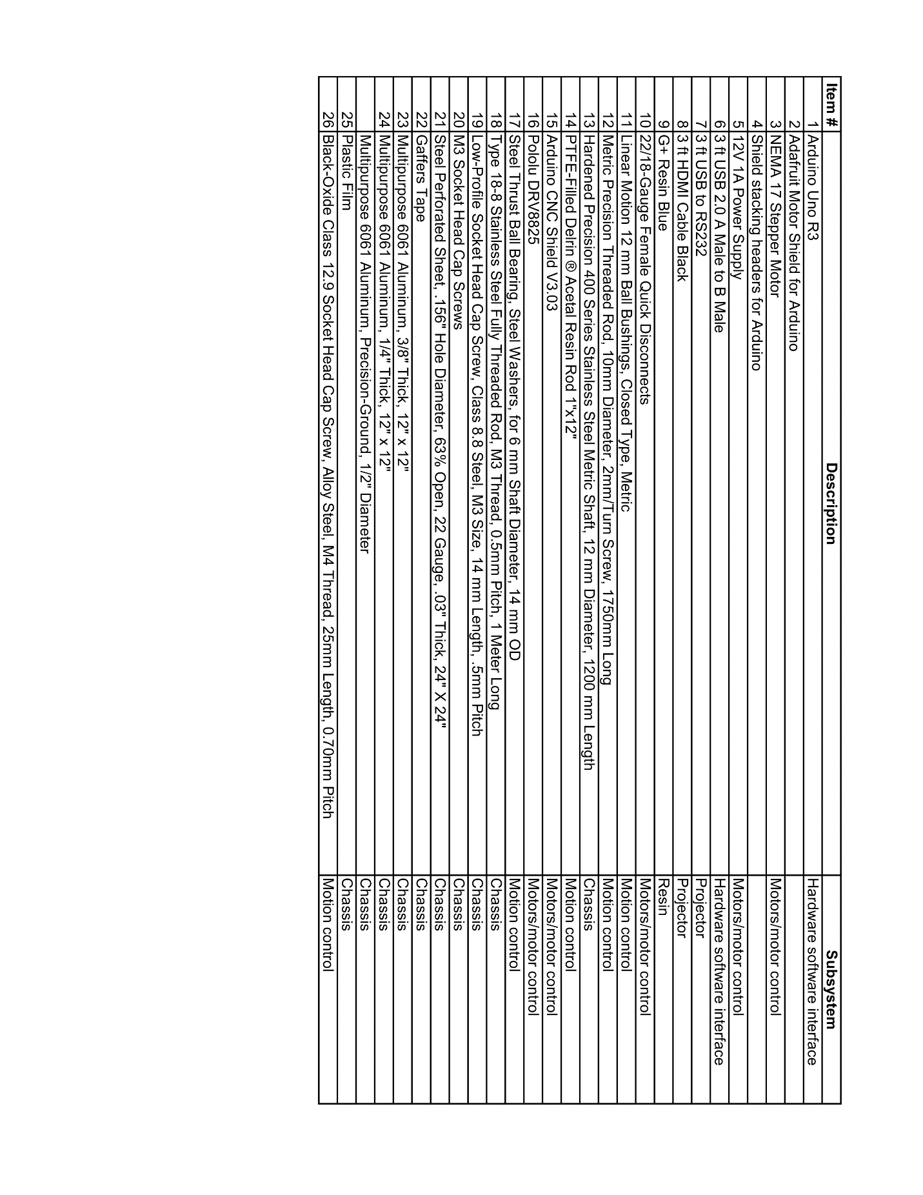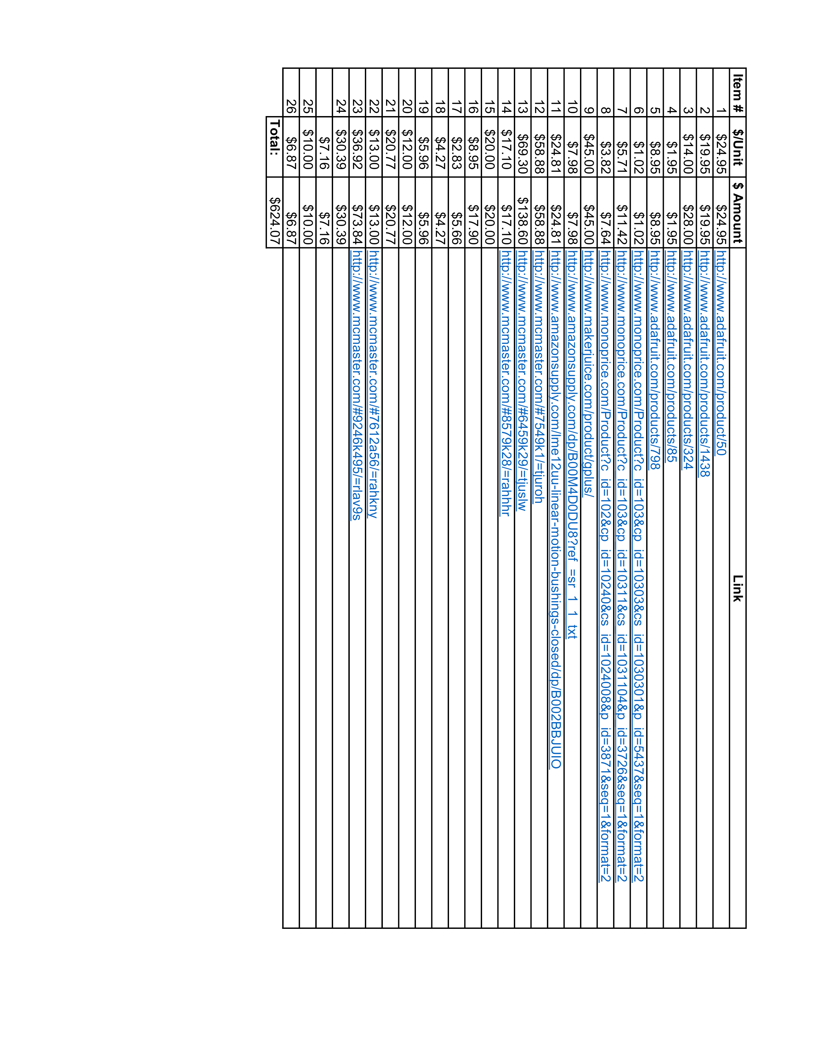

## CAD Models

### Printer

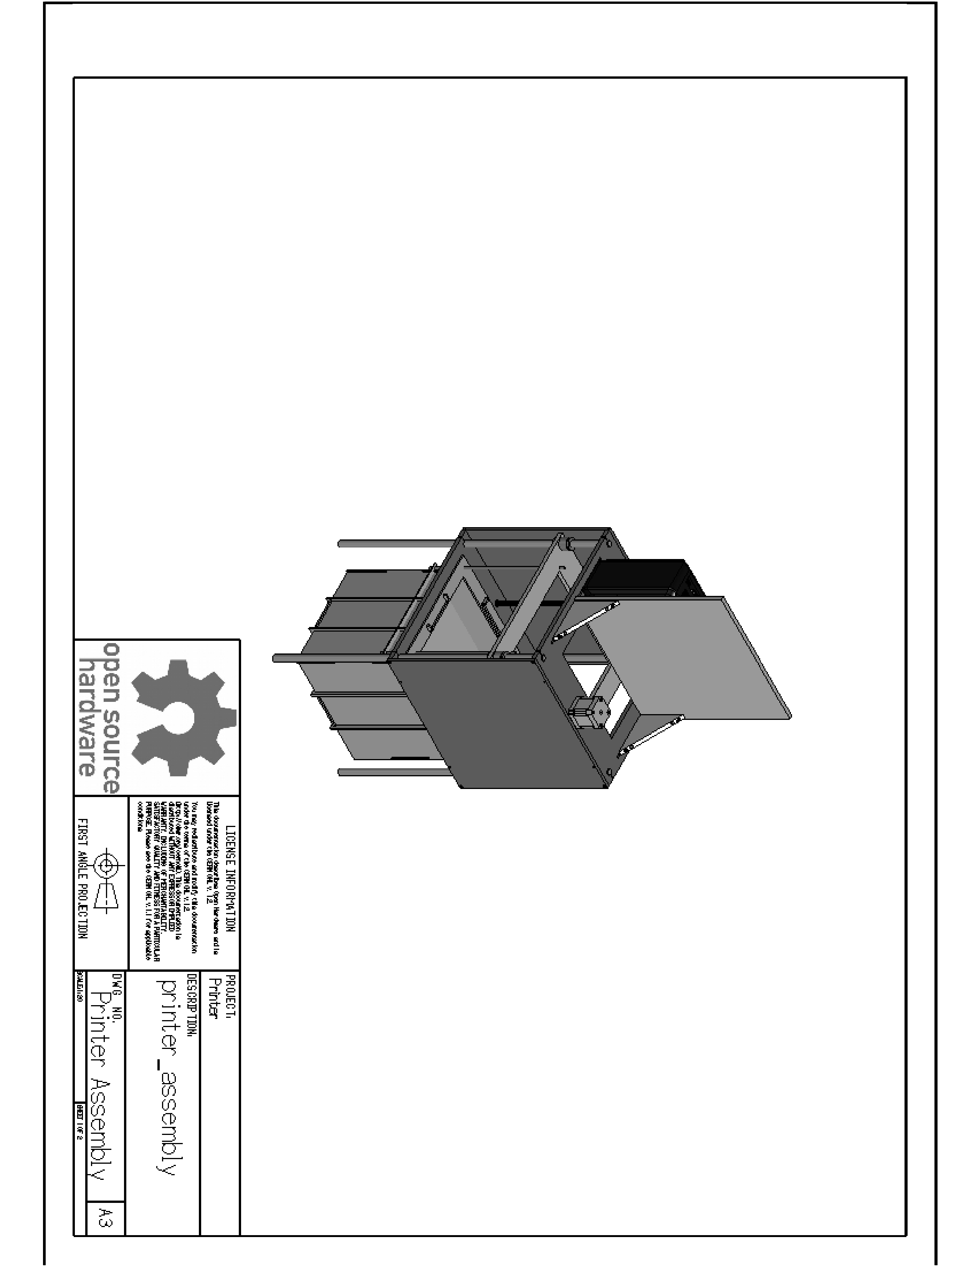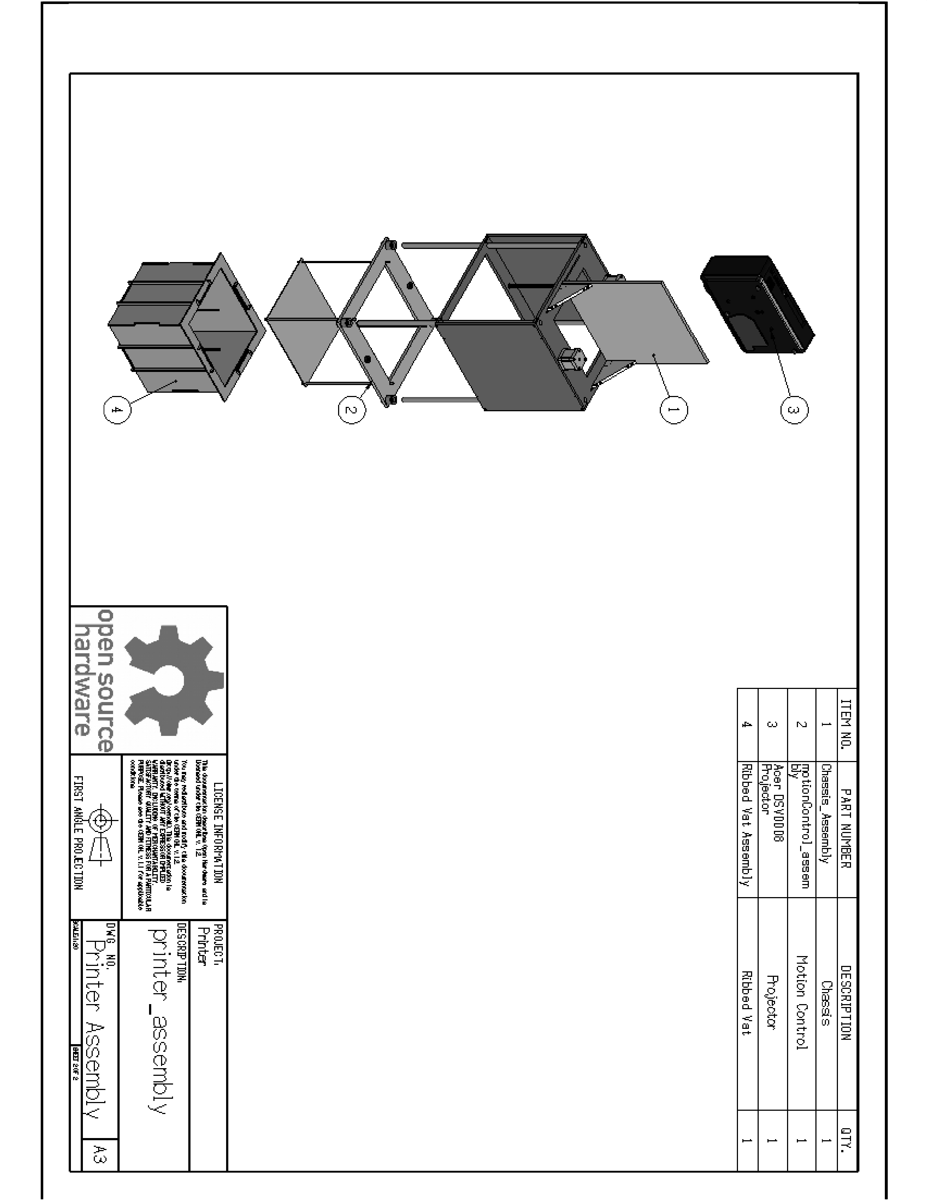

### Chassis

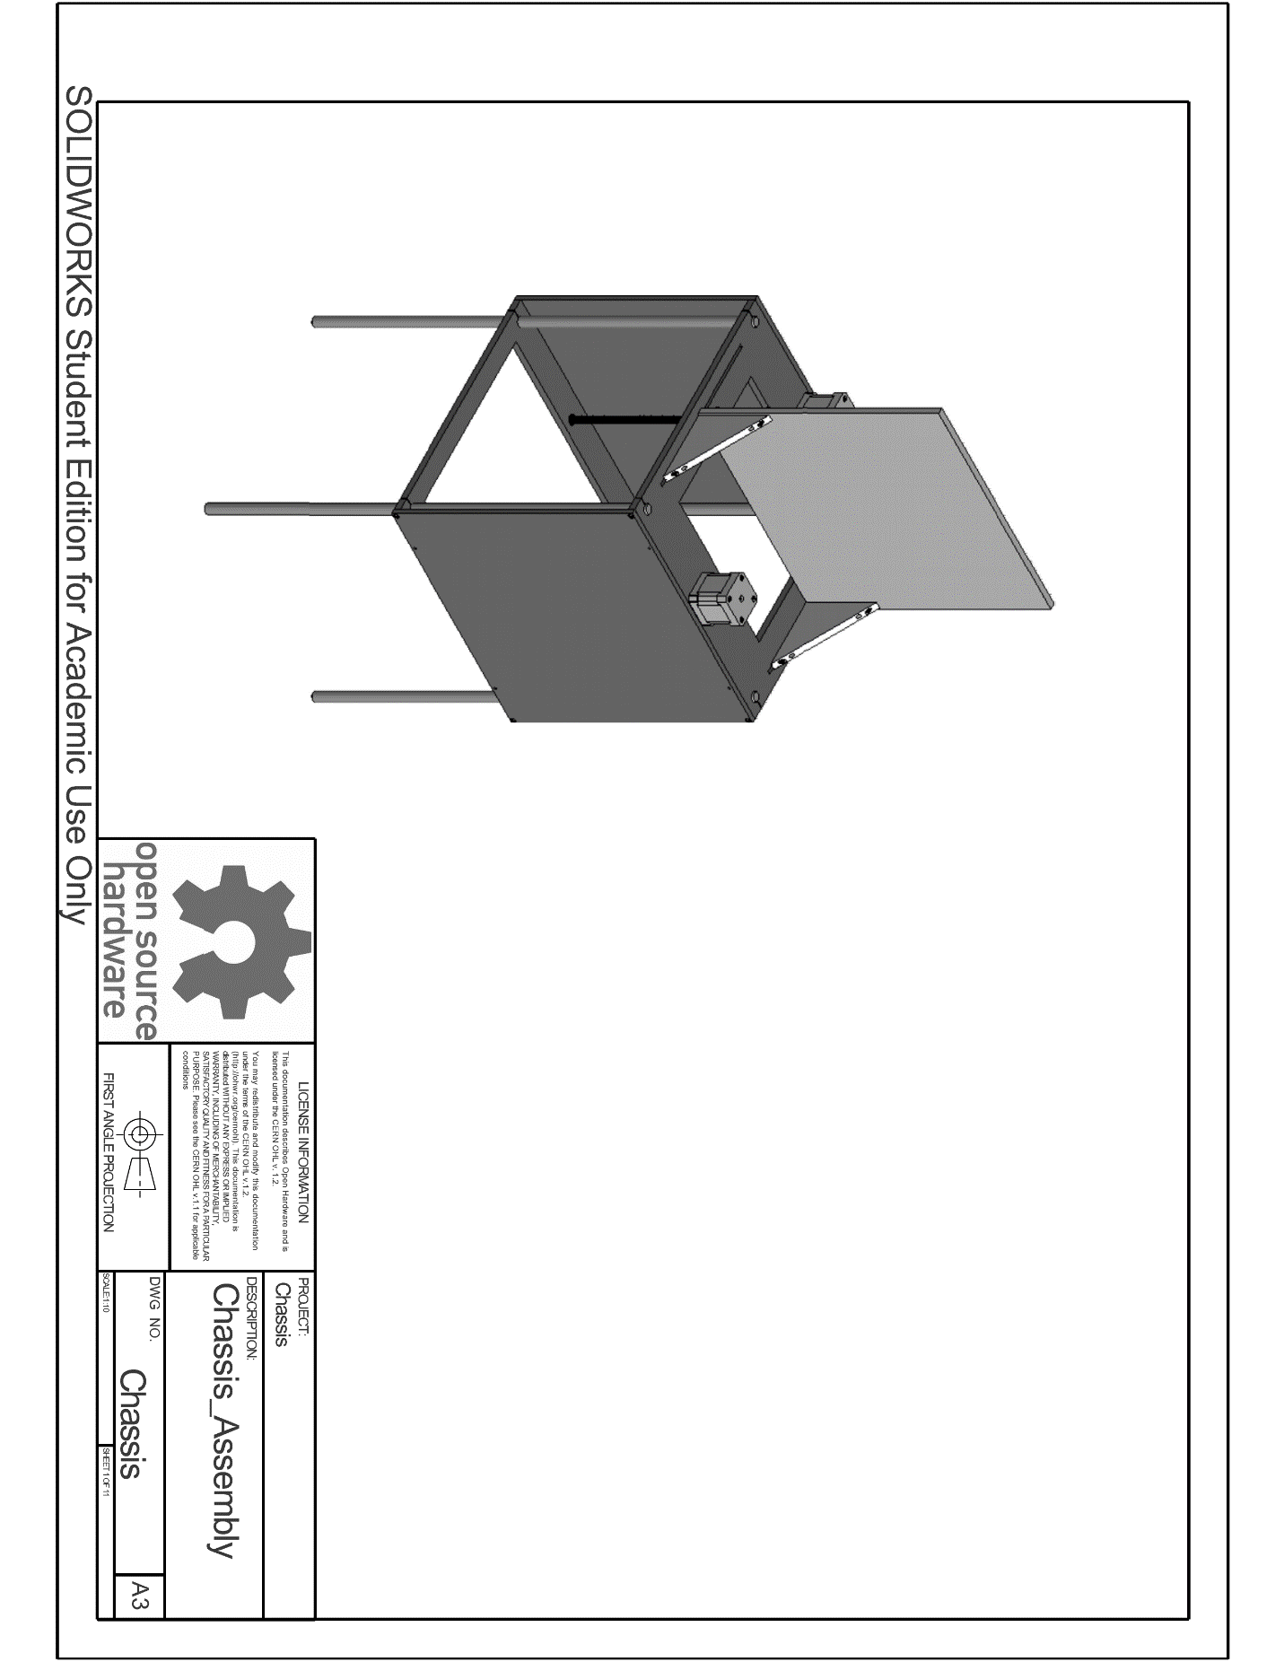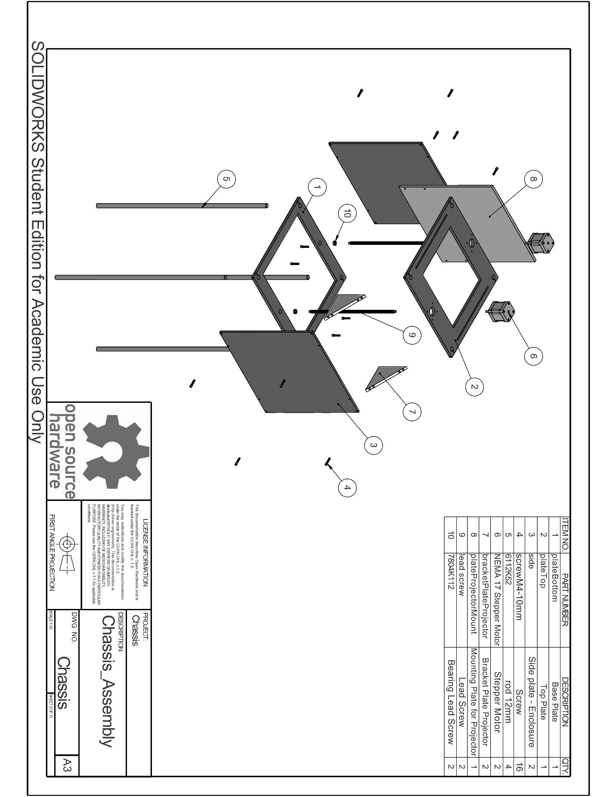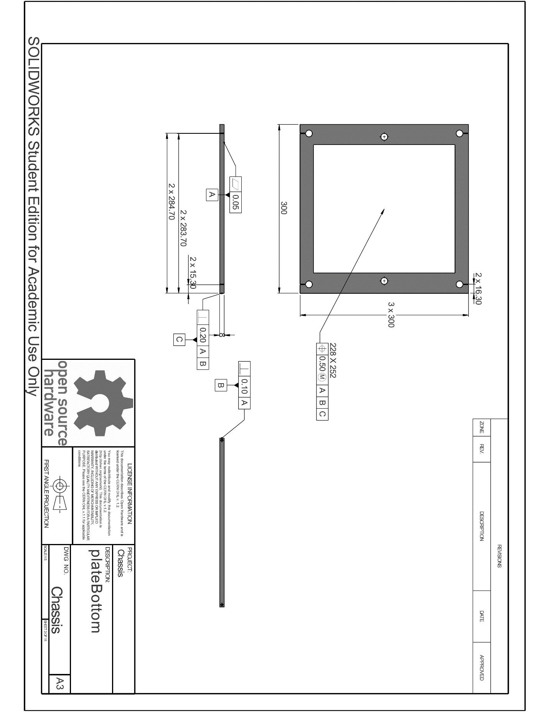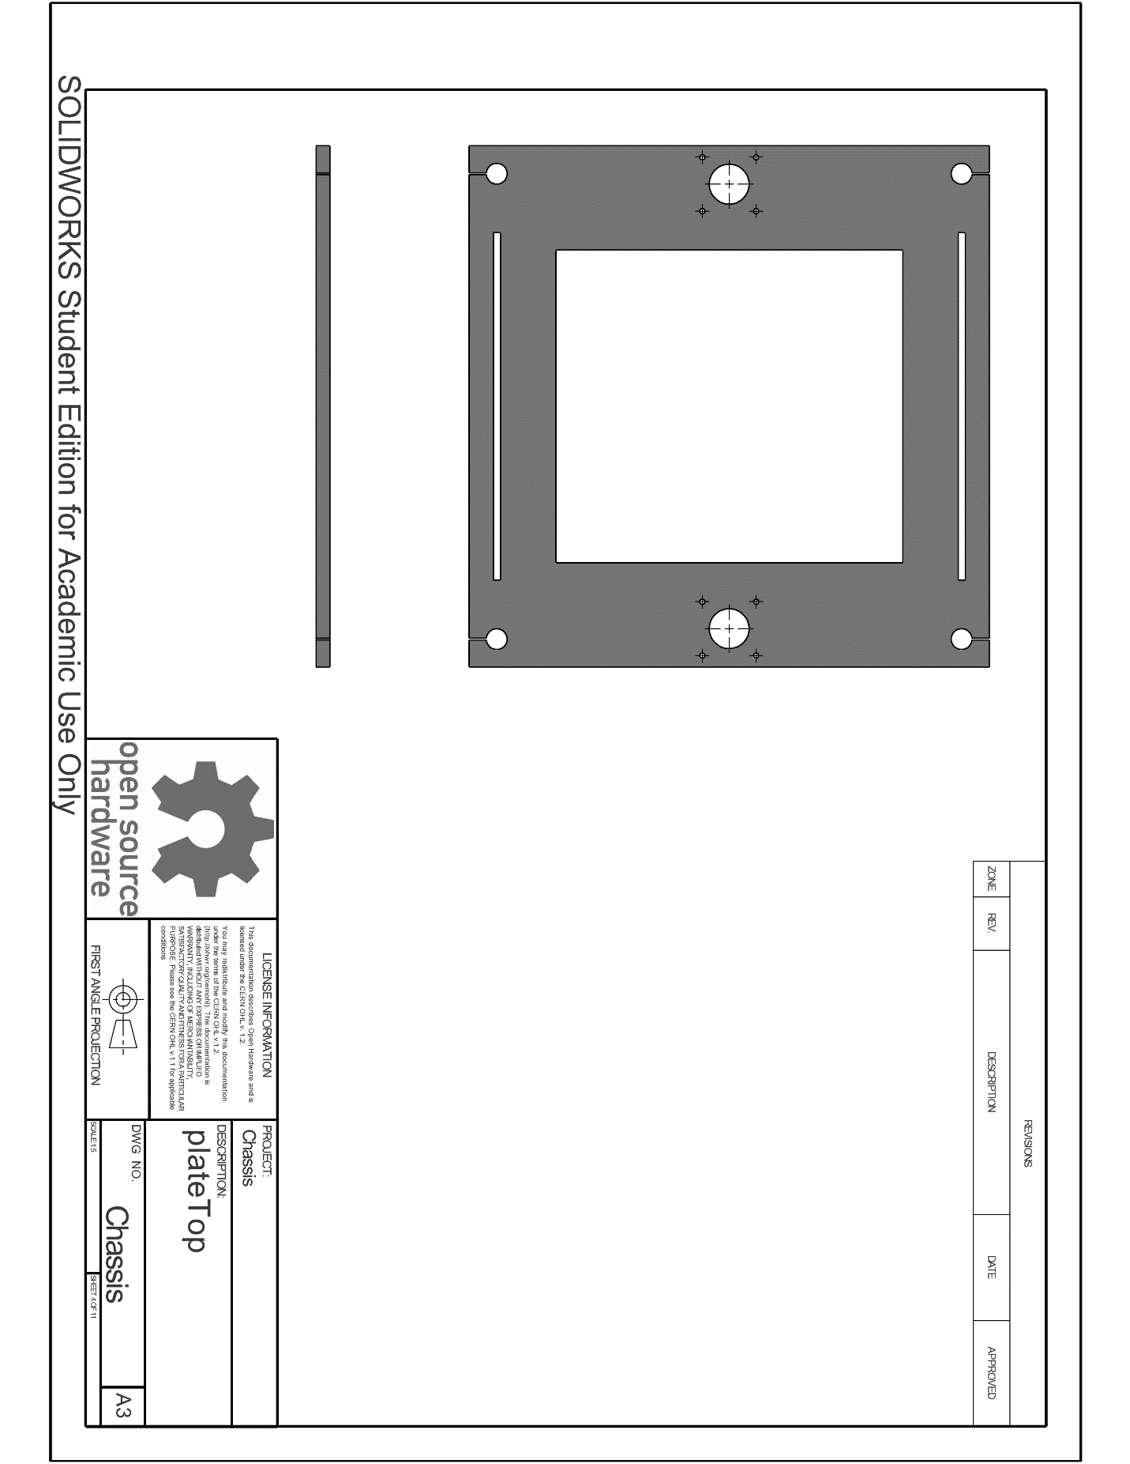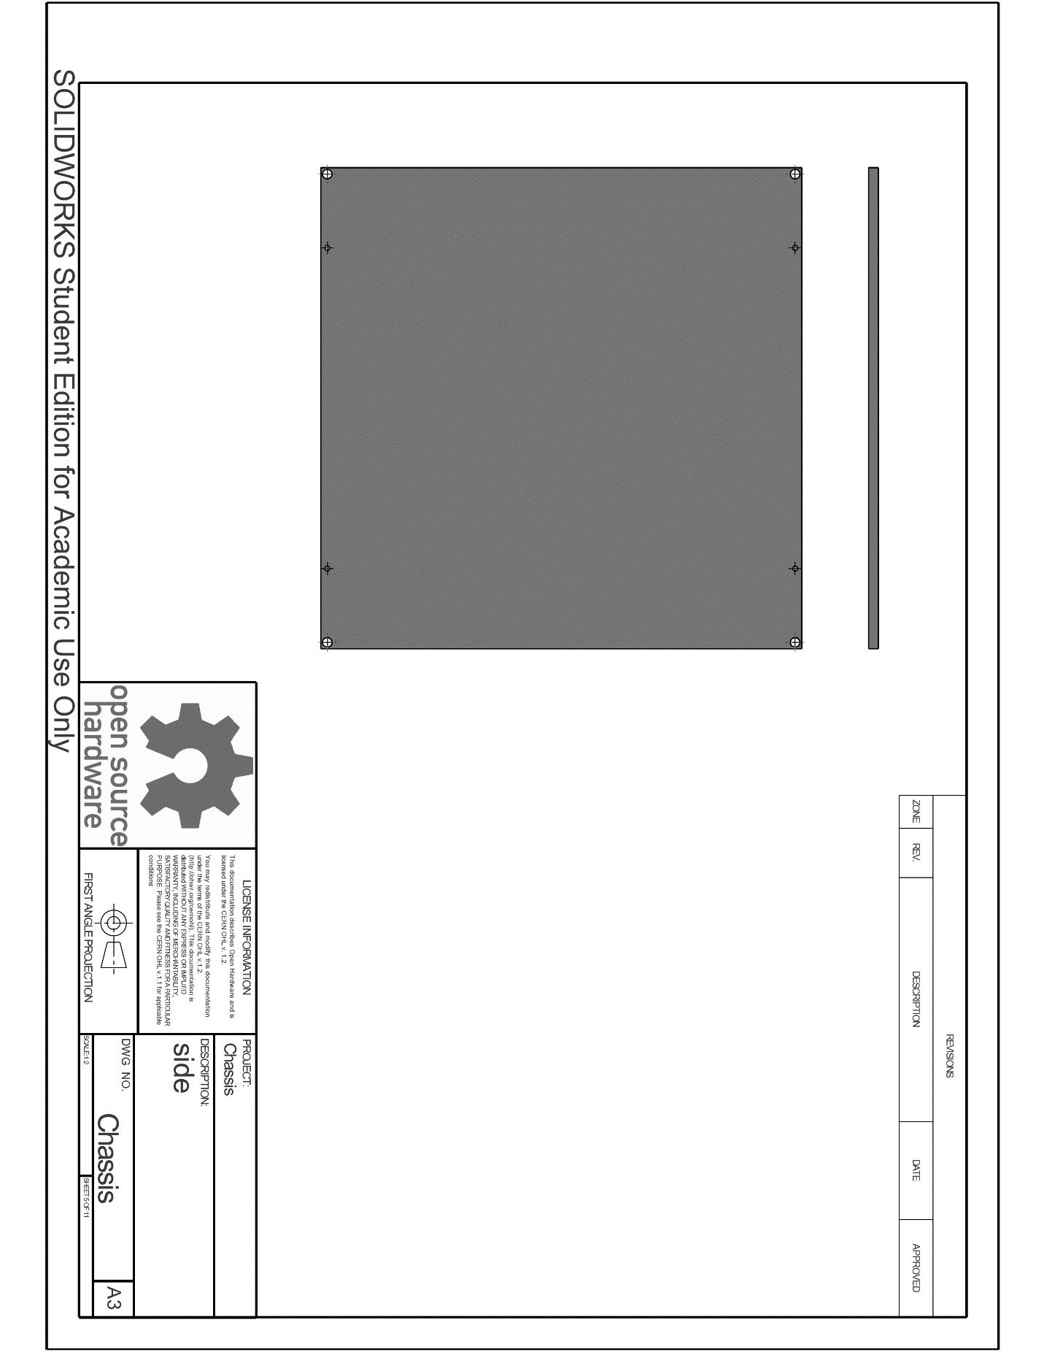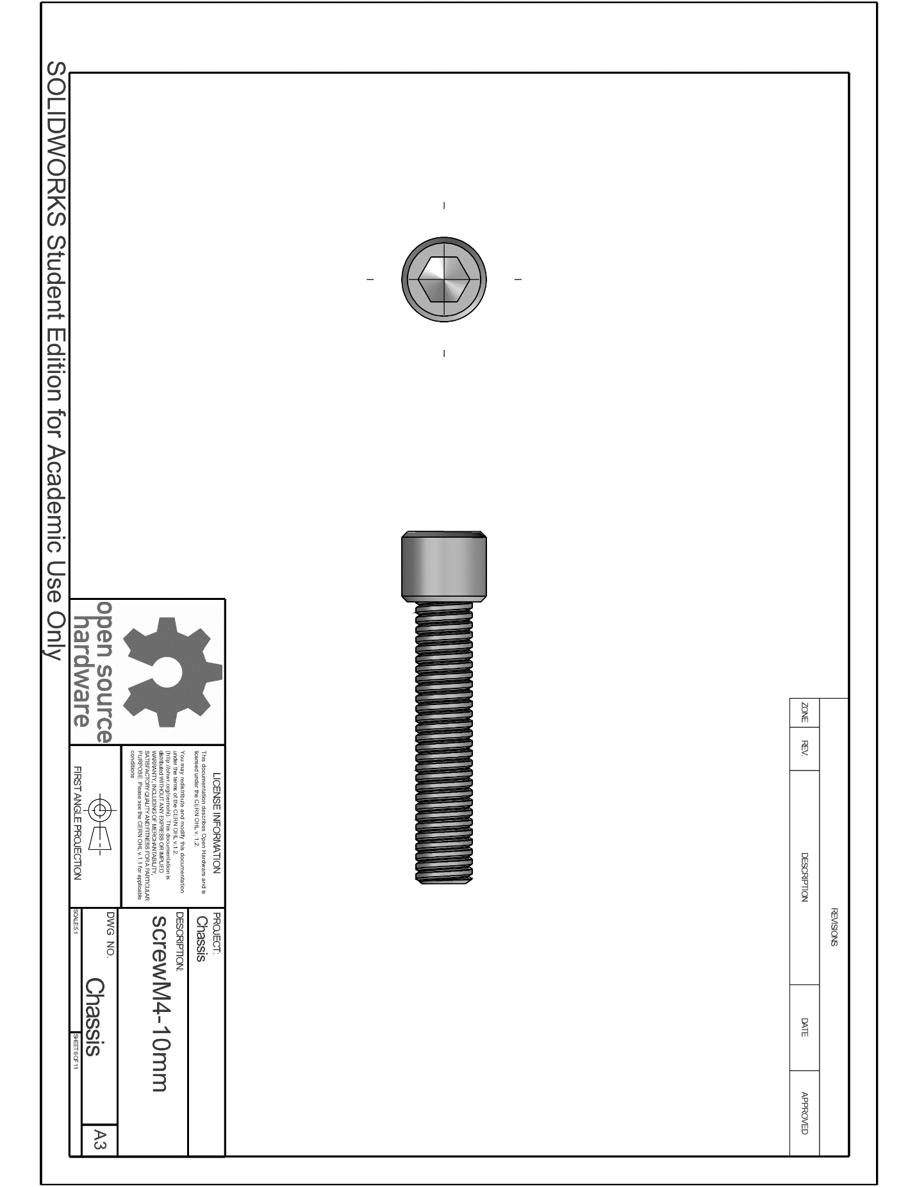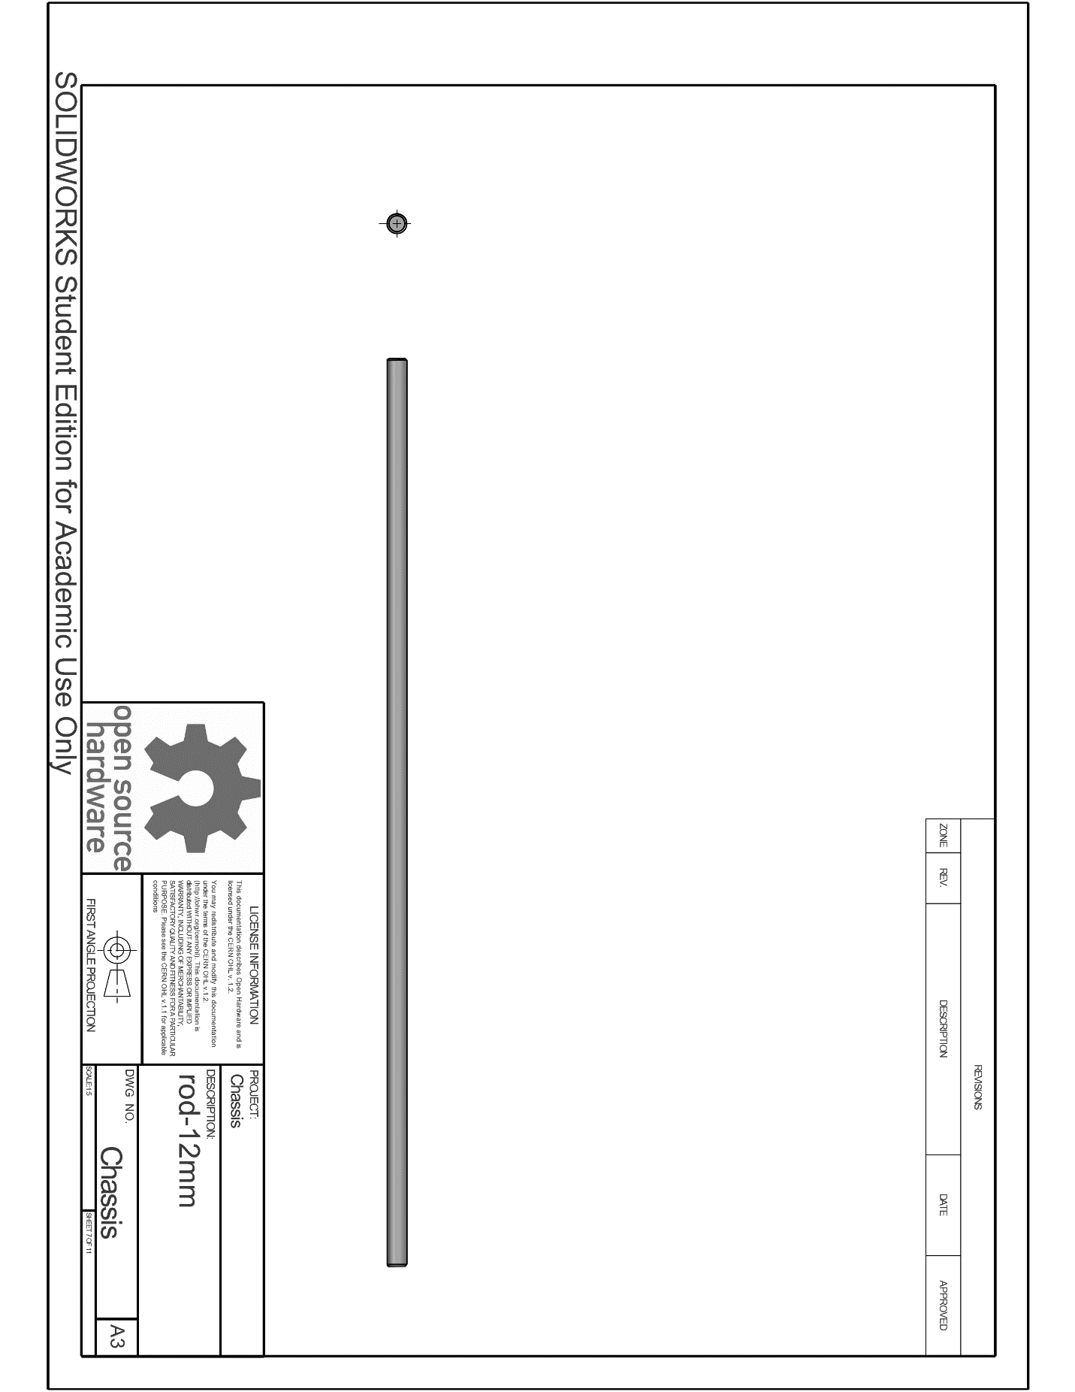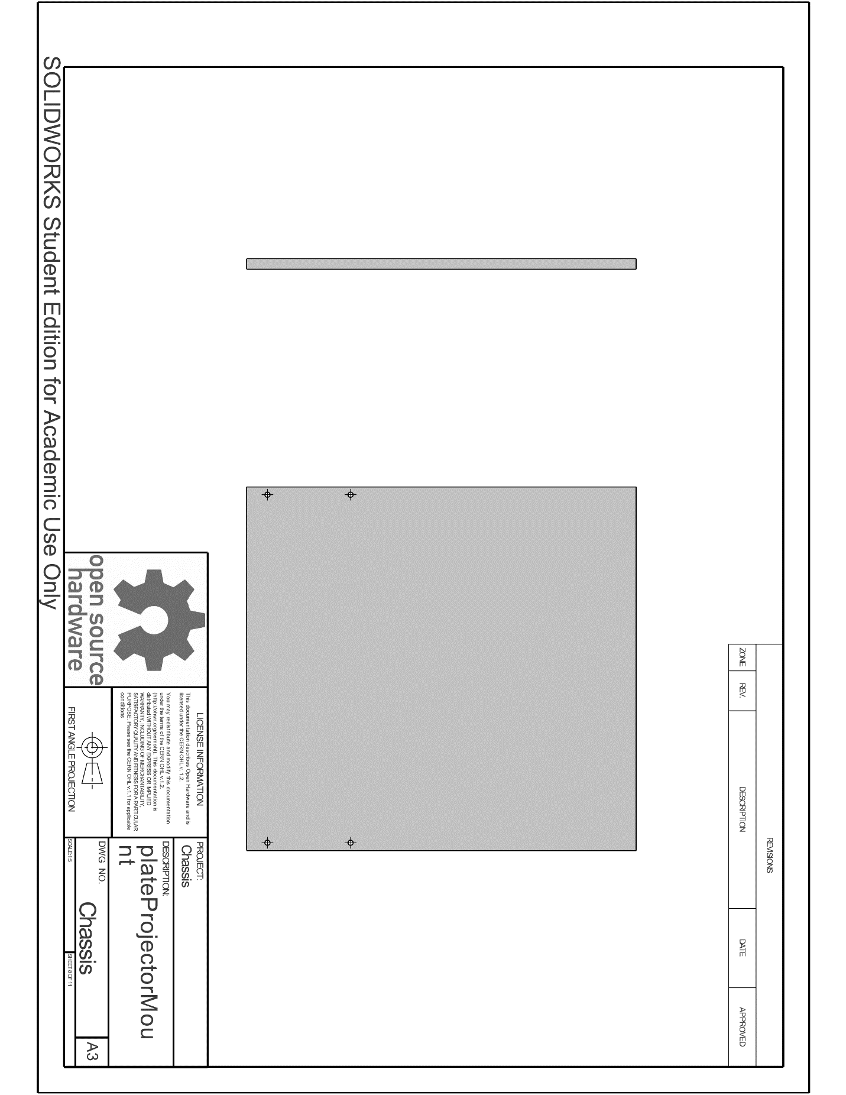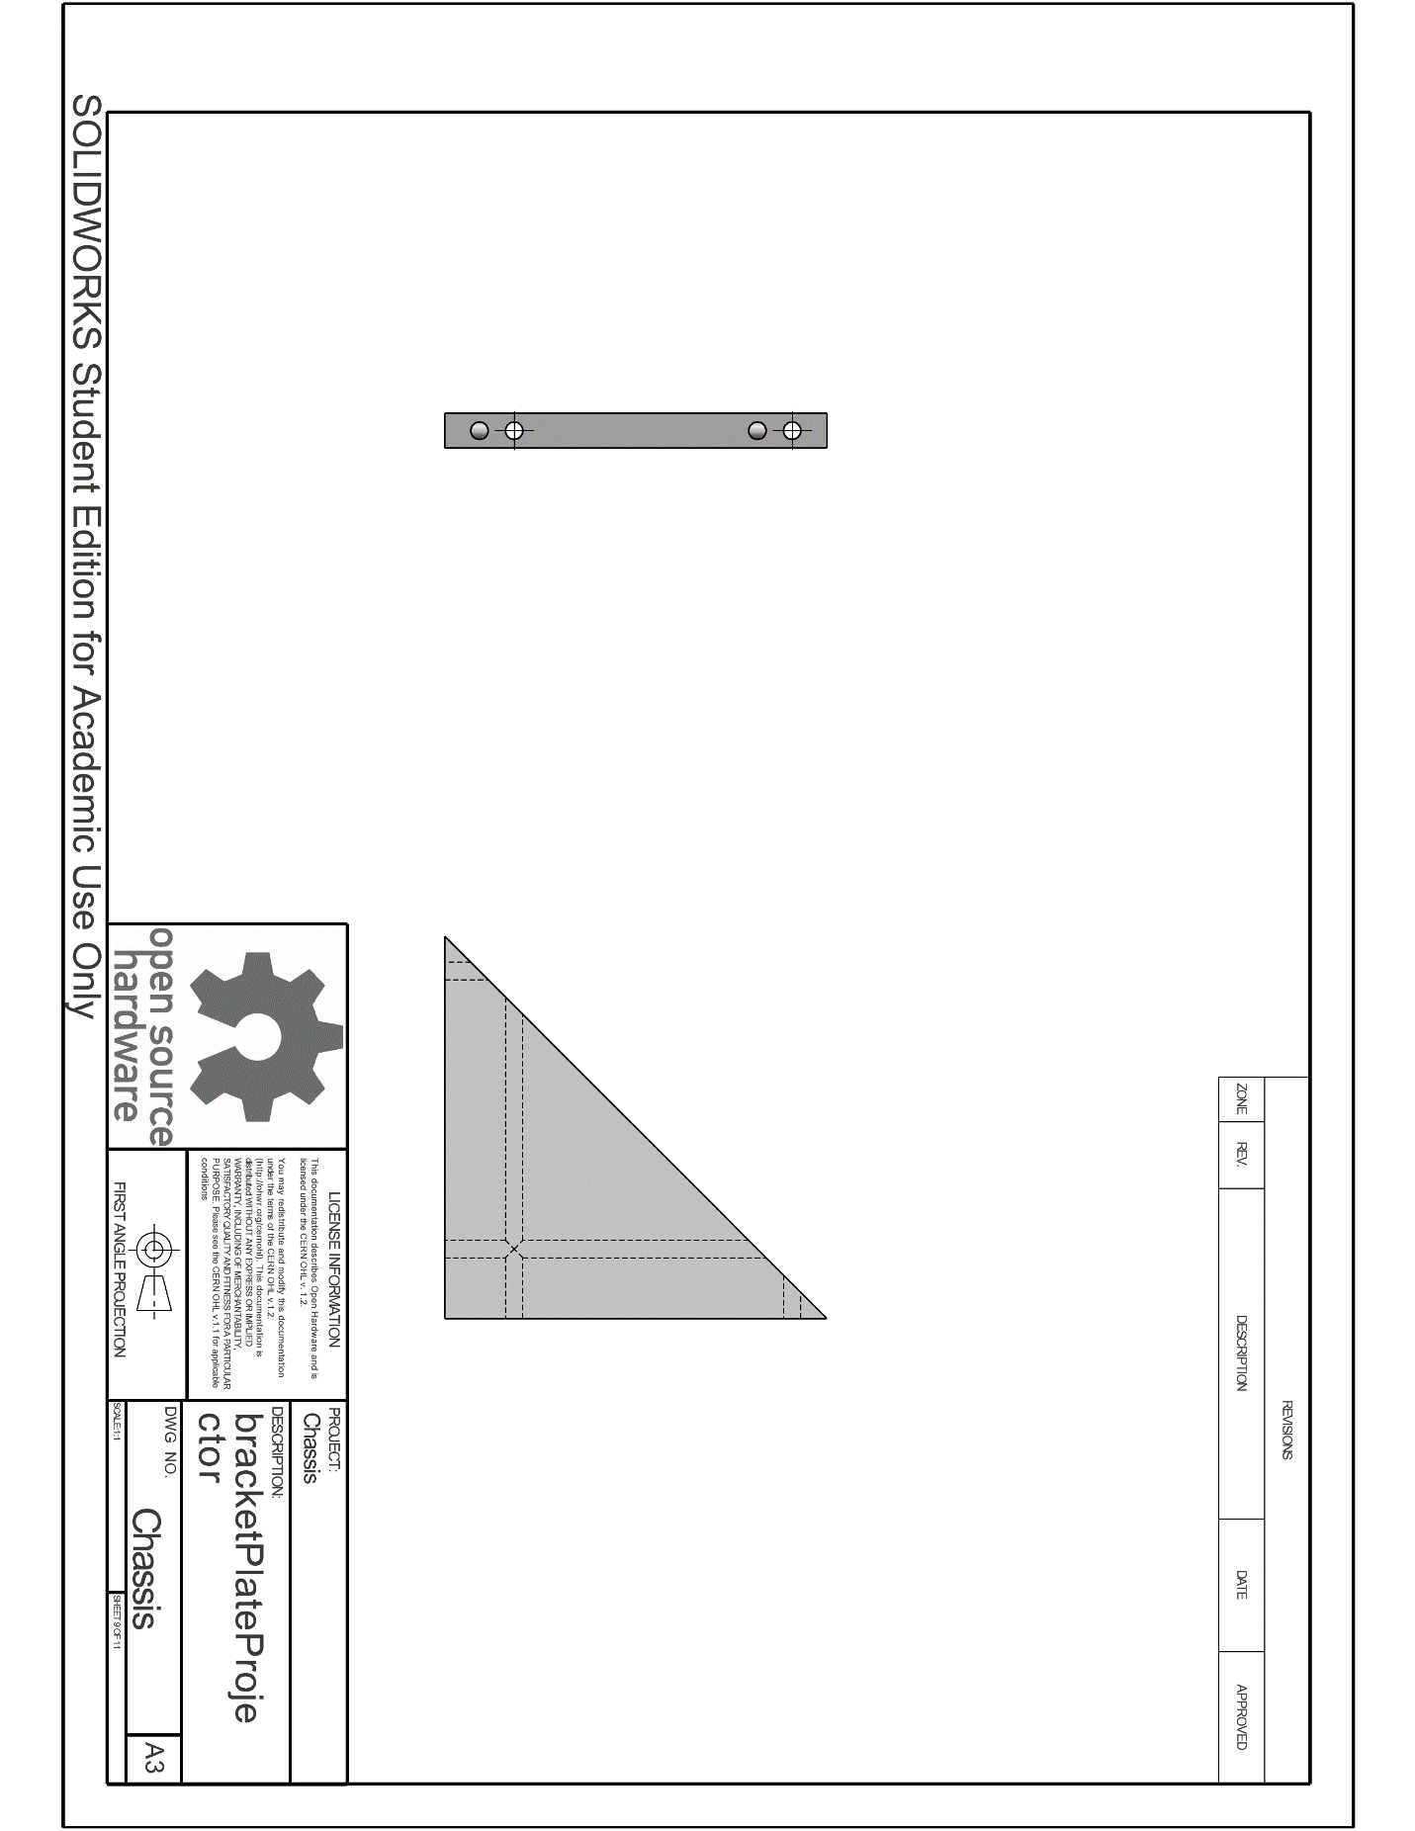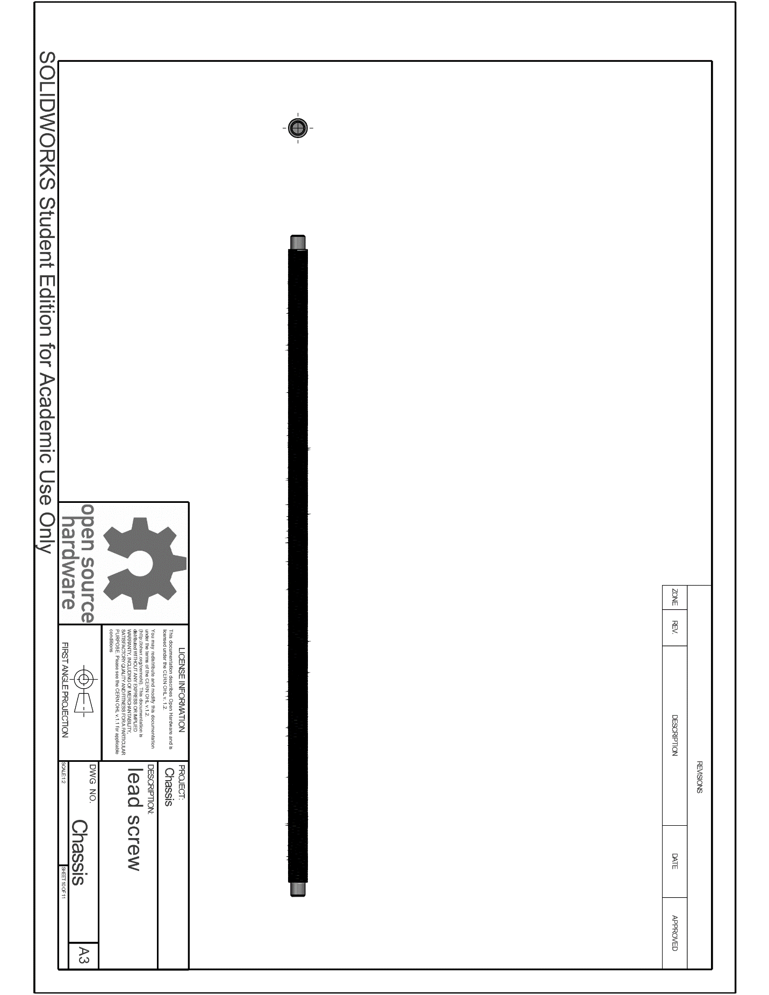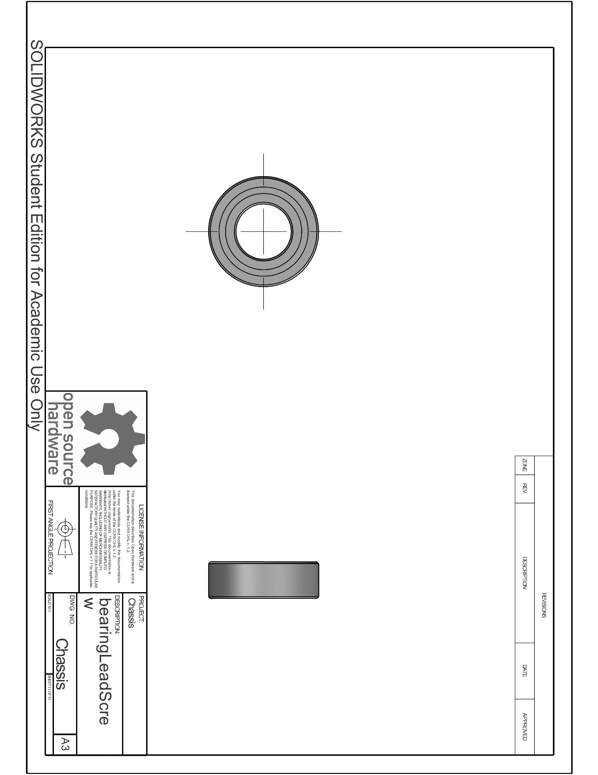

### Motion Control

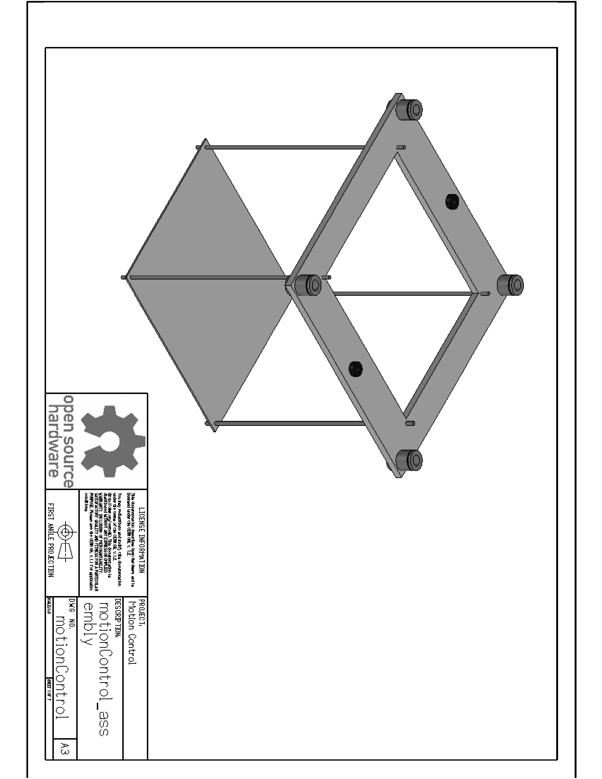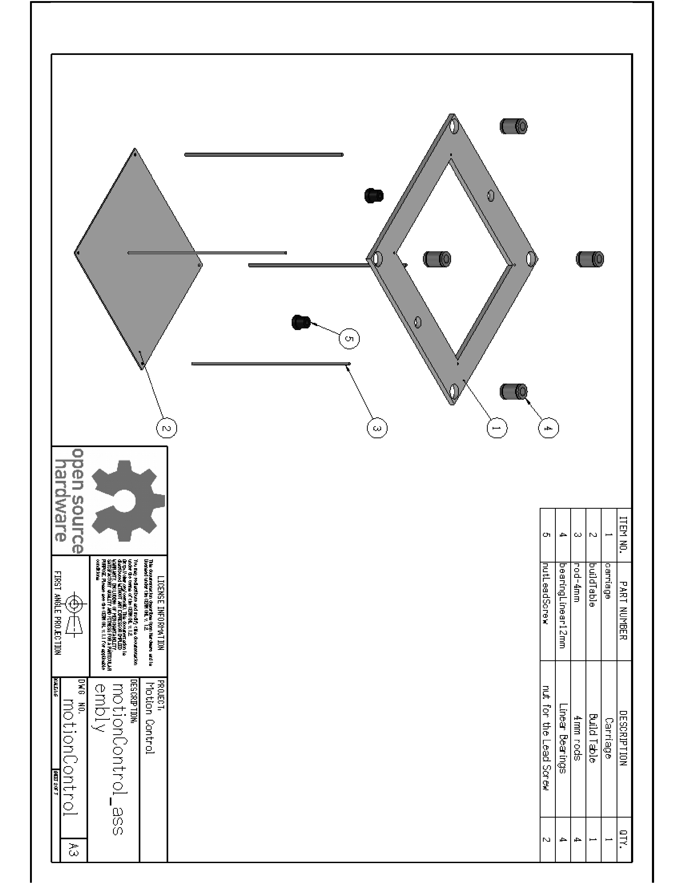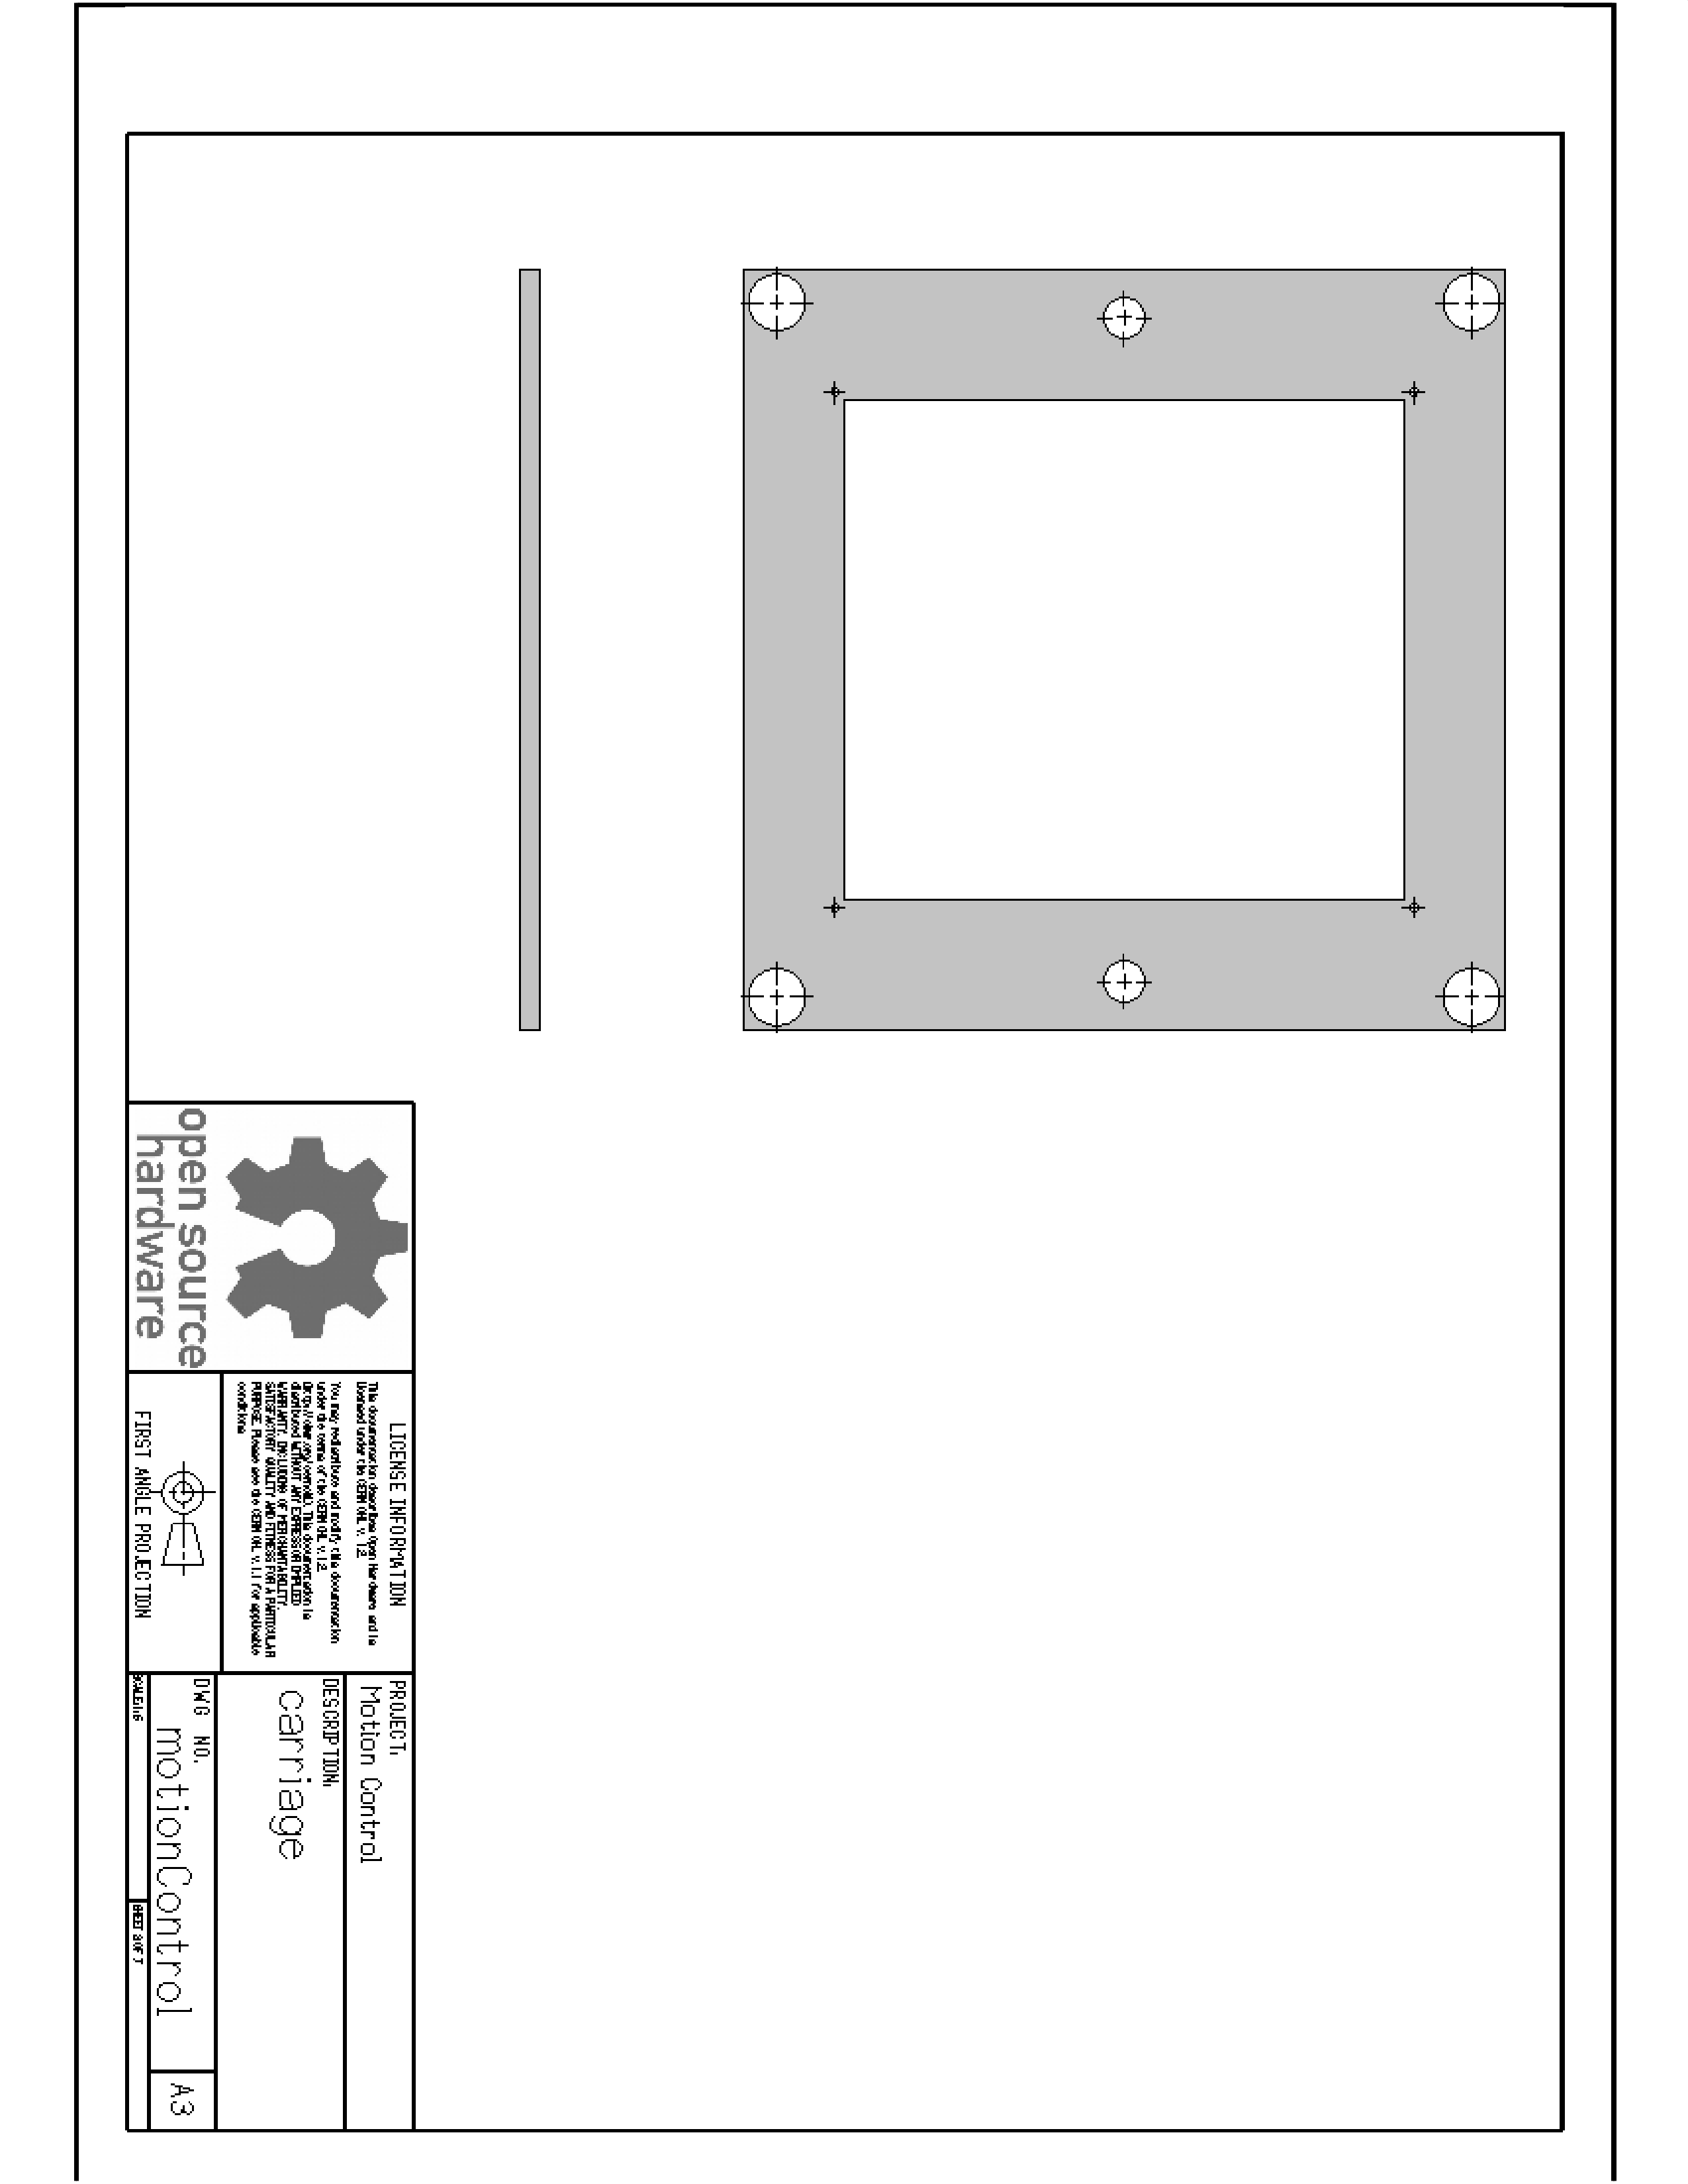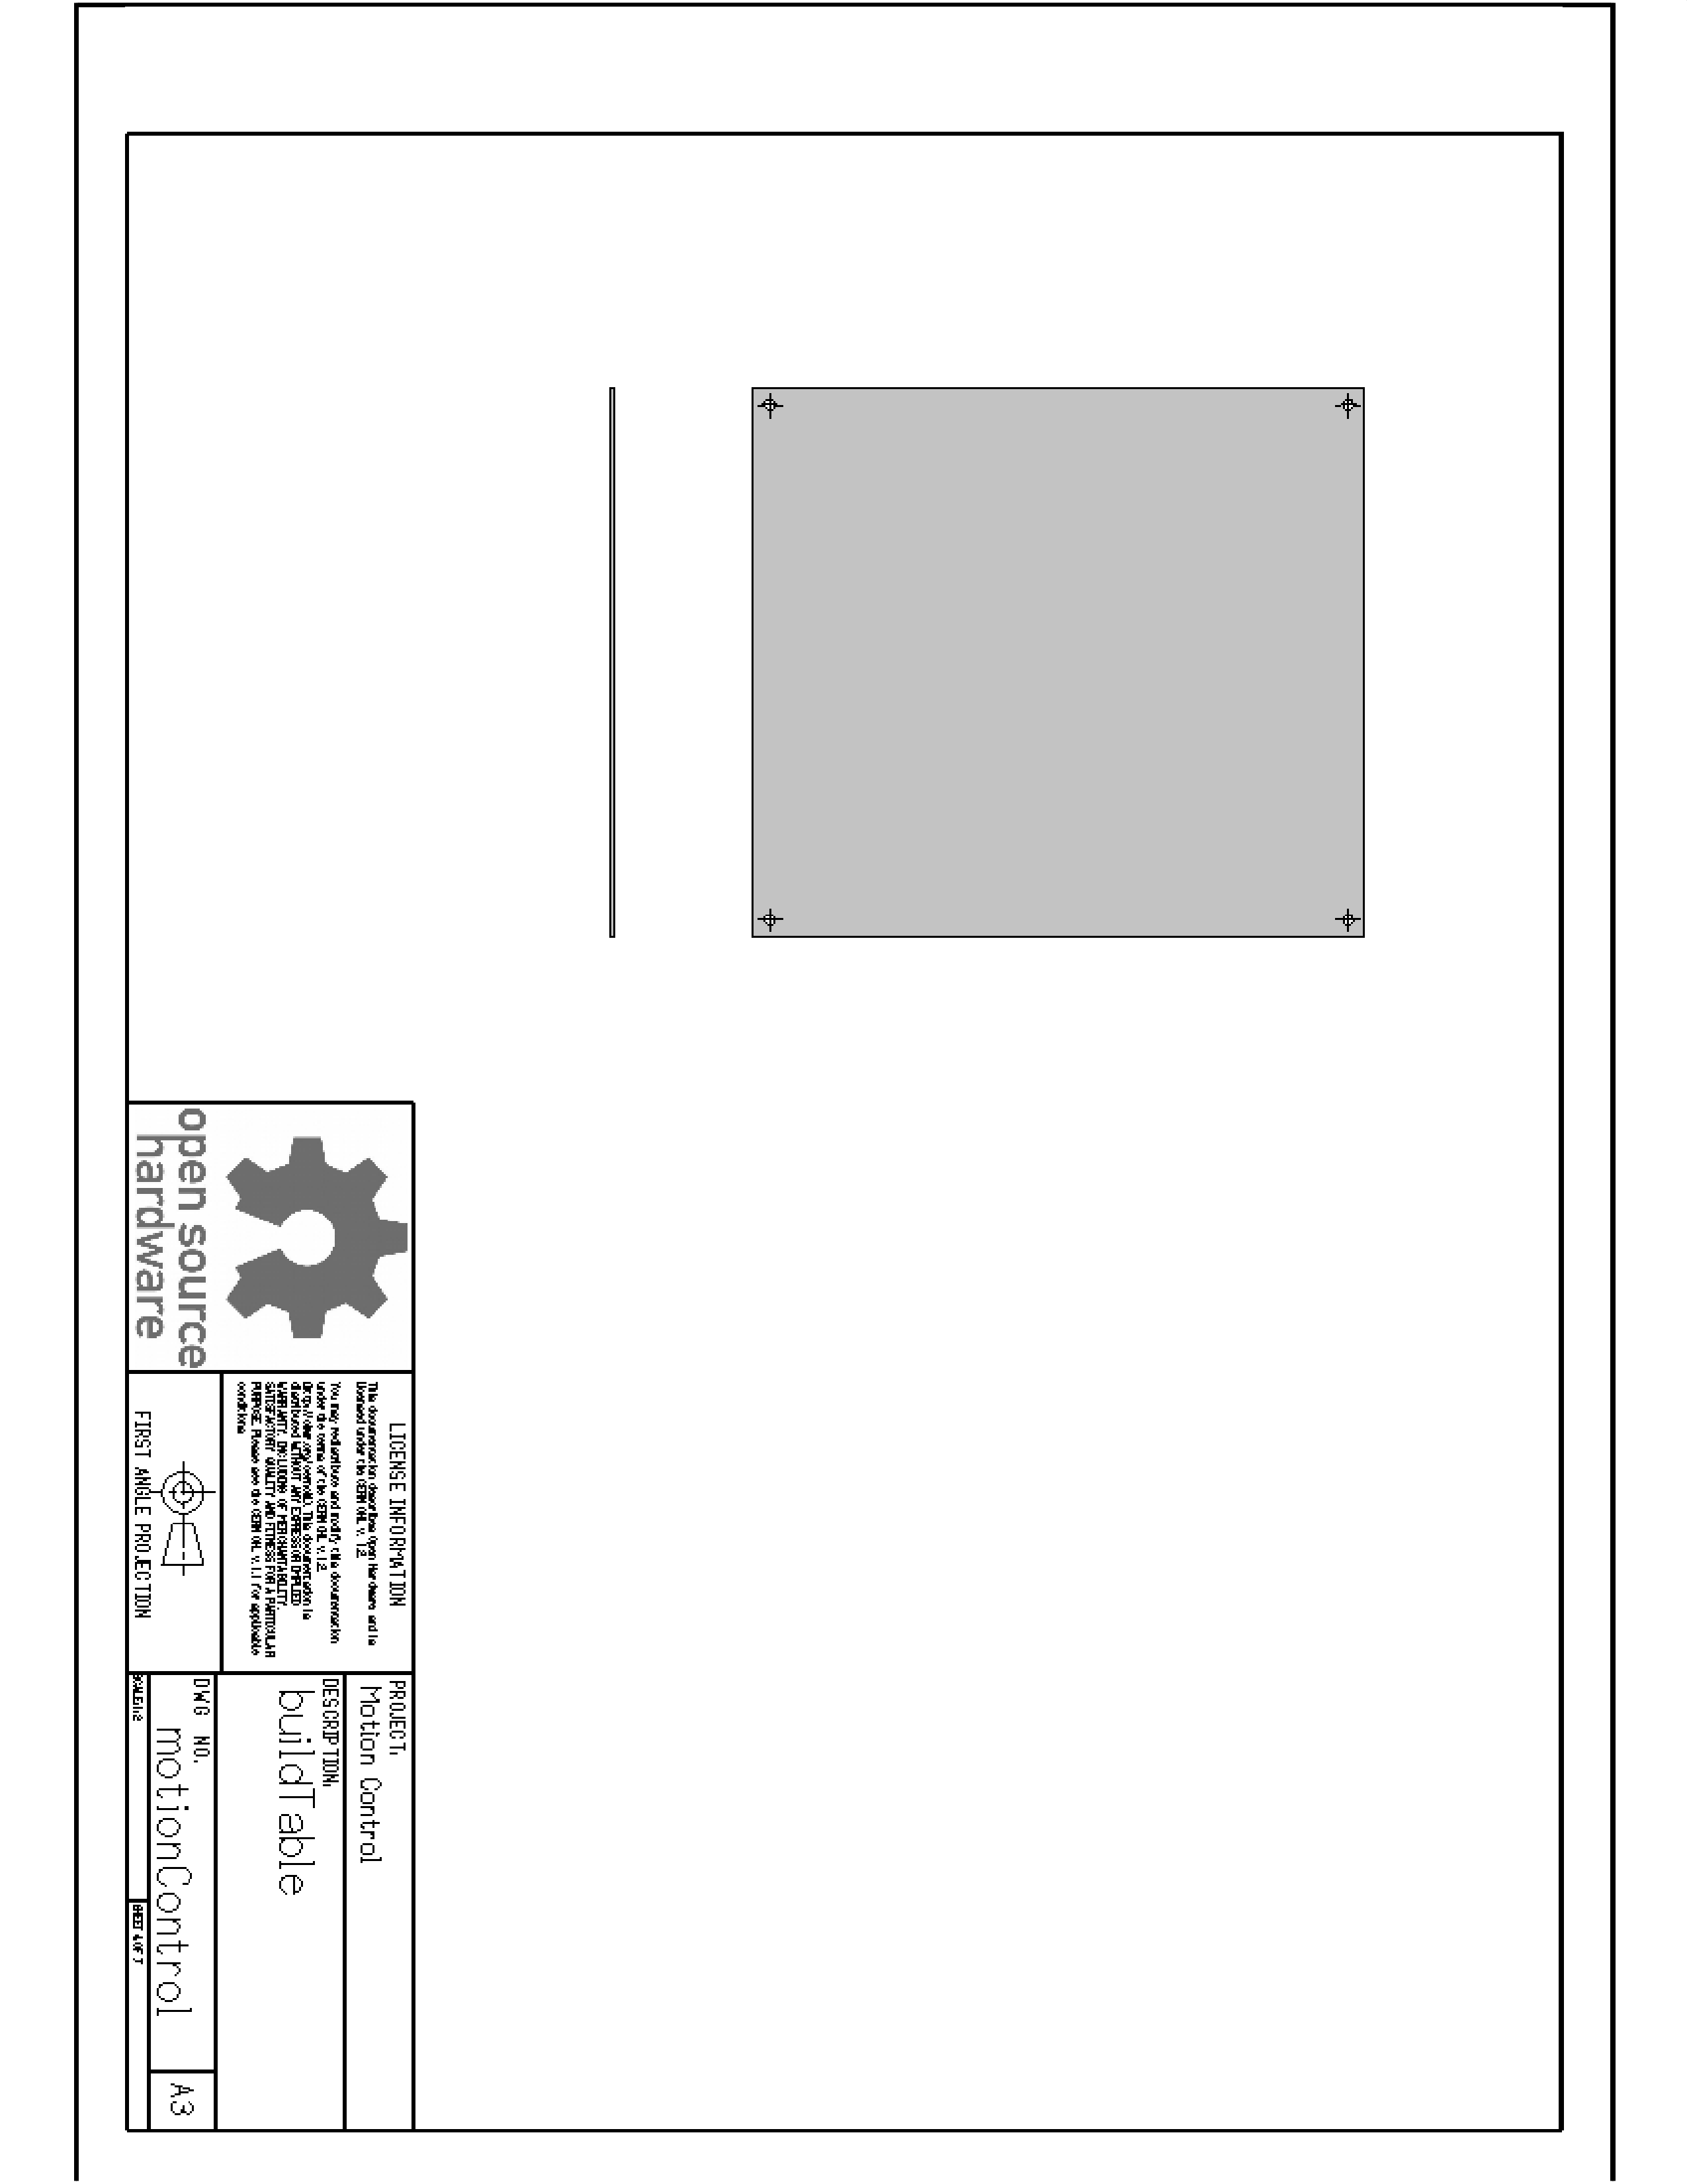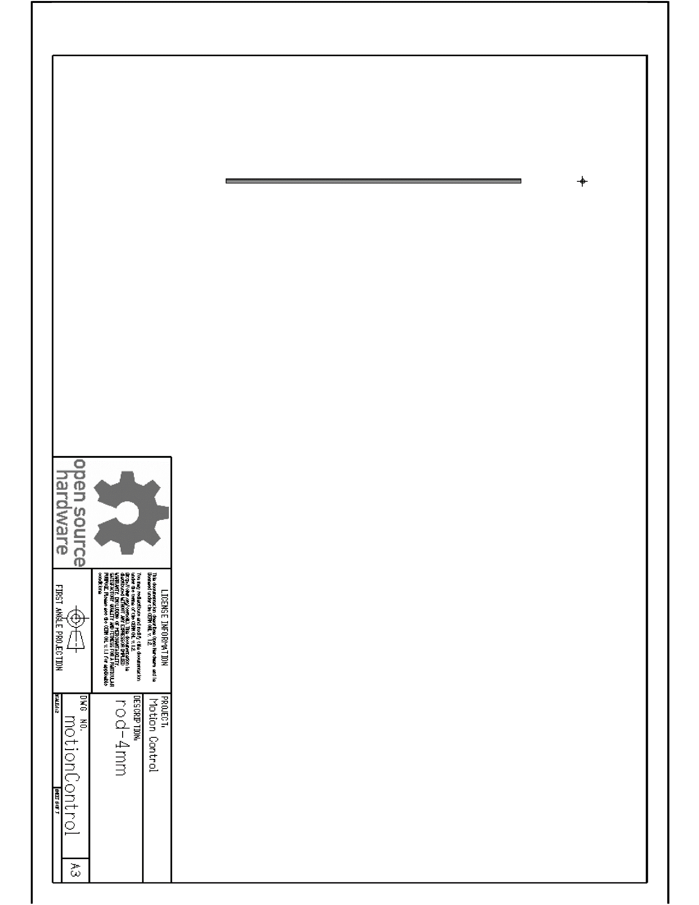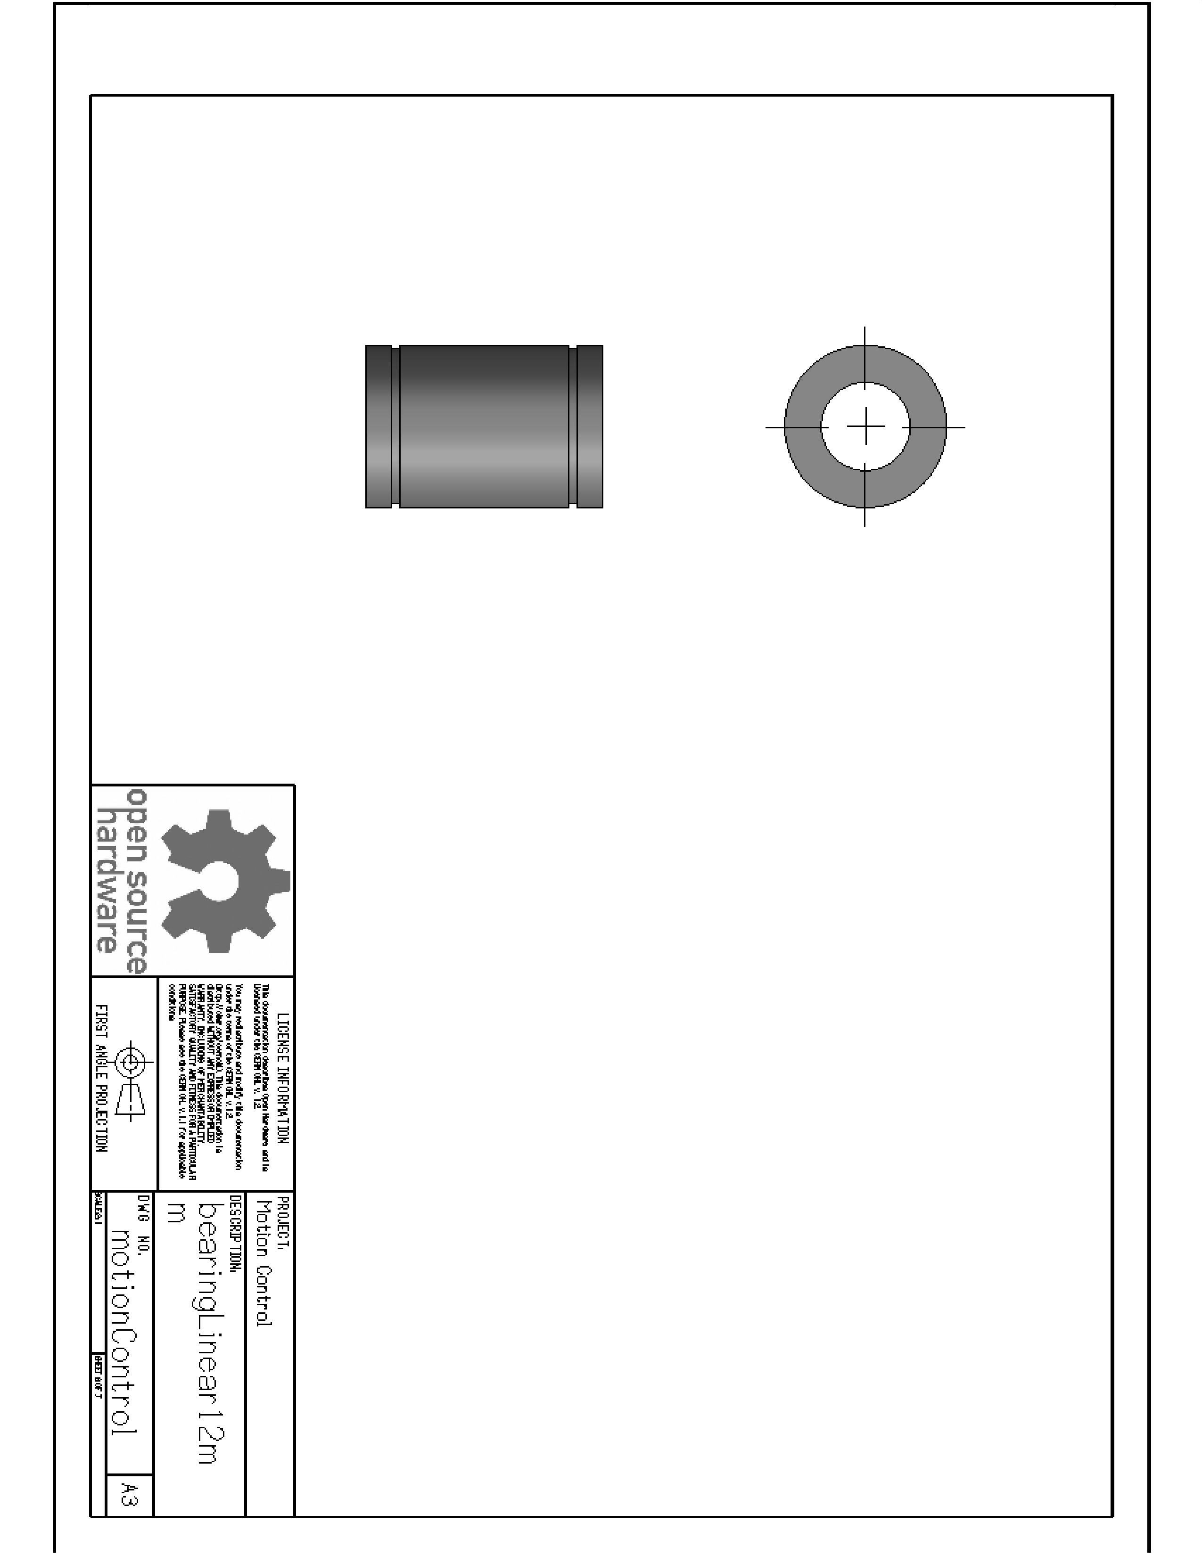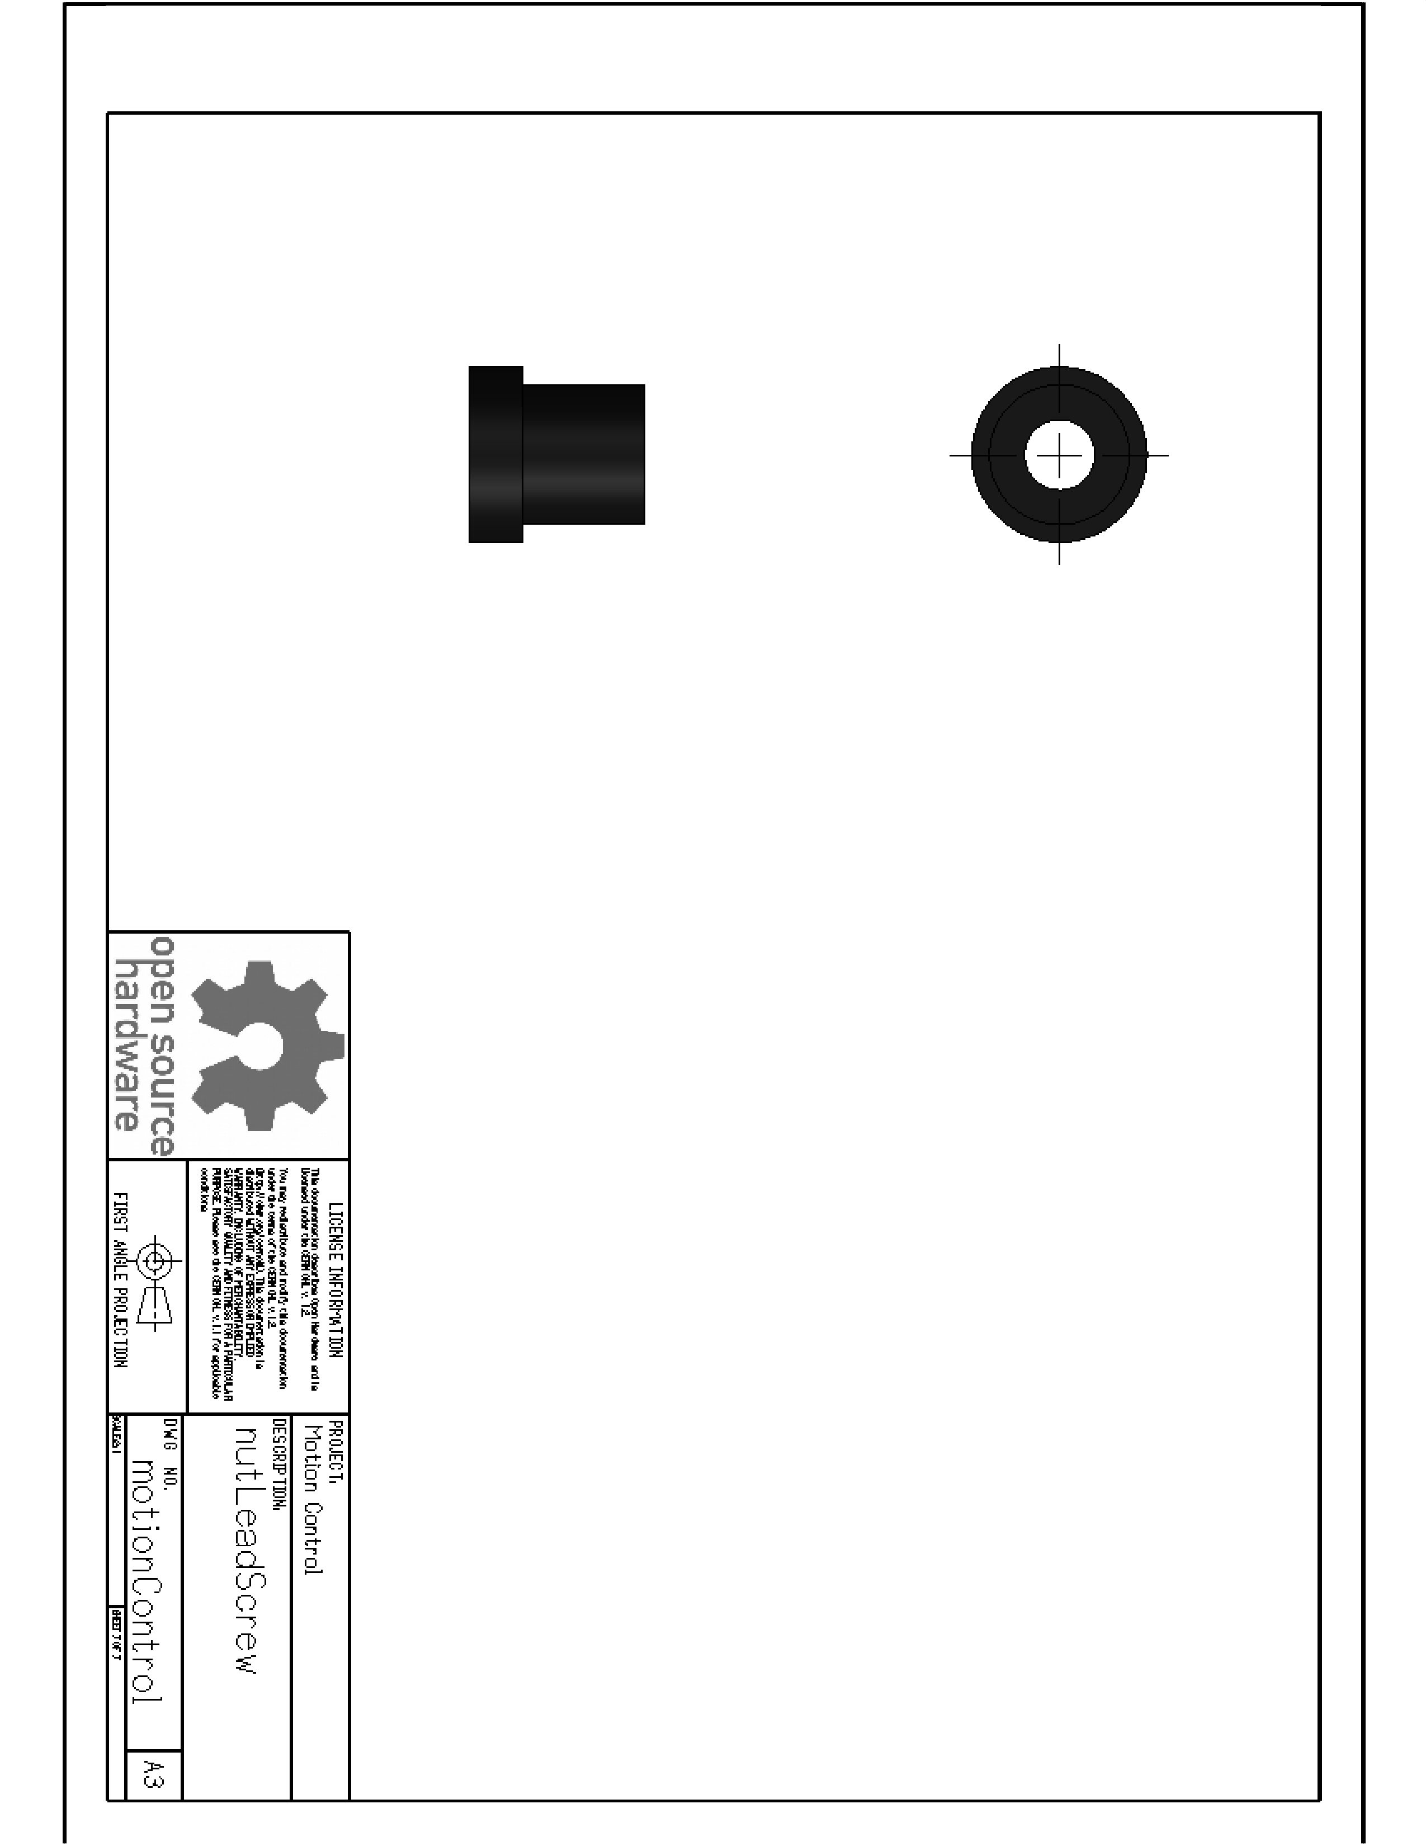

### Ribbed Vat

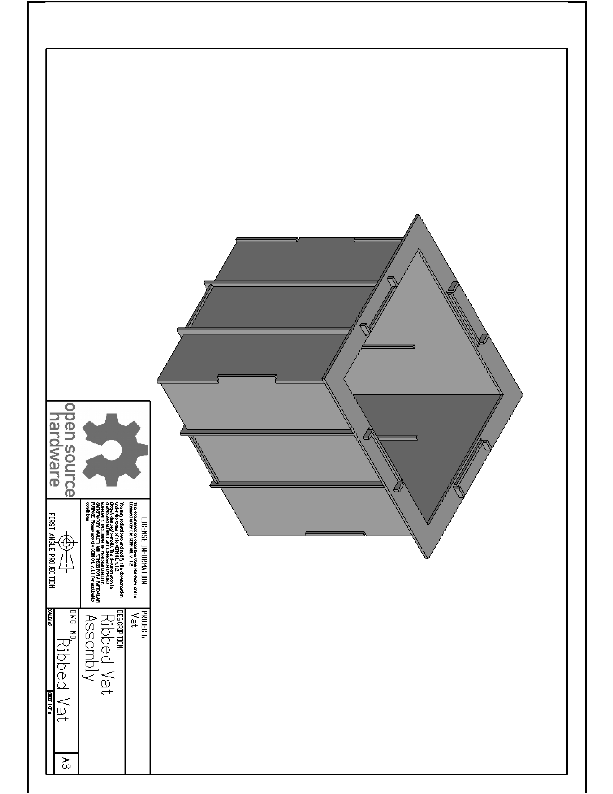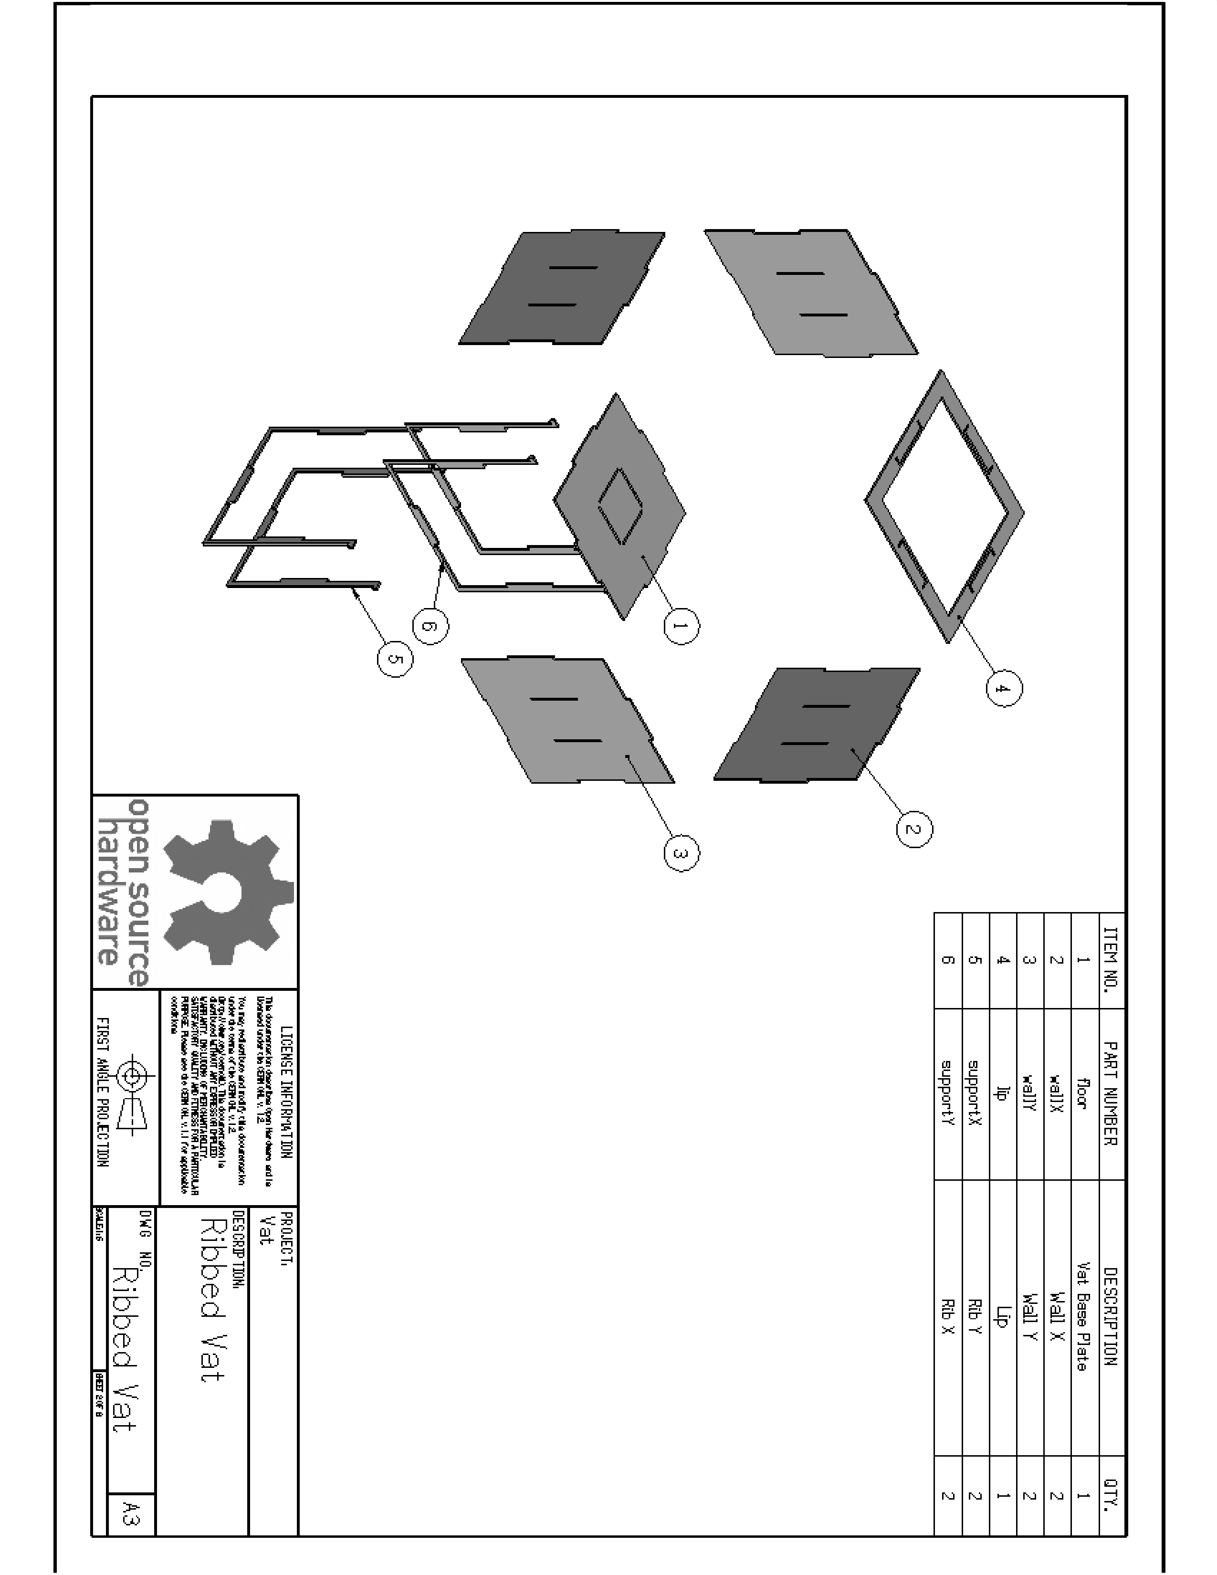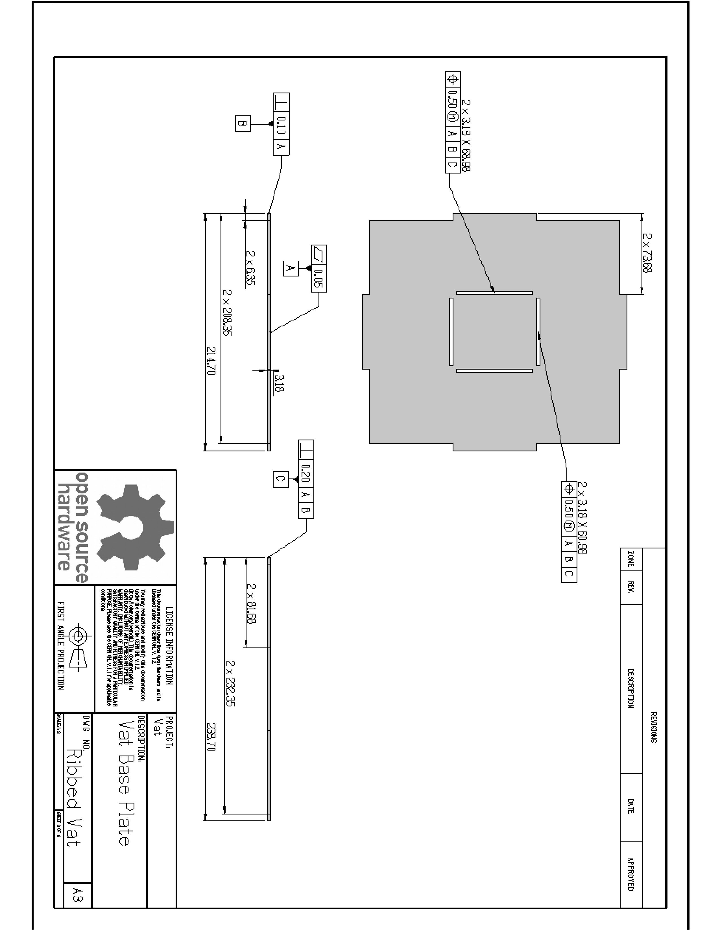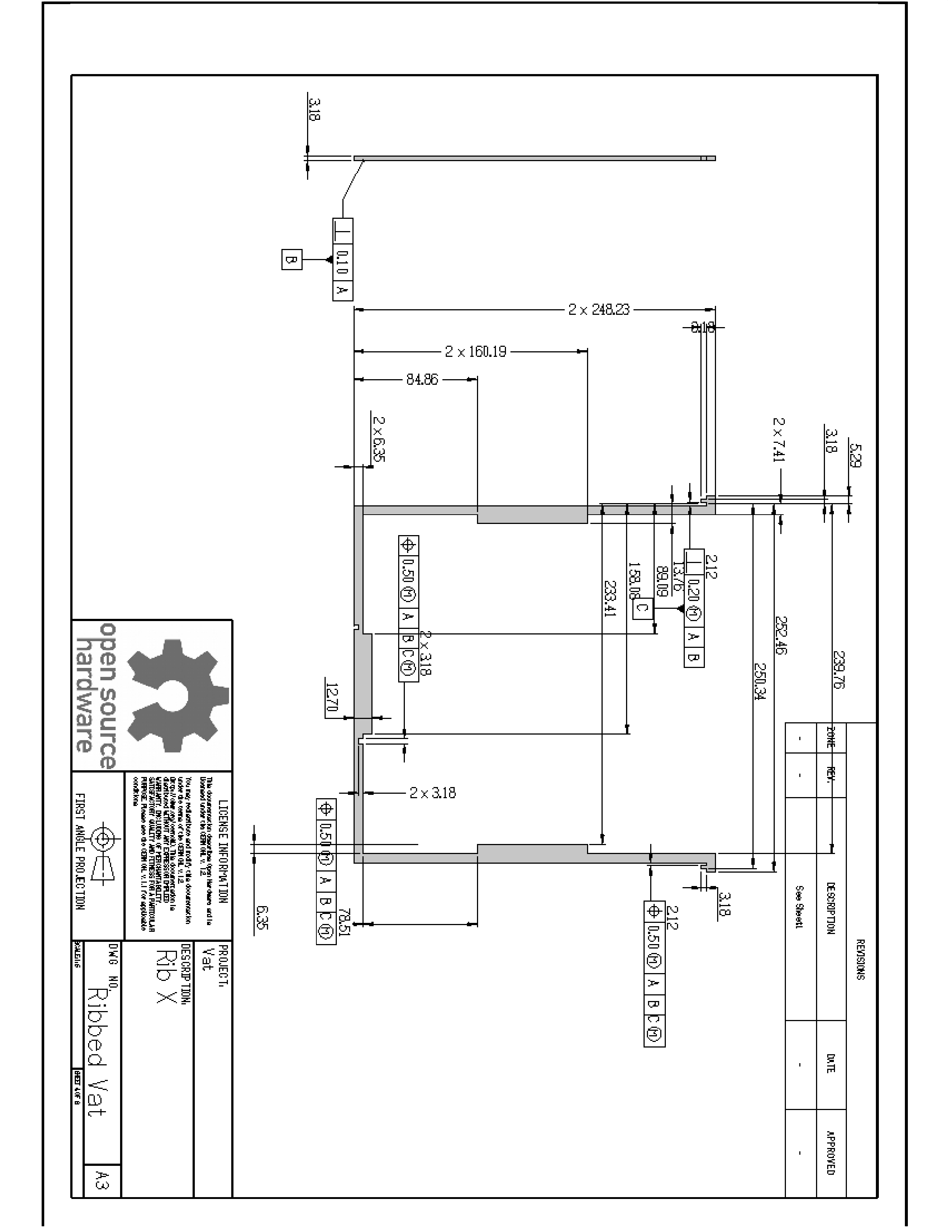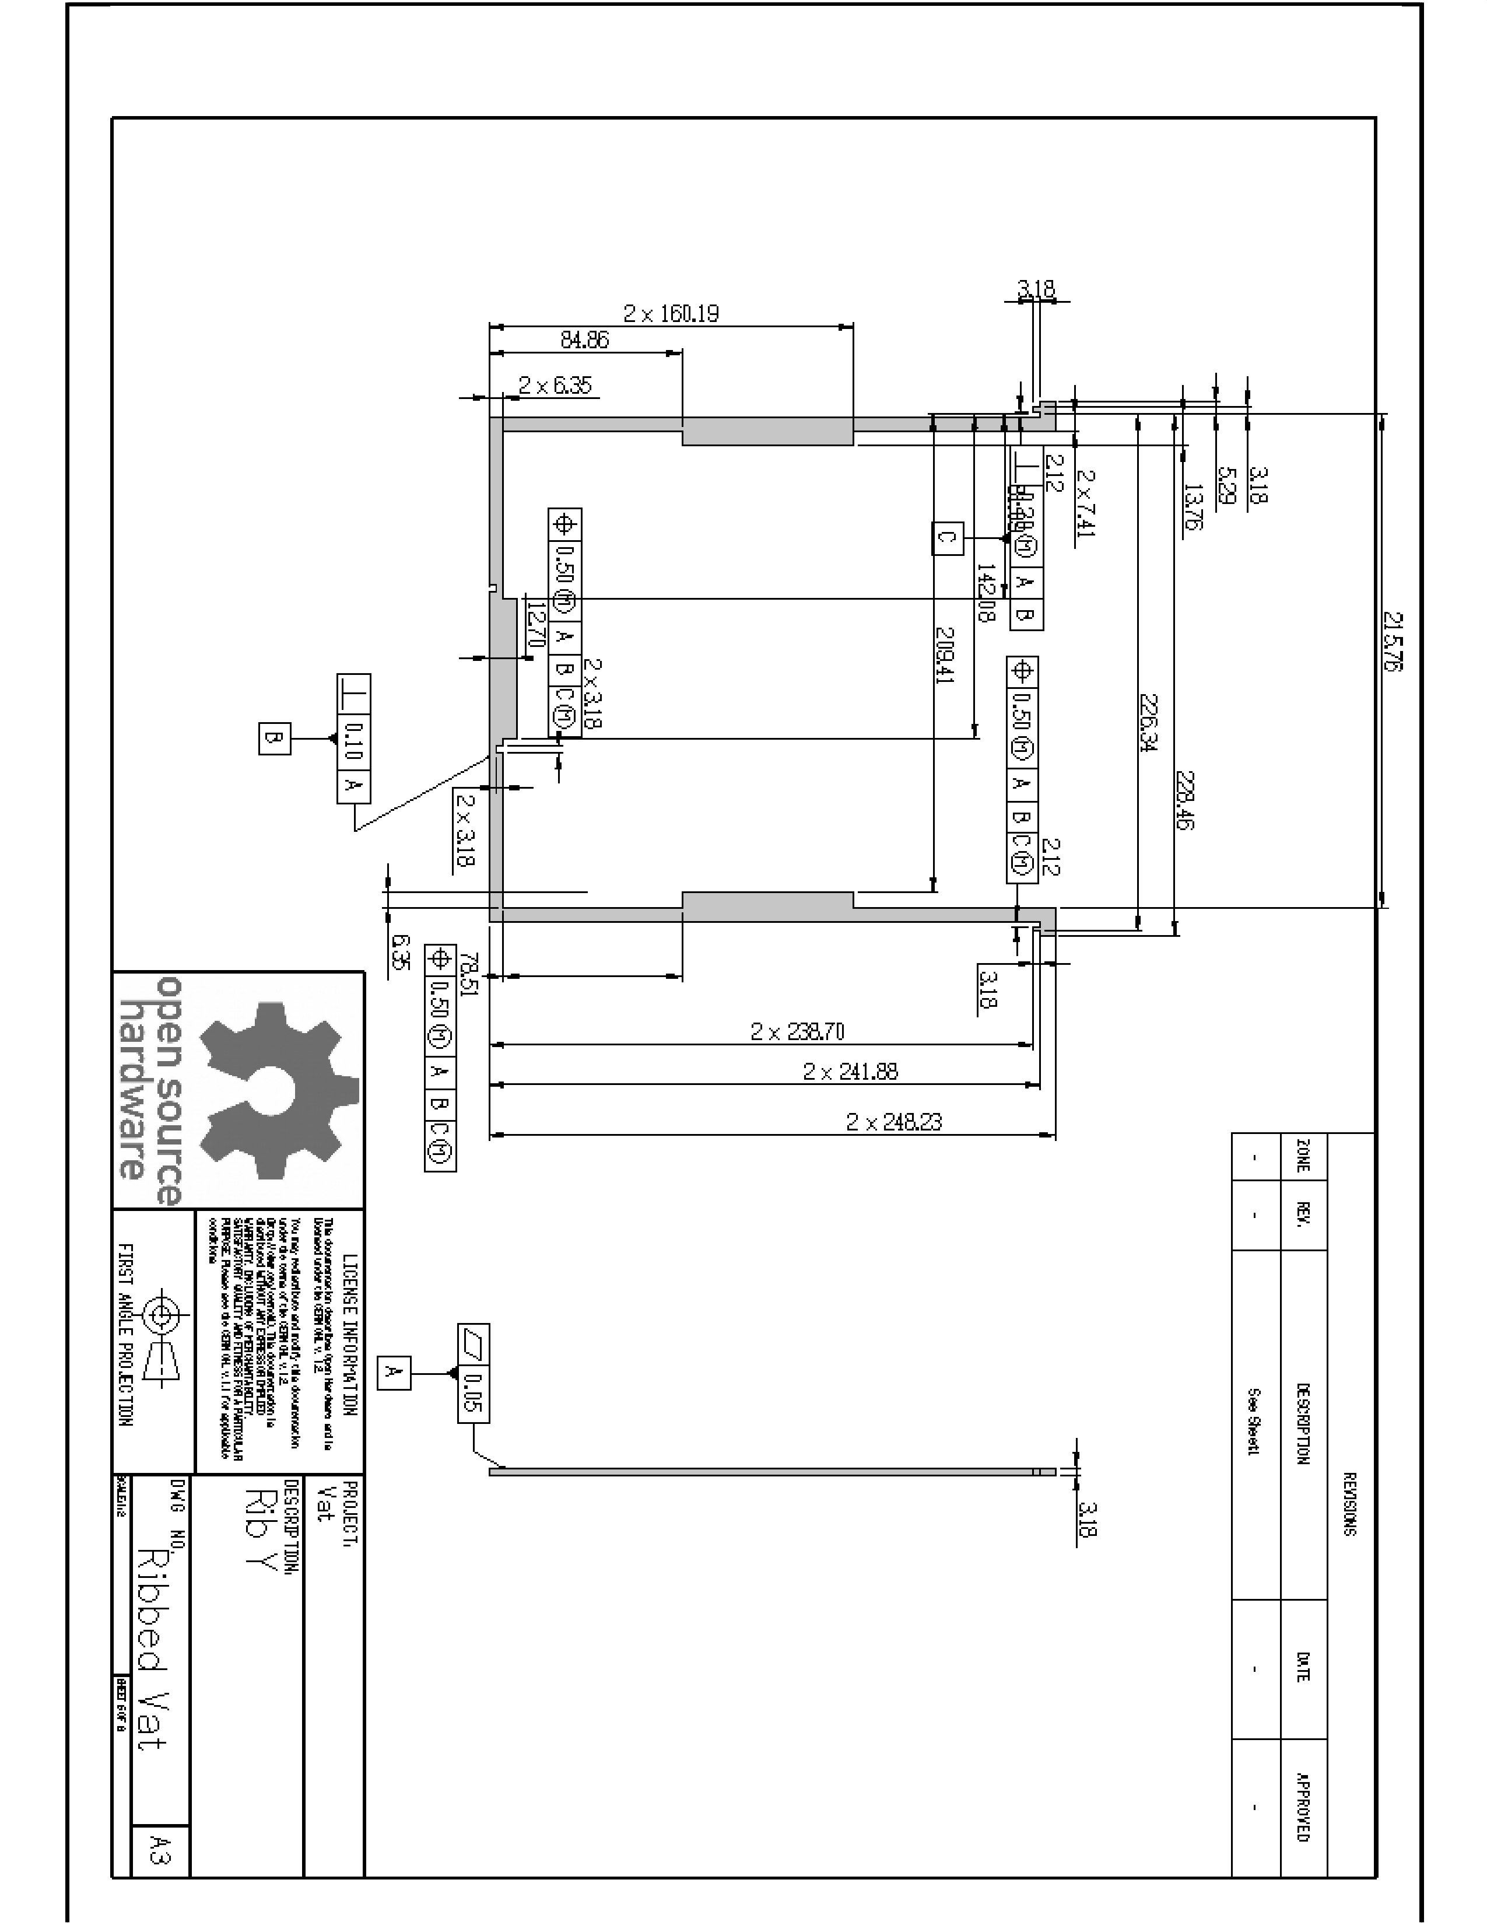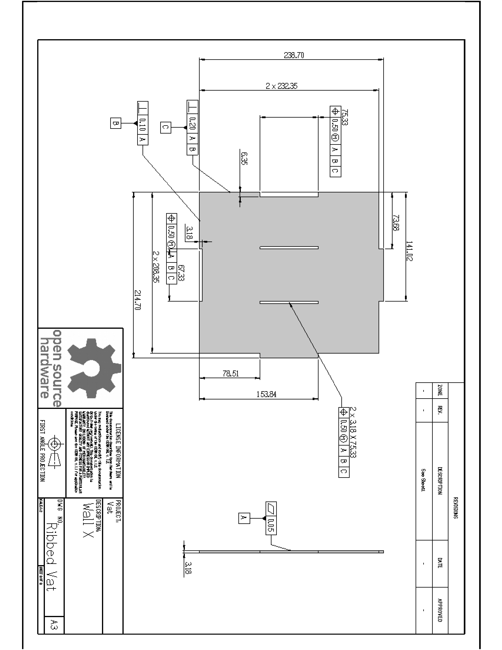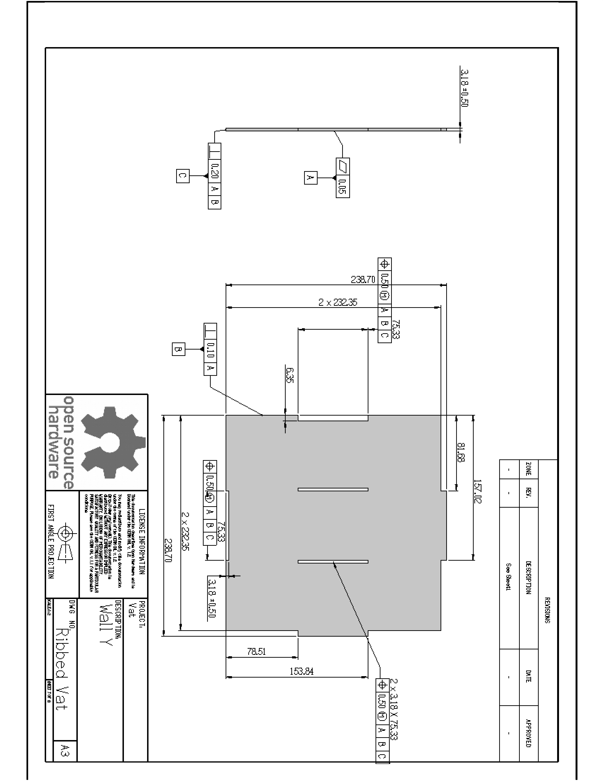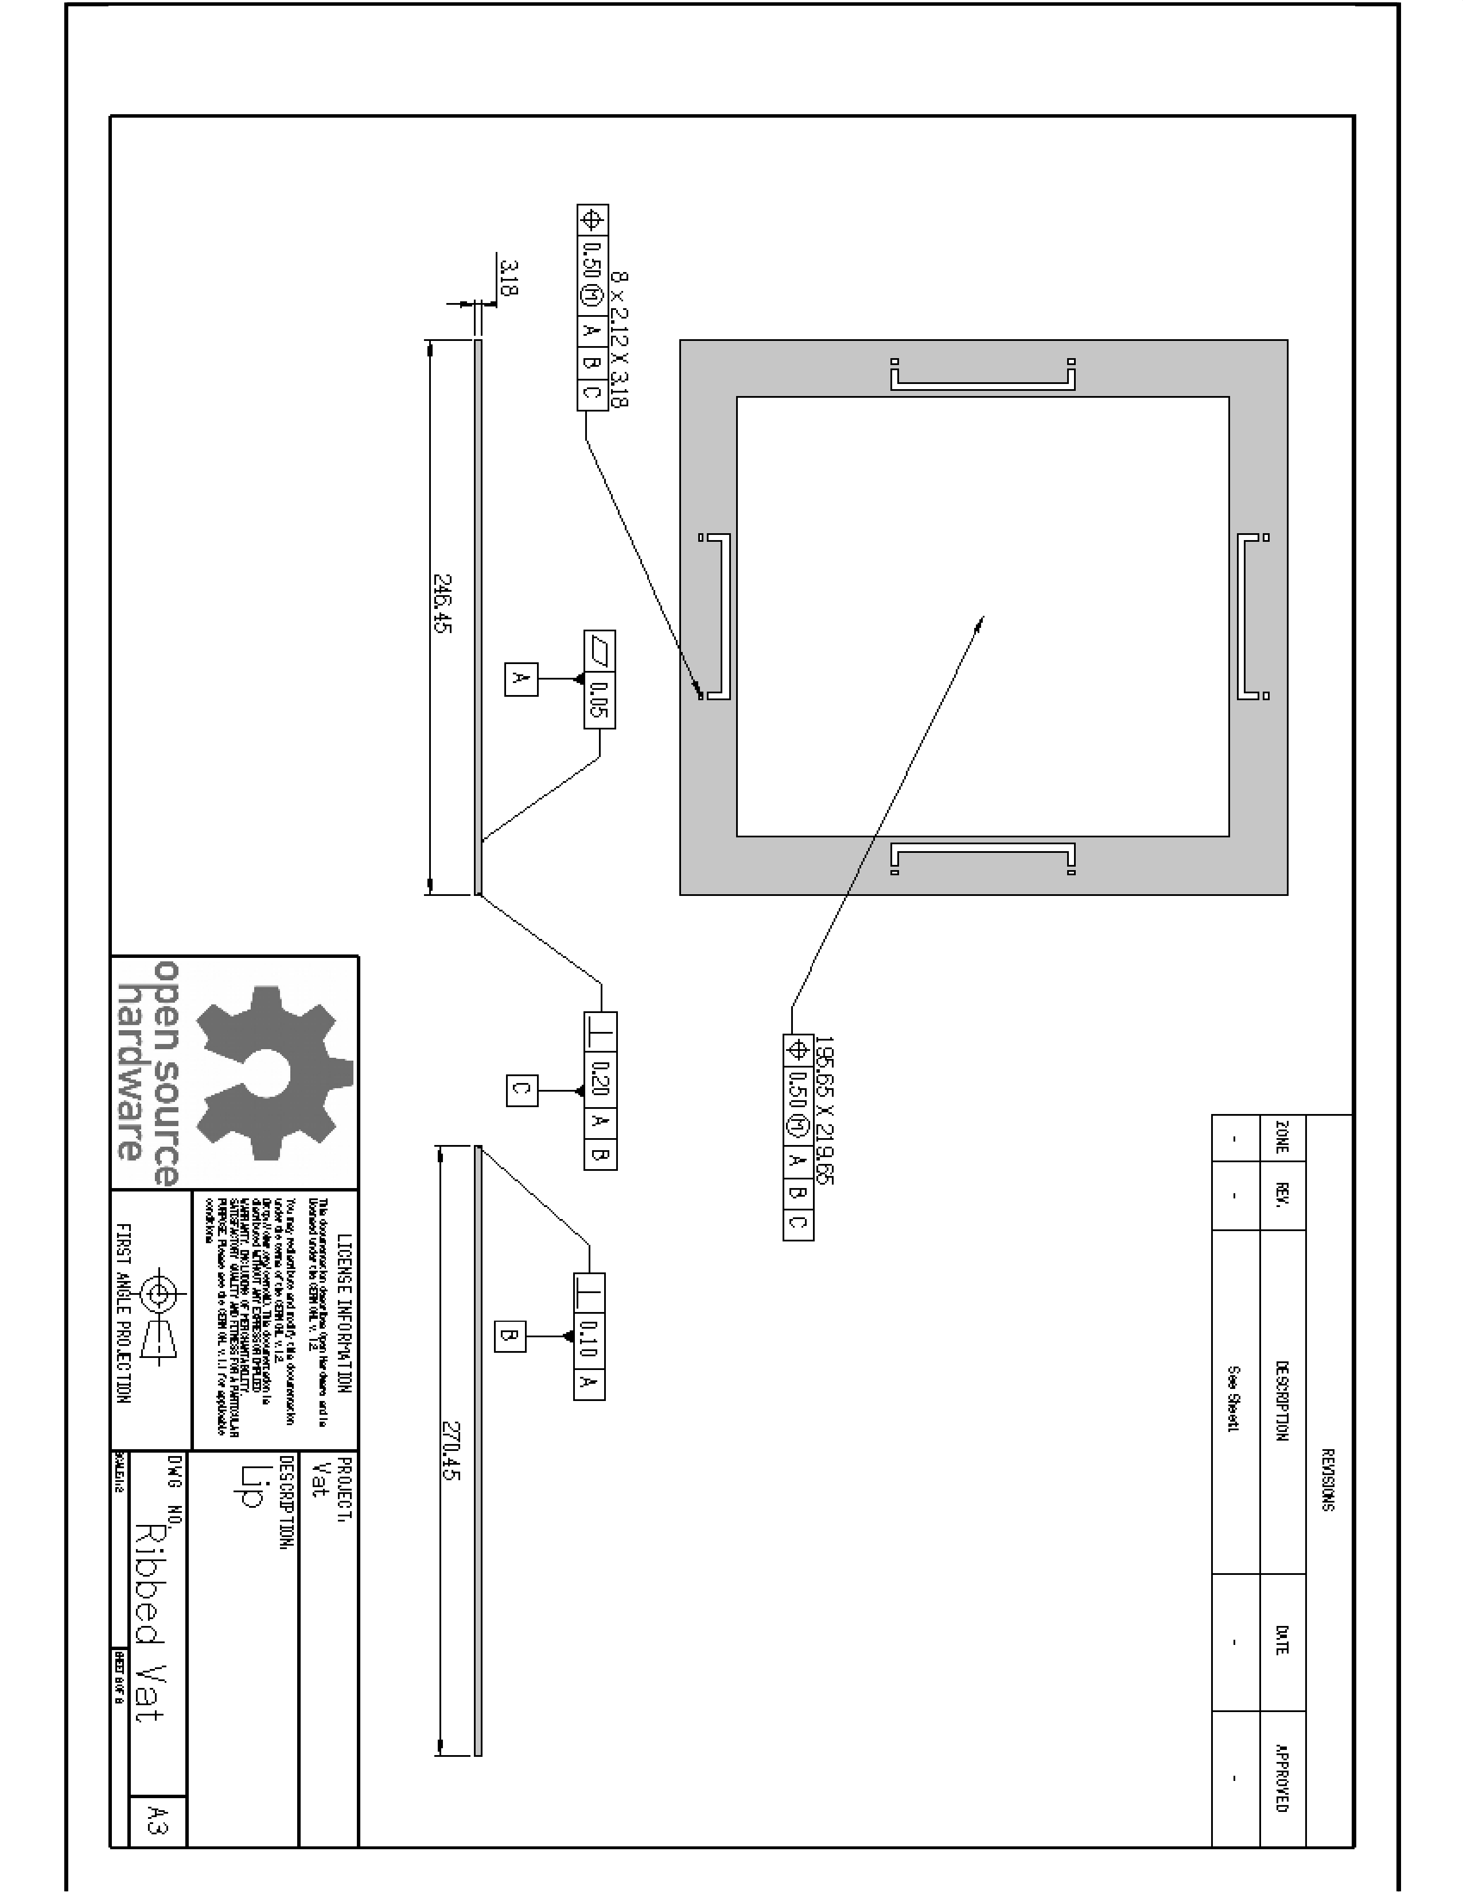

## MakerJuice G+ Safety Data Sheet

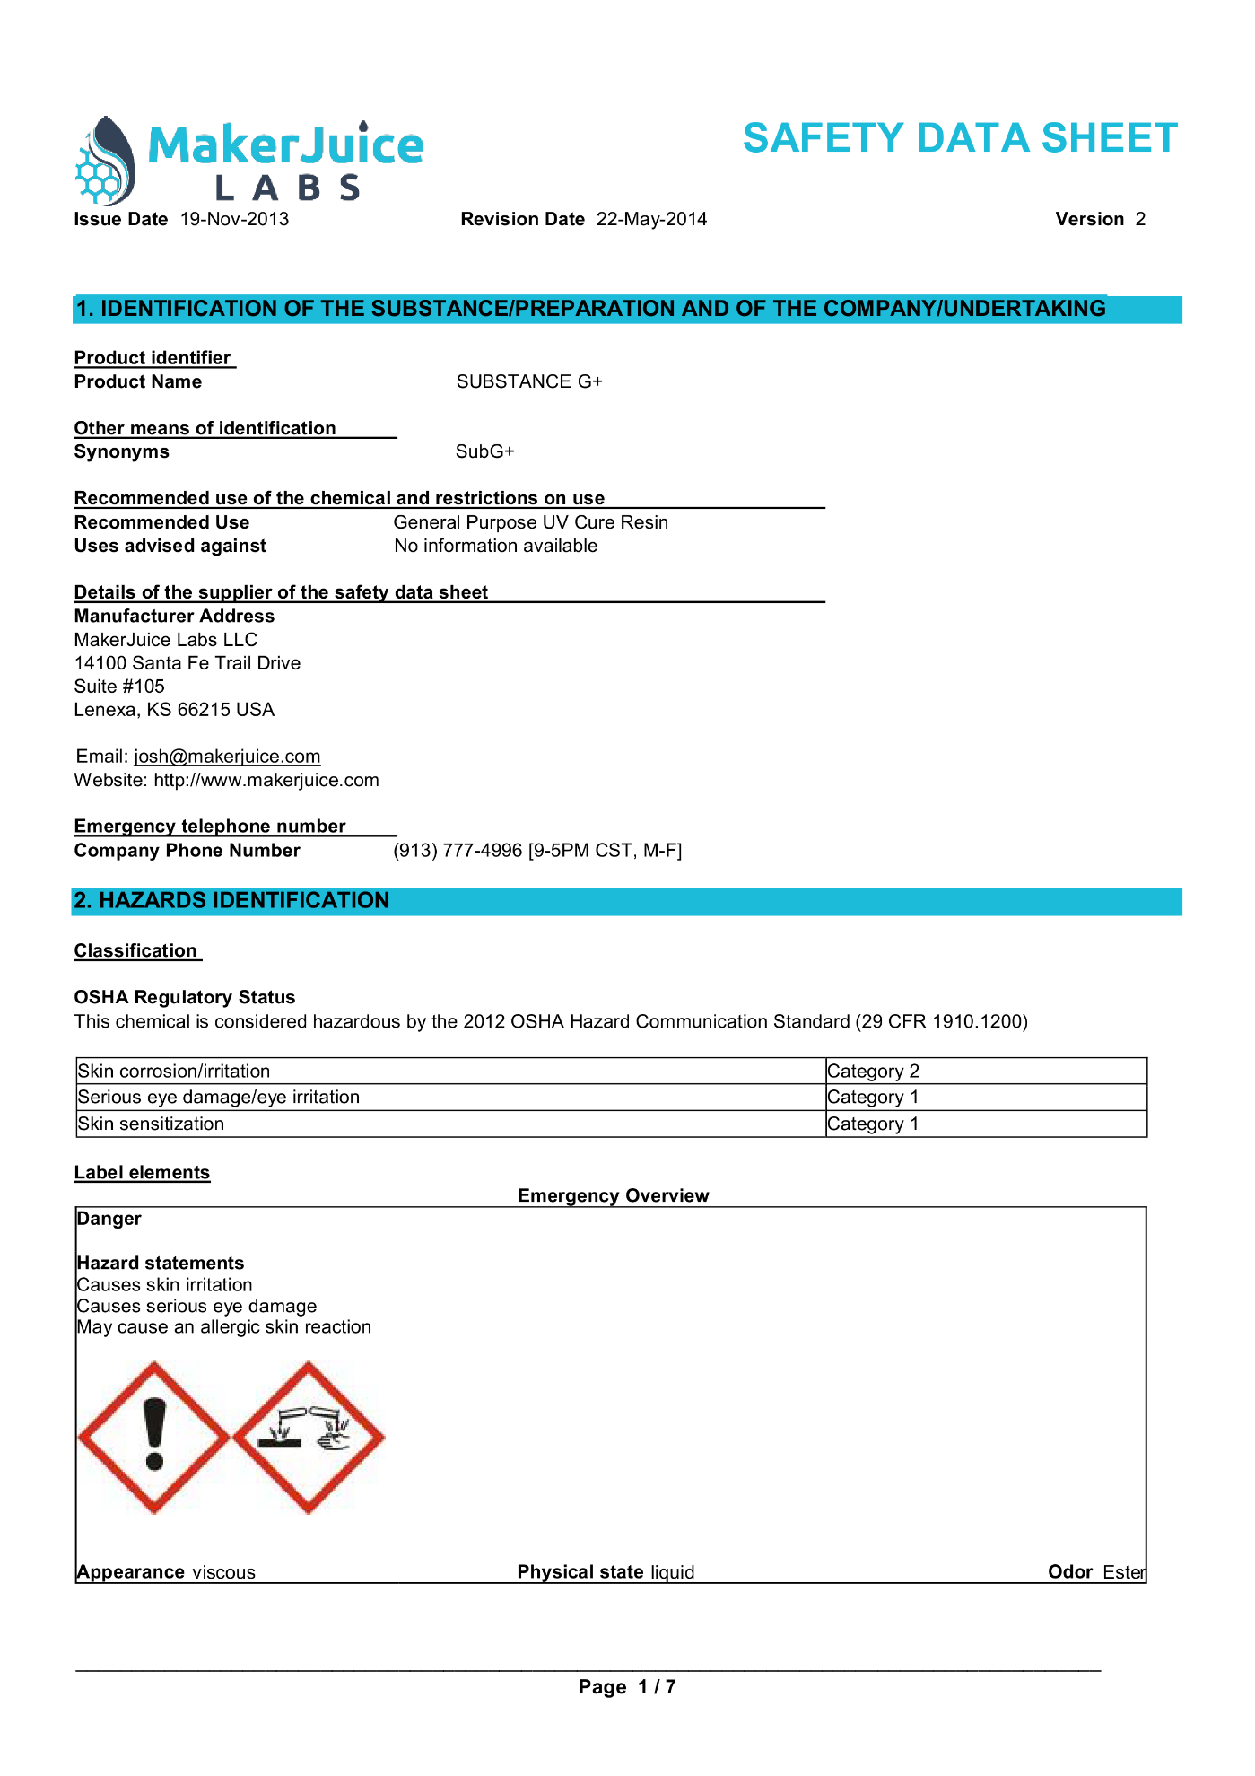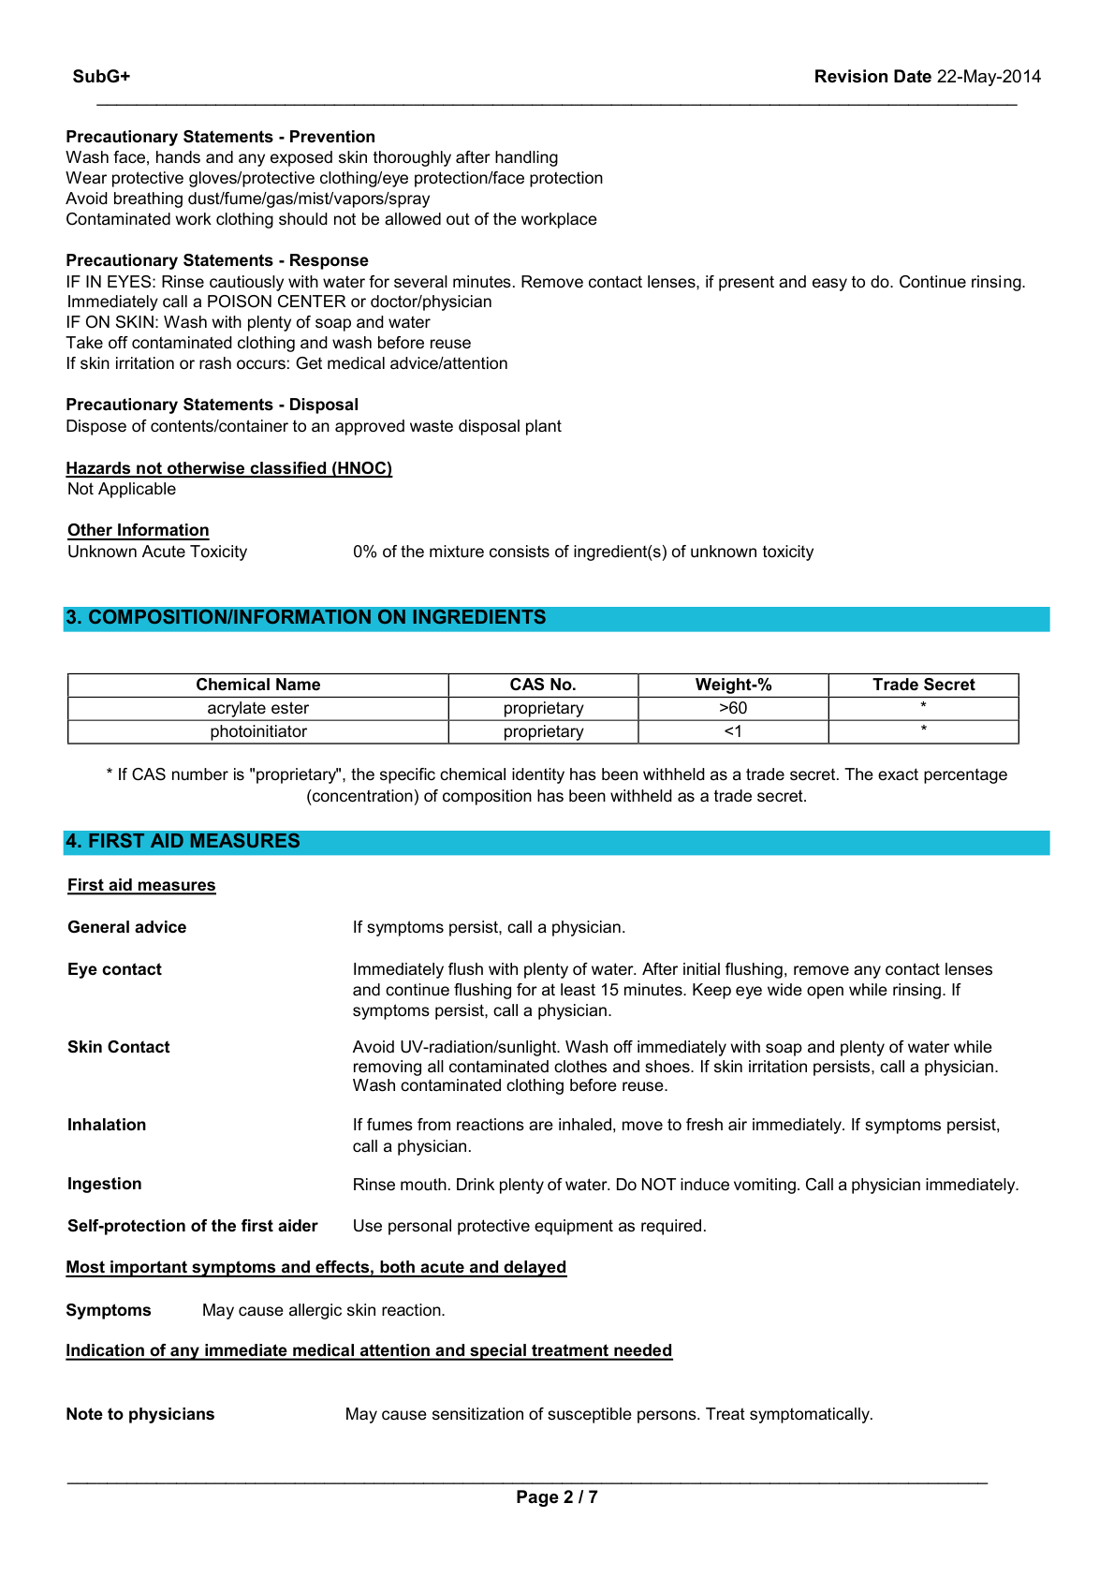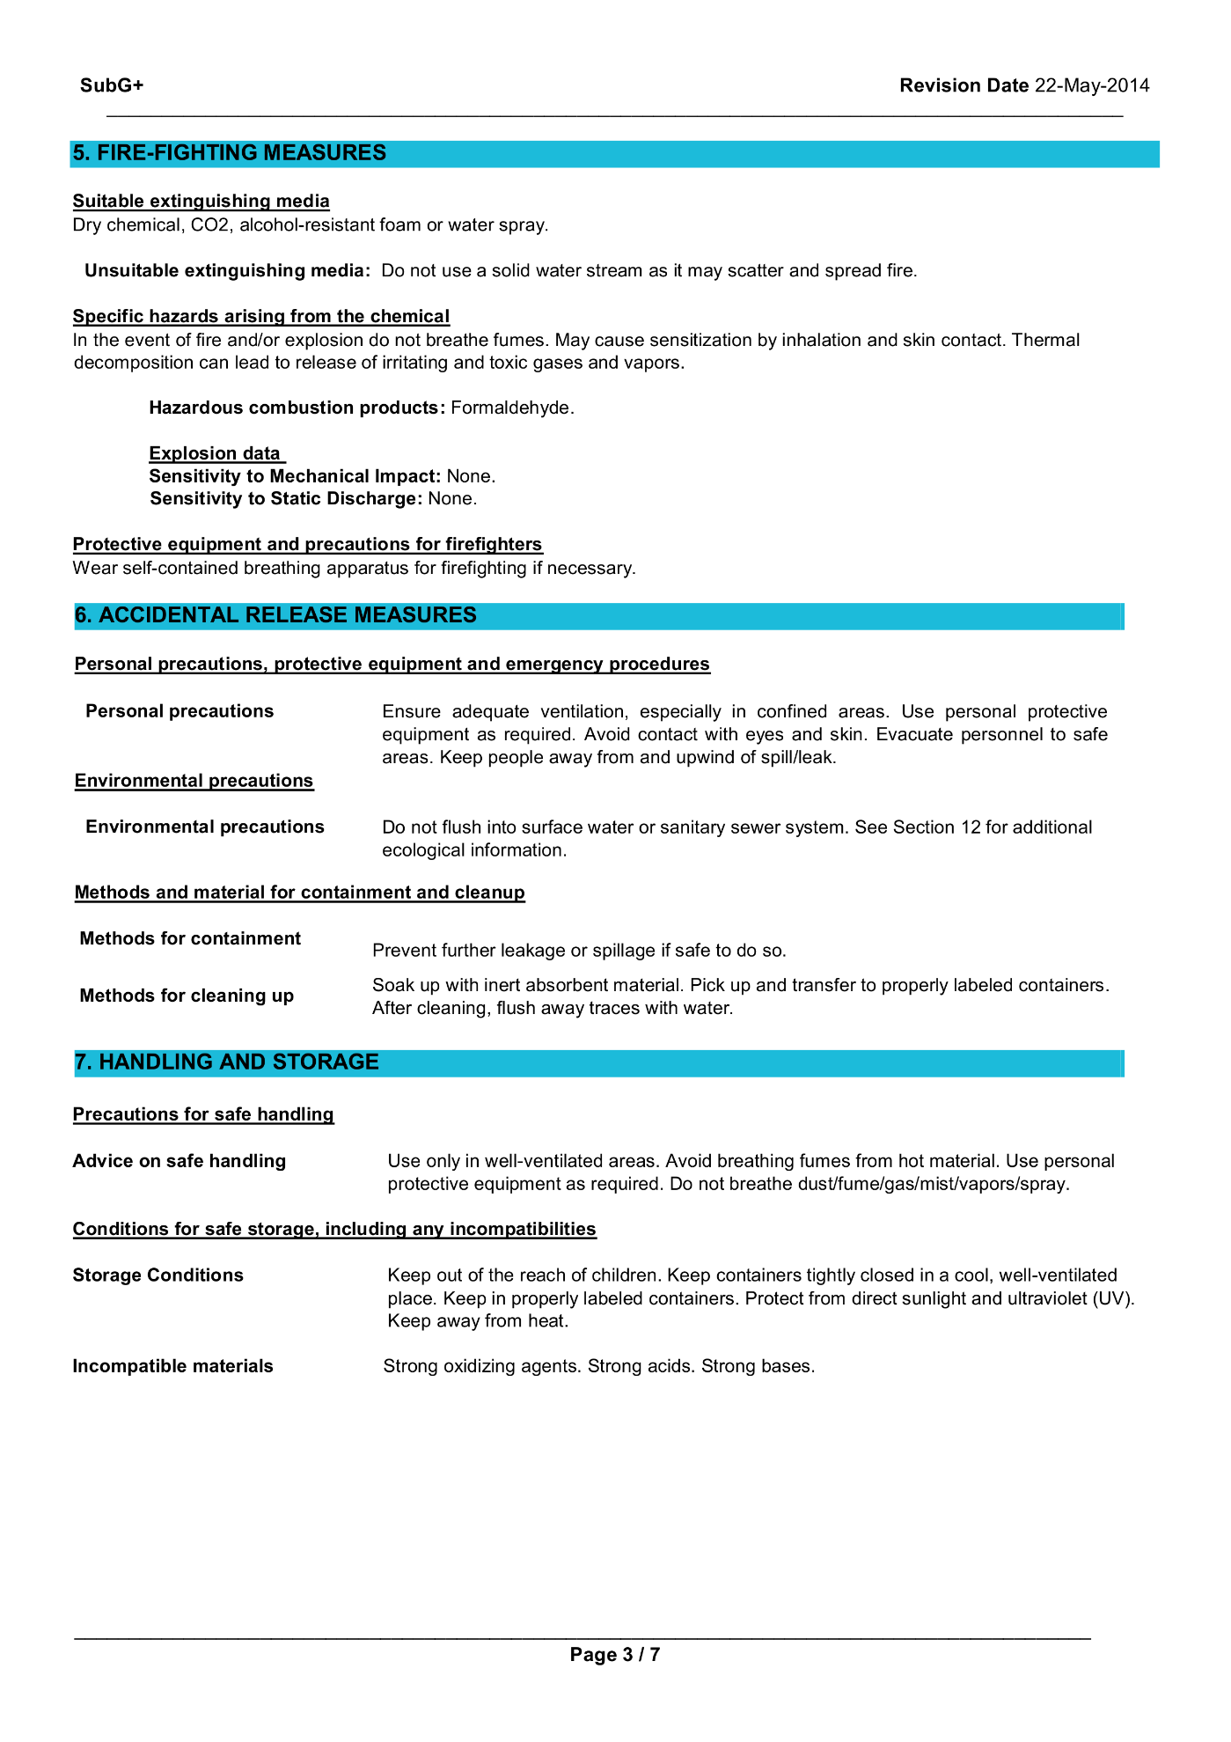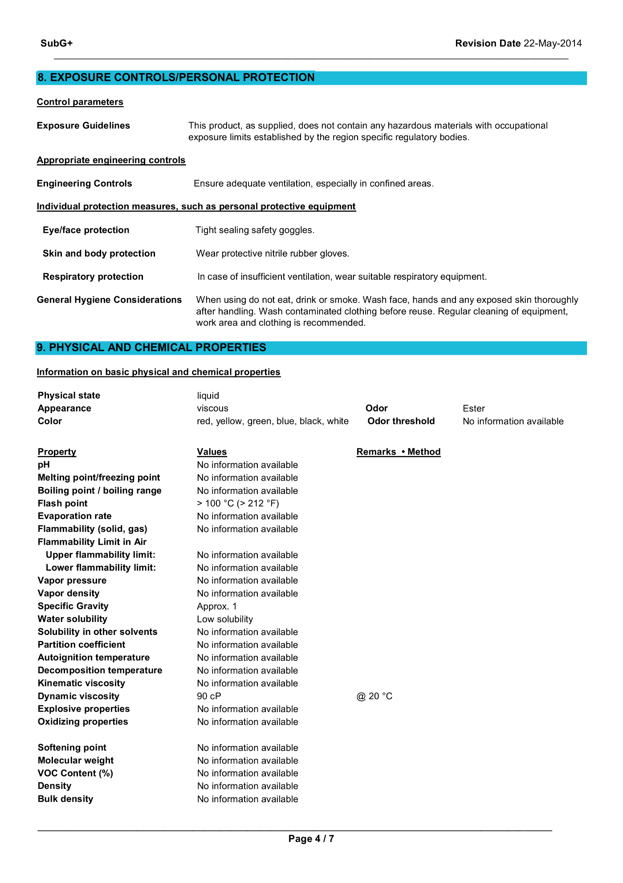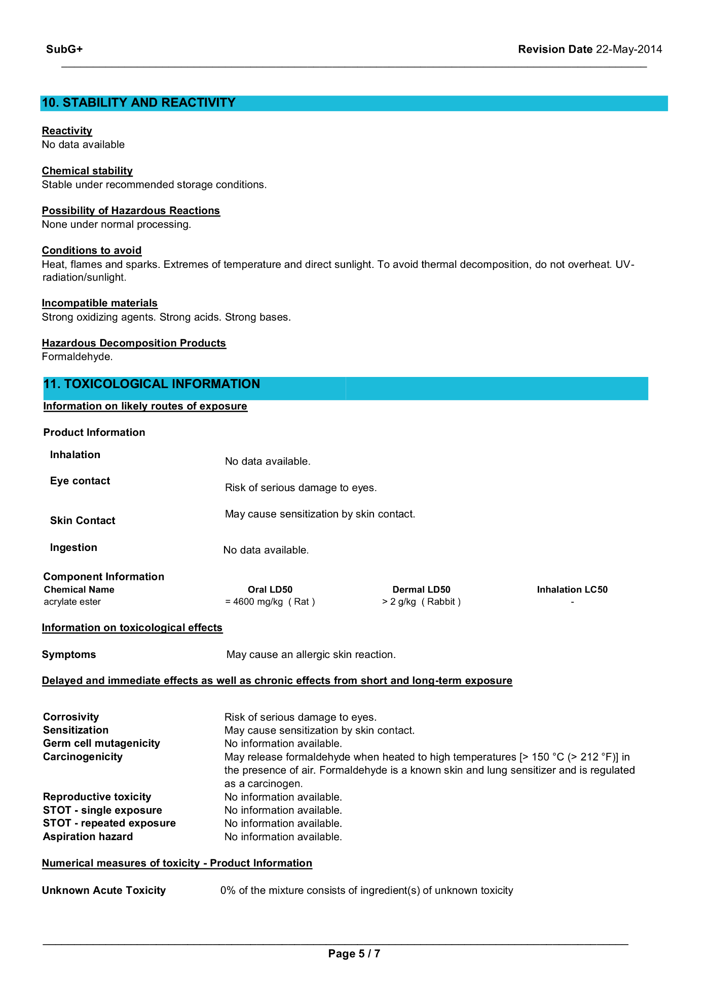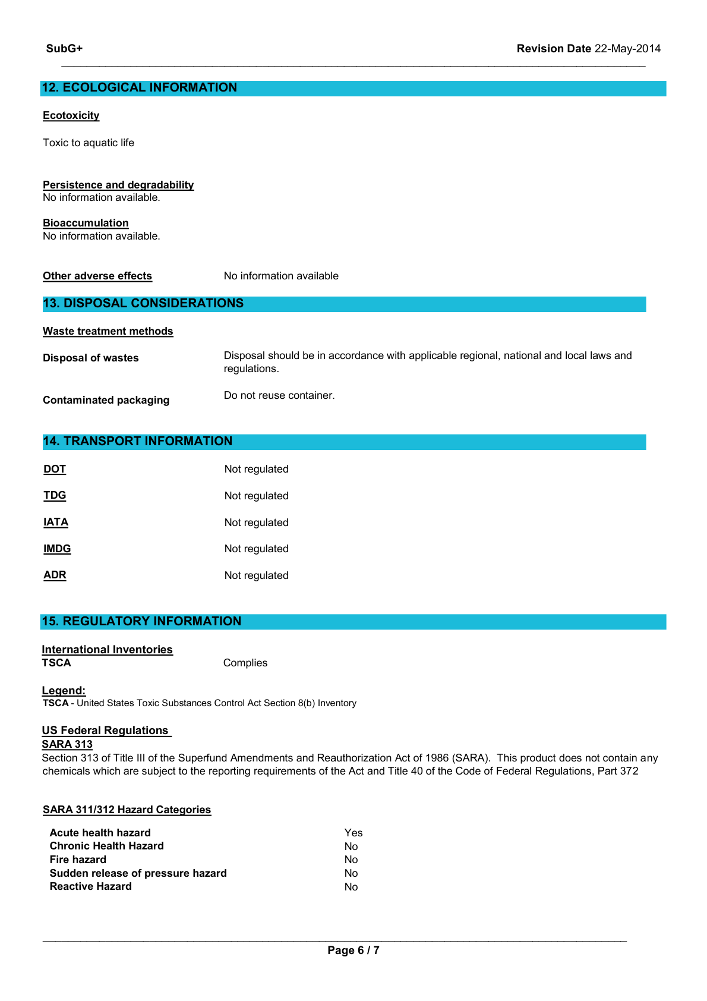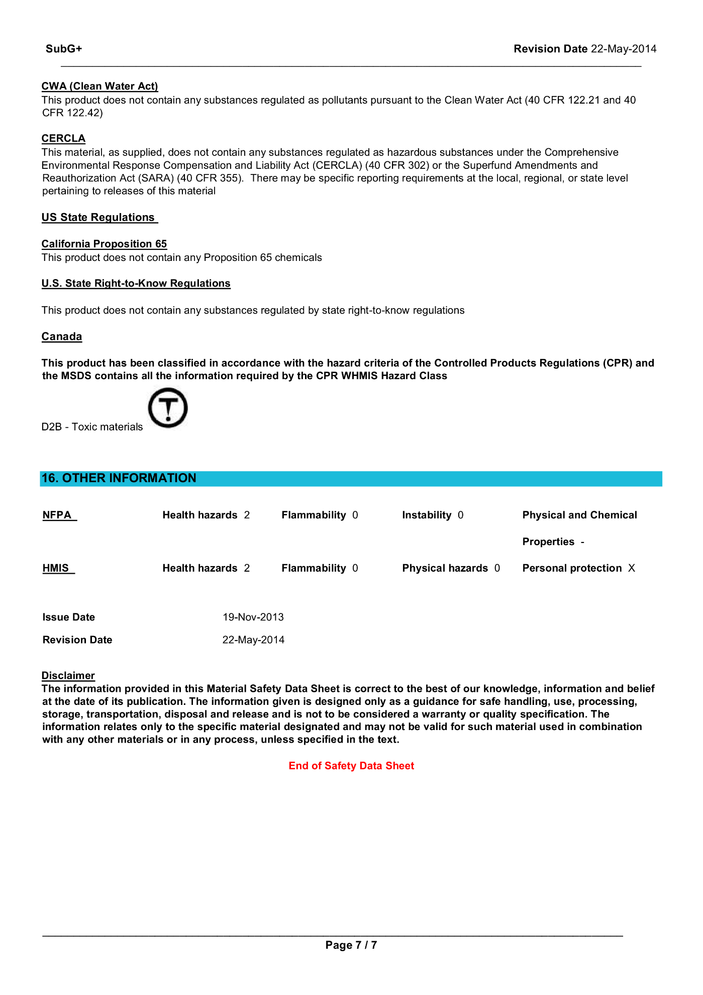

## MakerJuice G+ Techincal Data Sheet

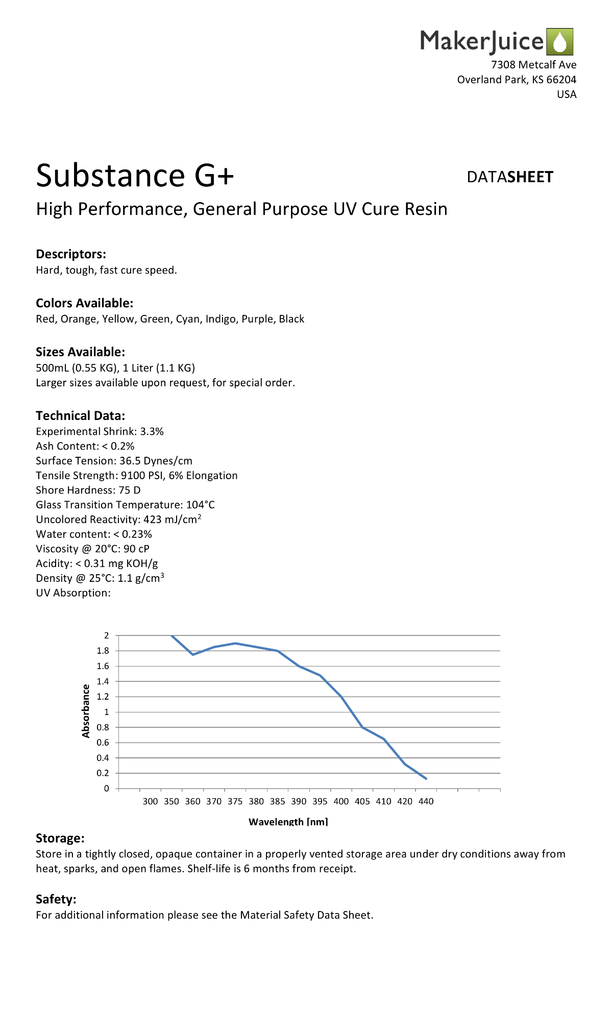

## Website (GitHub Pages)

### Home Page

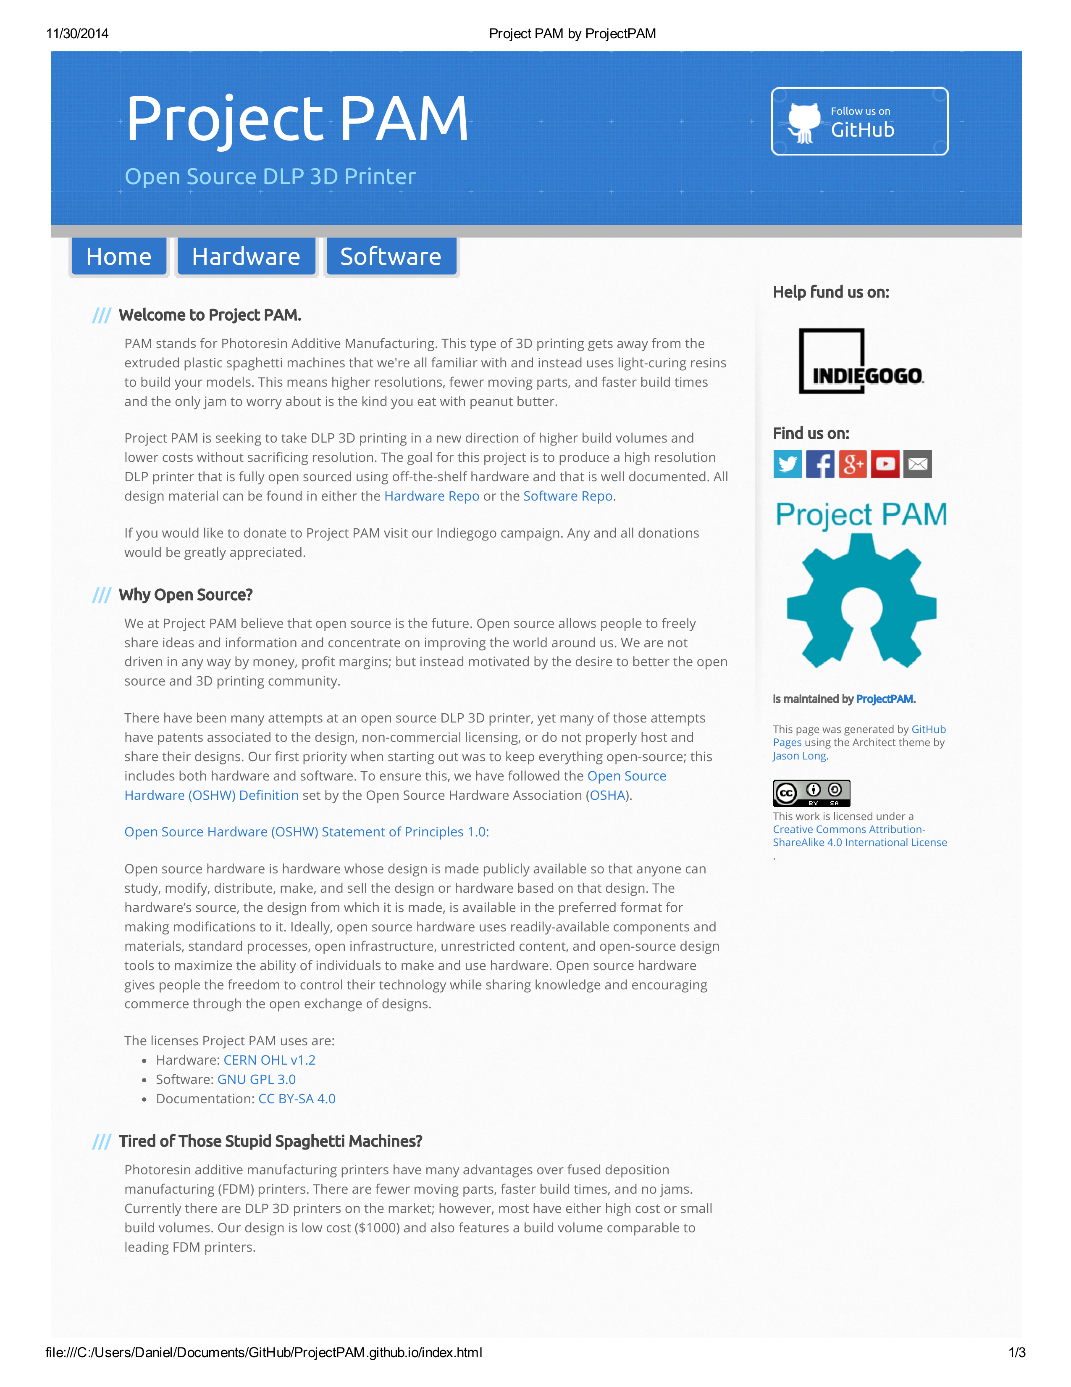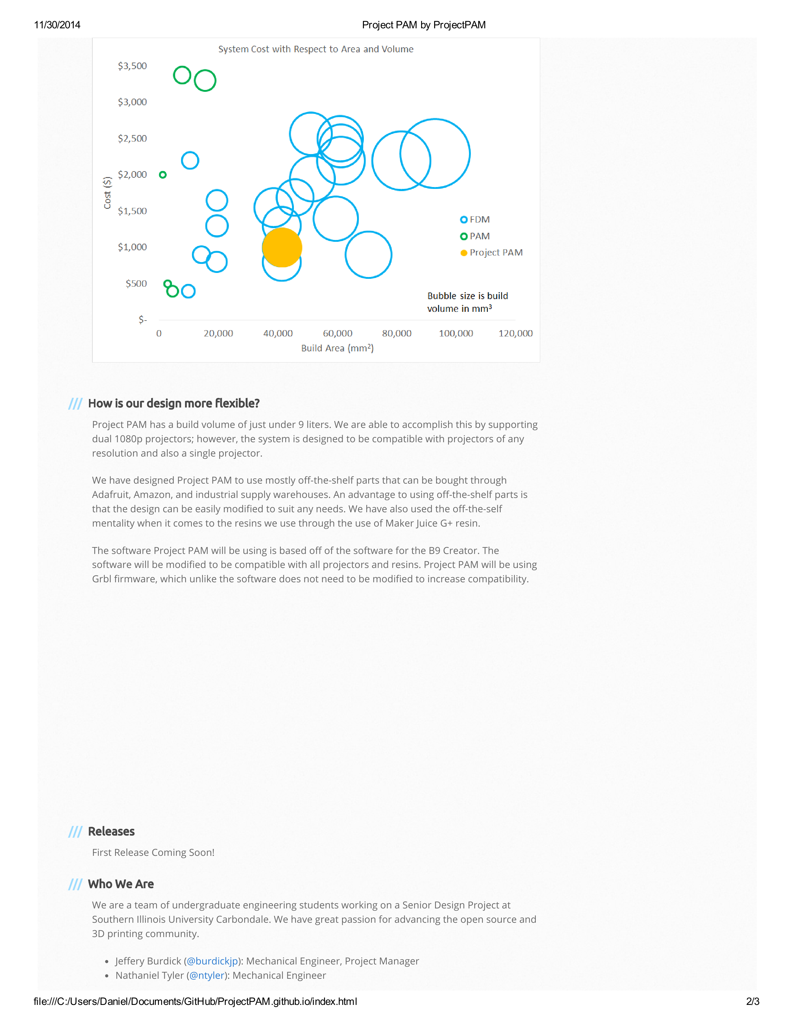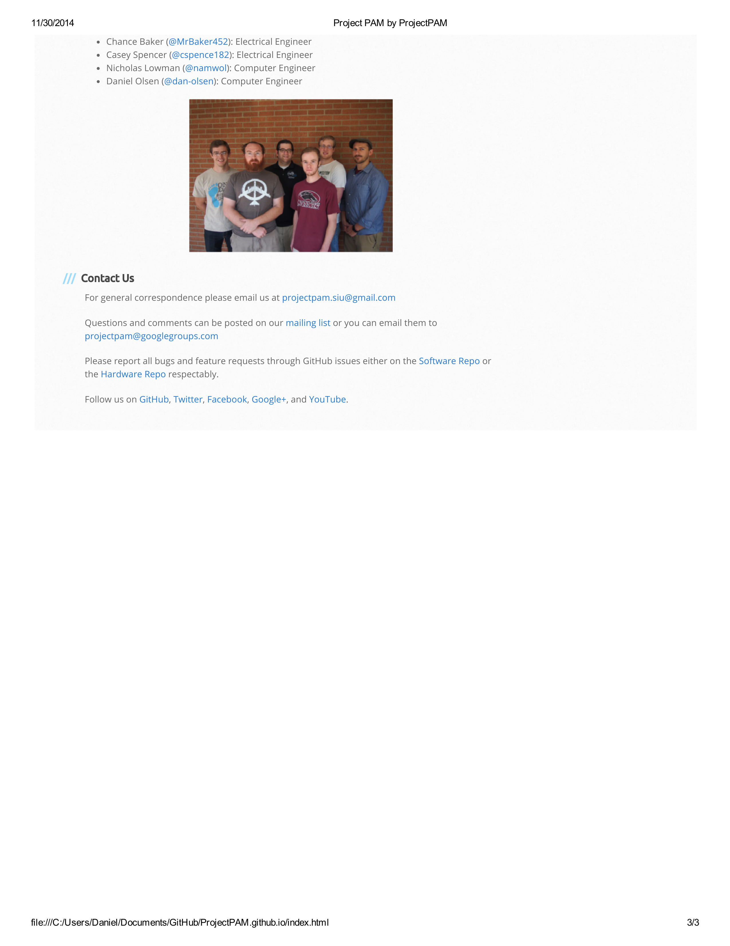

### Hardware Page

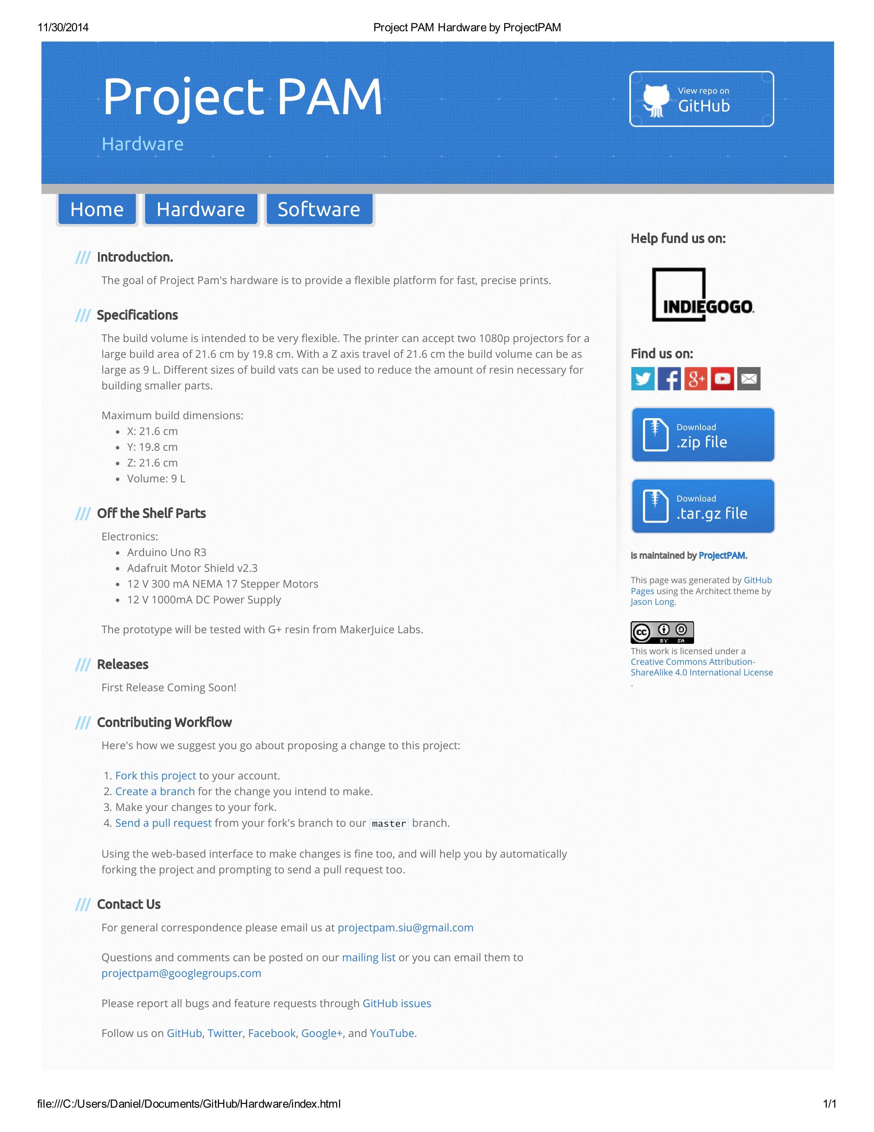

### Software Page

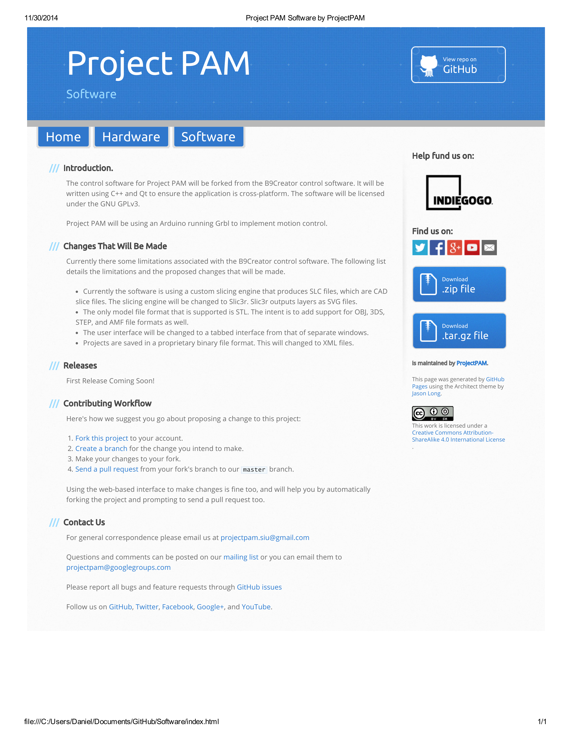

### Google Analytics Reports

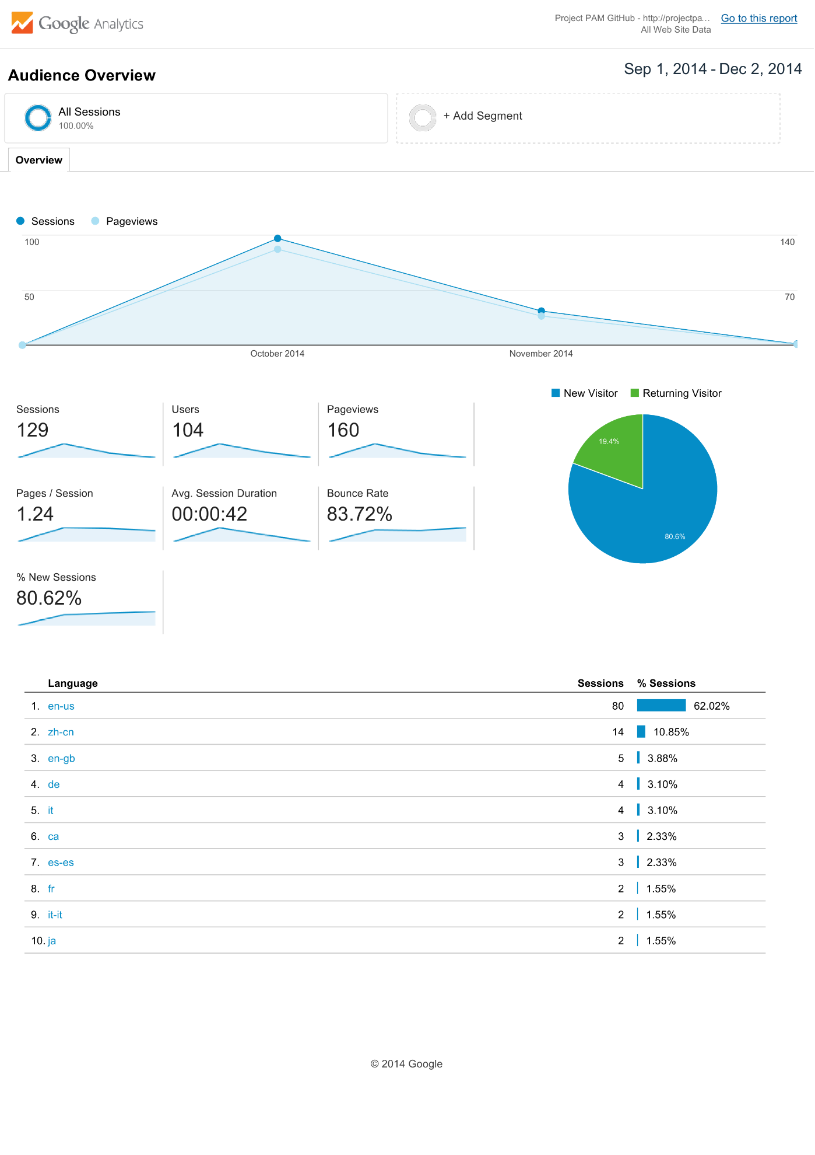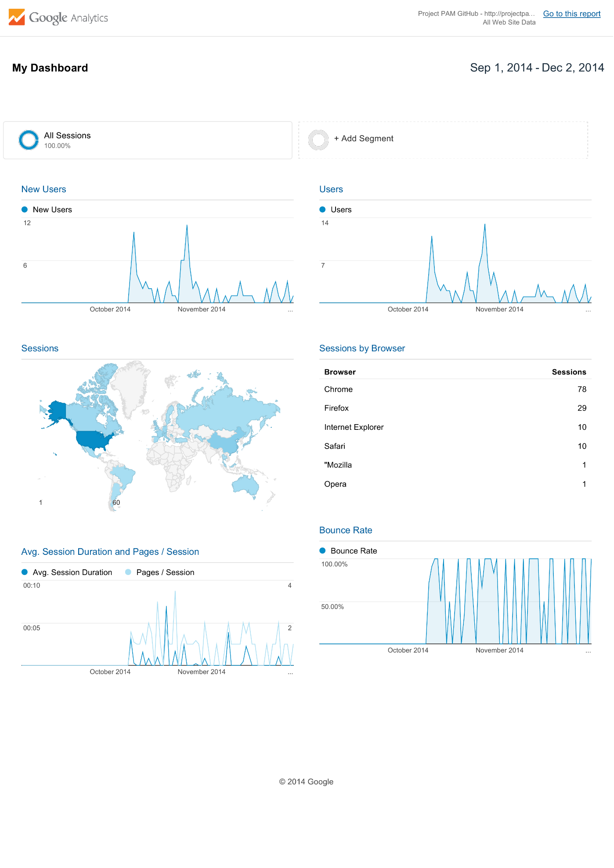

## Project PAM Prezi

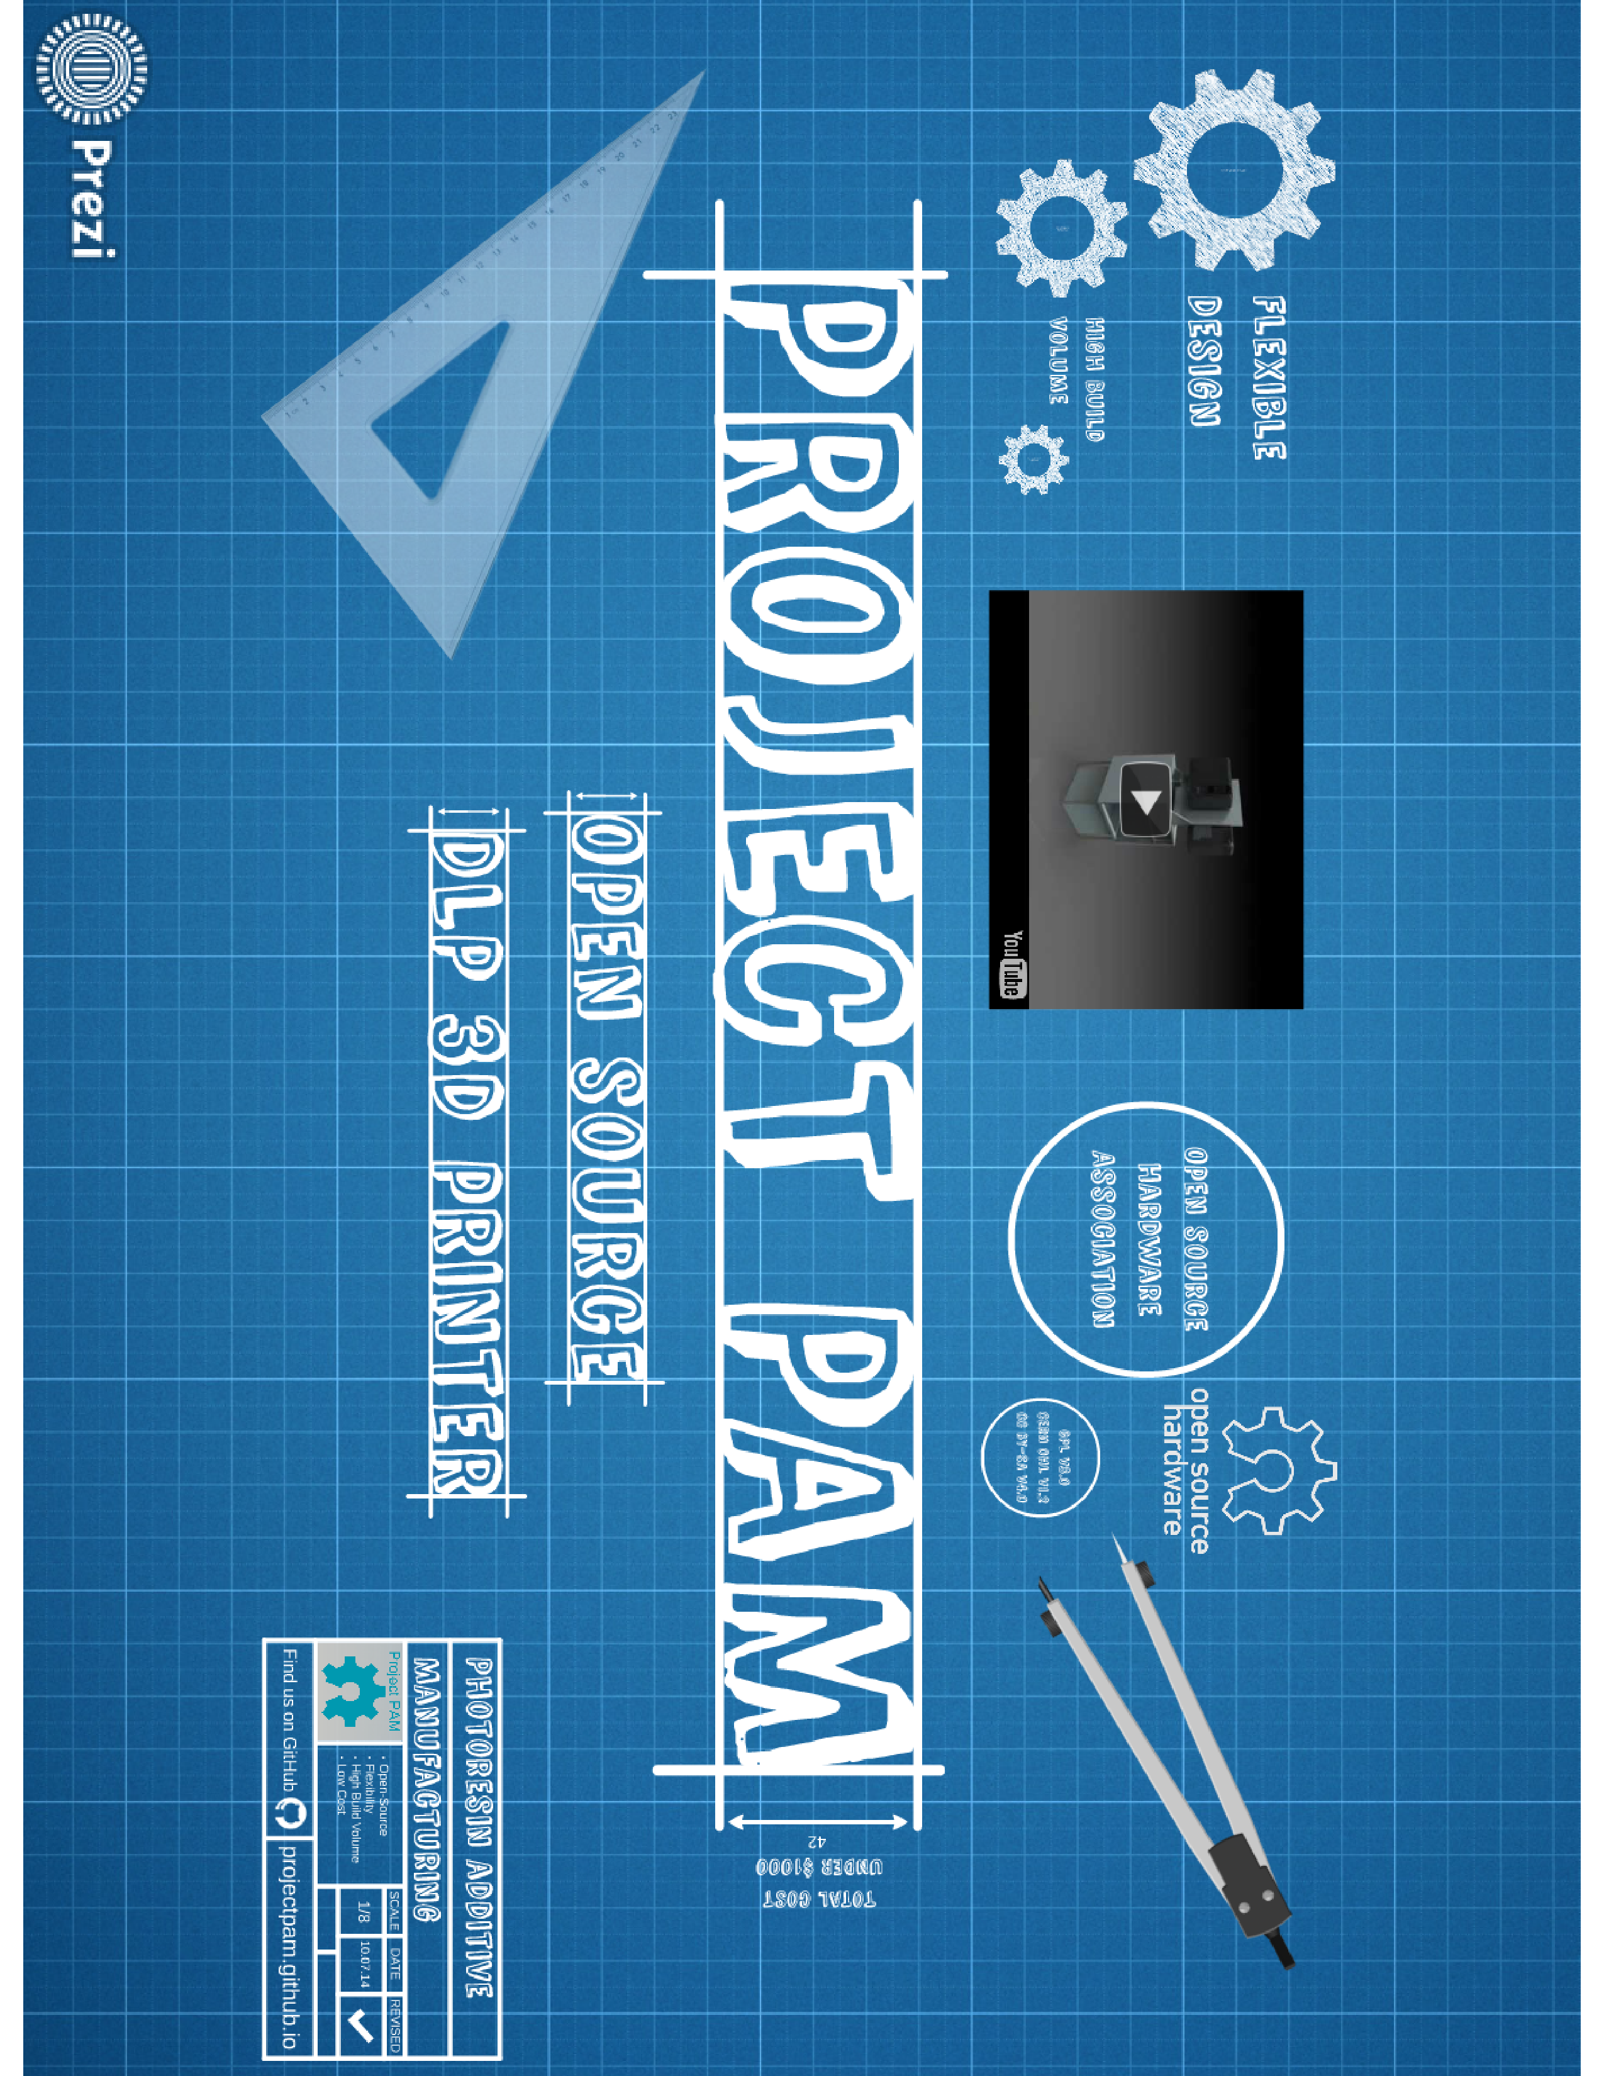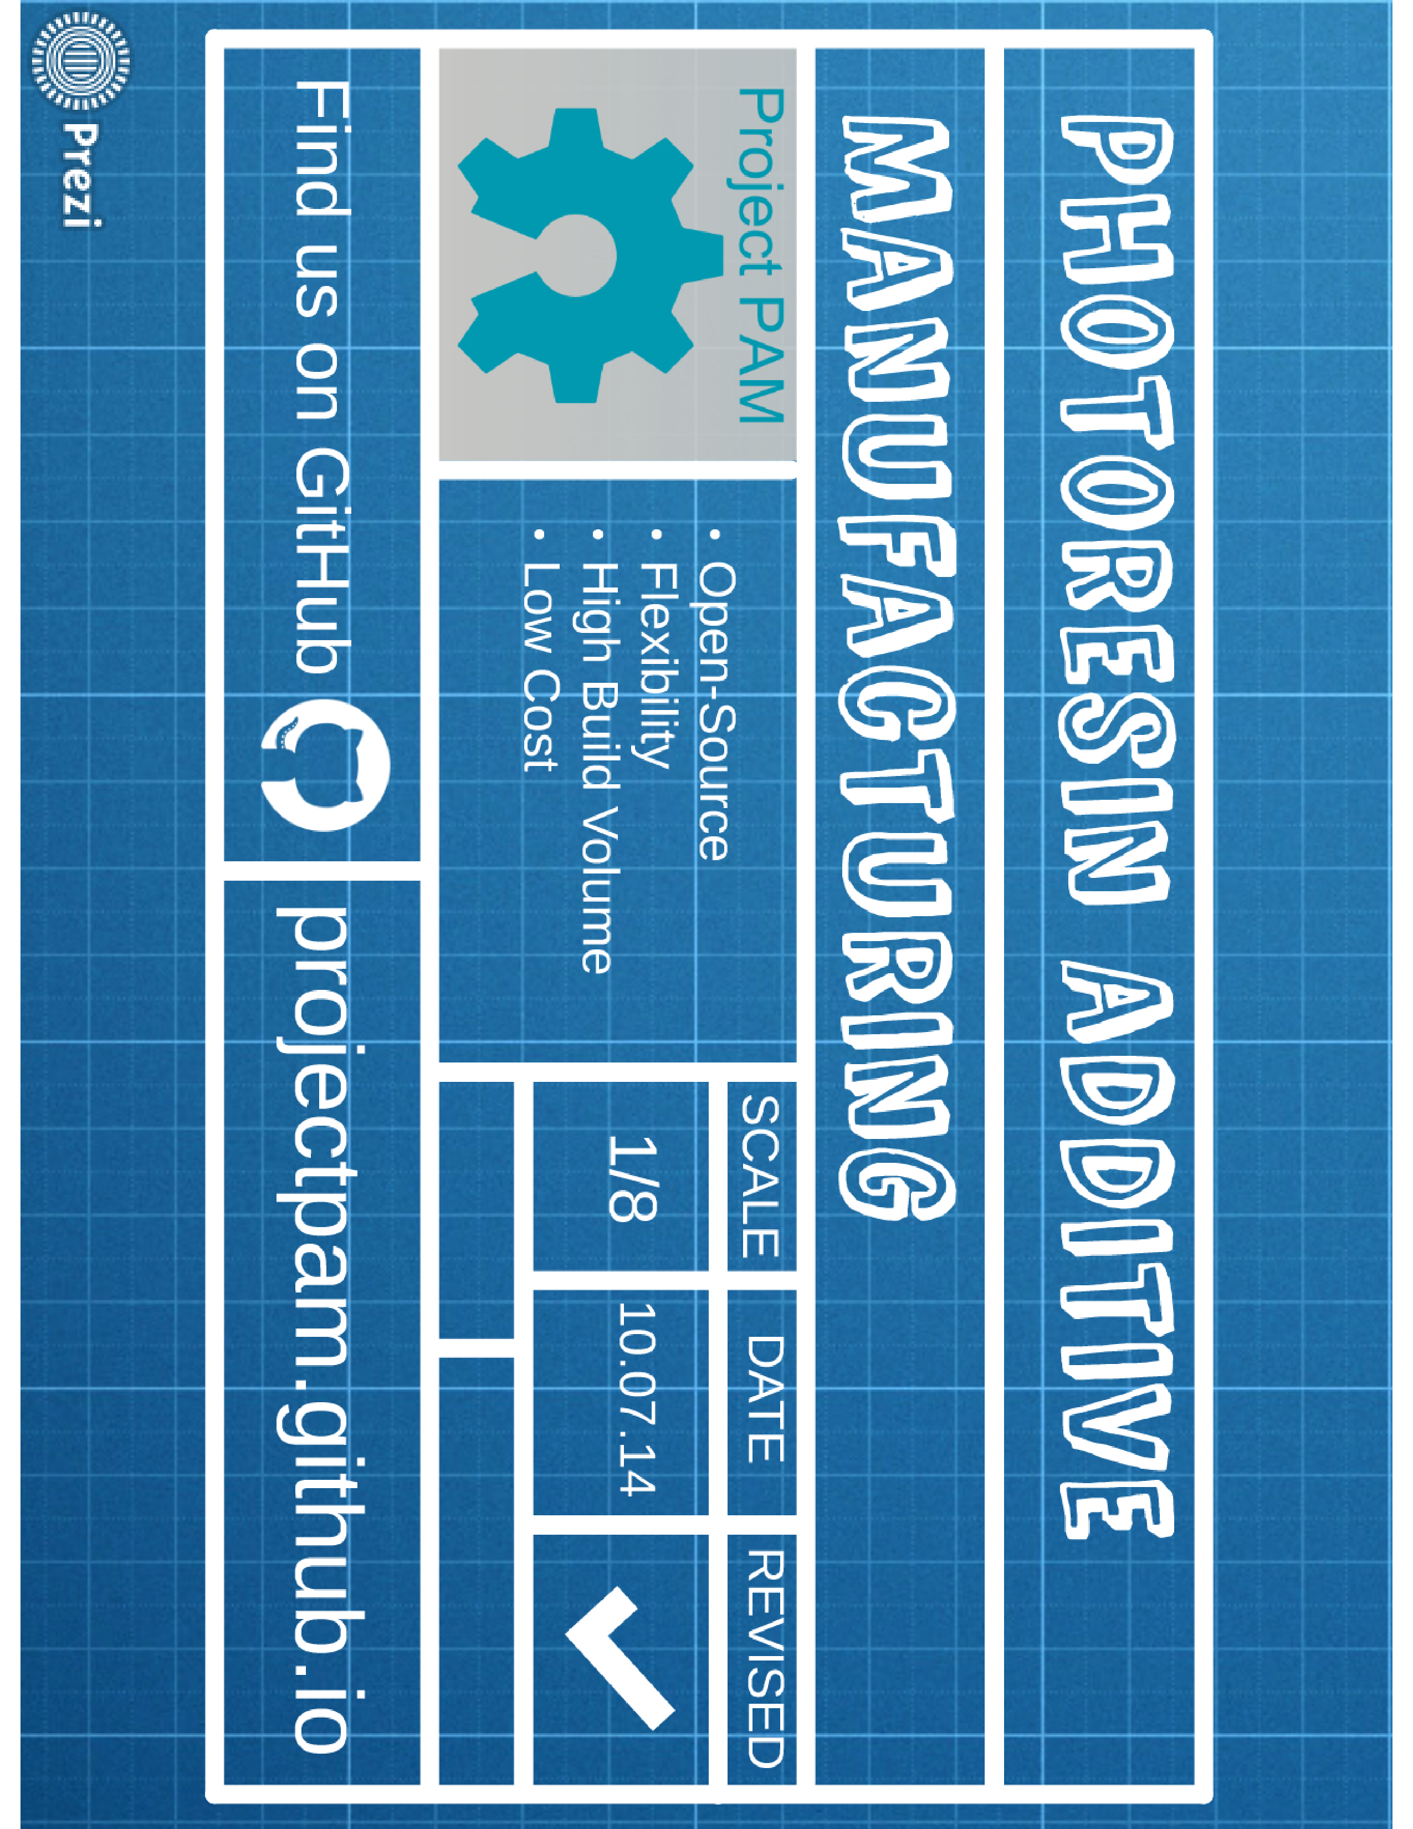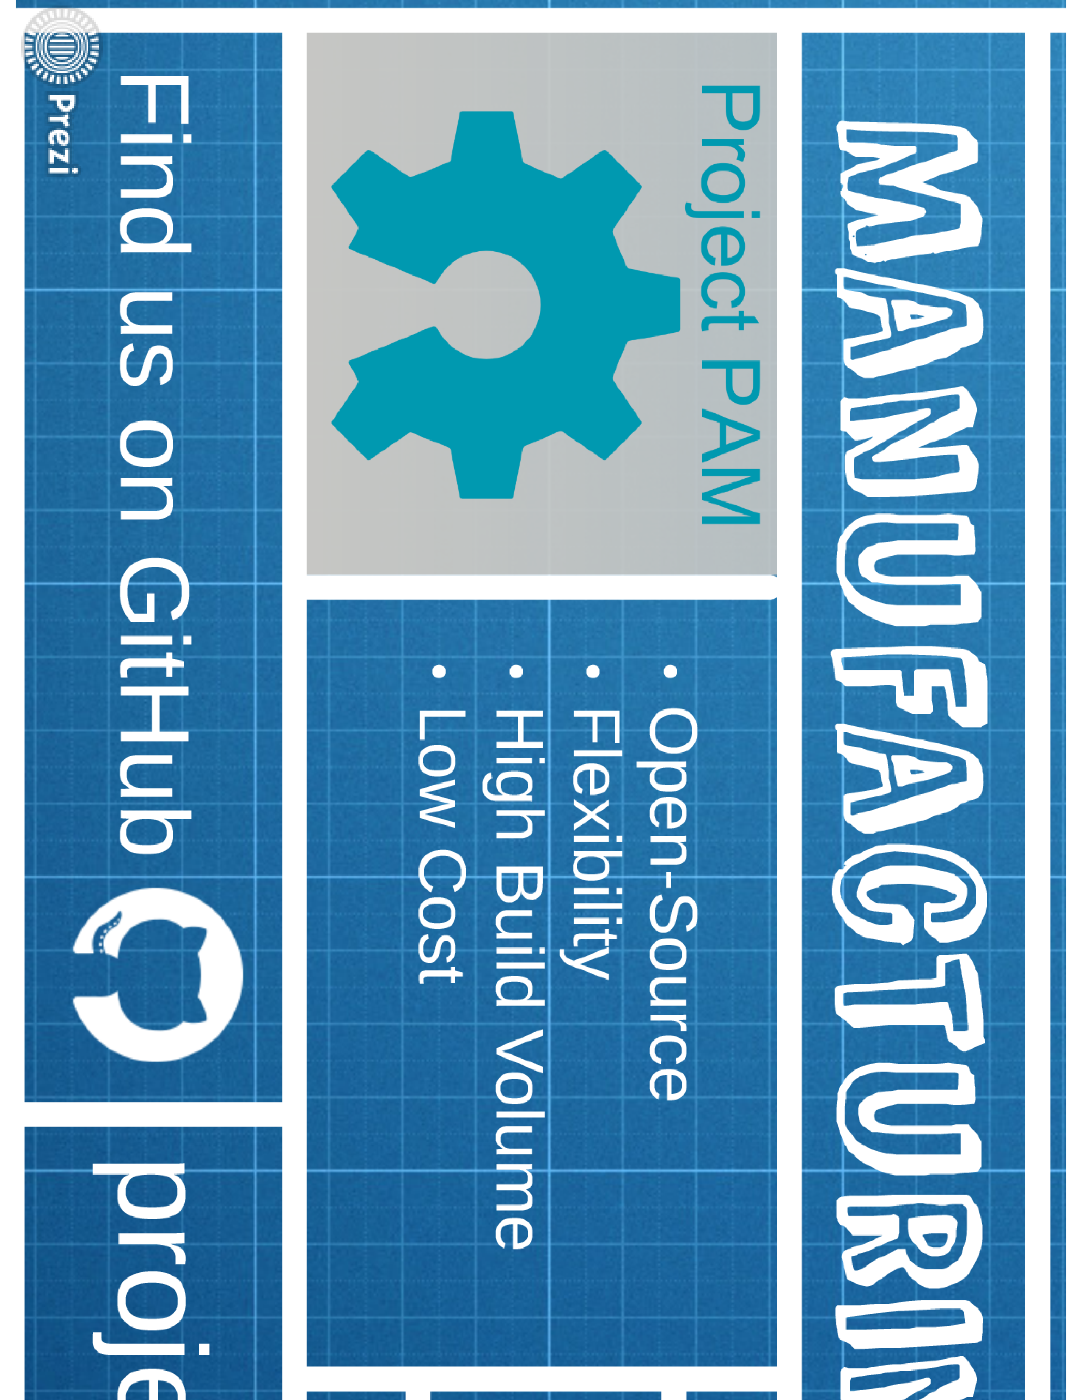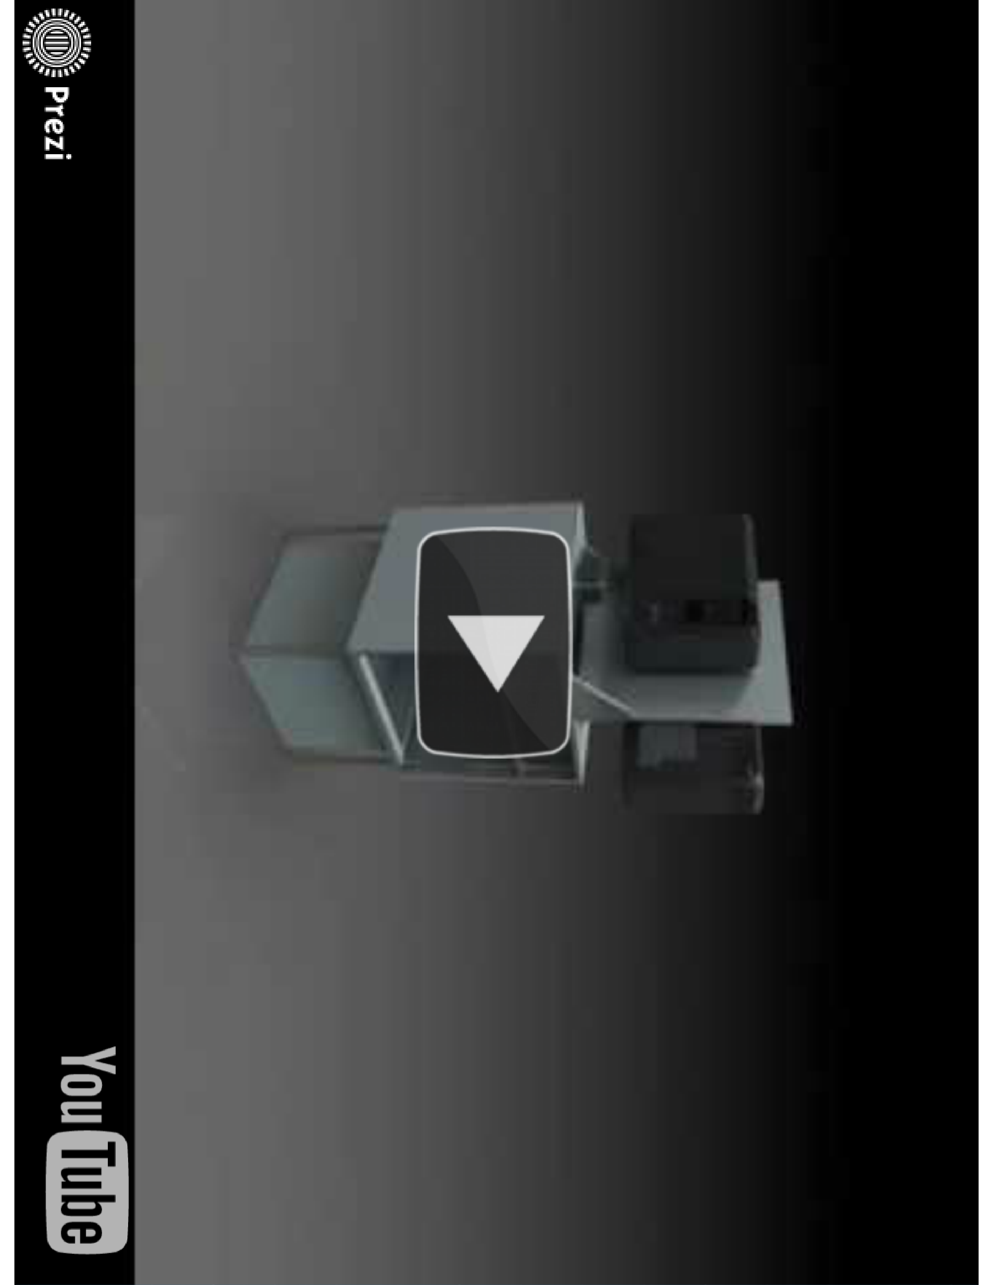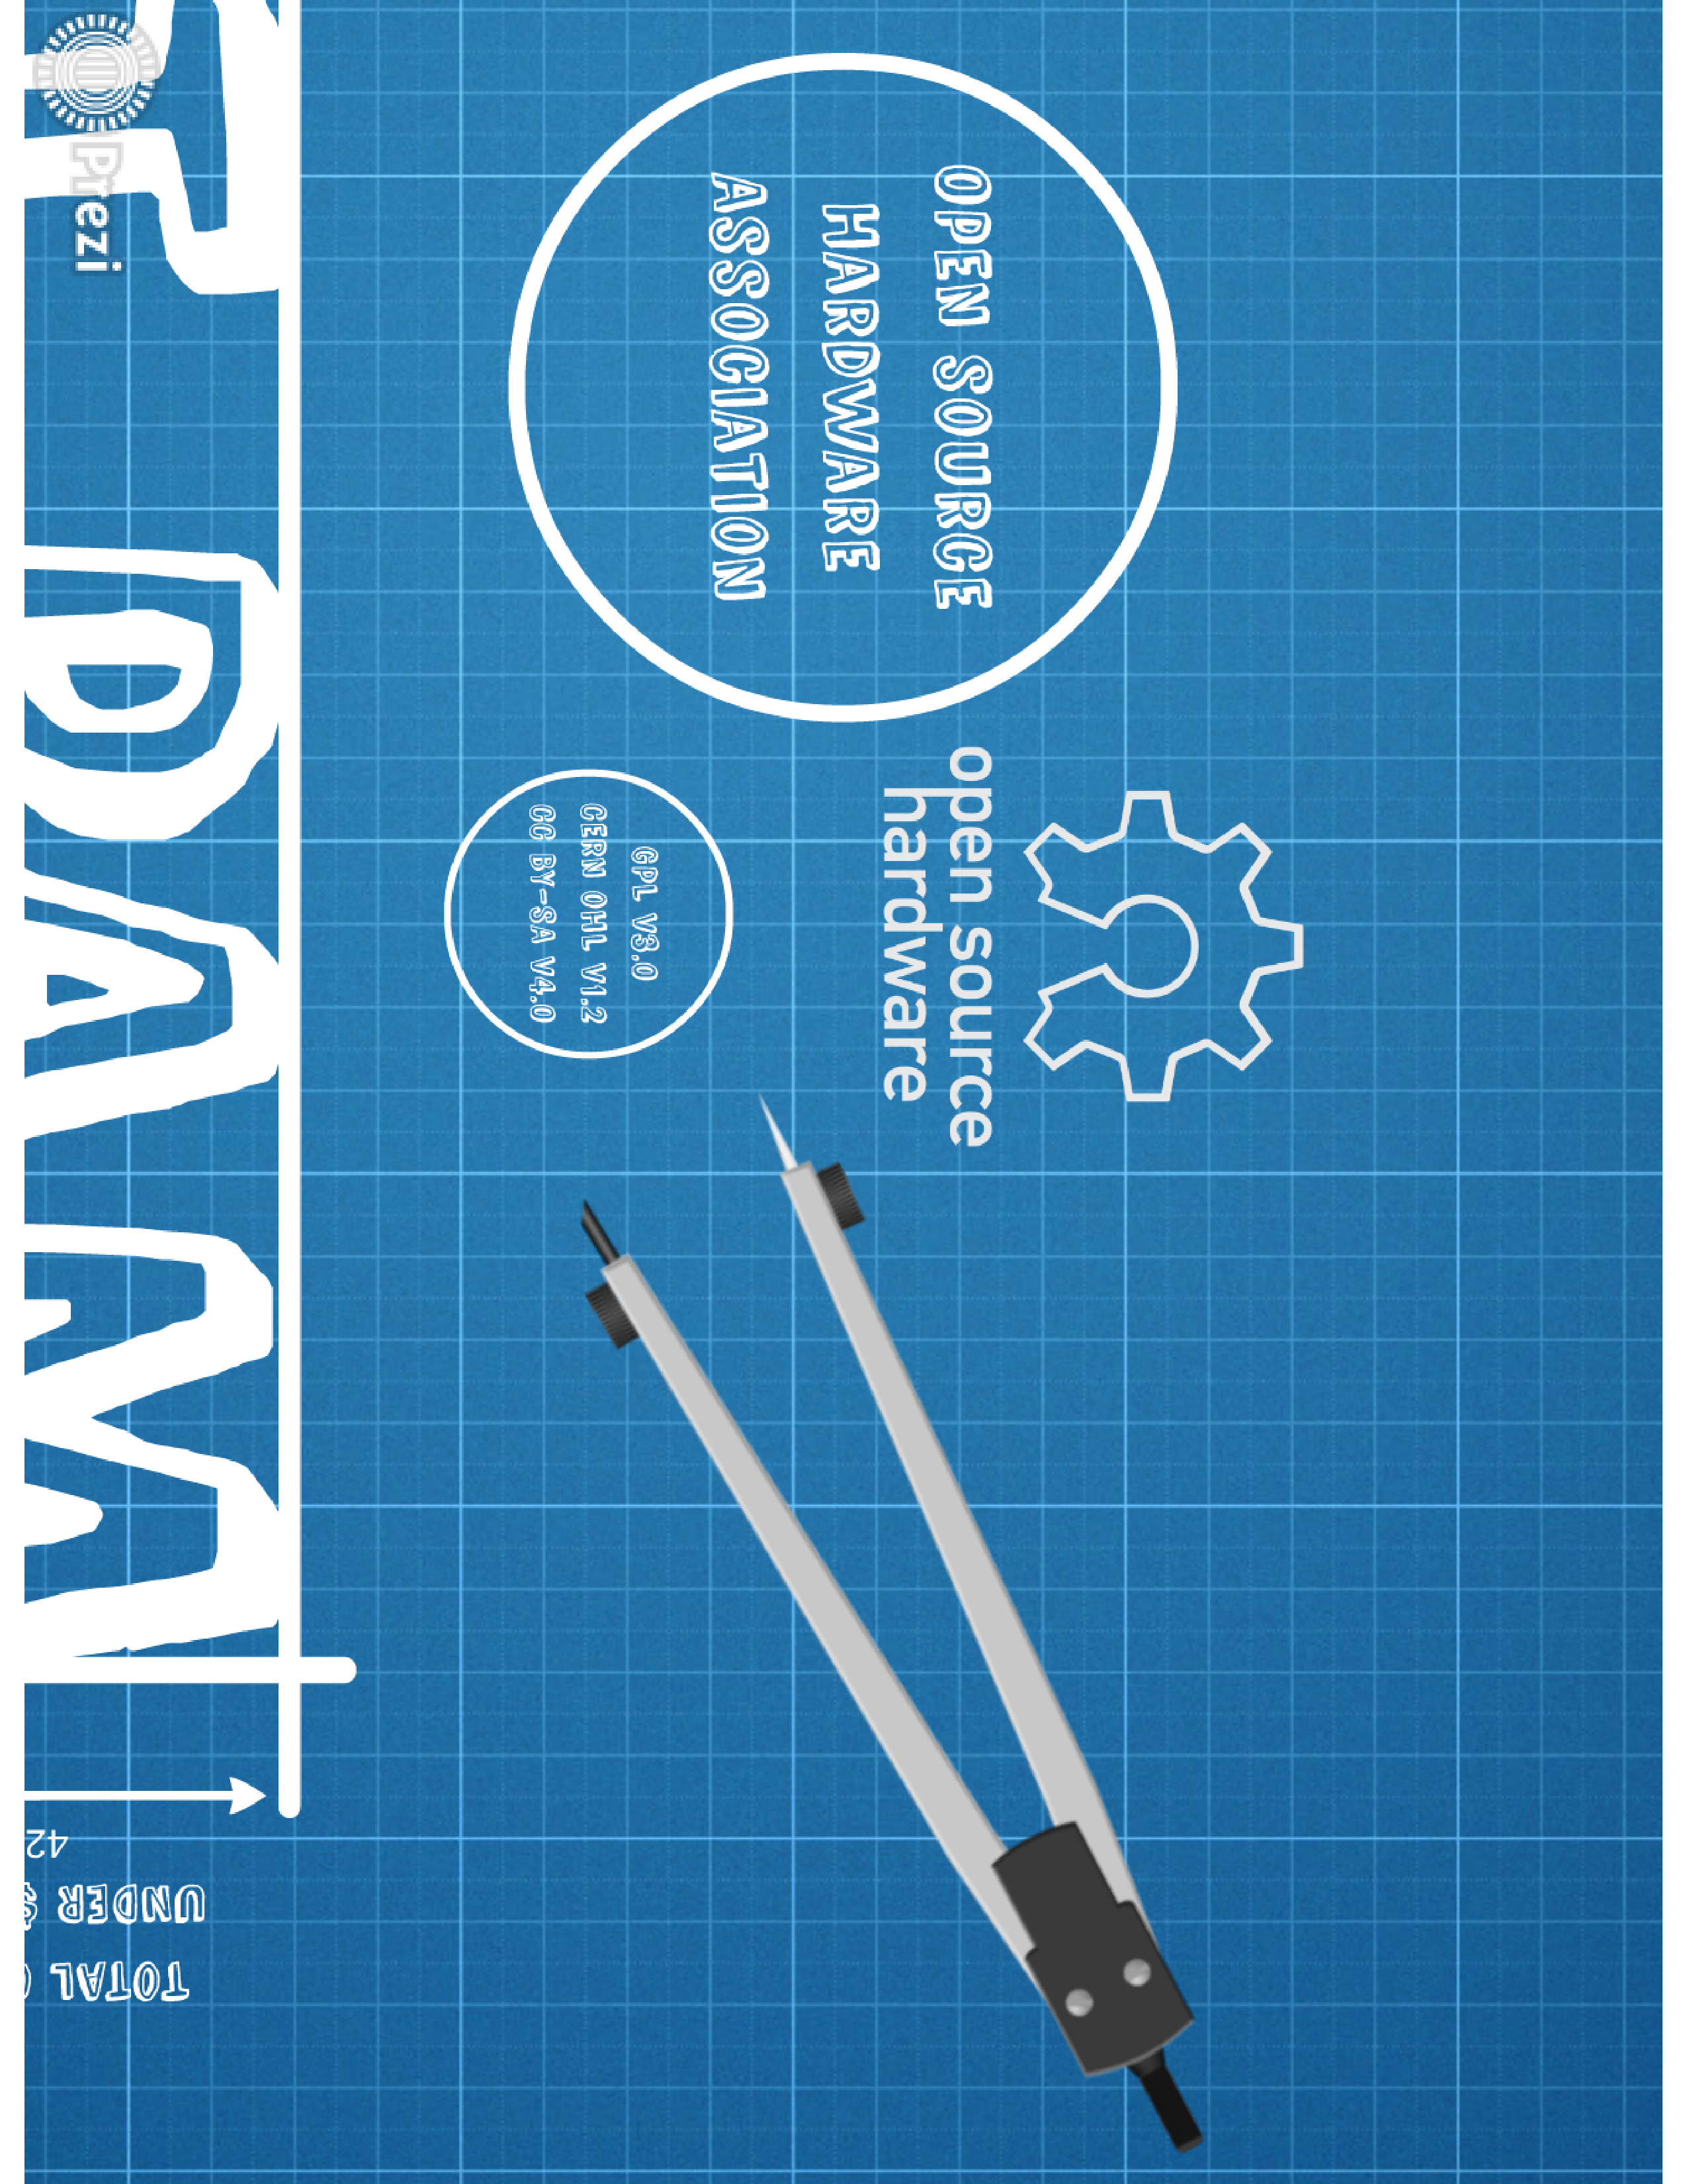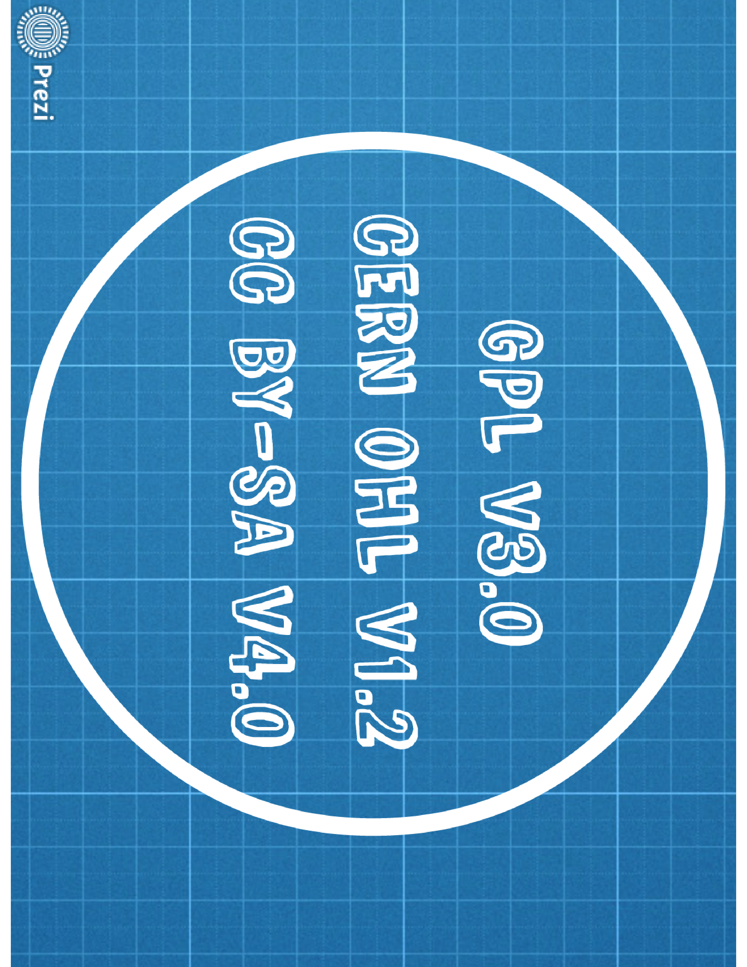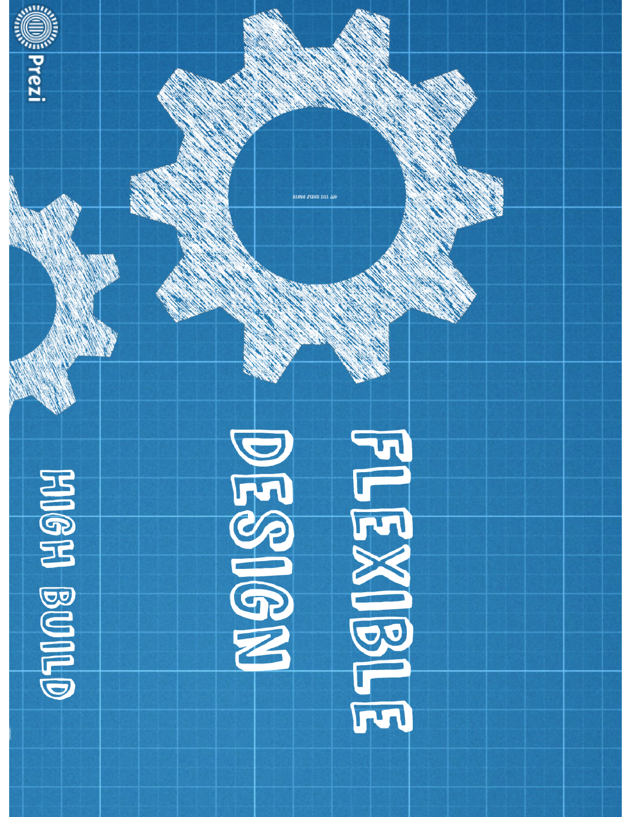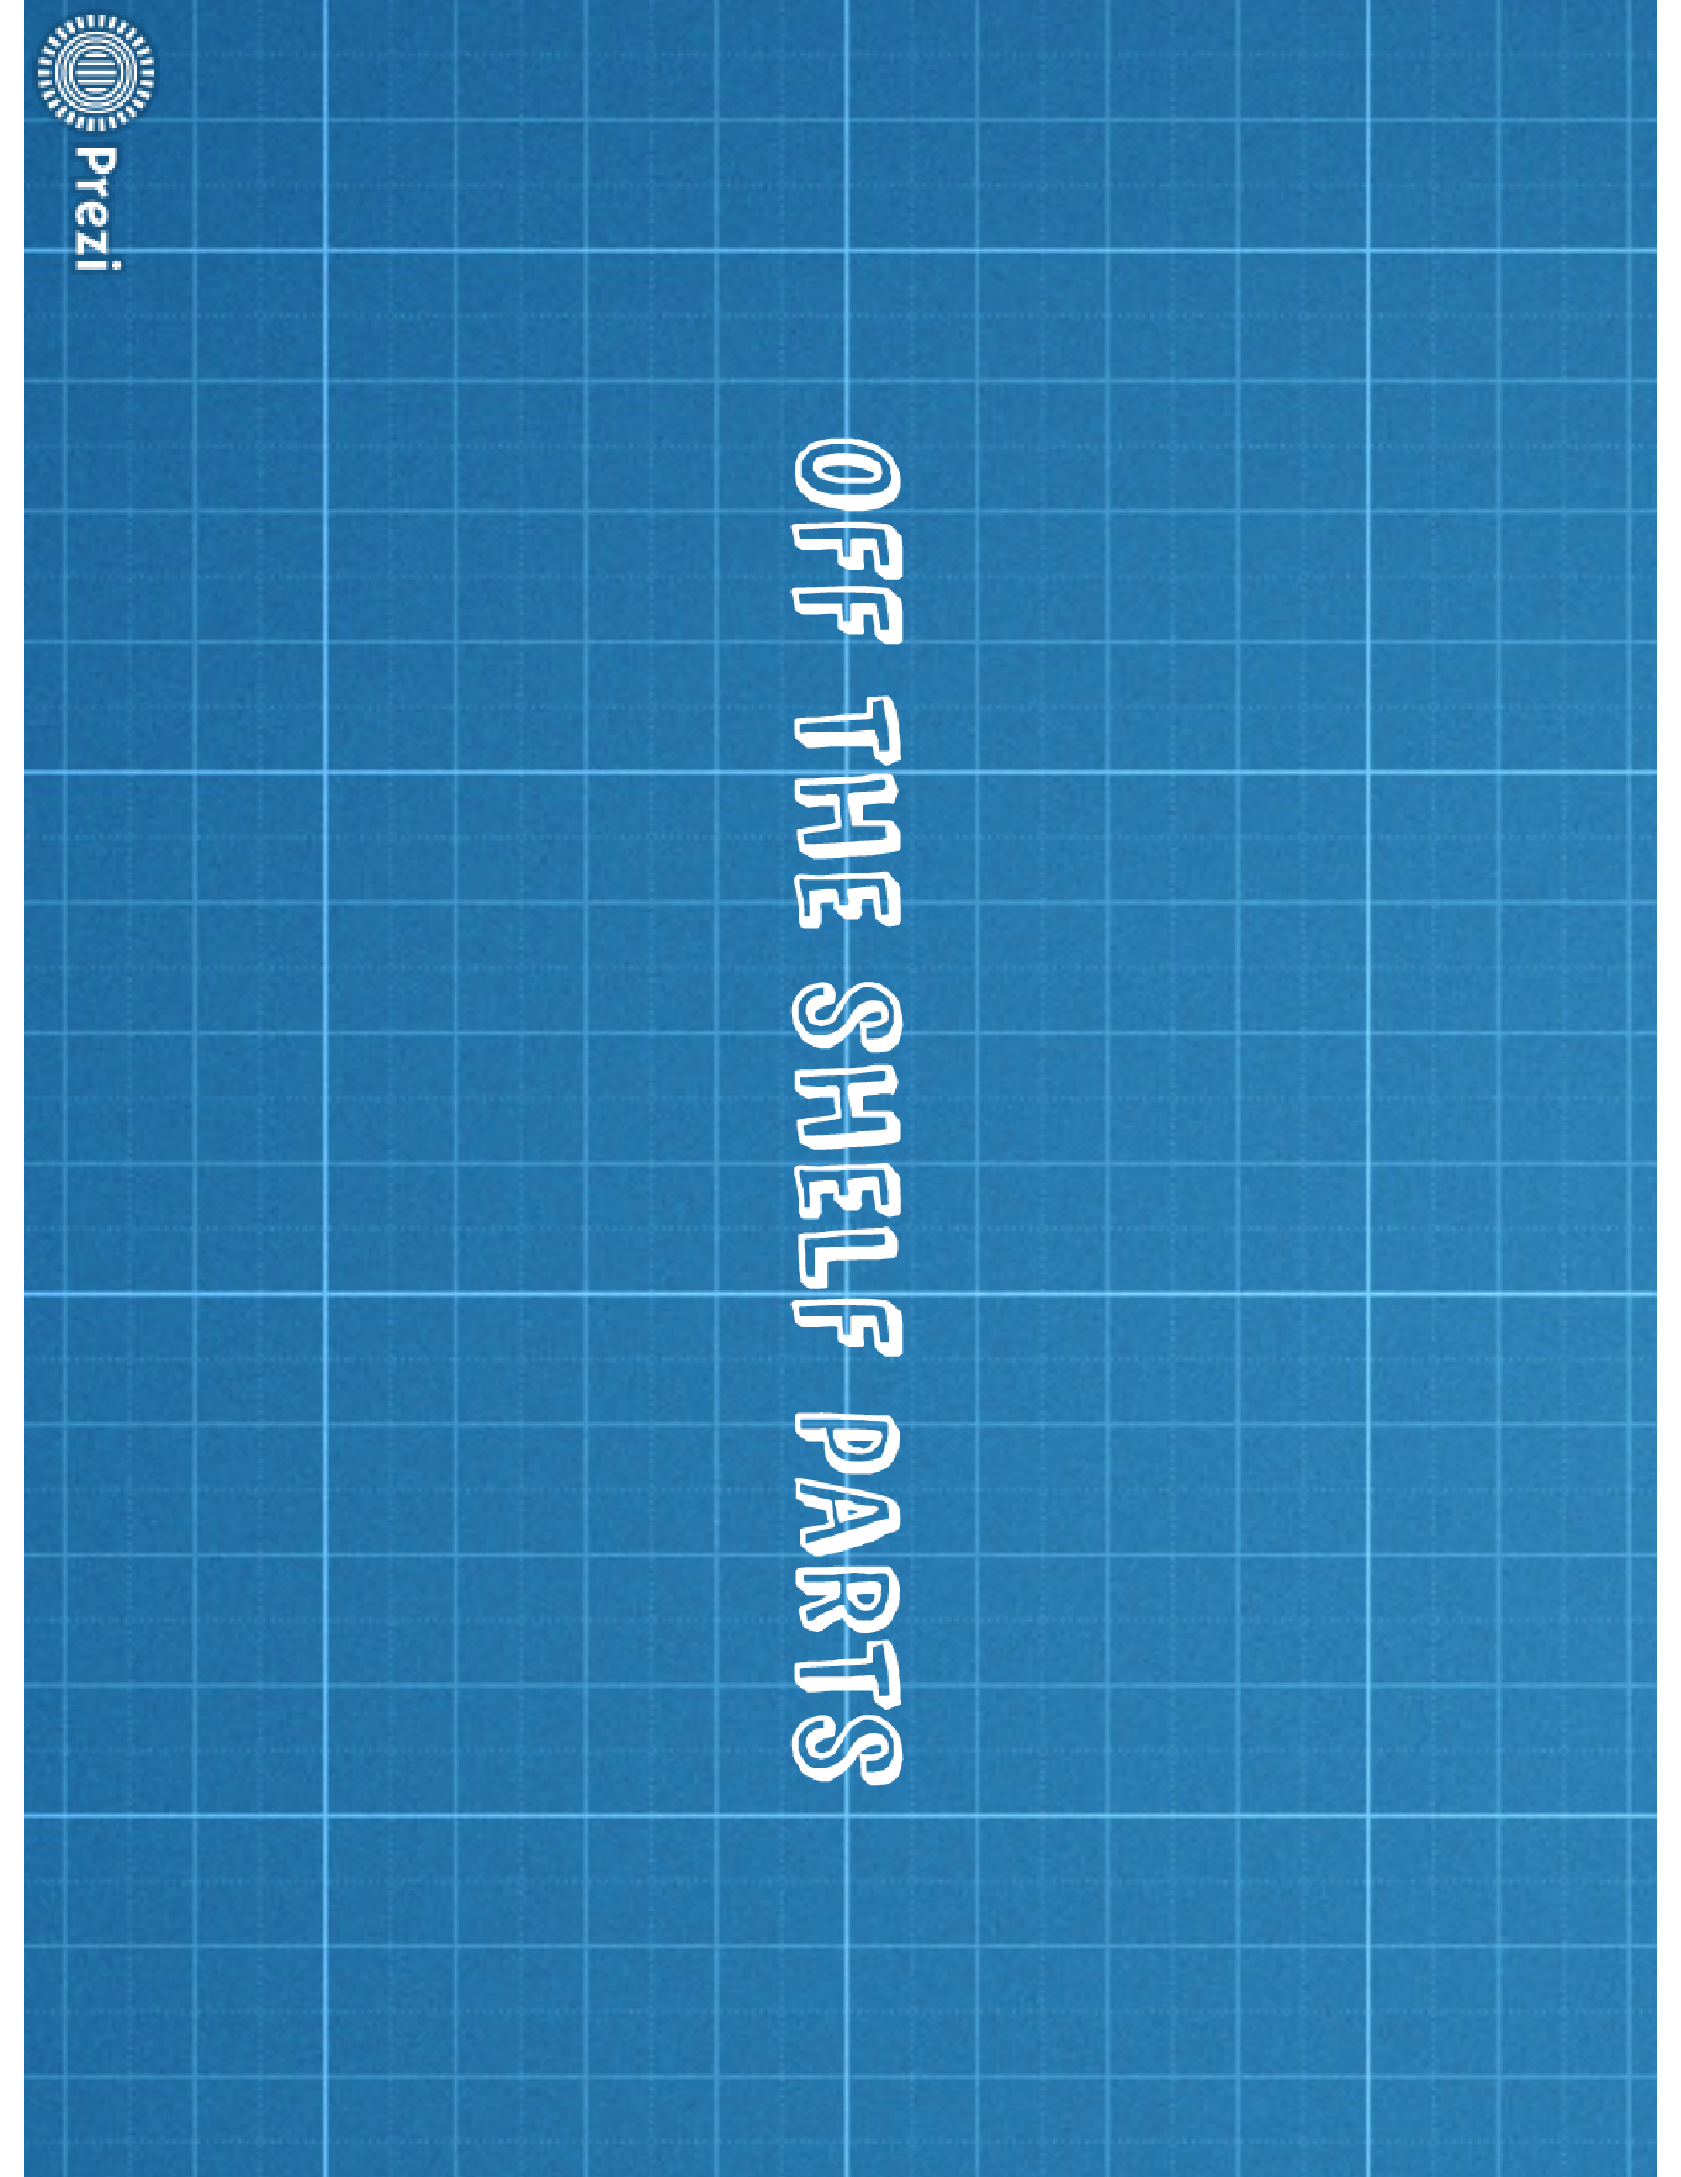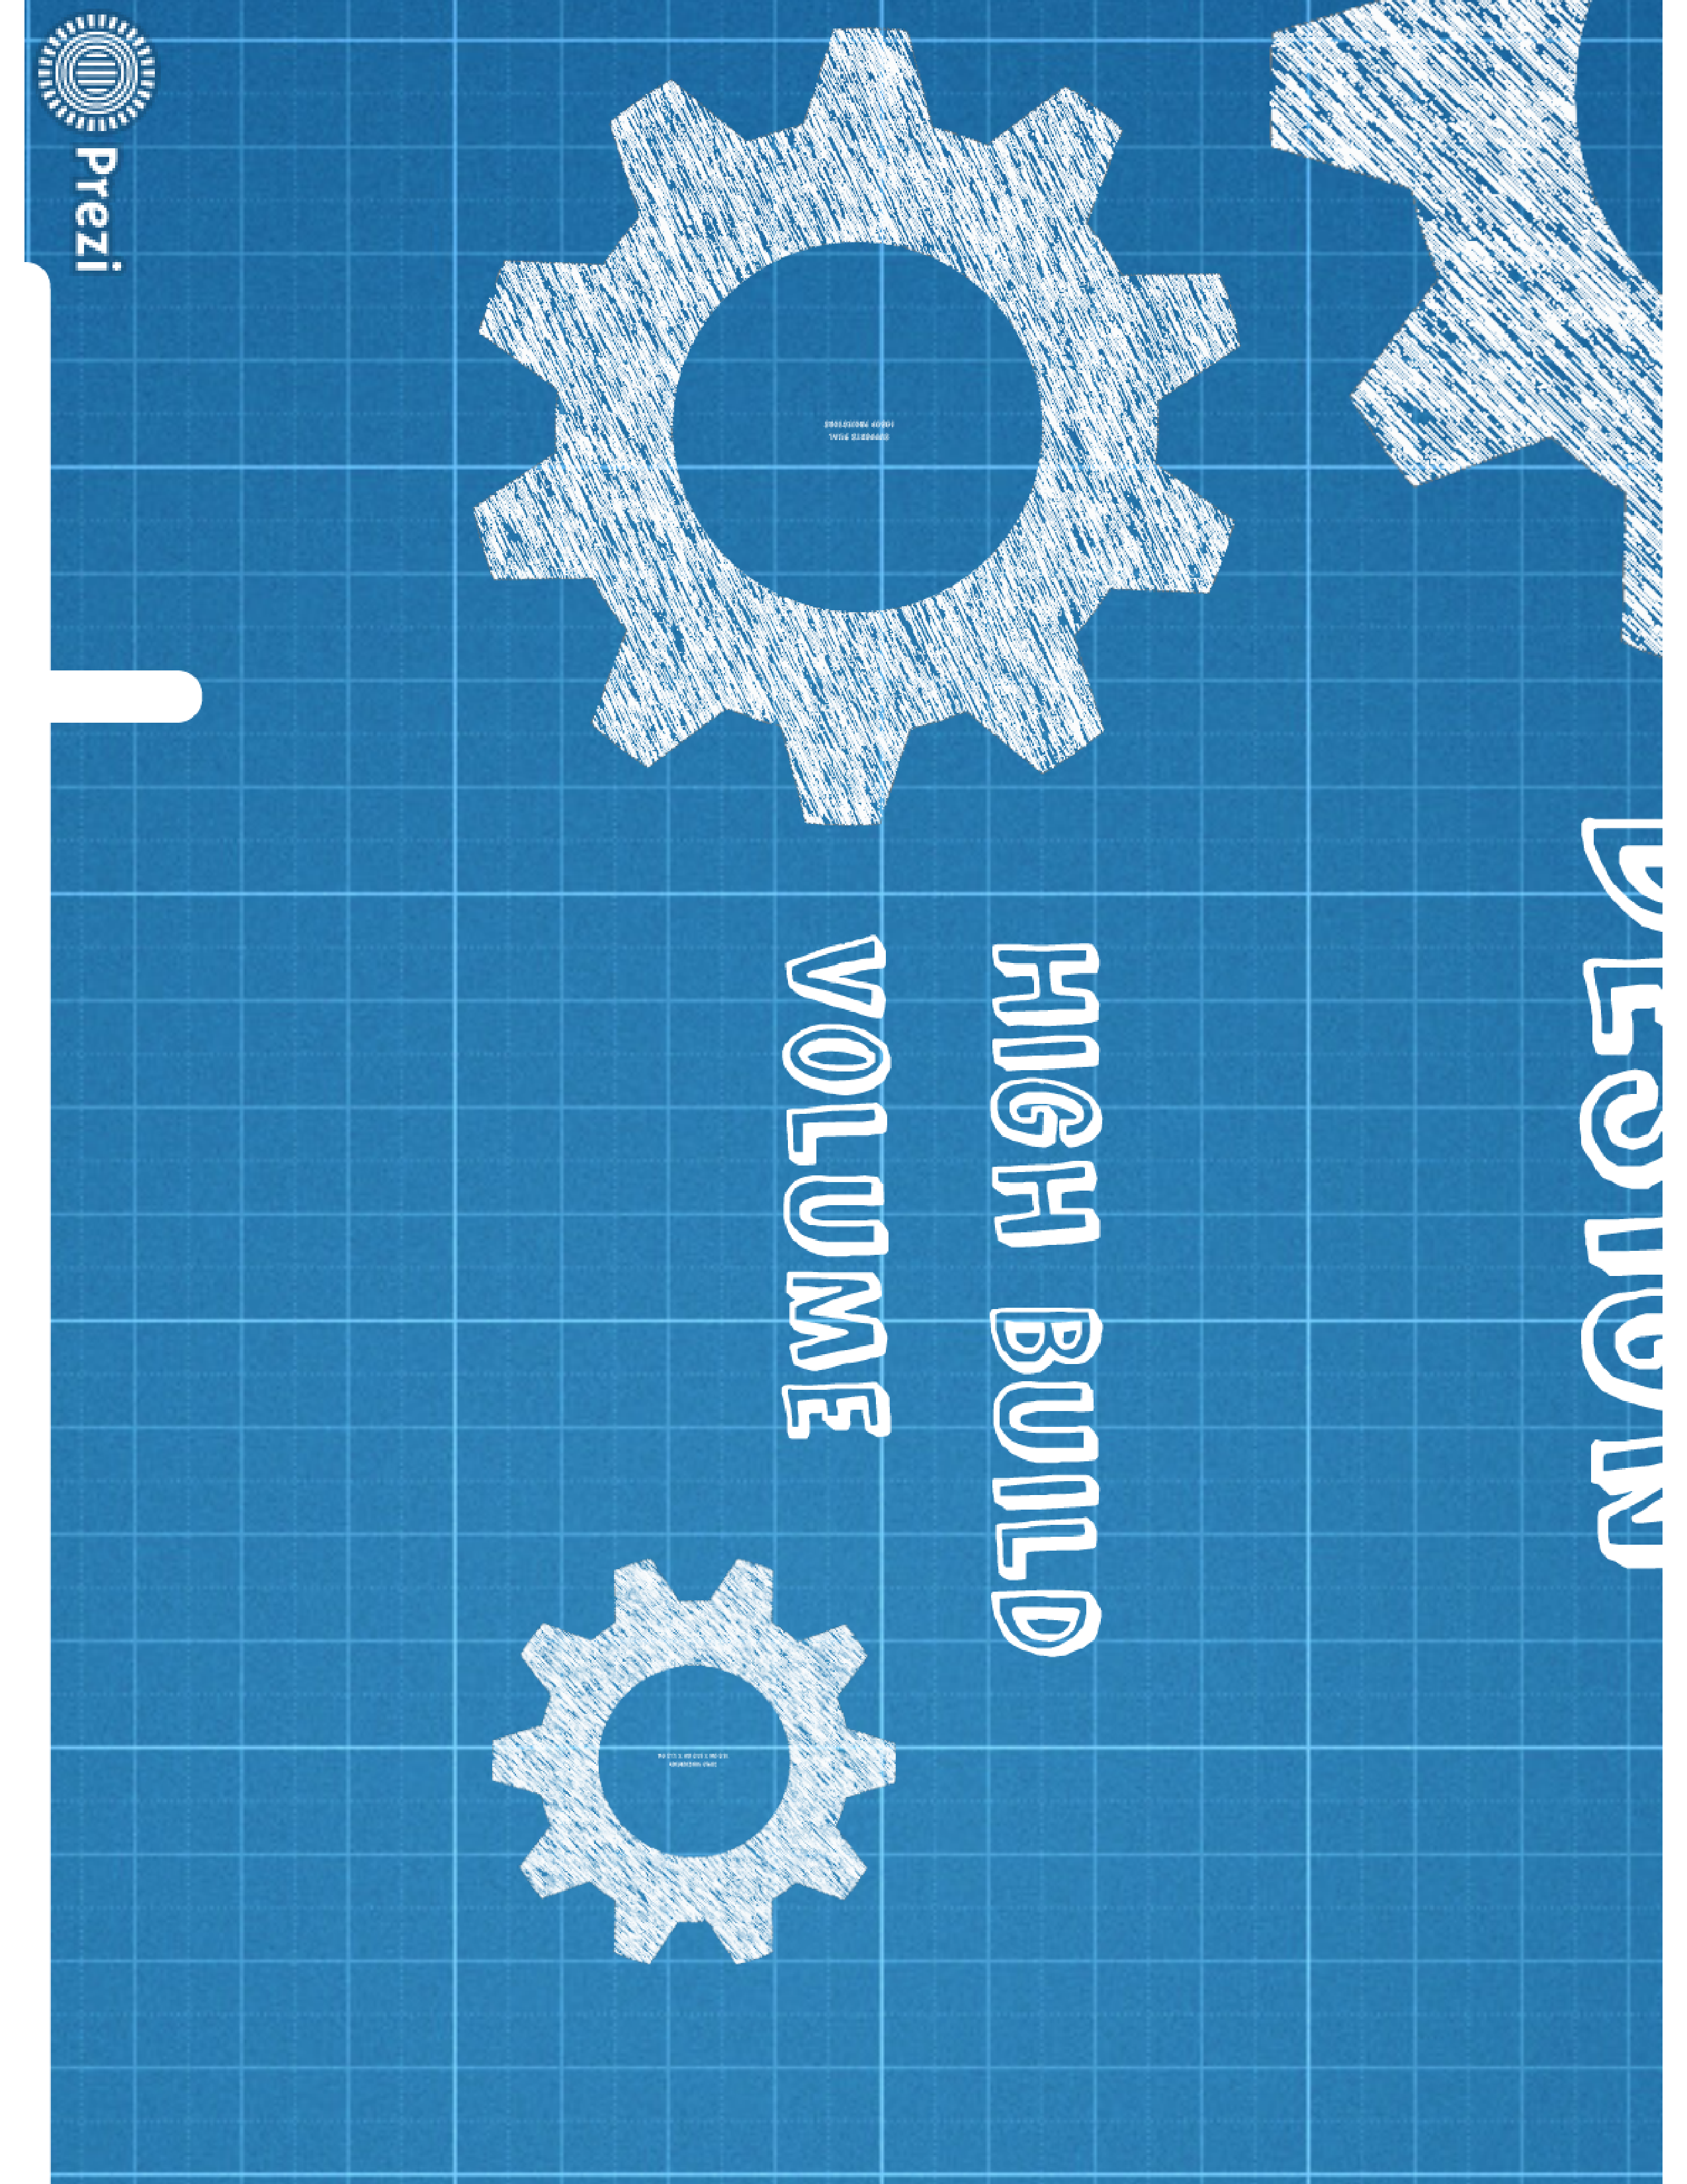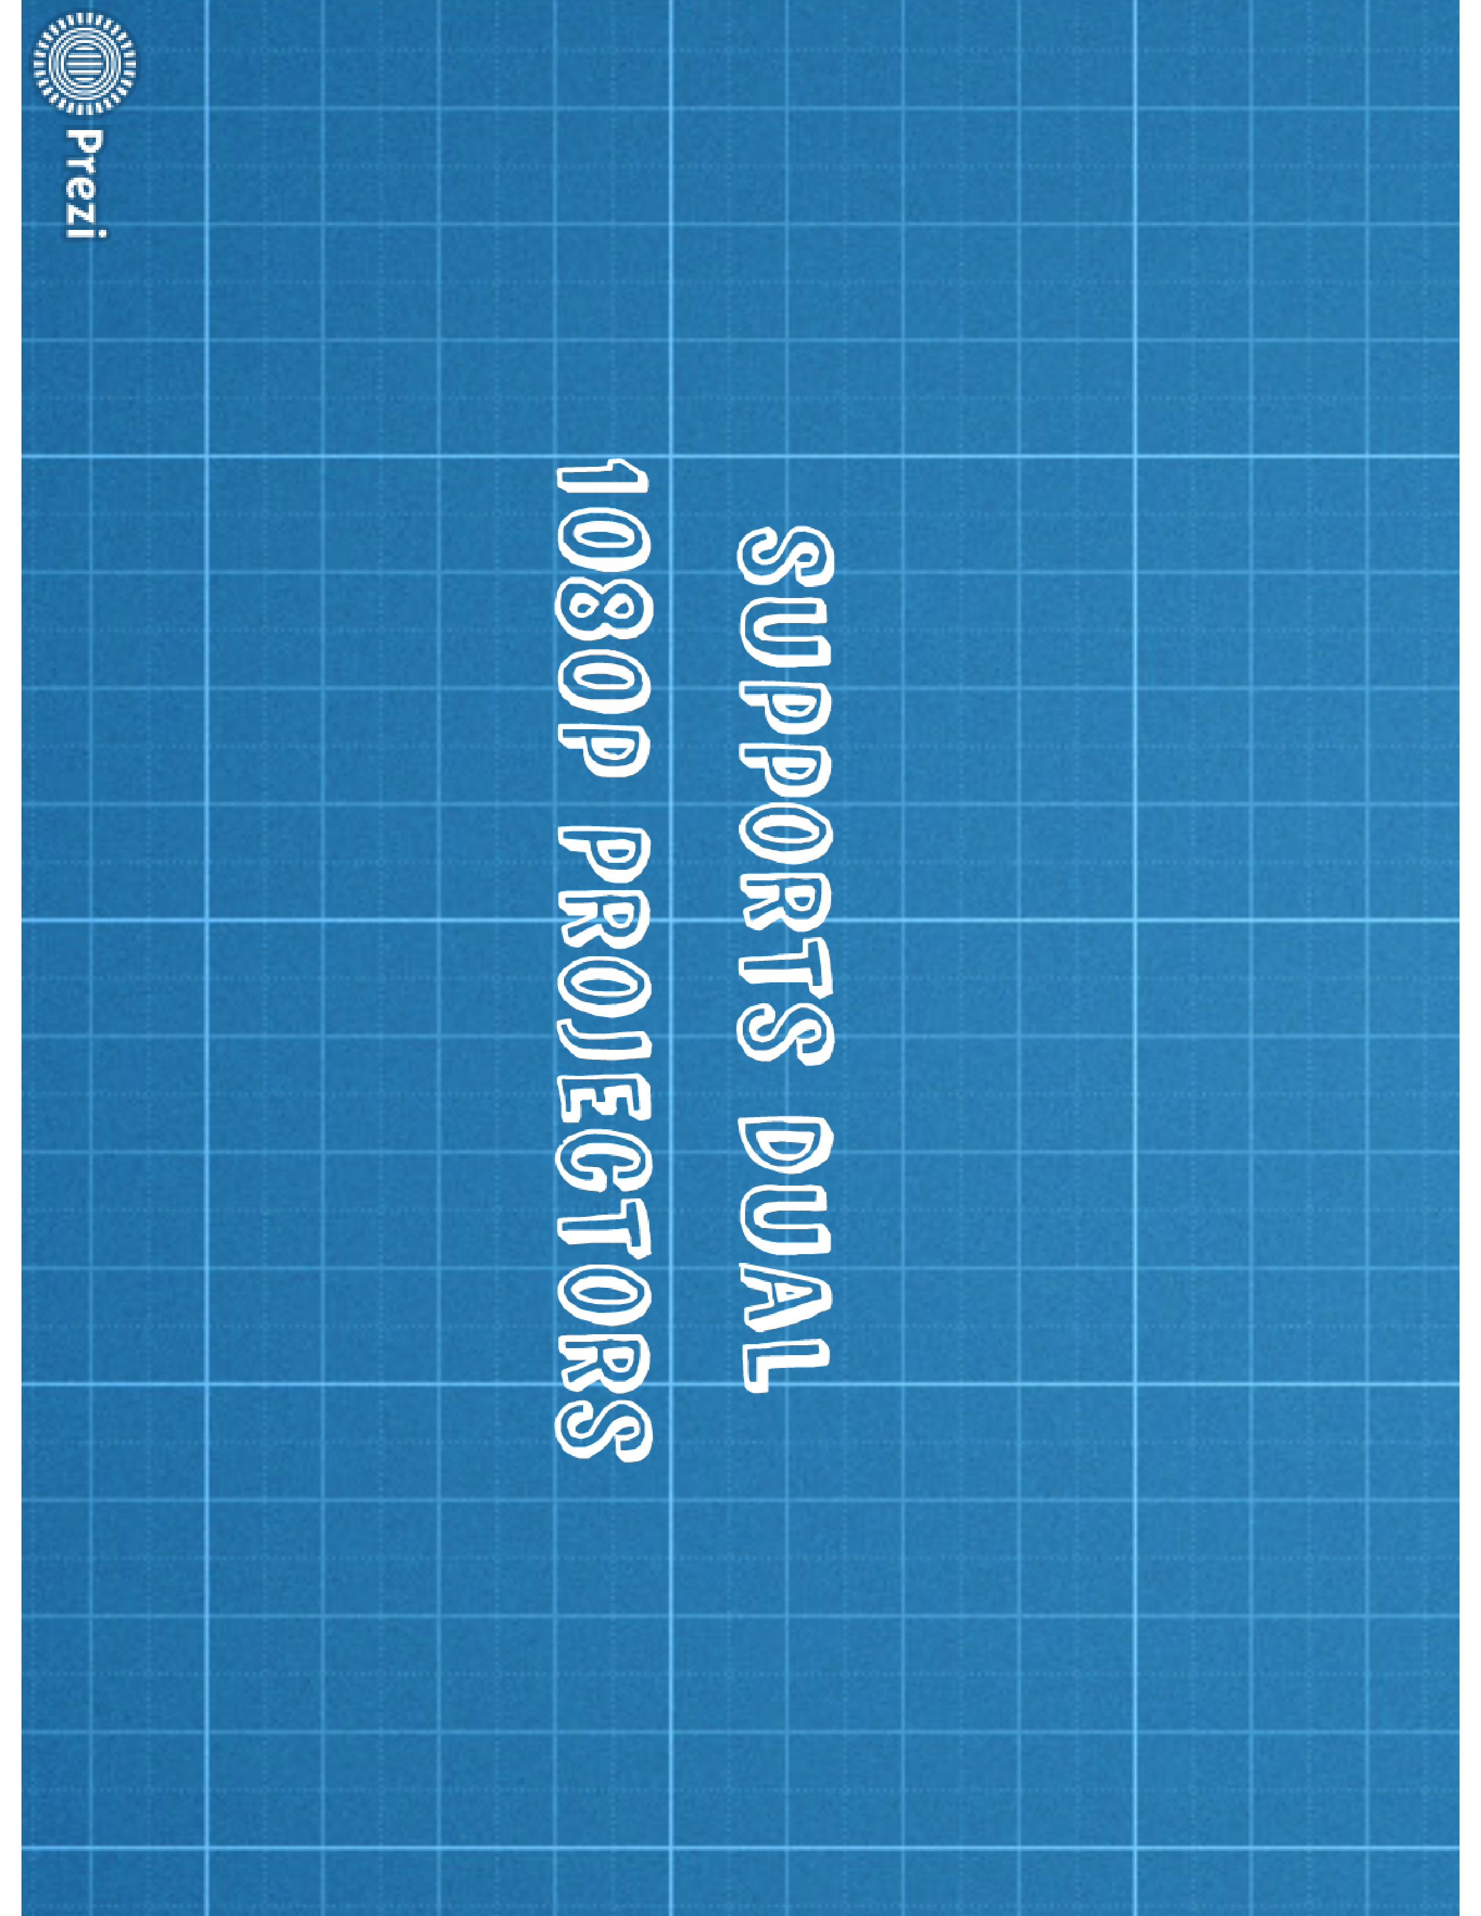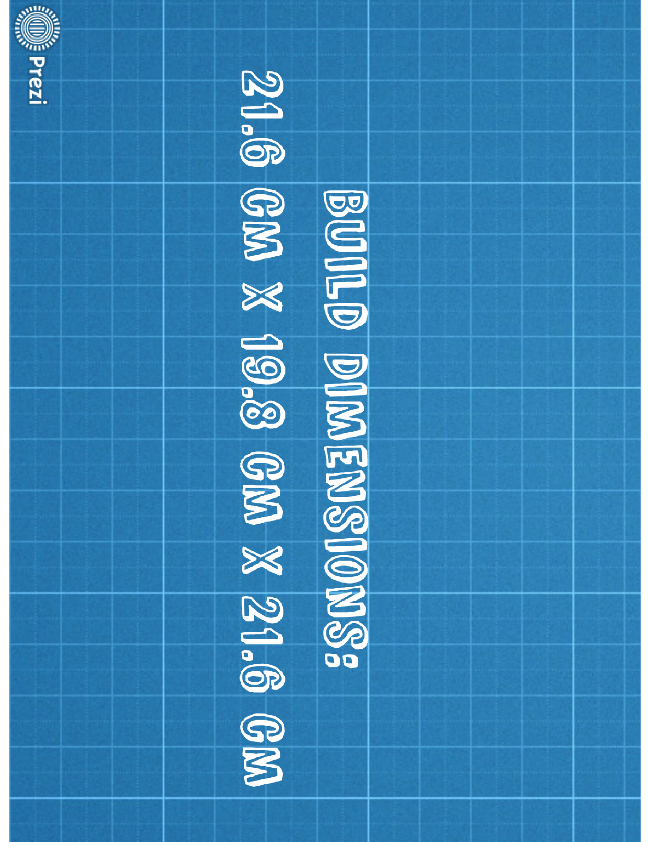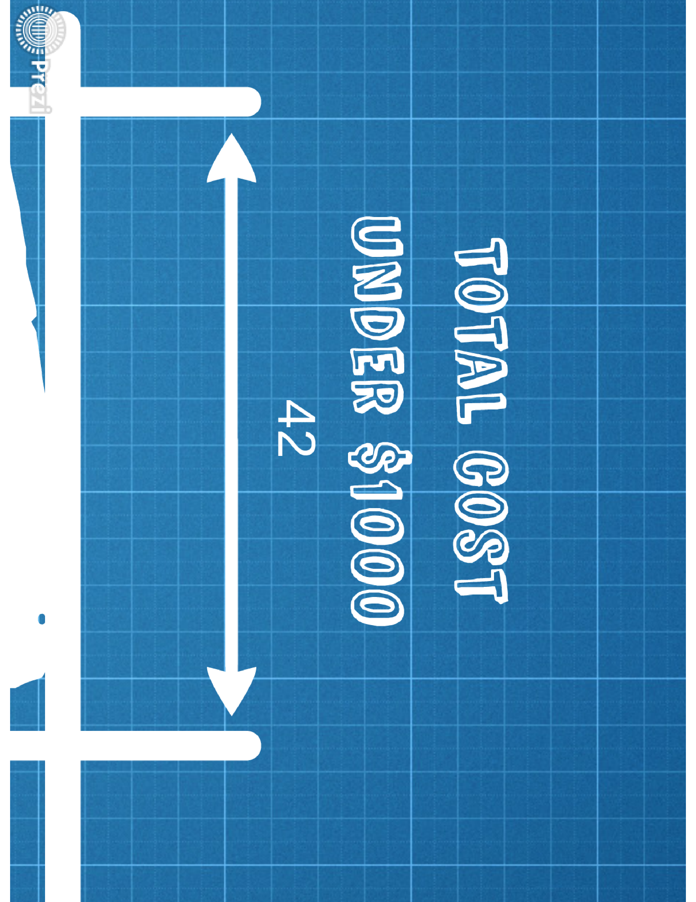

## Indiegogo

### Story

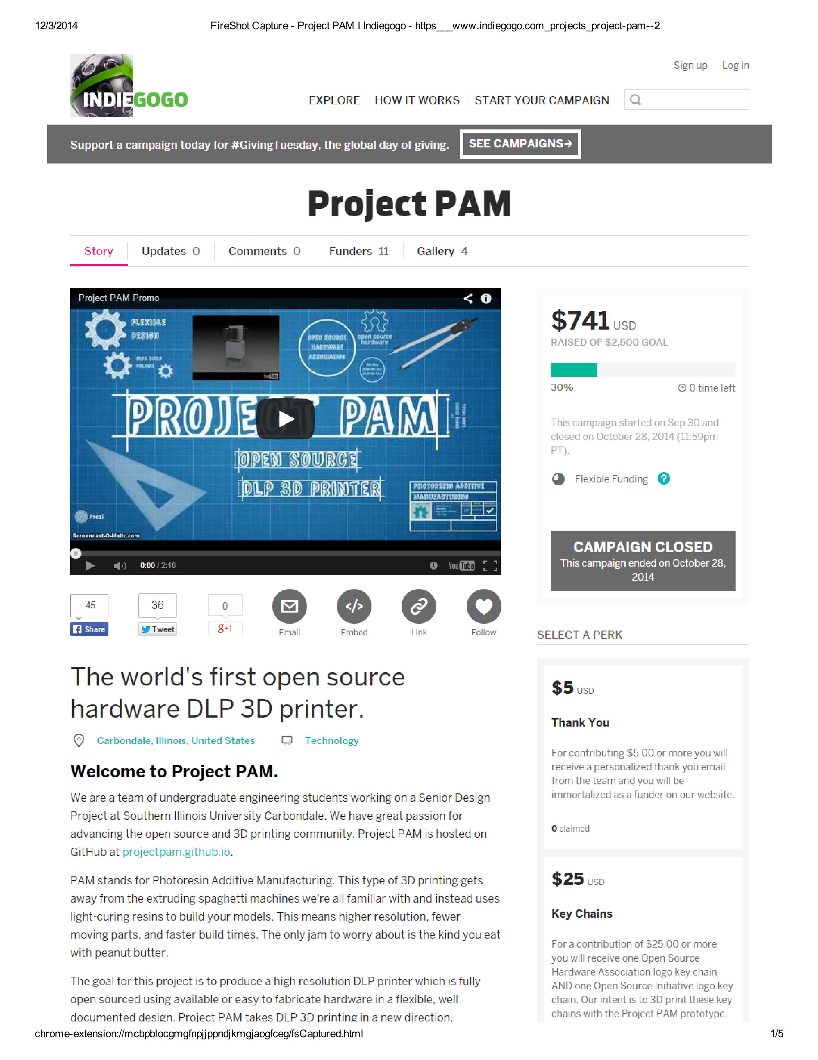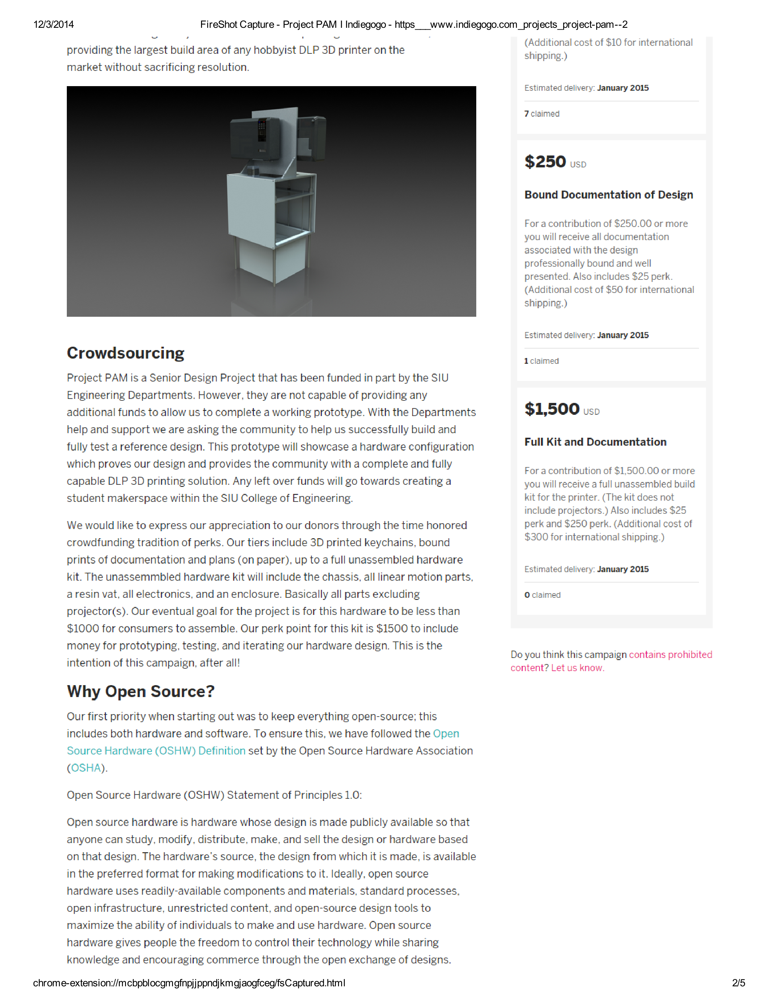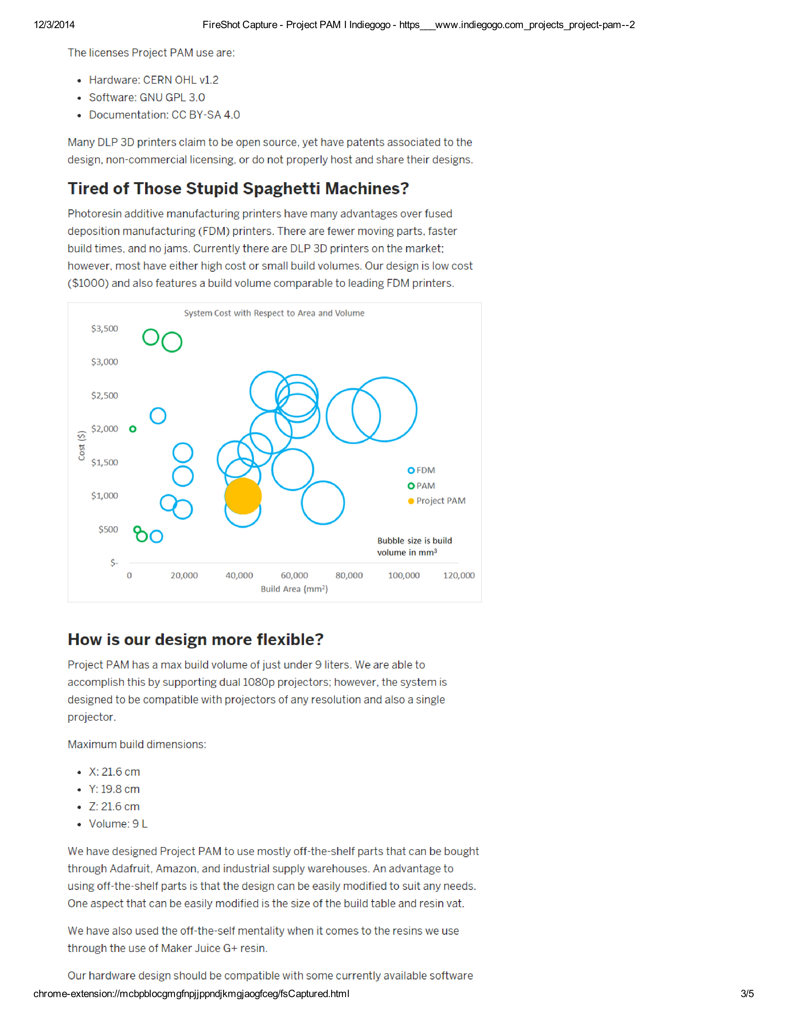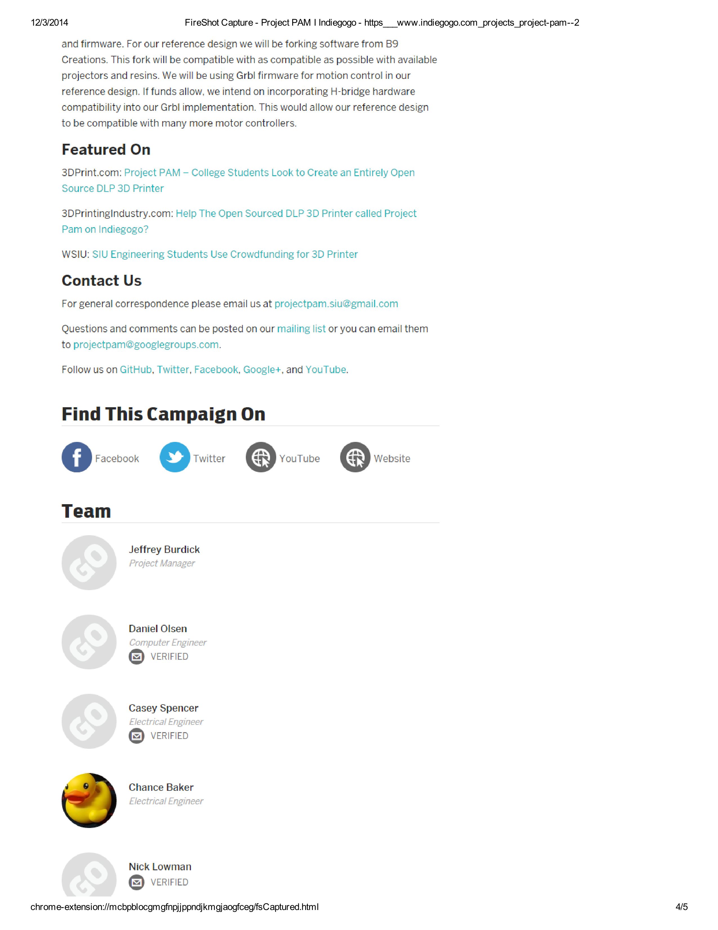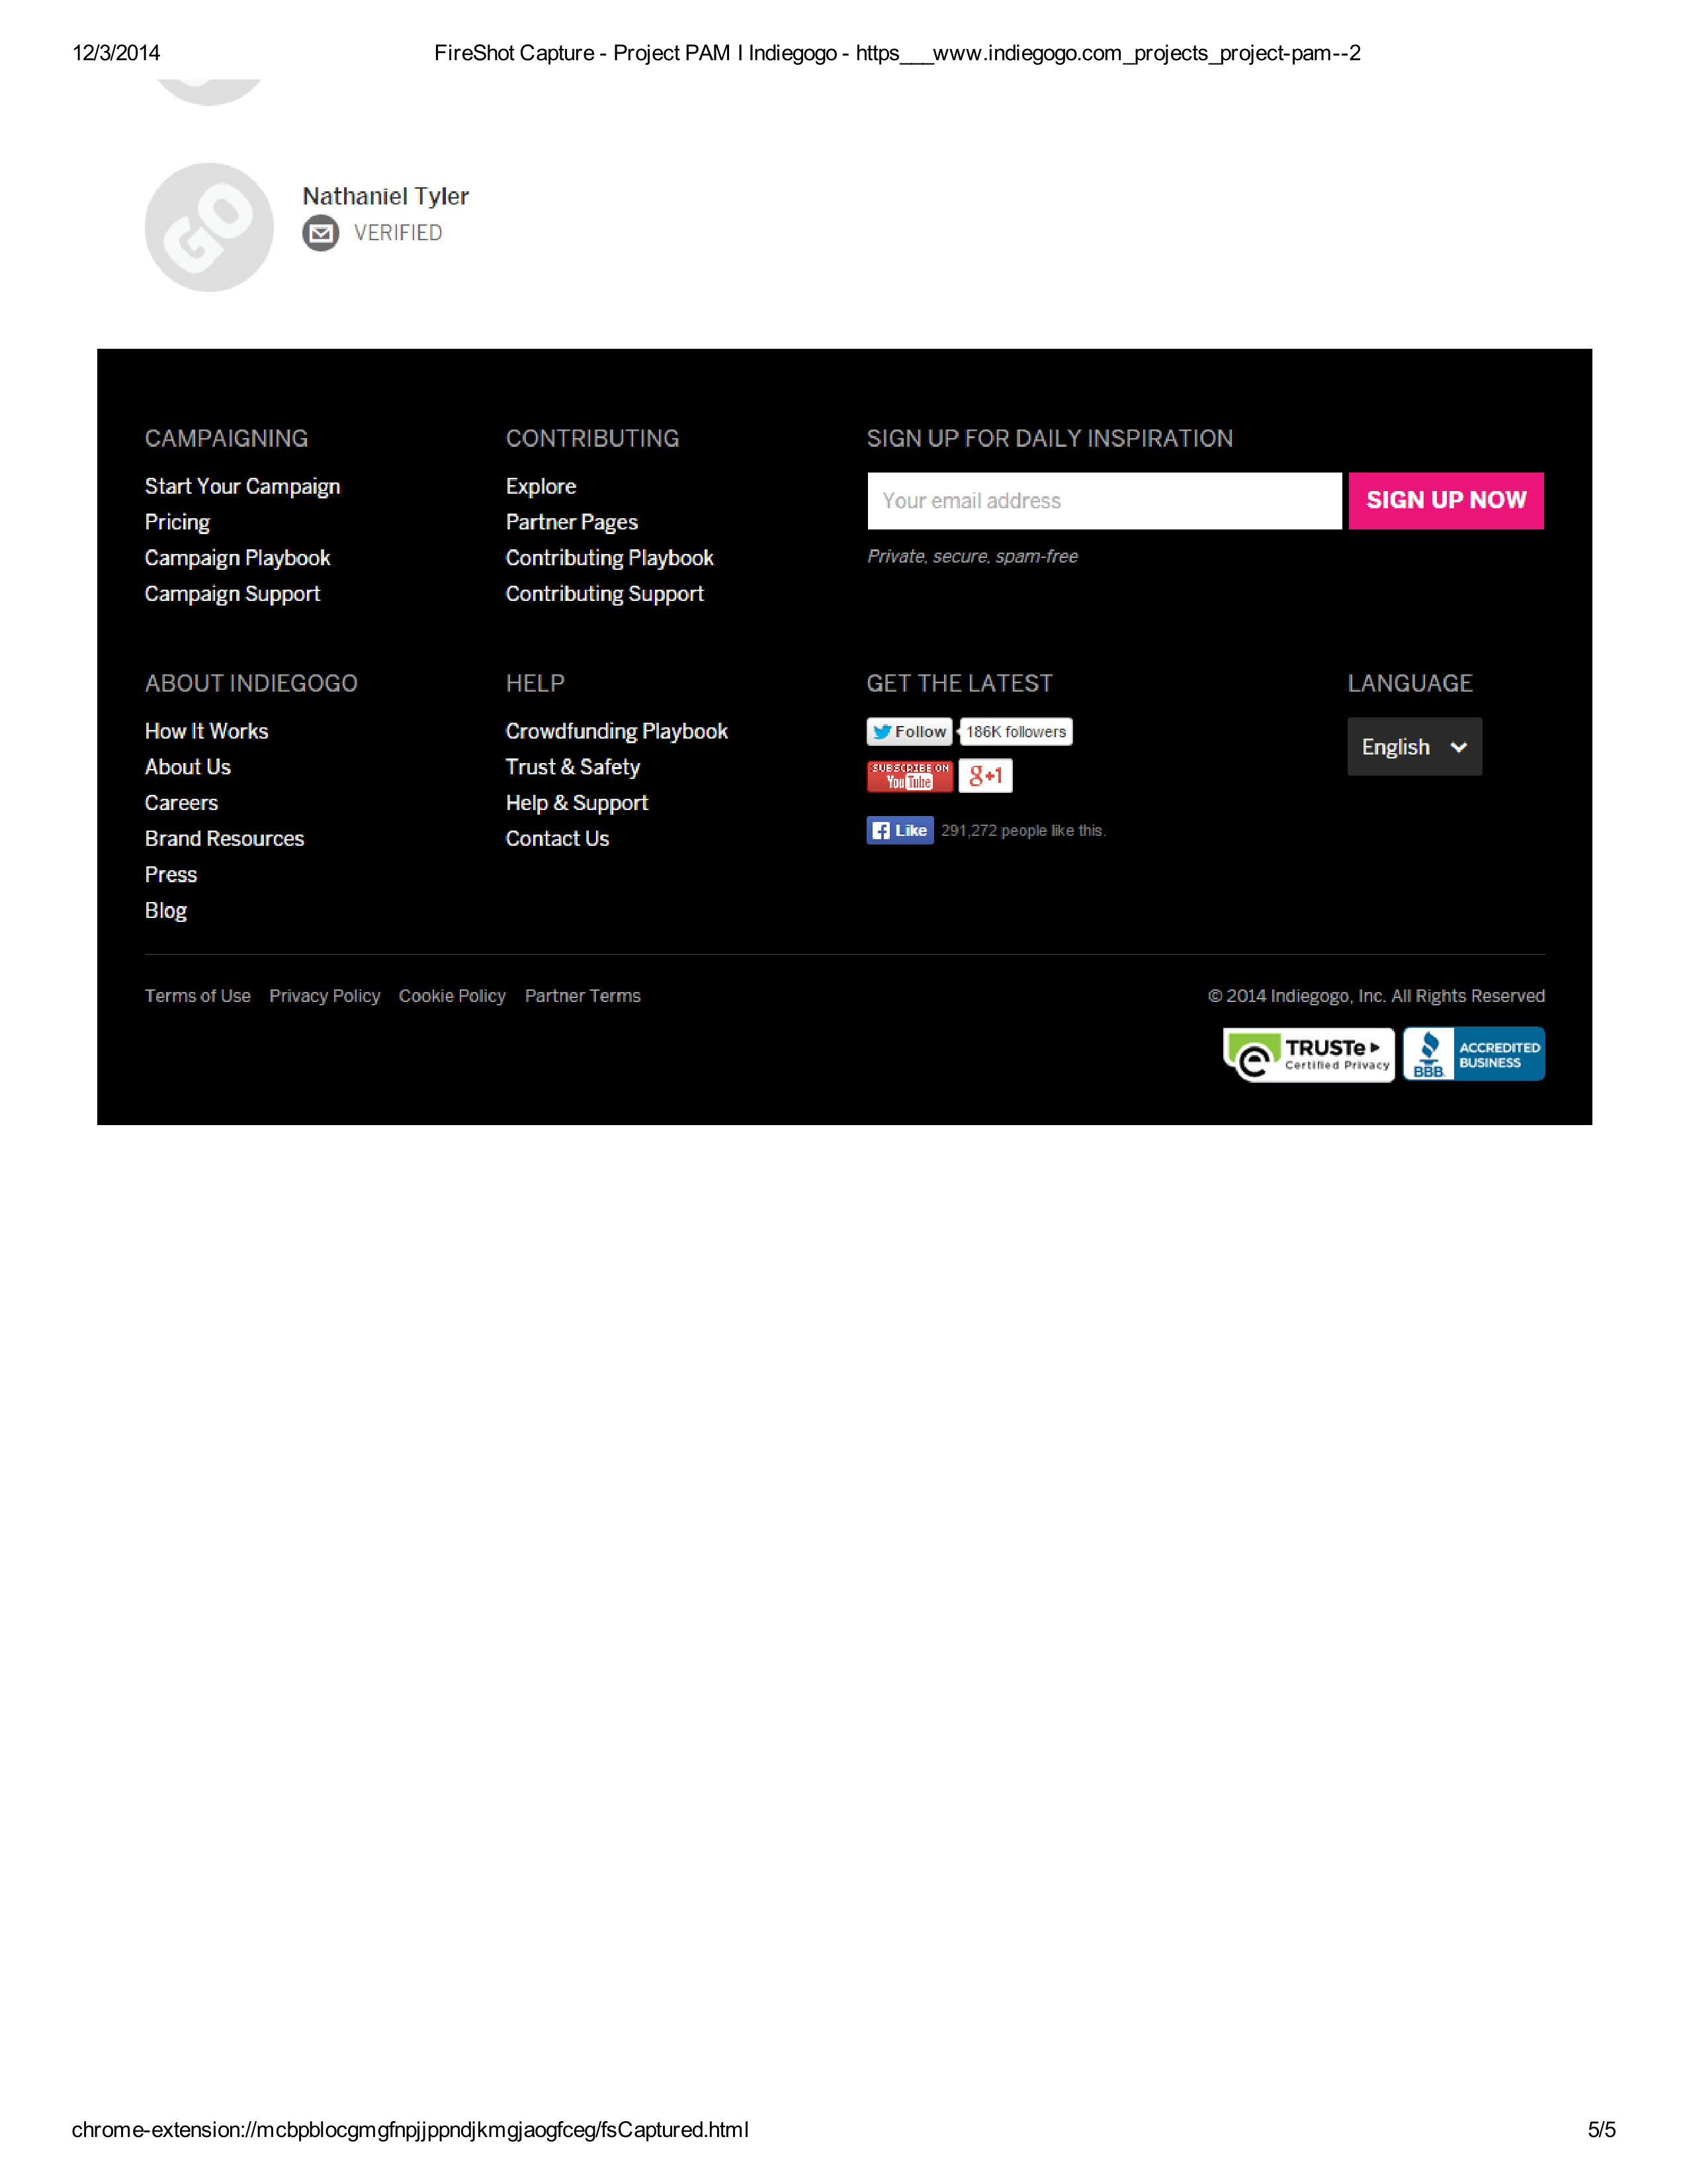

### Funders

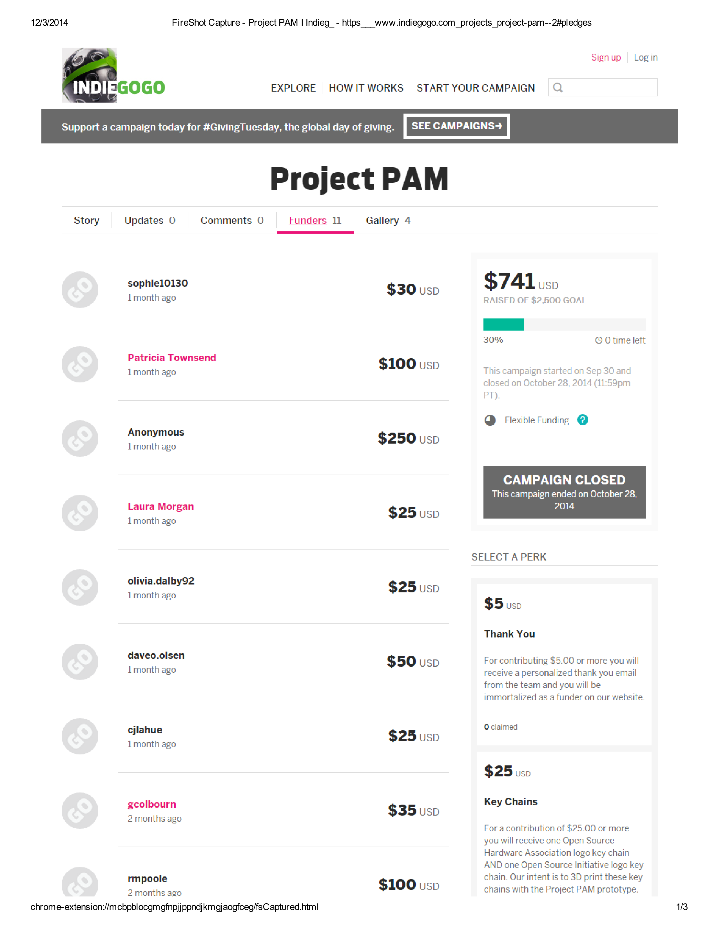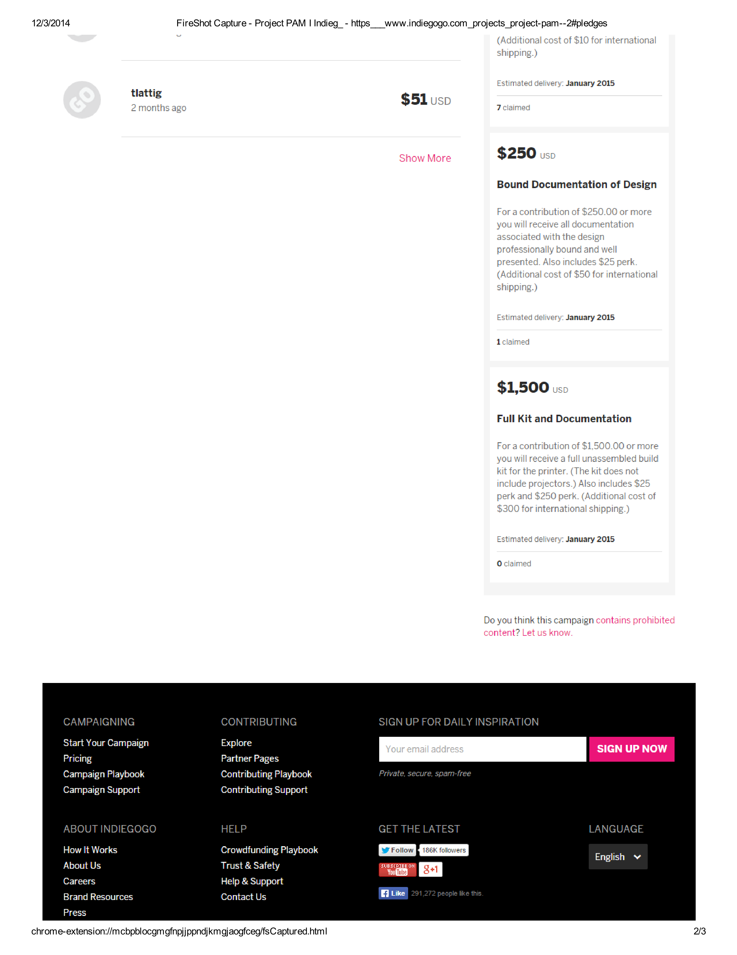

### Gallery

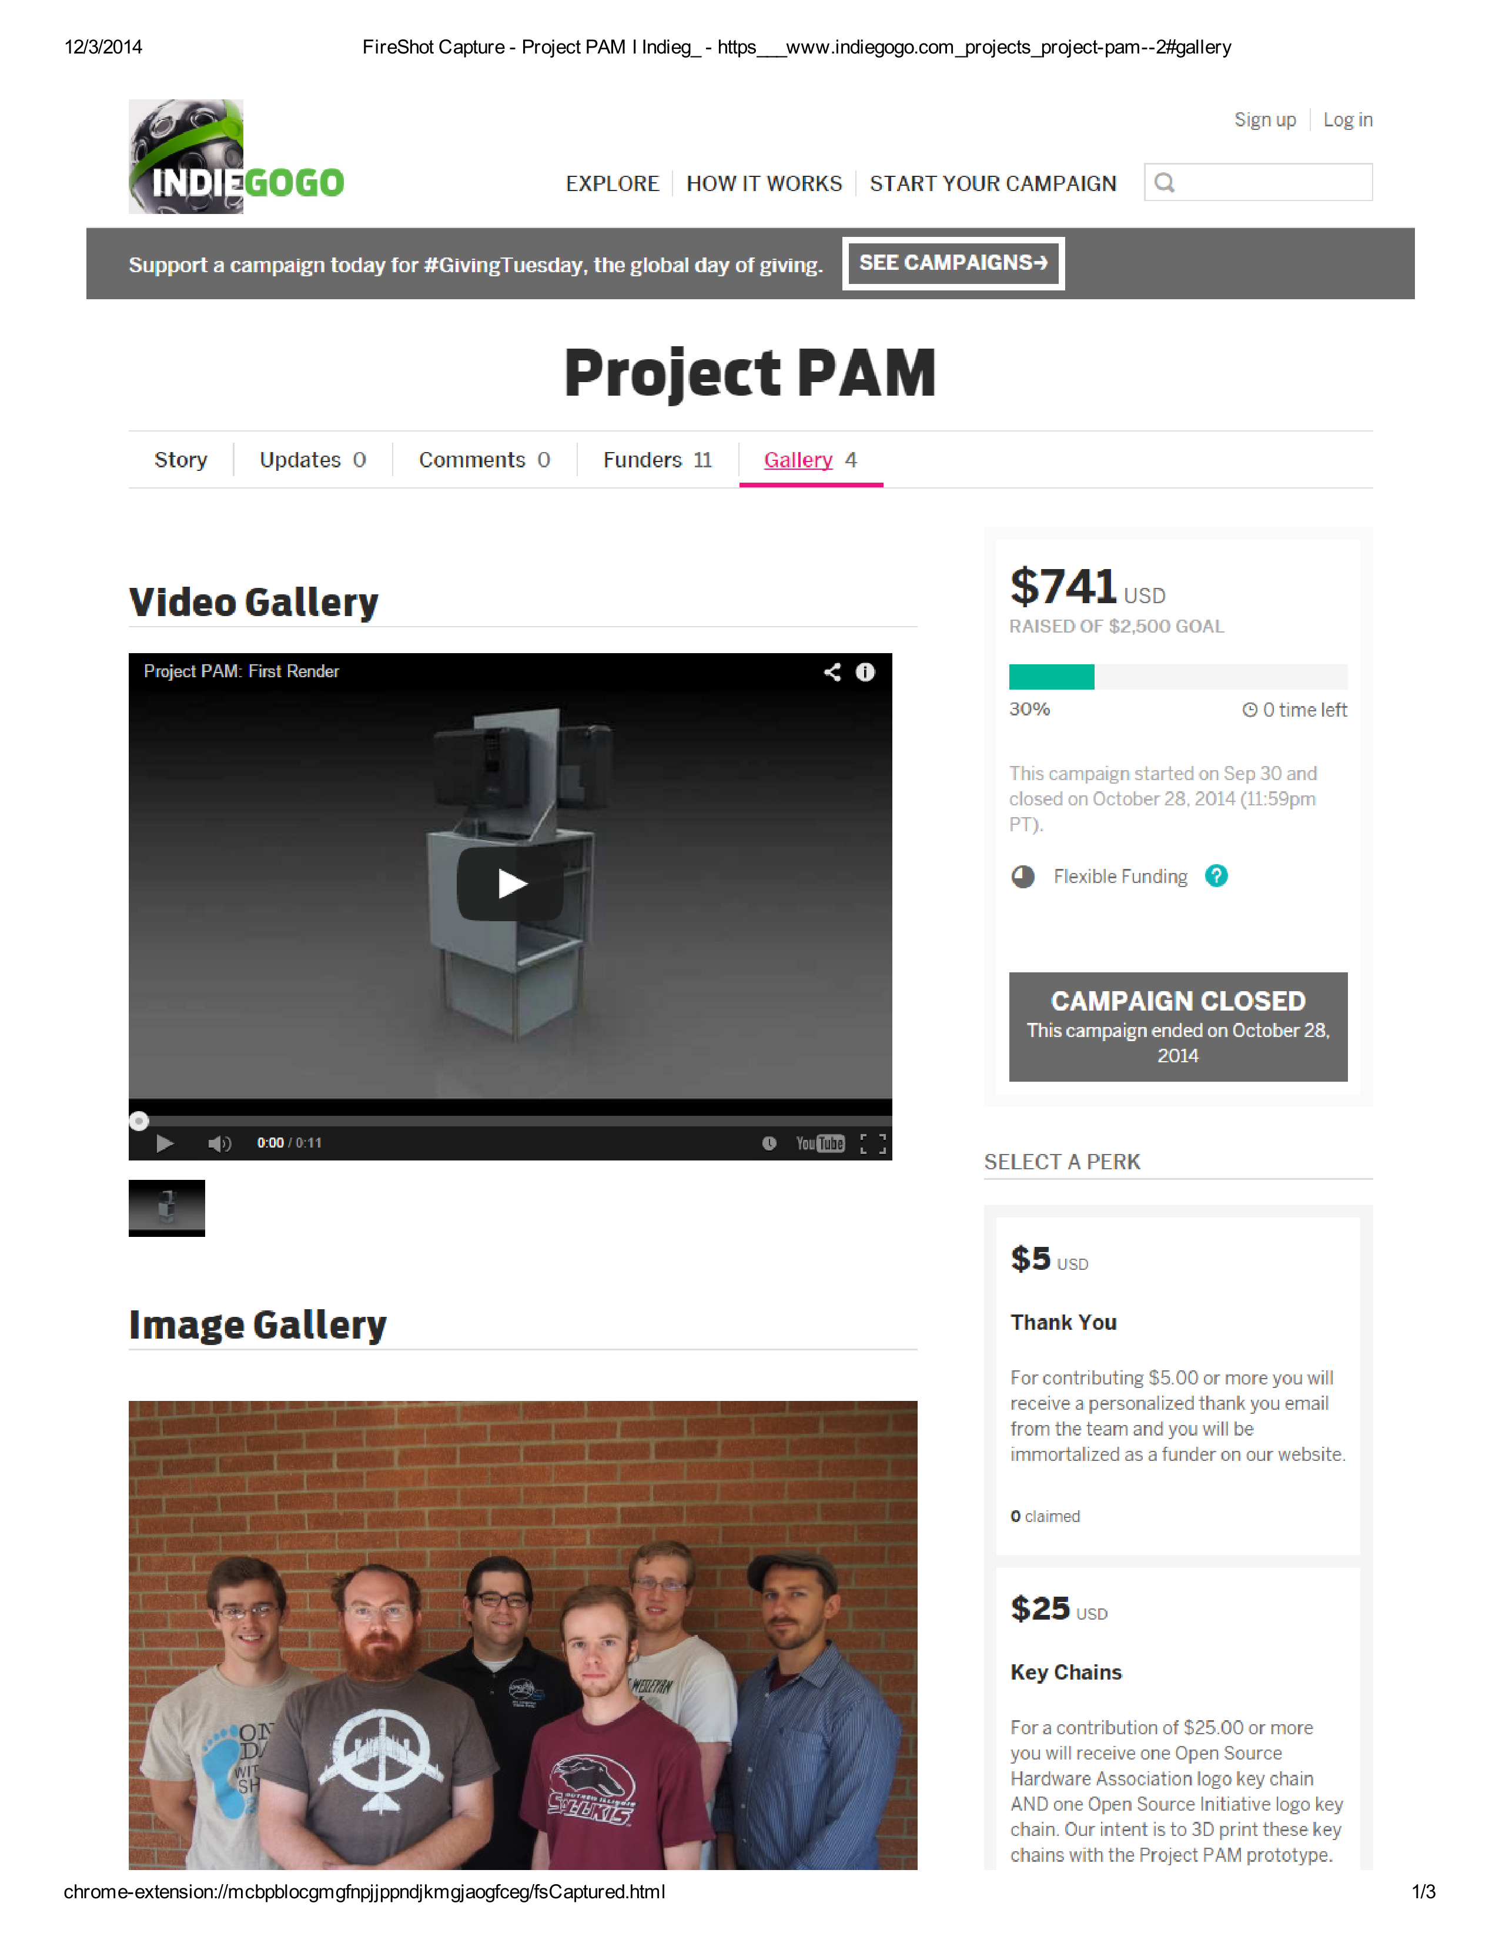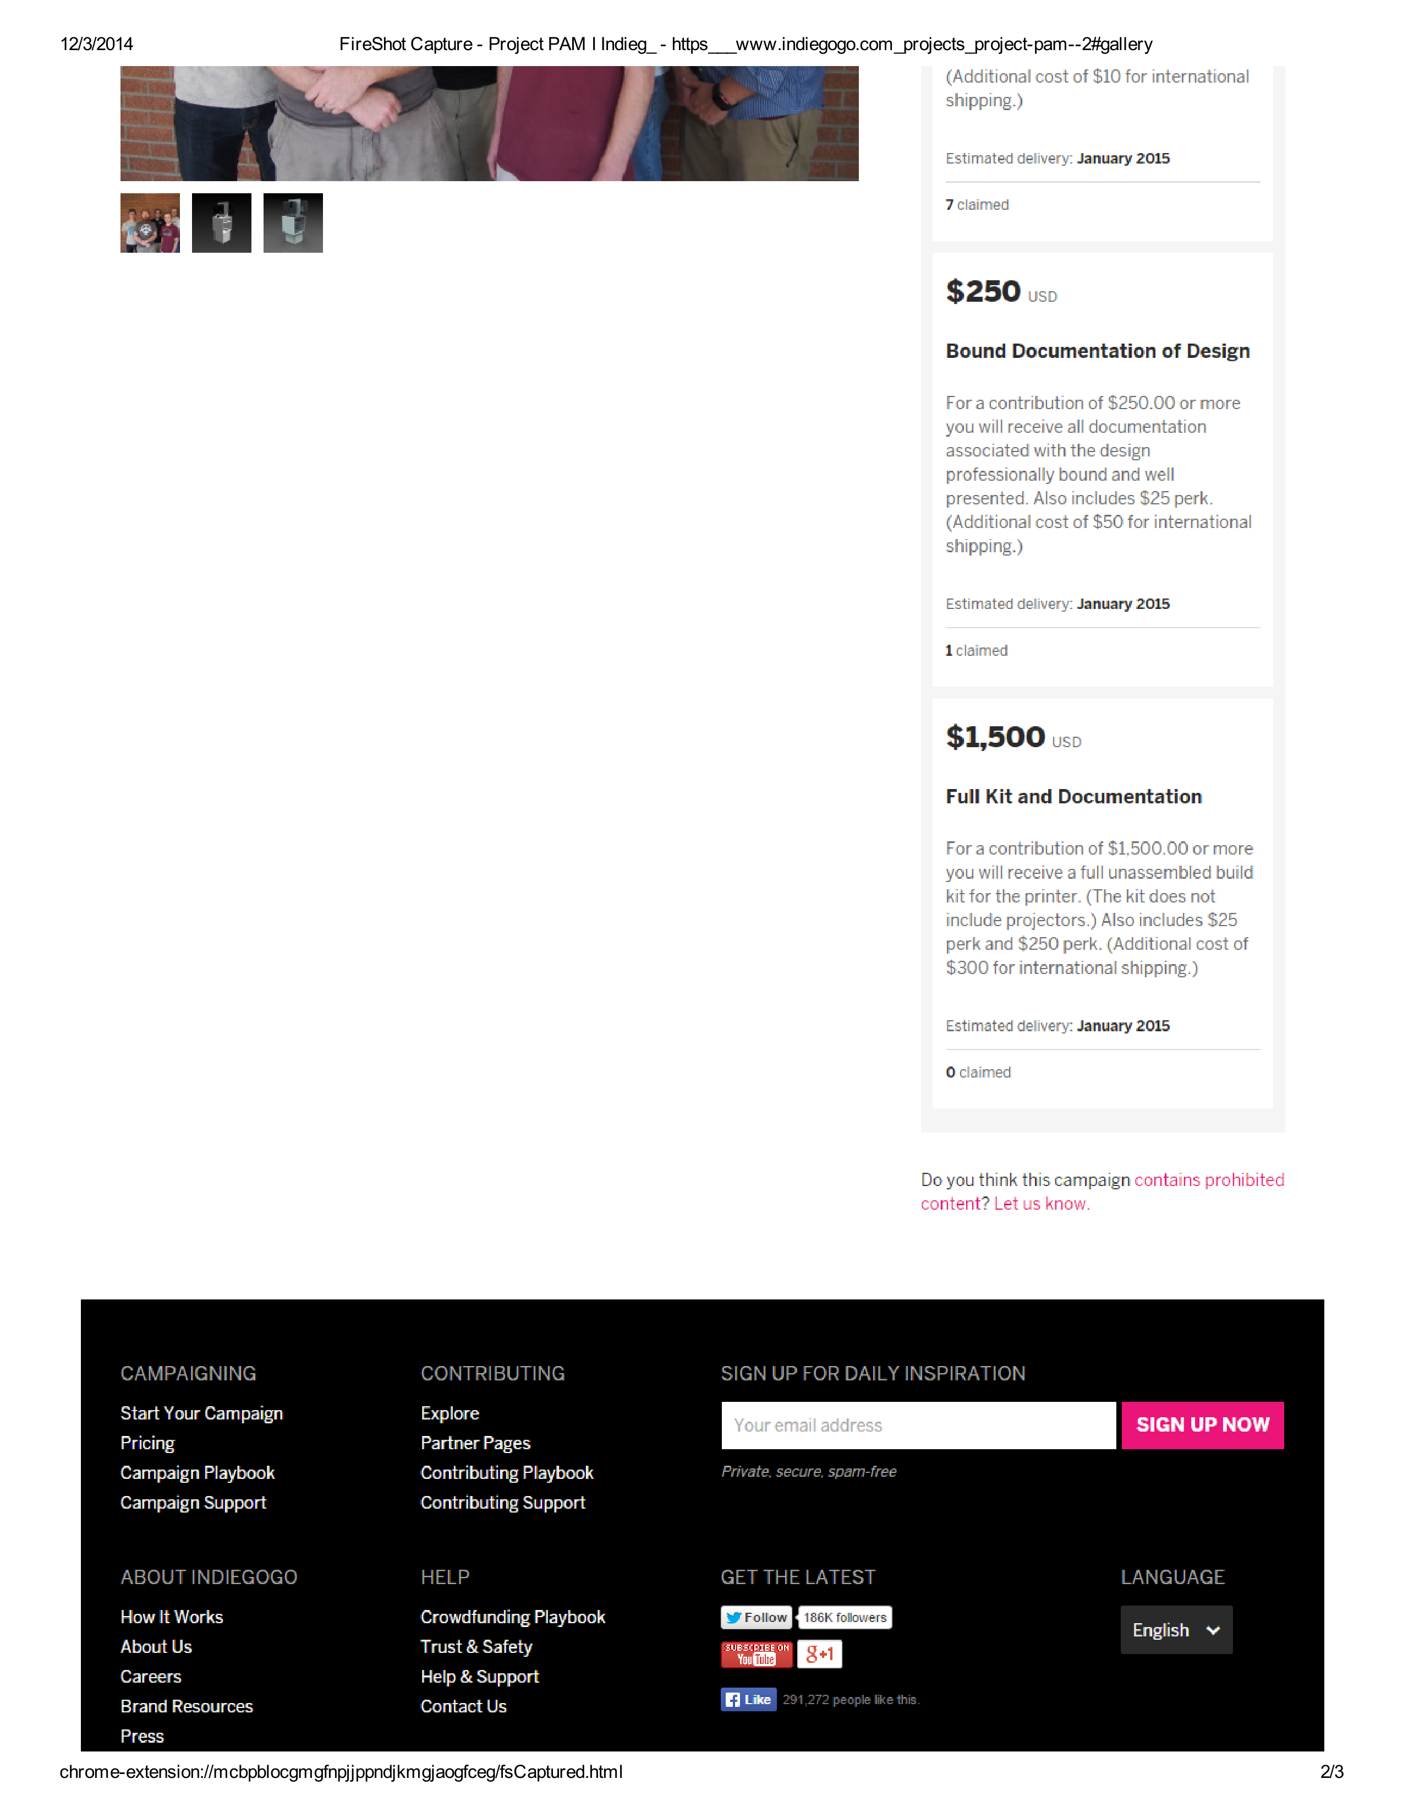

## Social Media Pages

### Twitter Page

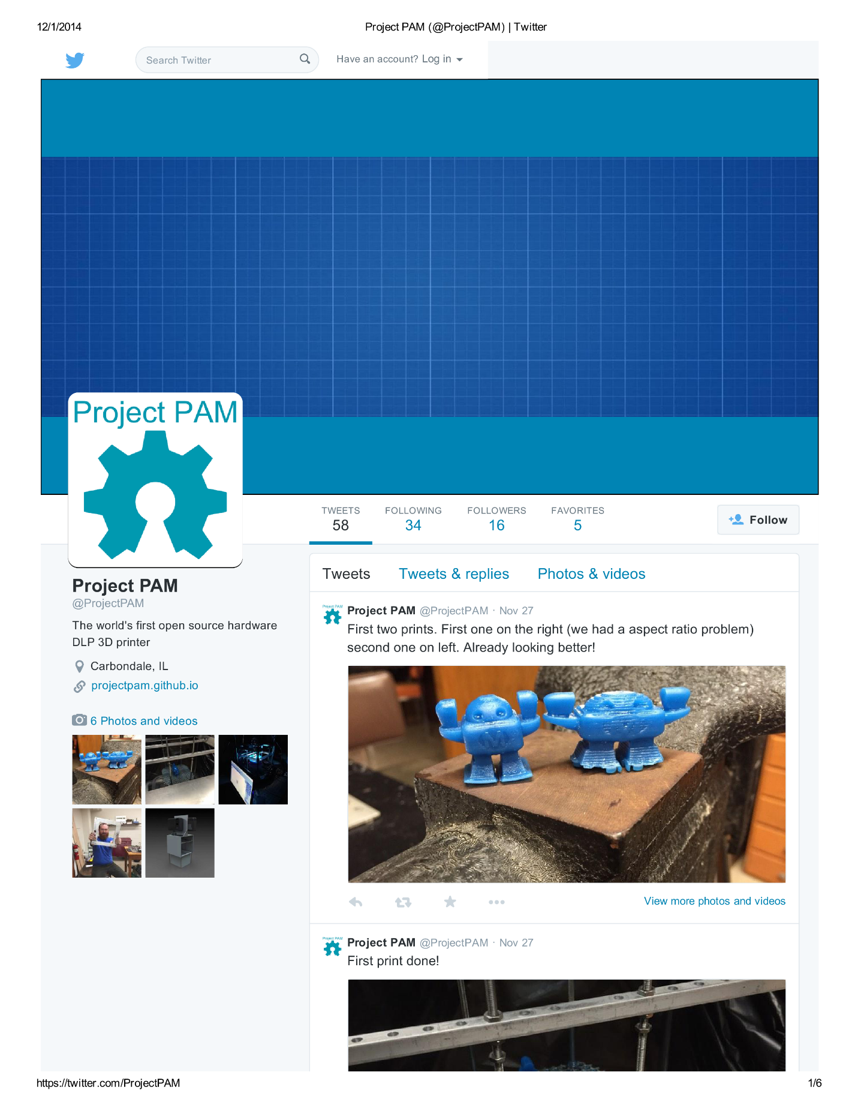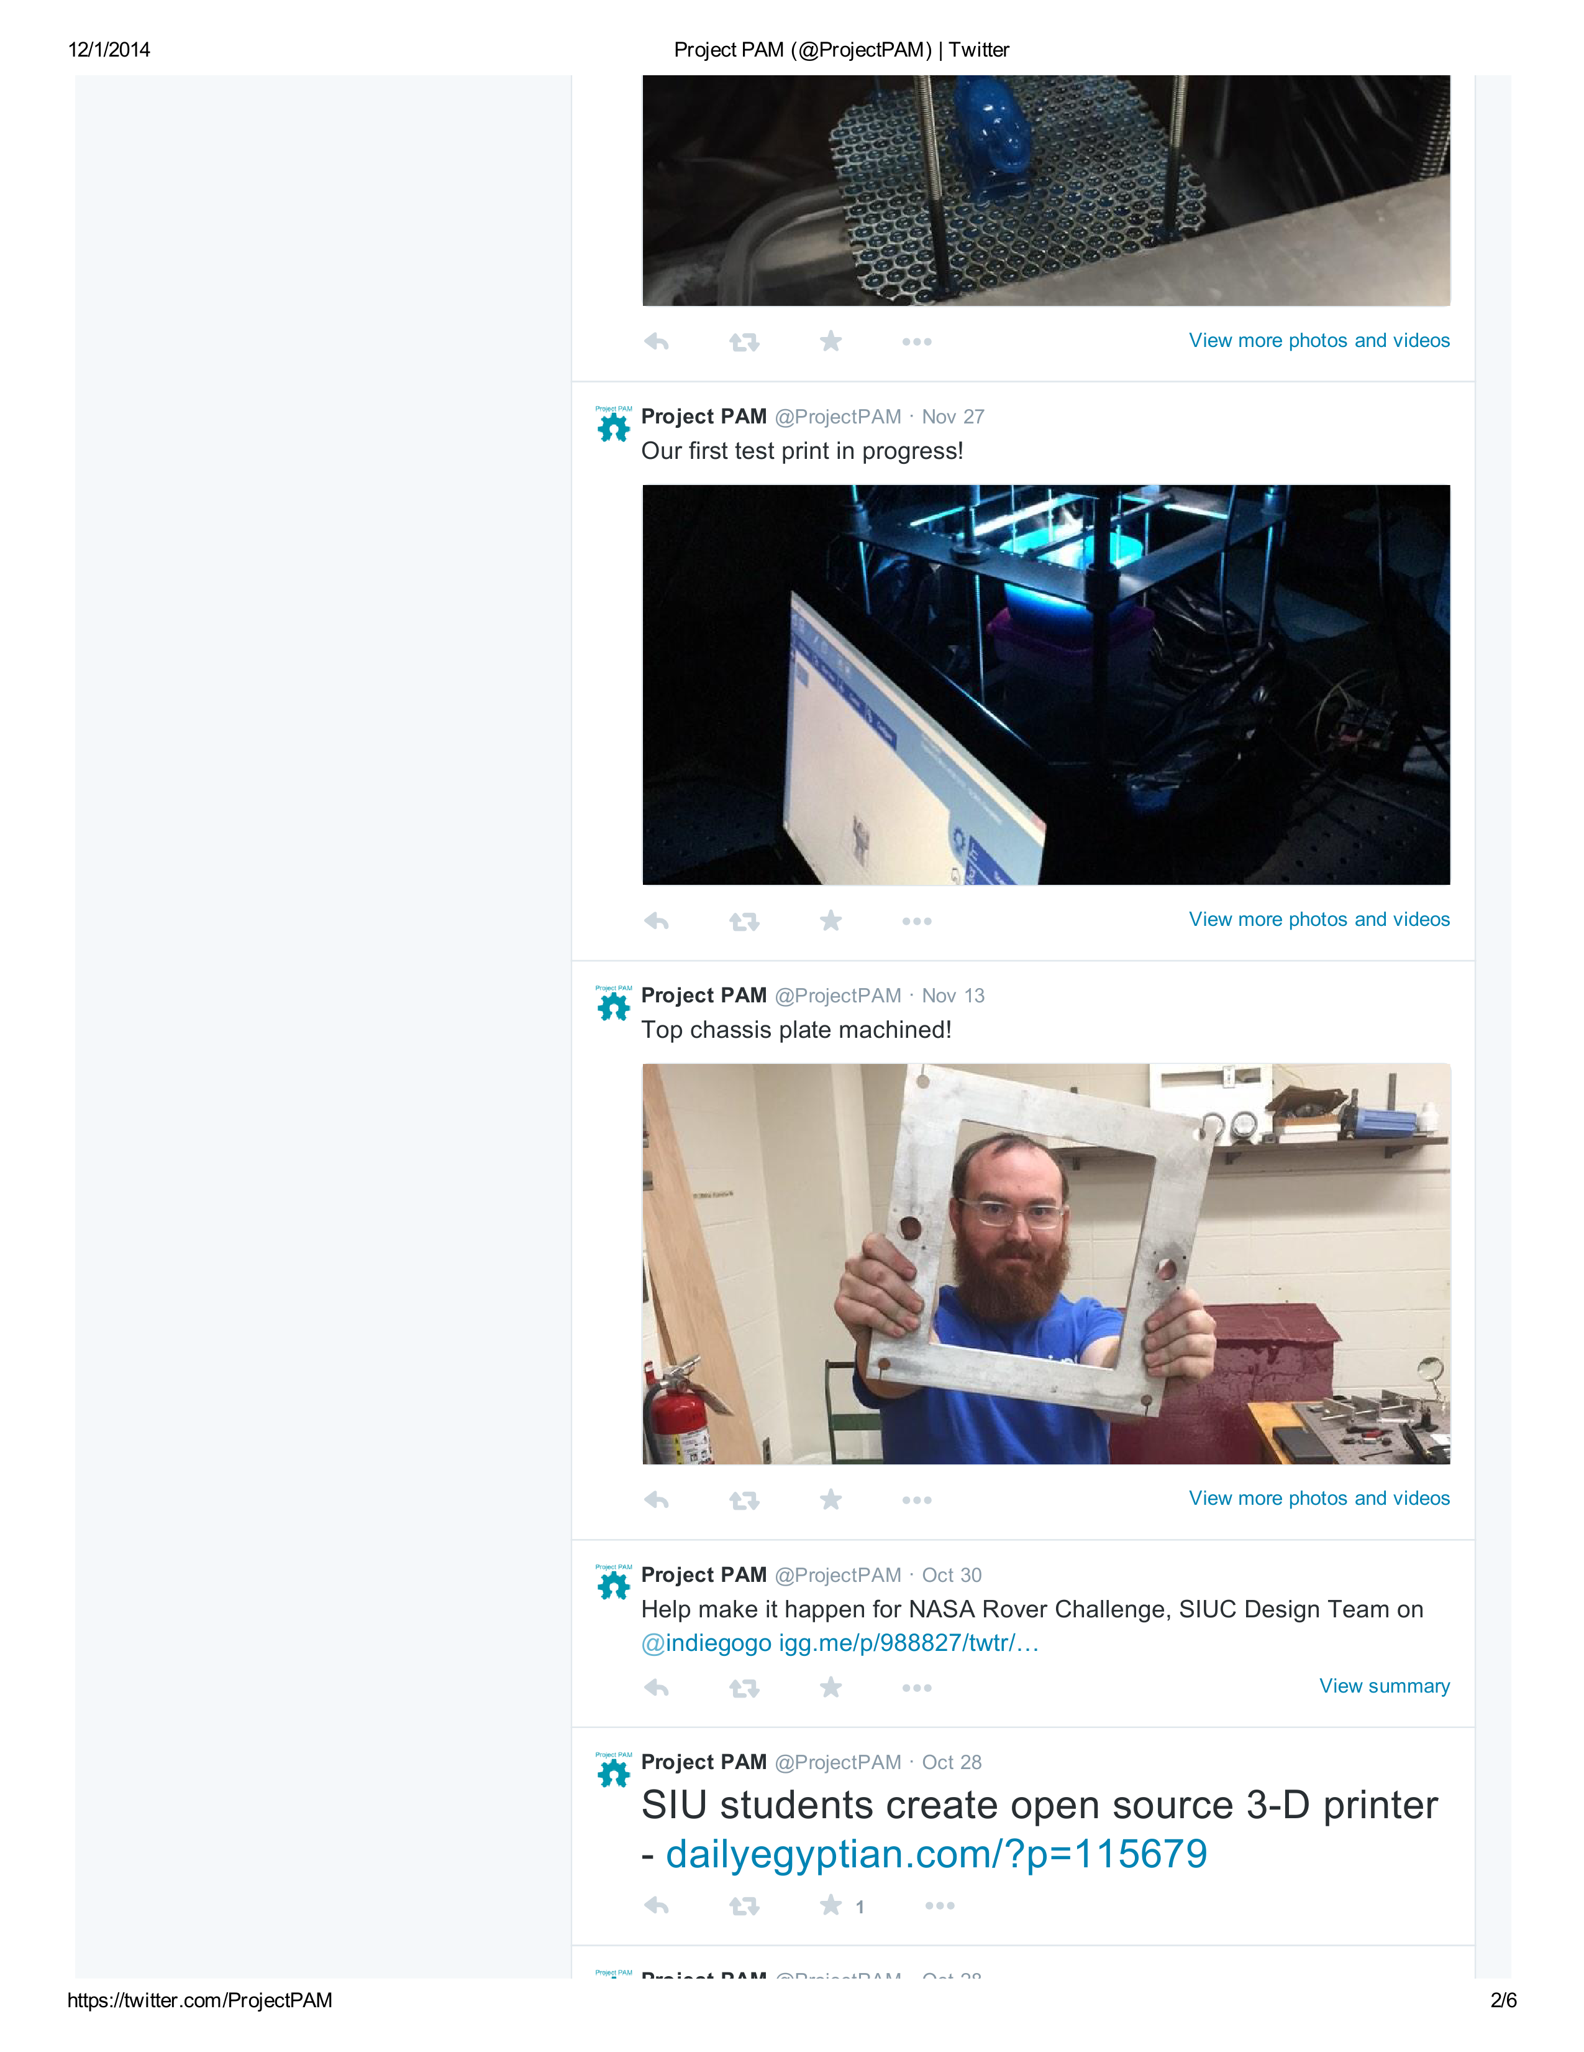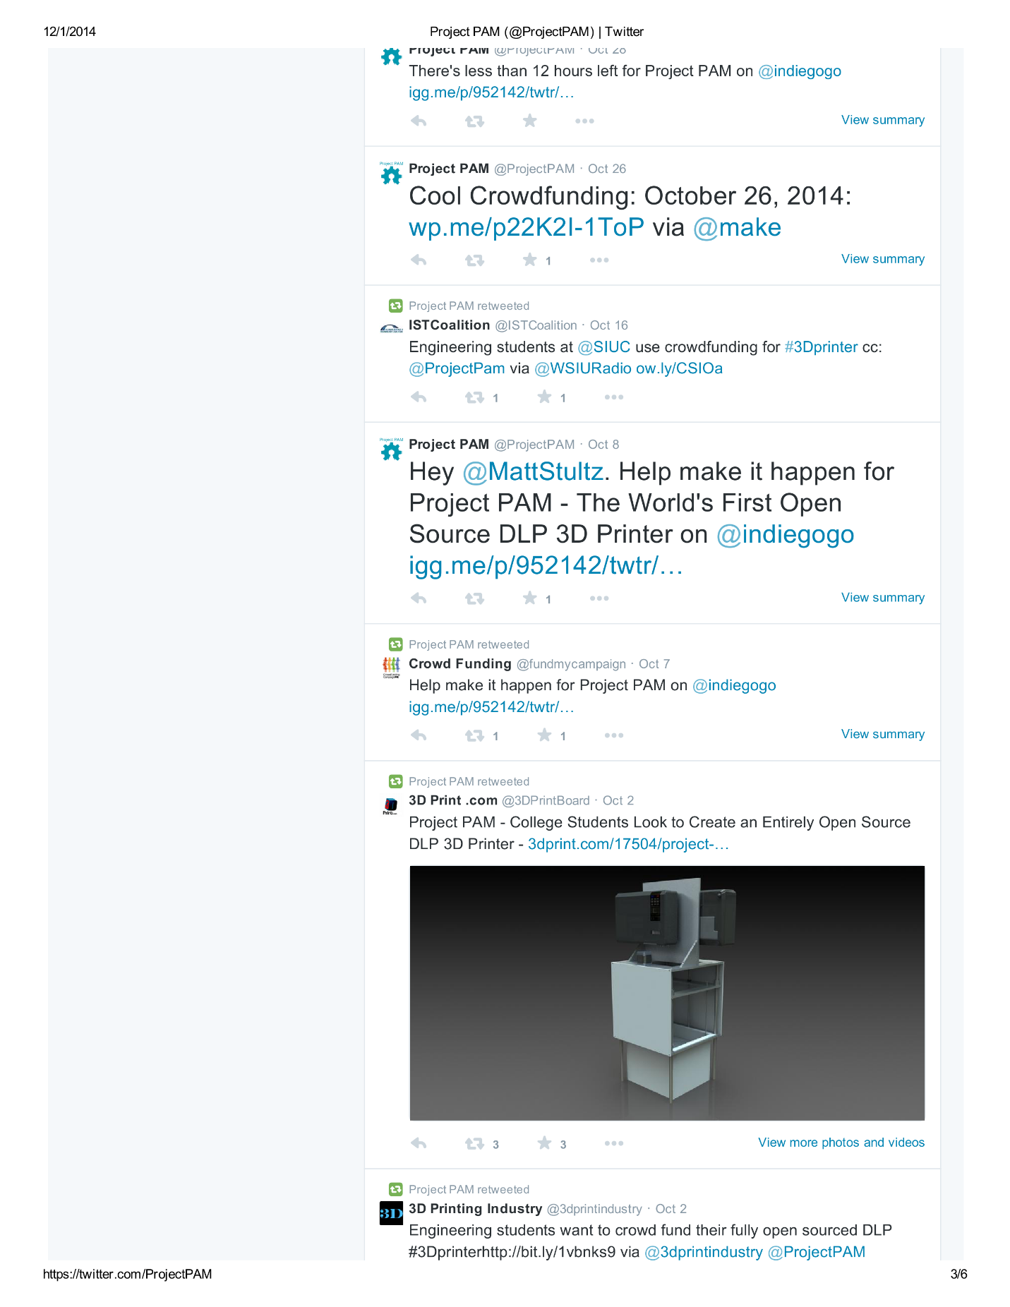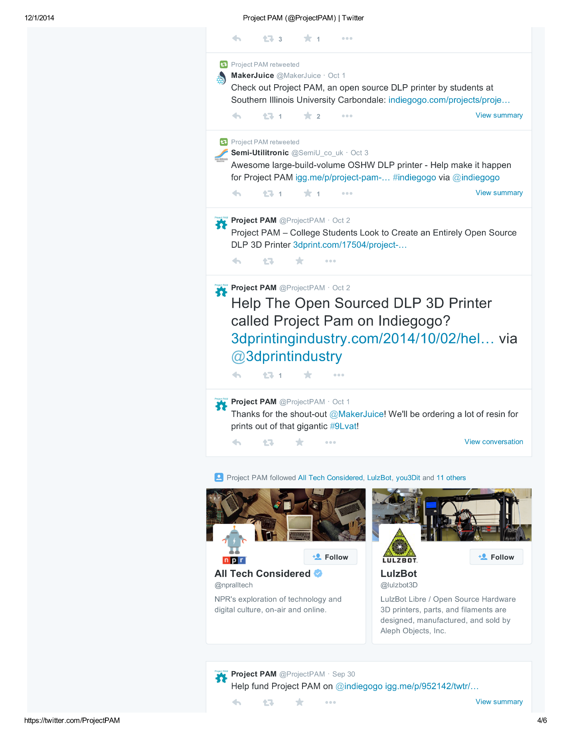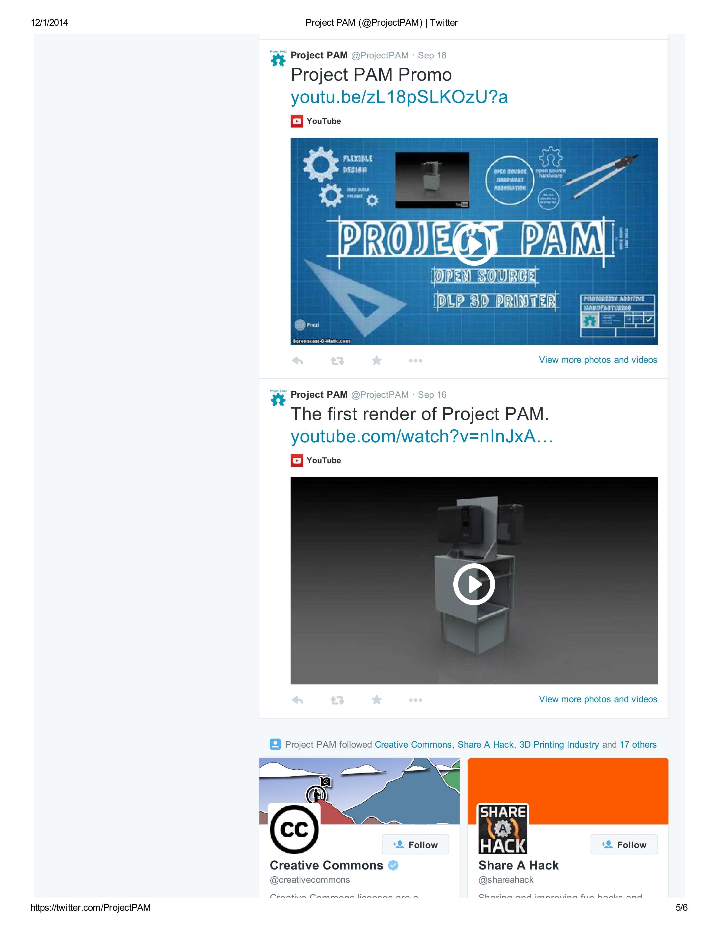

### Facebook Page

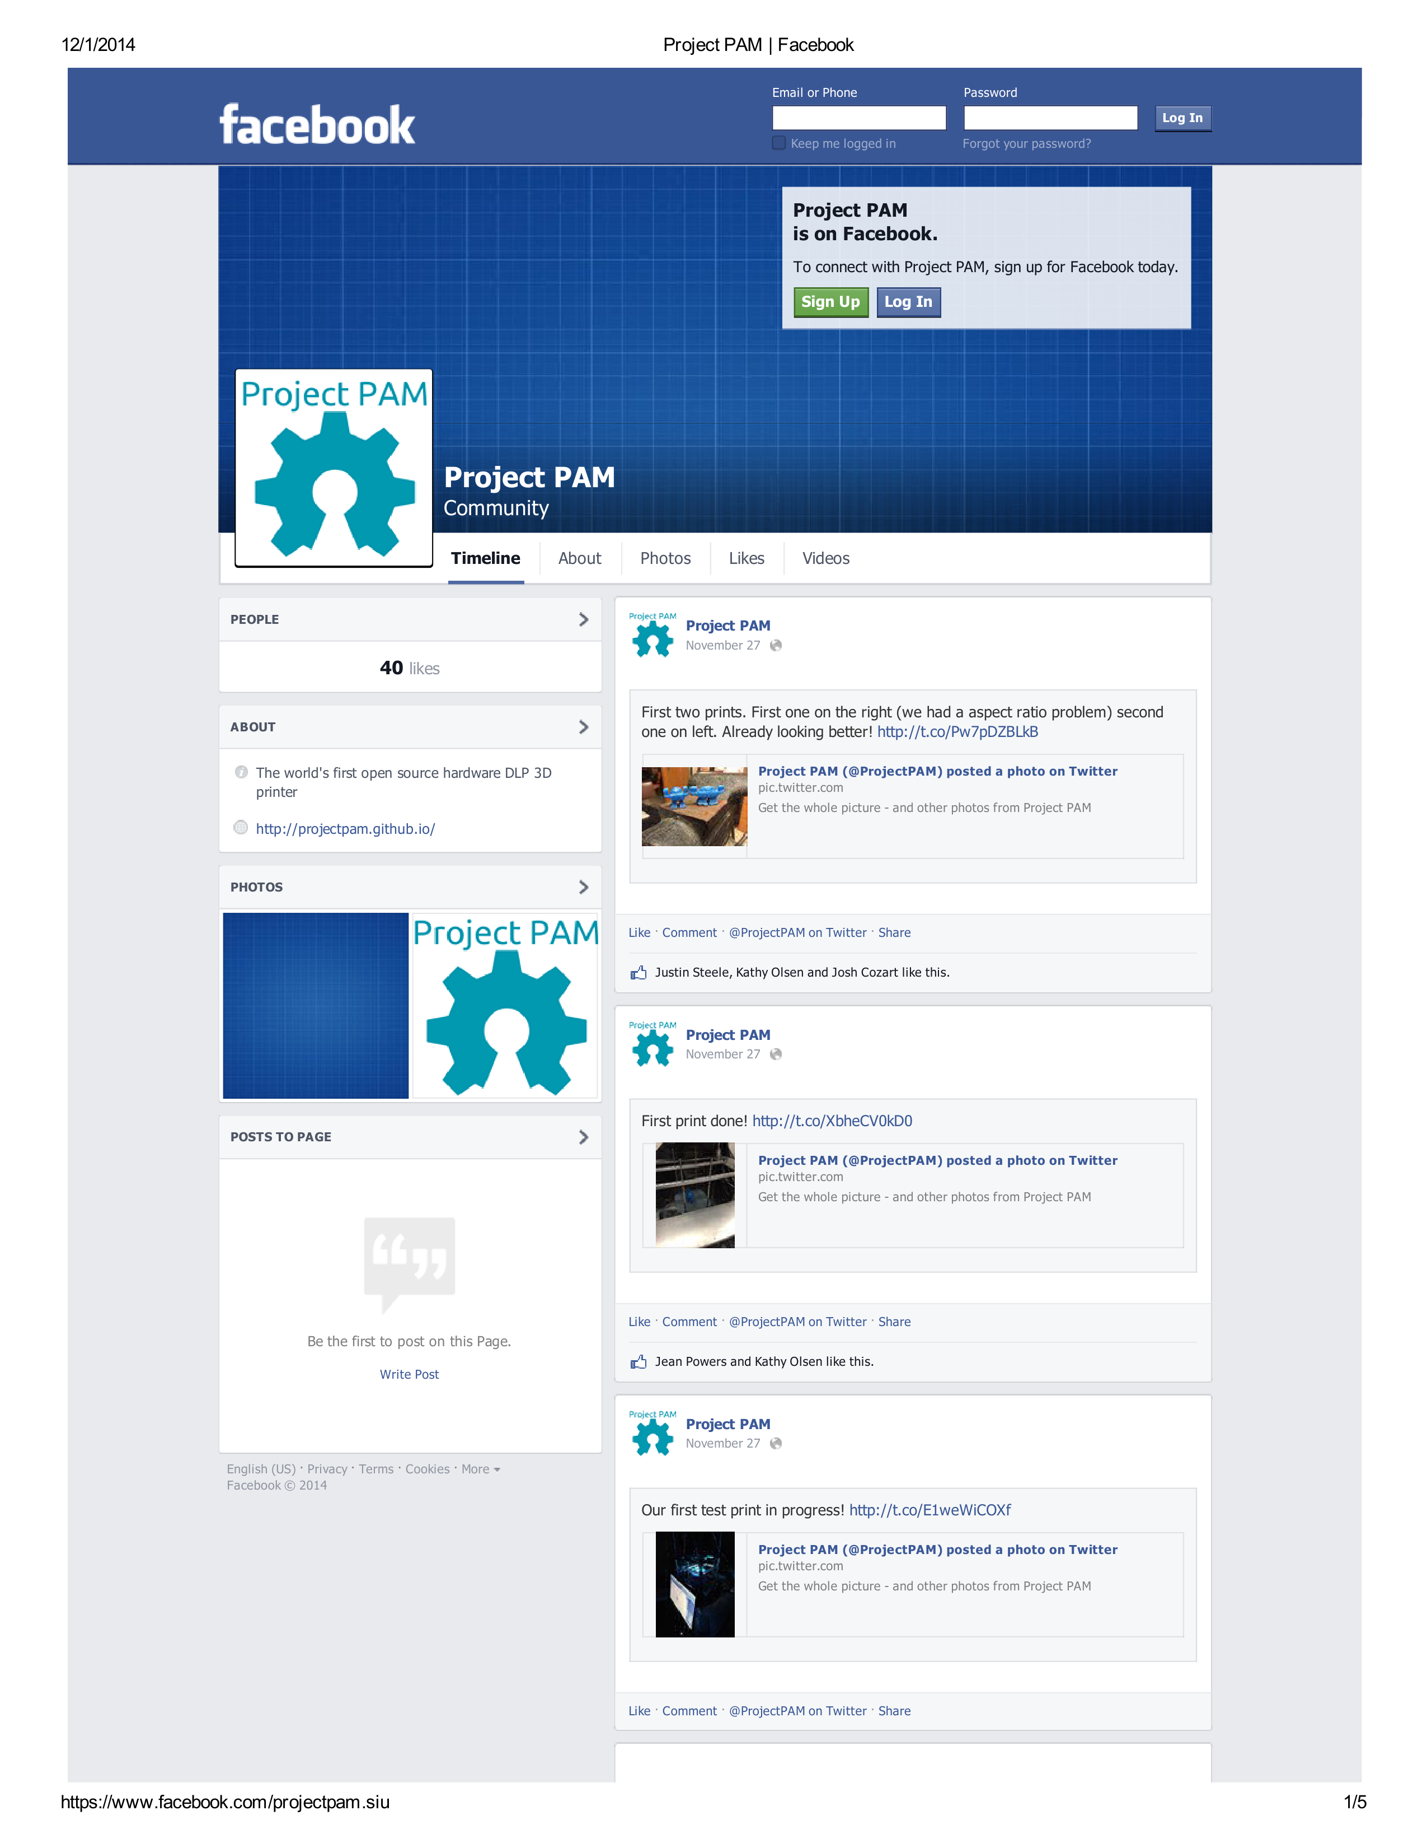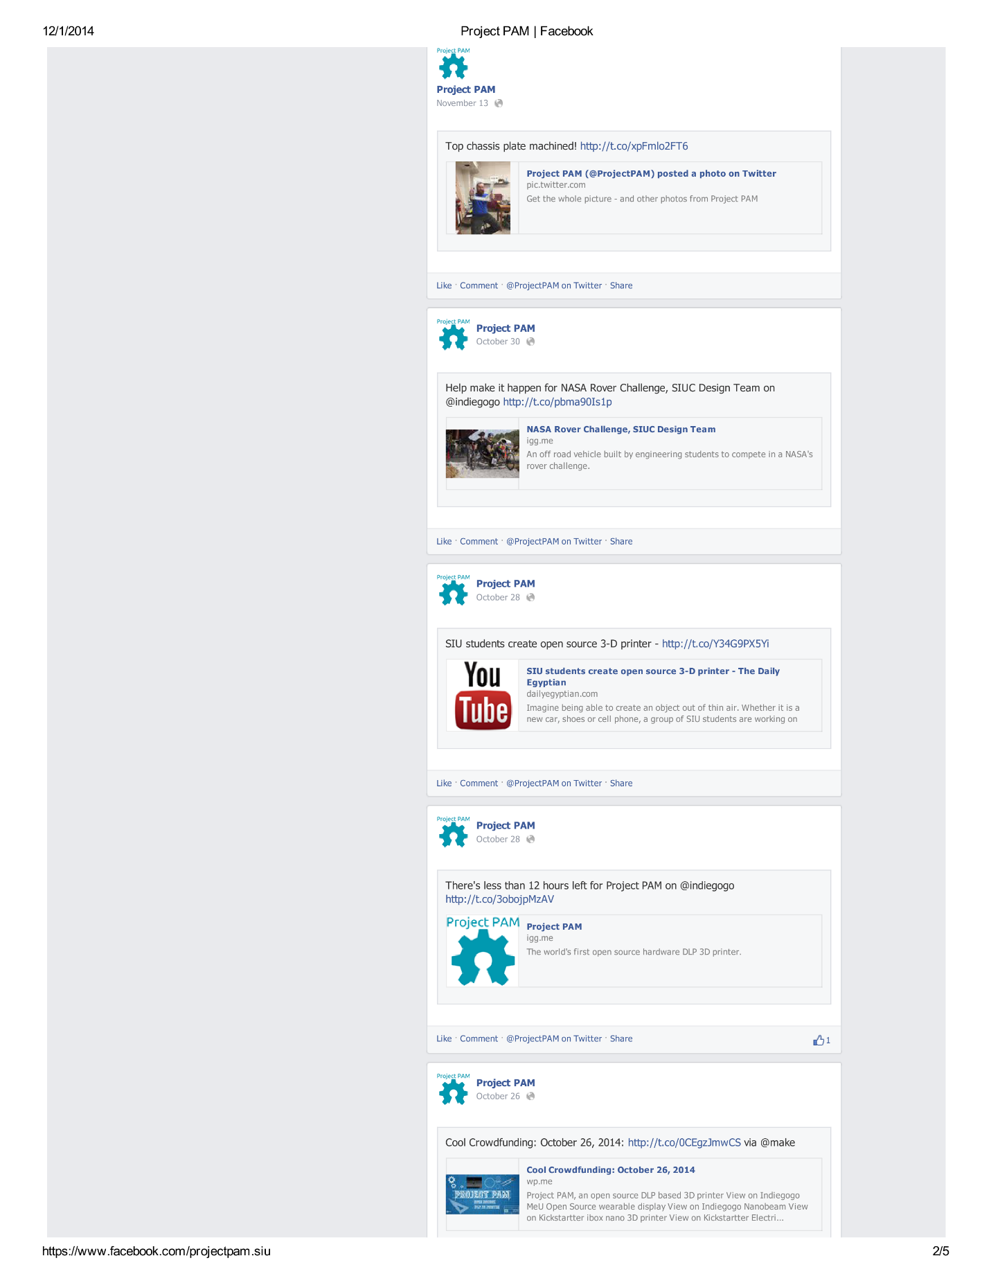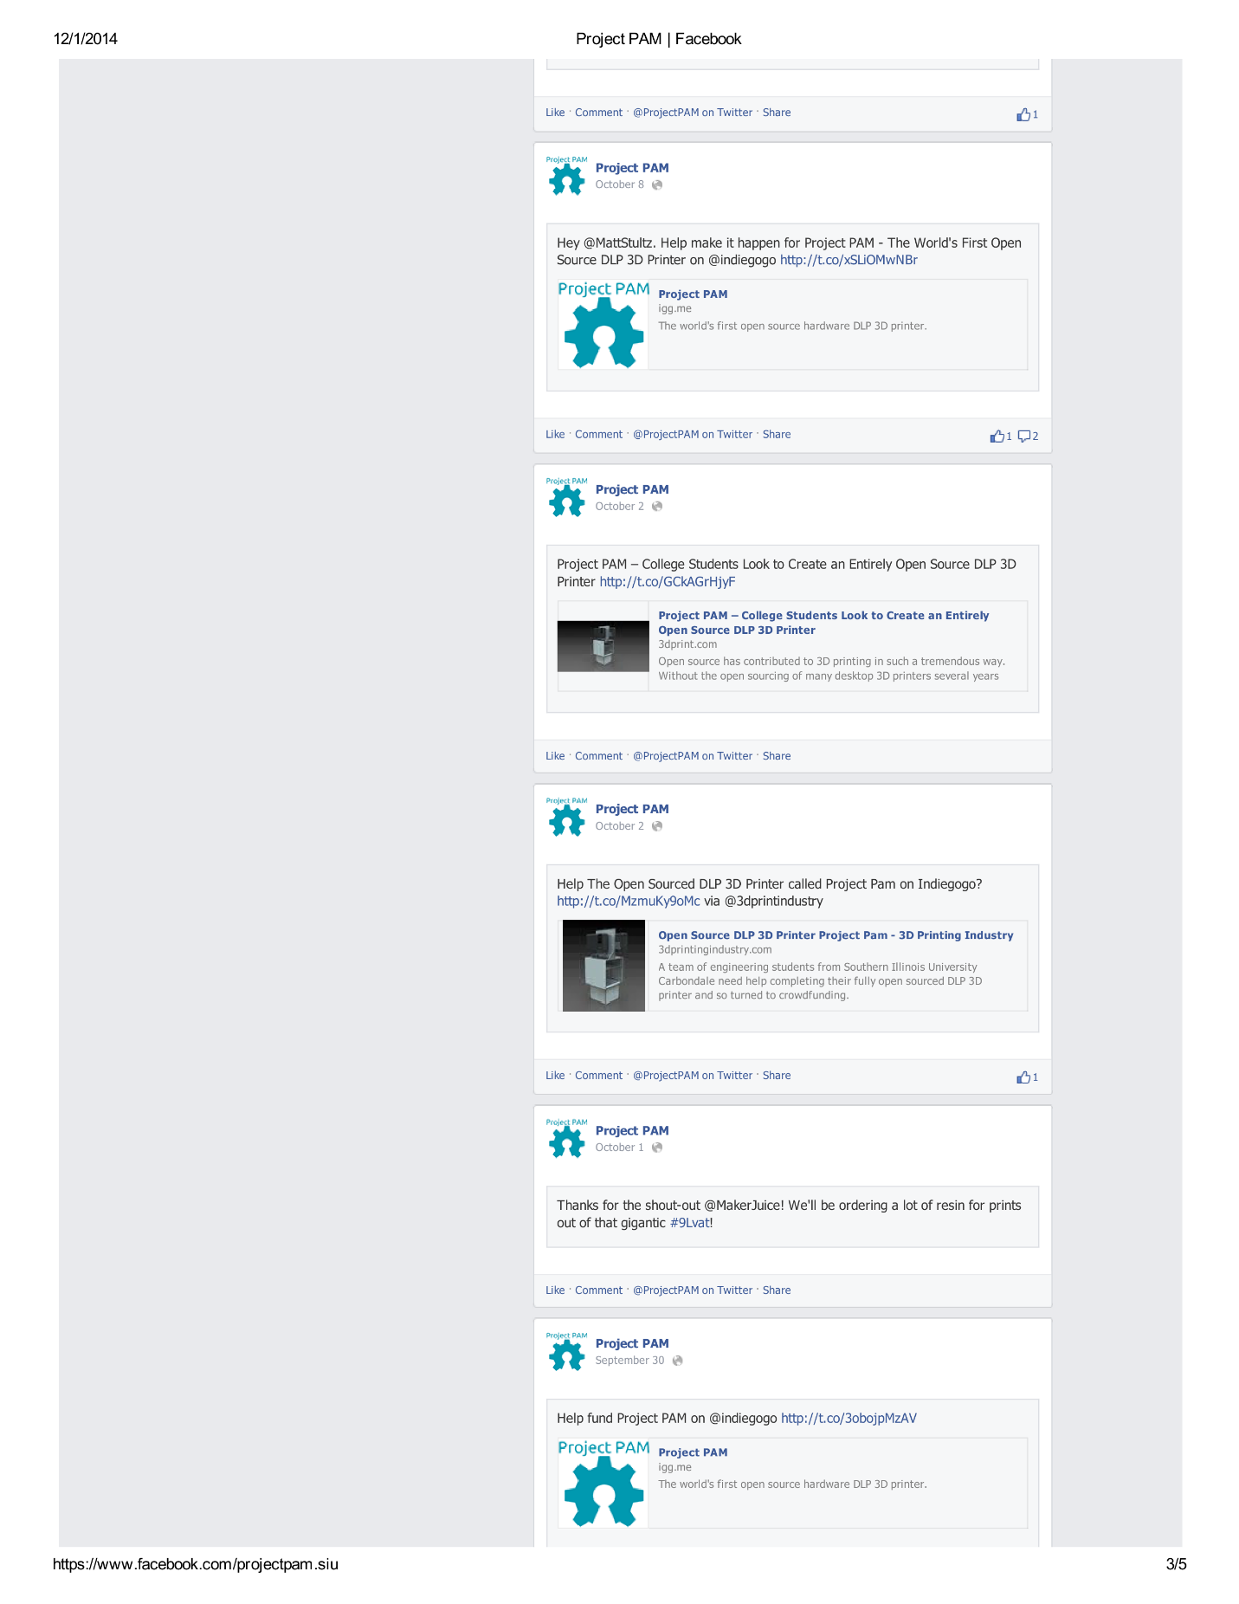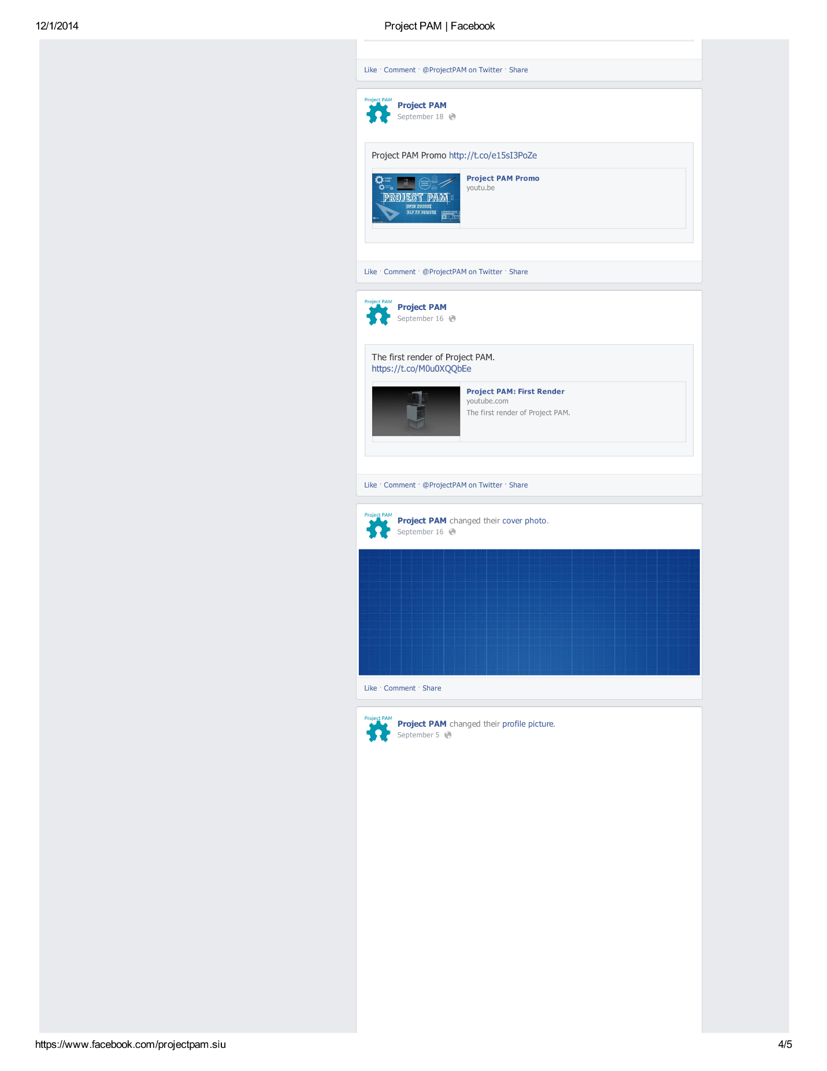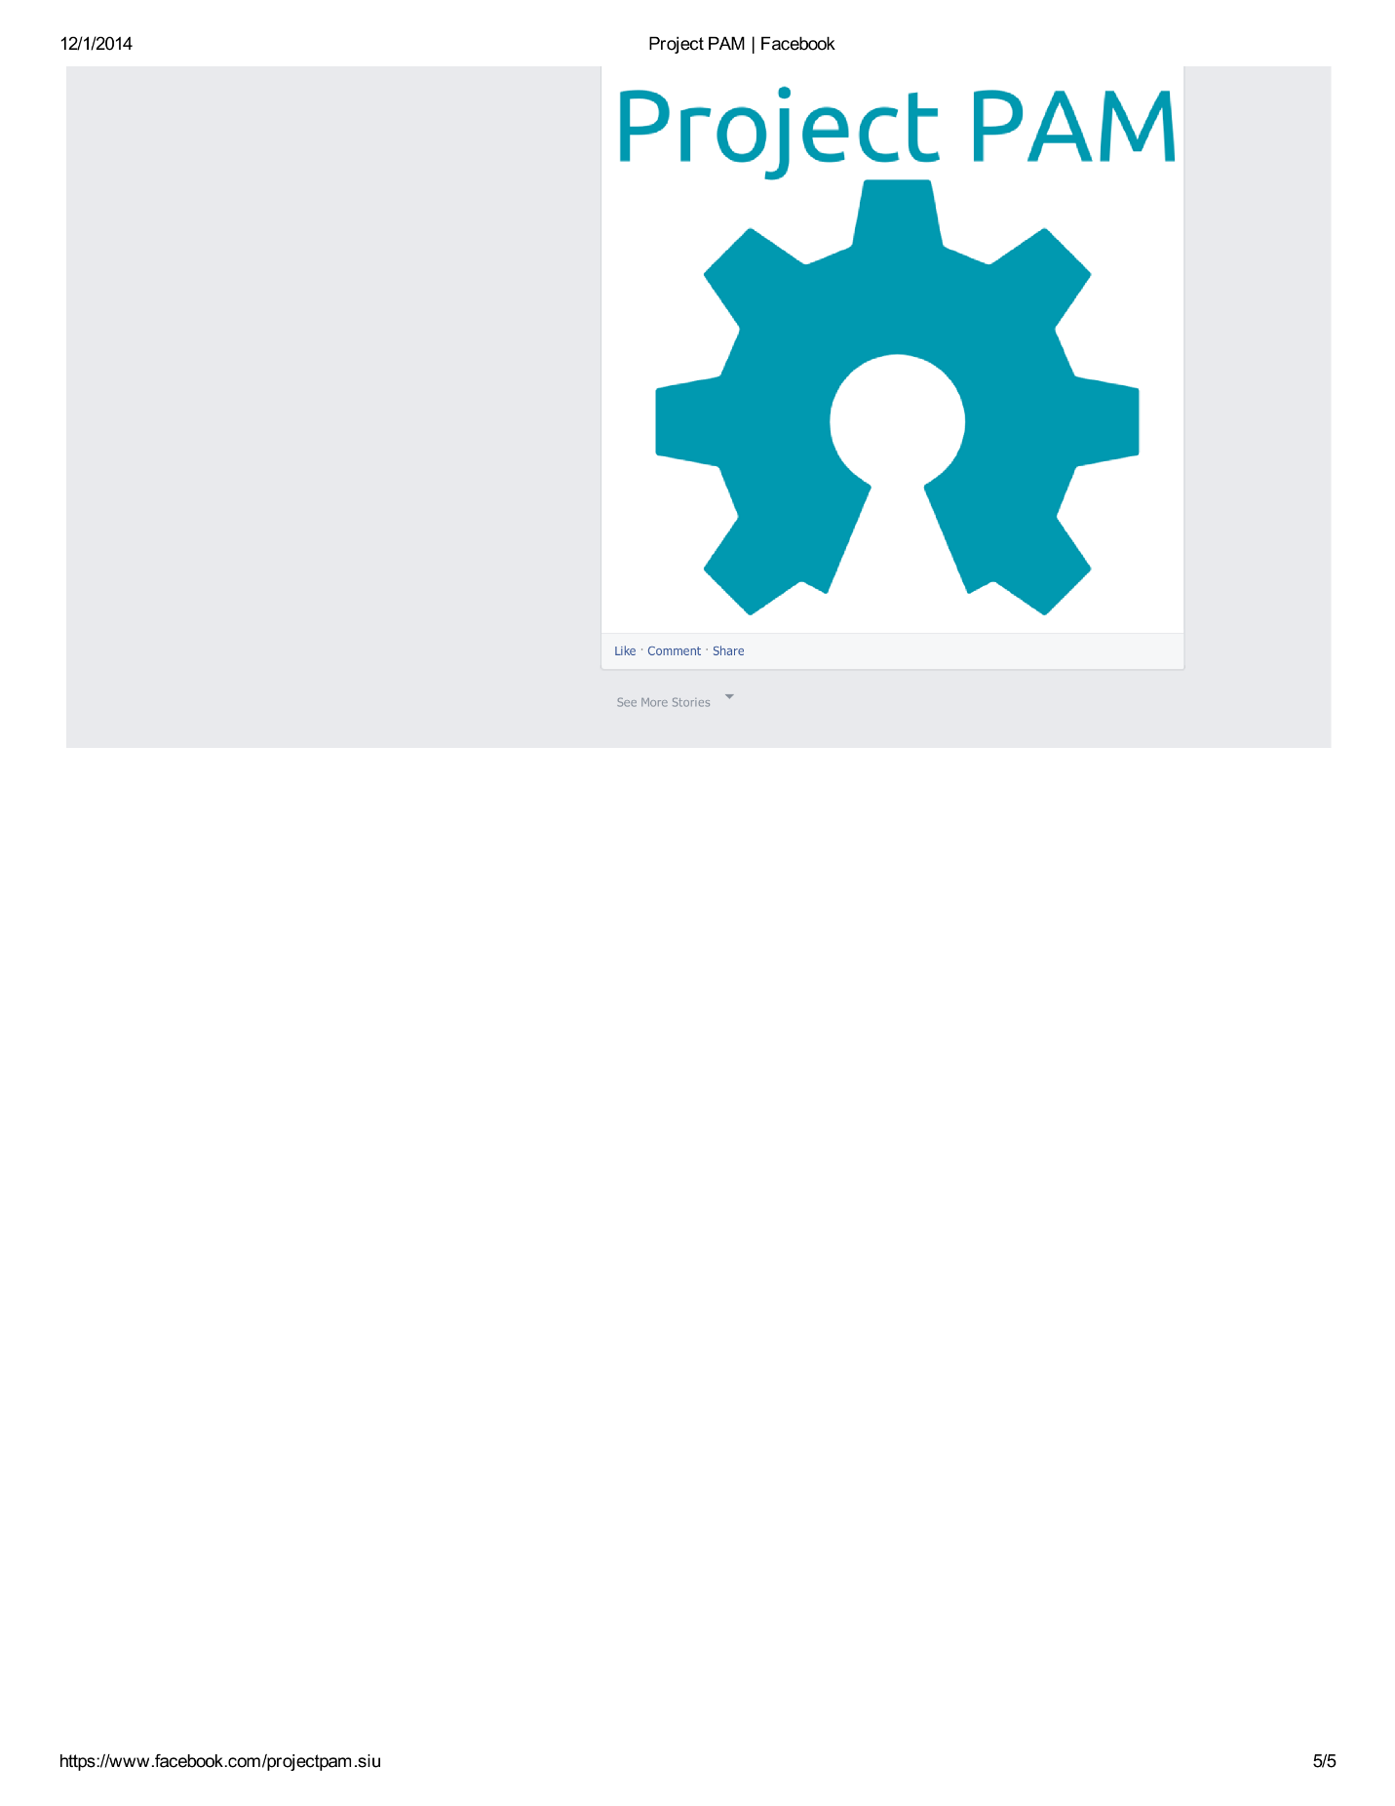

## Articles Project PAM Was Featured In

### 3DPrint.com

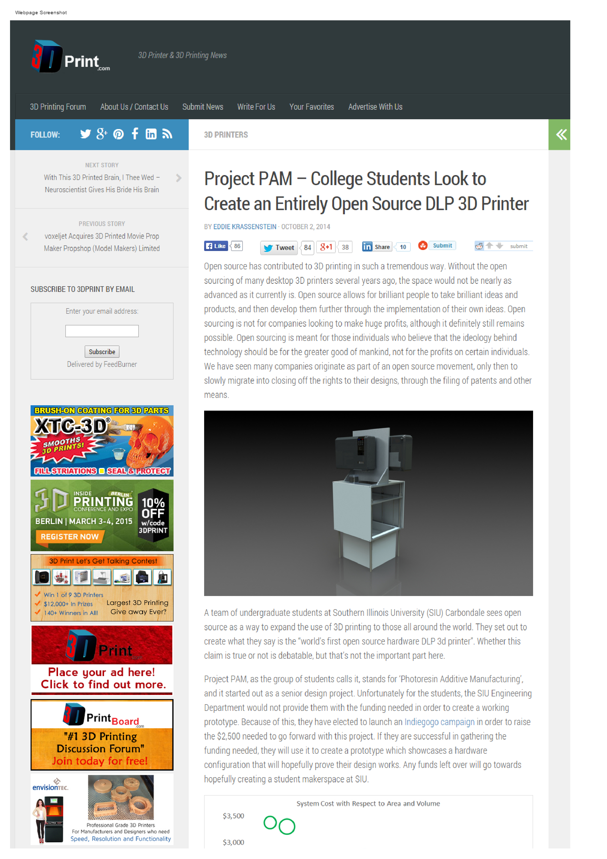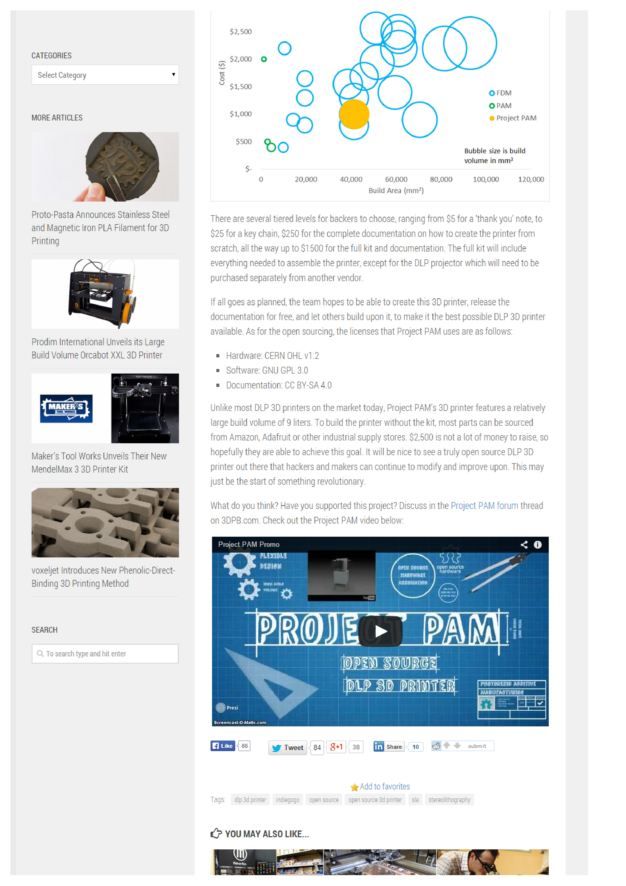

### 3D Printing Industry

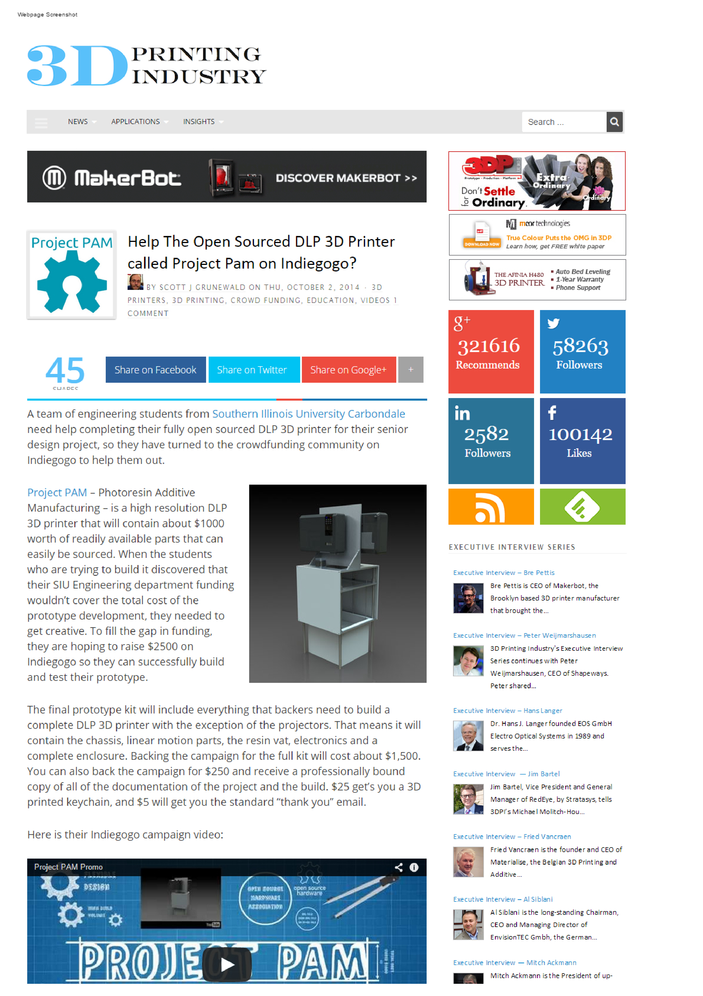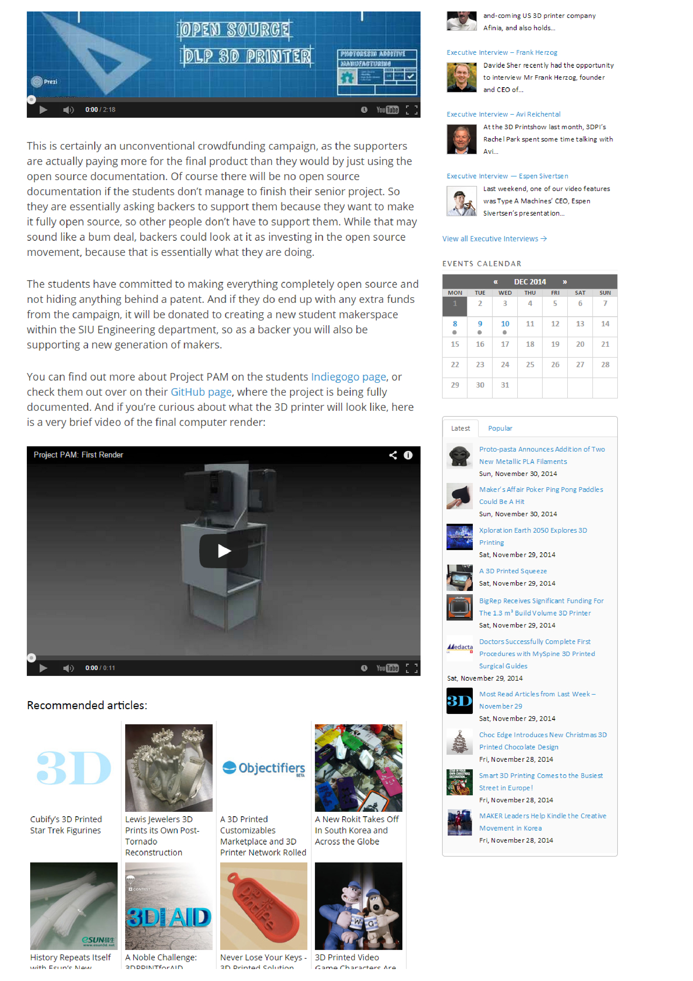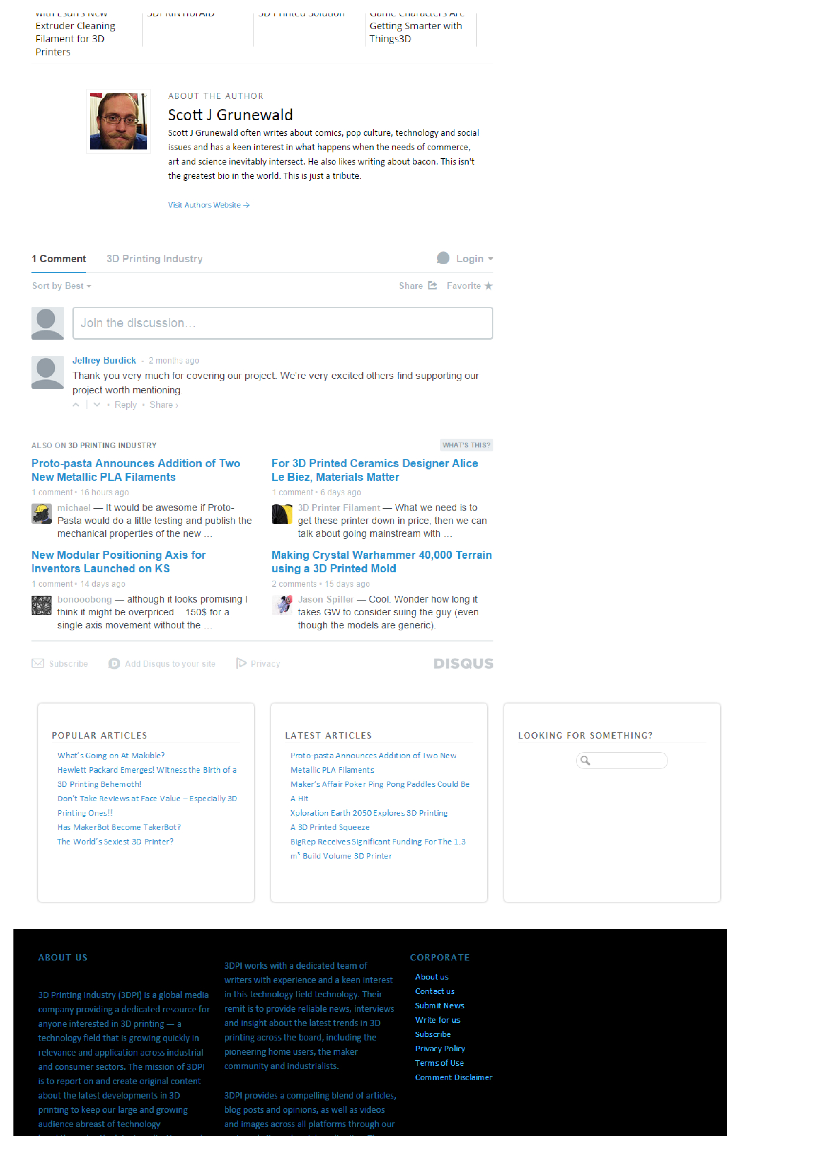

### WSIU

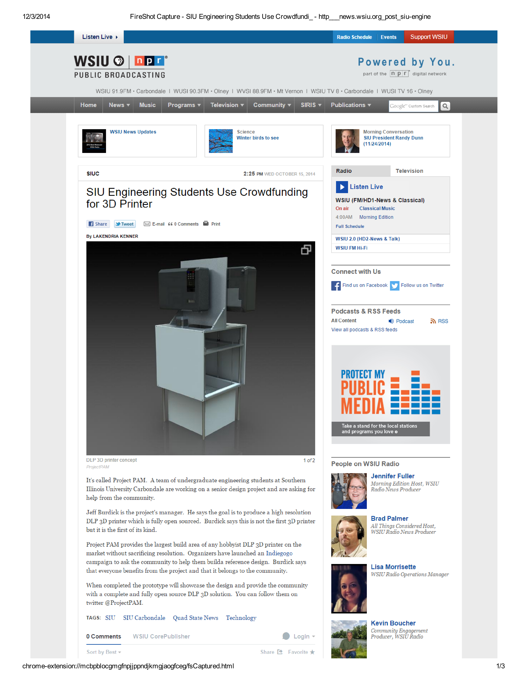

### Make Magazine

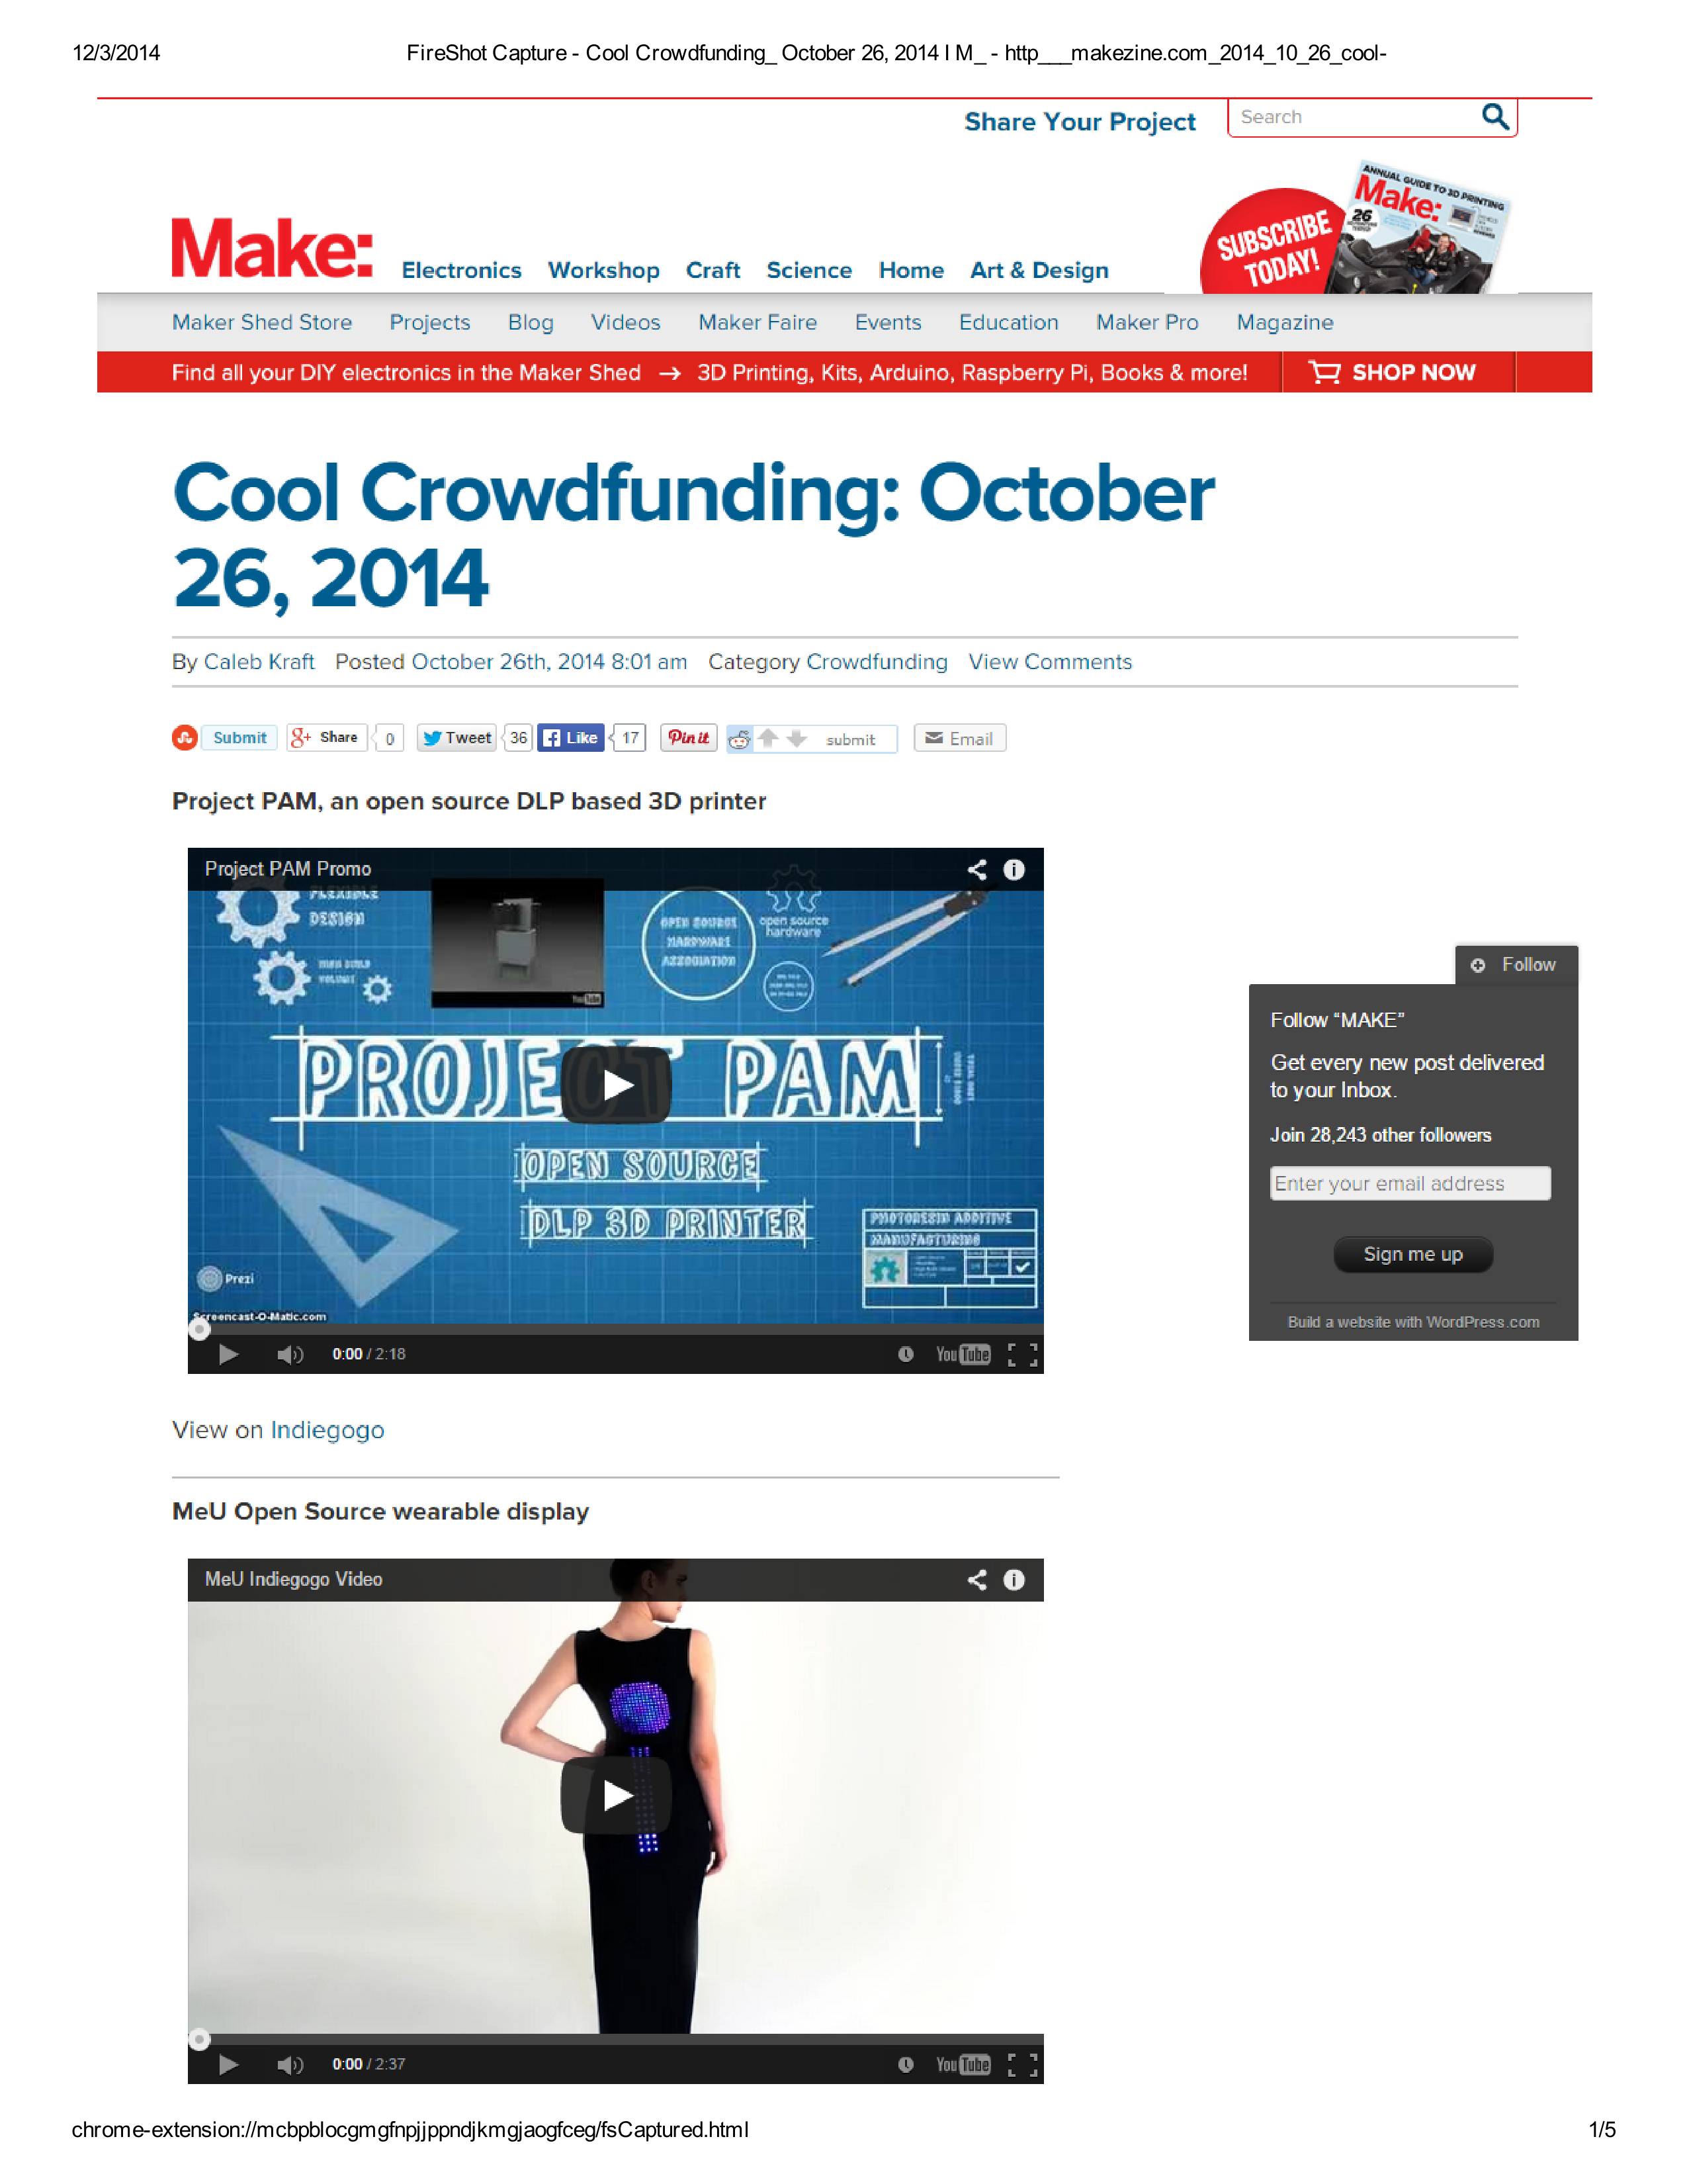

## User Manual

### Printing Instructions

Released under CC-SA

Version 0.1 2014-12-02

1. Pick a vat, build table, and build table ties based on build dimensions, leaving room for supports
2. Hang the build table and level with height gage
3. Set Z axis home based on desired X and Y dimensions
   1. Turn on projector
   2. Set rule on build table
   3. Adjust Z axis, zoom, and focus until projection is to desired dimensions
   4. Reset the Arduino so this position is zeroed
4. Position vat
   1. Move down from home dimensions to the bottom-most position of travel
   2. Set vat height, ensuring it does not interfere with the build table and provides enough Z axis travel for build
   3. Home the Z axis
5. Focus projector
   1. Place a piece of paper on the build table
   2. Project small text onto paper
   3. Adjust focus until text is clear
   4. Clear the build table
   5. Cover the lens on the projector
6. Adjust build aspect ratio
   1. Load a 20 mm test cube in software and project a layer which shows the extents of the build
   2. Place a rule on the build table and ensure the projection is 20 mm square
   3. Adjust the build dimensions until the build dimensions are correct
      1. The following formula is useful:
         1. measured dimension / 20 mm * current build dimension
      2. It is useful to do this with one axis and adjust the other using the aspect ratio of the projector.
      3. If entropy creeps in and the numbers on the calculator get rather large decimal values, round to an integer and use the aspect ratio to set the other axis, then repeat the process
      4. Iterate this process until the dimensions look good
7. Fill the vat
   1. Measure the distance between the floor of the vat and the top of the build table
      1. The depth extension of a caliper is good for this
   2. Remove the vat
   3. Switch to non-curing light (red light, usually) and ensure the lens of the projector is covered
   4. Fill the vat to the depth measured
      1. Using the same depth extension of the caliper is good for this
   5. Place the vat in the machine
8. Level and Refine Z home position
   1. Do small Z moves and adjust the build table ties until the surface of the resin and the build table are parallel and the build table is just below the resin
   2. If there were large Z moves involved remove the vat and cover it, refocus the projector, and ensure the build dimensions are correct
9. Load model, move it 2 mm off the bottom of the build volume, and add a few supports to the bottom
10. Slice
11. Build
12. Enjoi

## Flashing Grbl

1. Download the Grbl source code.

* https://github.com/grbl/grbl/archive/master.zip
* Once downloaded, unzip it and you'll have a folder called grbl-master or something similar.
* (On Arduino IDE < 1.0.6 or < 1.5.6) Re-name the folder to Grbl. You have to do this, because the Arduino IDE does not like the - hyphen in their library names.

1. Make sure are using the most recent version of the Arduino IDE (last tested on v1.05).

* NOTE: For pre-v1.05 Arduino IDE users, you may need to manually add Grbl's source code into your Arduino libraries, so that it will appear in the Import Library... menu. Google the internet for how to do this, and once installed, skip to step 4.

1. Load Grbl into the Arduino IDE as a Library.

* Launch the Arduino IDE.
* Click the Sketch drop-down menu, navigate to Import Library..., and click Add Library....
* Select the Grbl folder when asked to select a zip or folder for the library you'd like to add.
* It may take a few seconds for the Arduino IDE to import it.

1. Create a Grbl sketch in the Arduino IDE.

* Start a new sketch, if one isn't already up on the screen.
* Click the Sketch drop-down menu, navigate to Import Library..., and click the new menu option Grbl at the bottom of the list.
* A long list of #include<>'s used by Grbl will be added to the sketch. Ensure (edit if necessary) that "system.h" is at or near the top of the list of includes. At this point, *don't add anything else! No void, no loop, nothing!*

1. Compile and upload Grbl to your Arduino.

* Connect your Arduino Uno to your computer.
* Make sure your board is set to the Arduino Uno in the Tool->Board menu and the serial port is selected correctly in Tool->Serial Port.
* Click the Upload, and Grbl should compile and flash to your Arduino! (Flashing with a programmer also works by using the Upload Using Programmer menu command.

### Configuring Grbl

1. First, connect to Grbl using the serial terminal of your choice. Set the baud rate to **115200** as 8-N-1 (8-bits, no parity, and 1-stop bit.)
2. Once connected you should get the Grbl-prompt, which looks like this:

* Grbl 0.9g ['$' for help]

1. Type **$** and press enter to have Grbl print a help message. You should not see any local echo of the $ and enter. Grbl should respond with:

$$ (view Grbl settings)

$# (view # parameters)

$G (view parser state)

$I (view build info)

$N (view startup blocks)

$x=value (save Grbl setting)

$Nx=line (save startup block)

$C (check gcode mode)

$X (kill alarm lock)

$H (run homing cycle)

~ (cycle start)

! (feed hold)

? (current status)

ctrl-x (reset Grbl)

1. We need to set the steps per millimeter variable equal to the pitch of your lead screw. **Type $$** to list variables

$100 = 314.961 (x, step/mm)

$101 = 314.961 (y, step/mm)

$102 = 314.961 (z, step/mm)

$110 =635.000 (x max rate, mm/min)

$111 = 635.000 (y max rate, mm/min)

$112 = 635.000 (z max rate, mm/min)

$120 = 50.000 (x accel, mm/sec2)

$121 = 50.000 (y accel, mm/sec2)

$122 = 50.000 (z accel, mm/sec2)

1. Setting variables for your system

* **Type $100** = (pitch of lead screw) to set the x motors variable
* **Type $101** = (pitch of lead screw) to set the y motors variable
* **Type $120** = 5 setting x motors acceleration to 5mm/sec2 allowing the motor to accelerate during the move, rather than starting at the maximum velocity
* **Type $121** = 5 setting y motors acceleration to 5mm/sec2

1. Next you will need to adjust the maximum velocity of the motors, depending on the pitch of the lead screw you will need a faster or slower maximum velocity in order to prevent miss-stepping and losing track of the positioning. Our system works fine at 250mm/min, adjust accordingly

* **Type $110** = (x motor velocity)
* **Type $111** = (y motor velocity)